The evolutionary dynamics of genome sizes and repetitive elements in Ensifera (Insecta: Orthoptera)

Hao Yuan¹, Xiao-Jing Liu², Xuan-Zeng Liu², Li-Na Zhao², Shao-Li Mao³*, Yuan Huang²*

¹ School of Basic Medical Sciences, Xi’an Medical University, Xi’an, China;
² College of Life Sciences, Shaanxi Normal University, Xi’an, China;
³ Xi’an Botanical Garden of Shaanxi Province/Institute of Botany of Shaanxi Province, Shaanxi Engineering Research Centre for Conservation and Utilization of Botanical Resources, Xi’an, China.

* Corresponding author

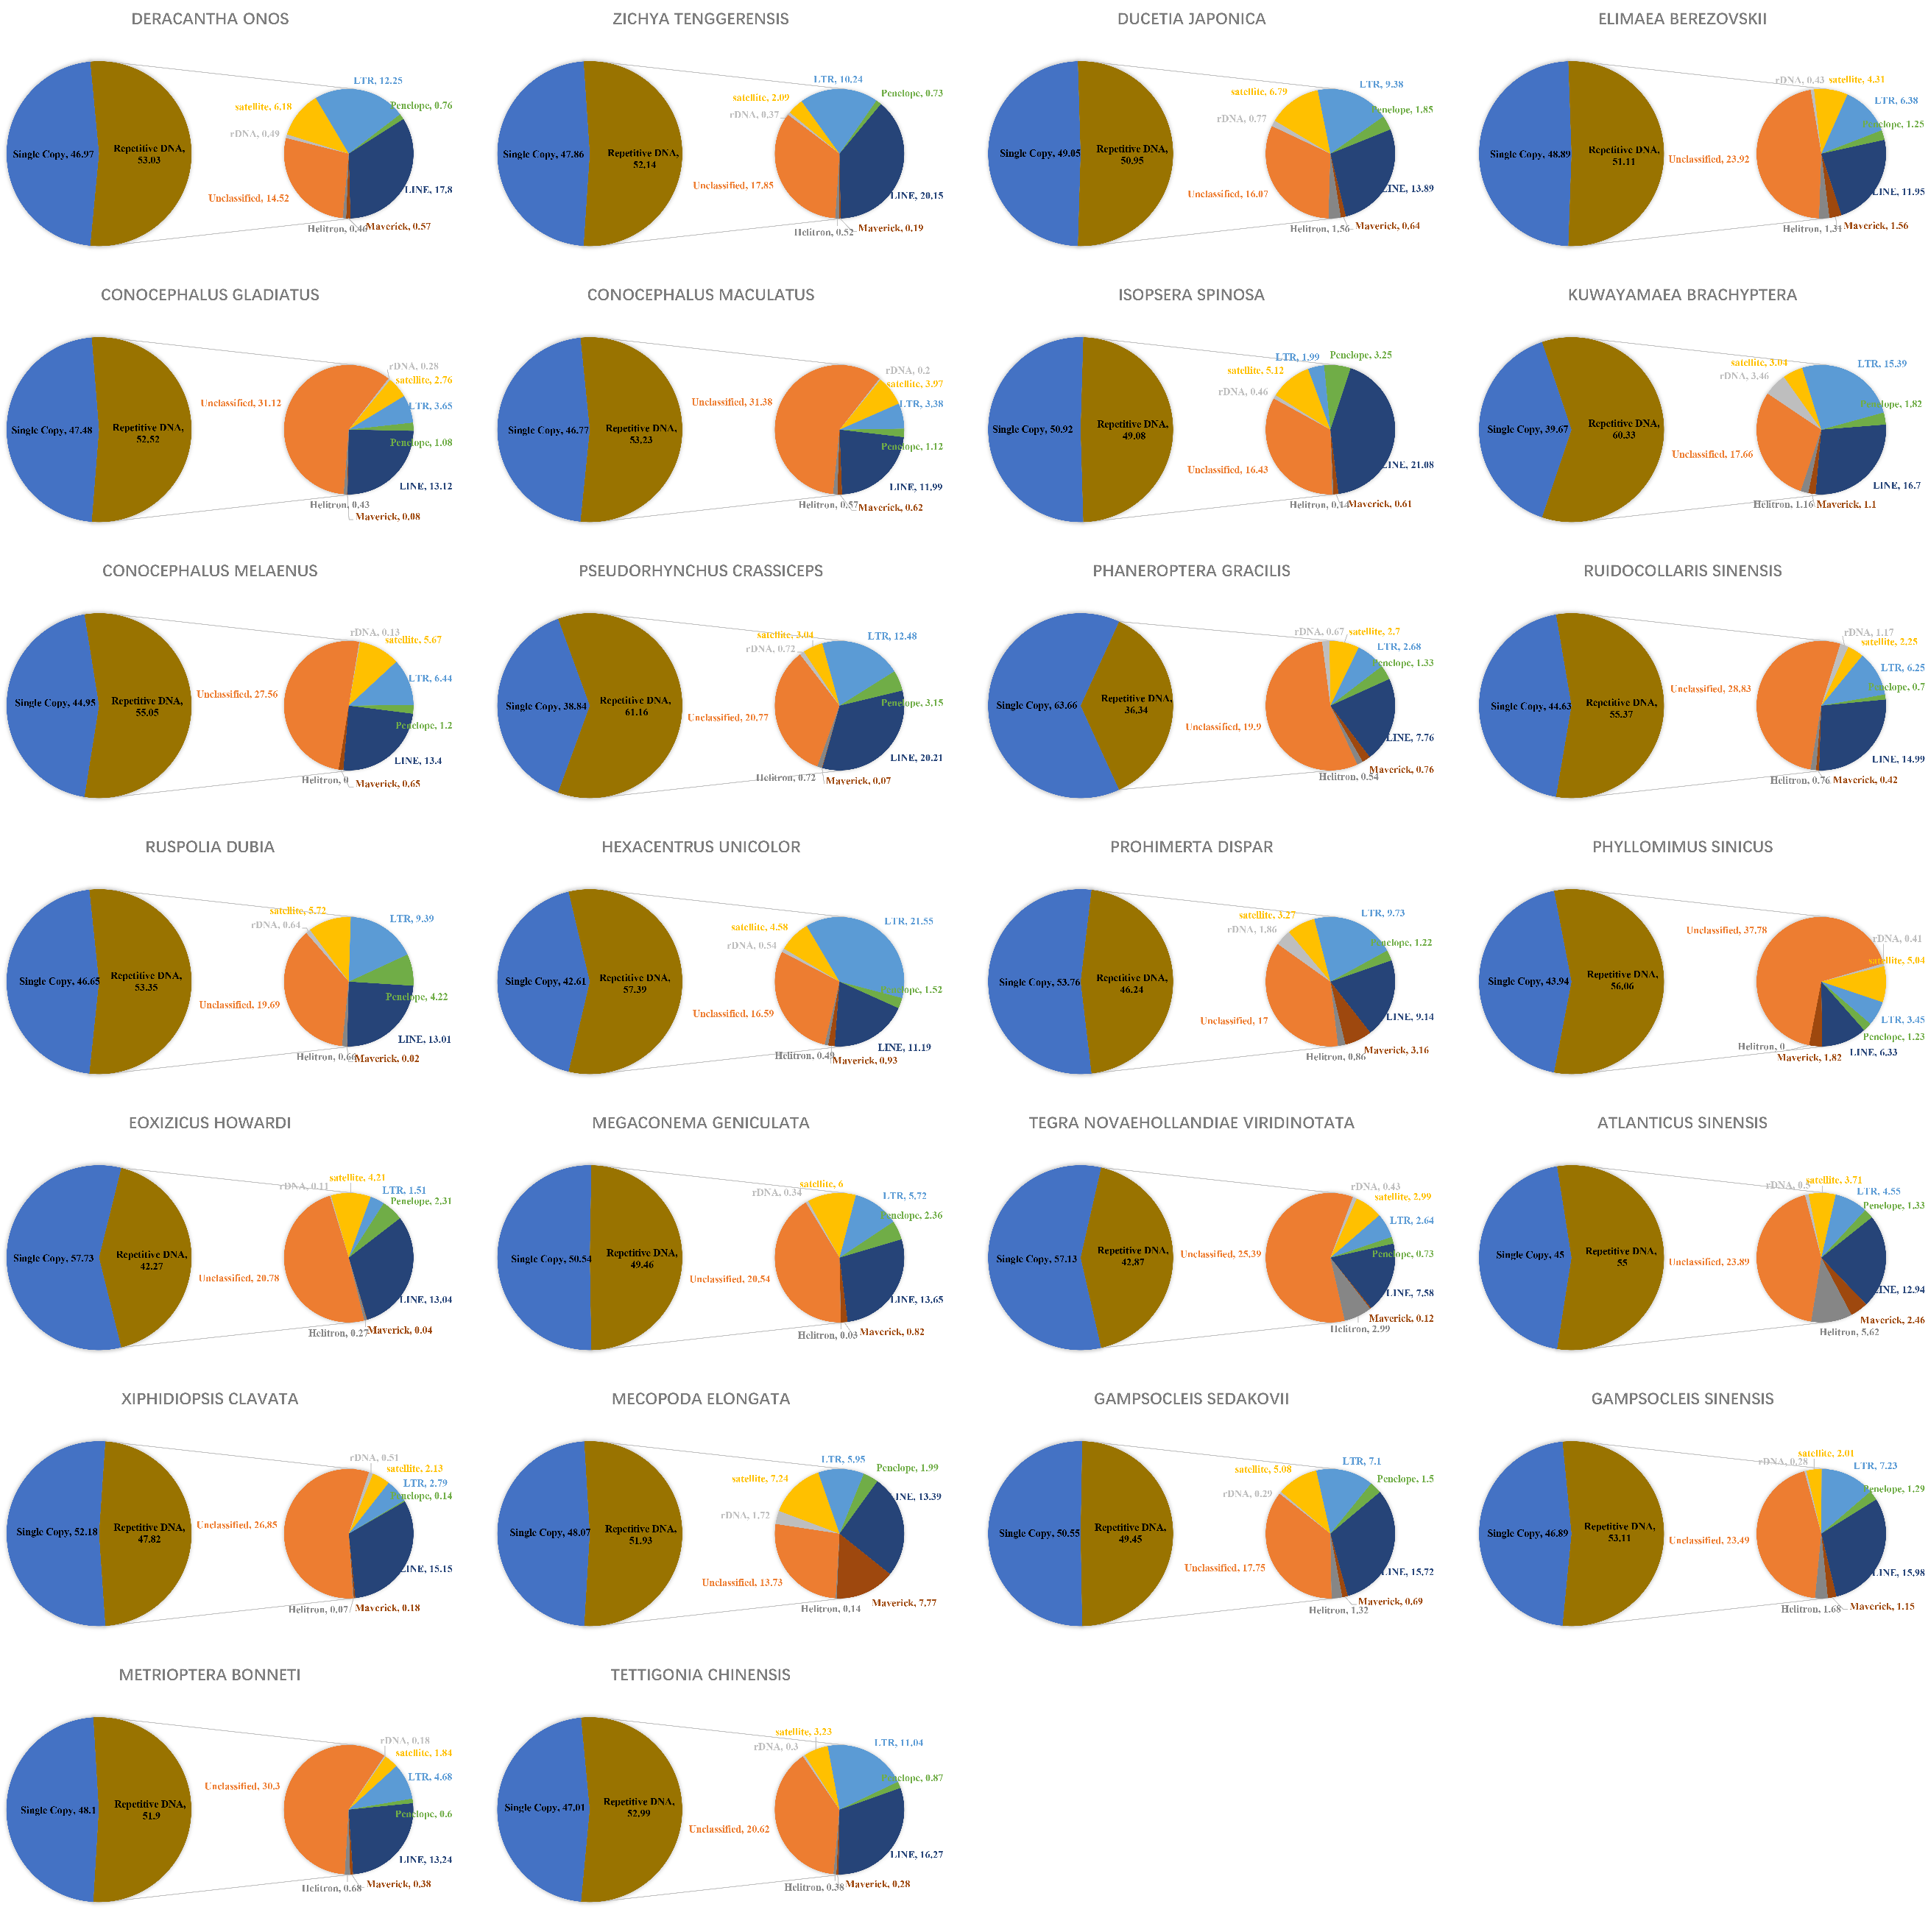
Fig. S1. The proportion of repetitive DNA in genome of 26 species of Tettigonioidea.

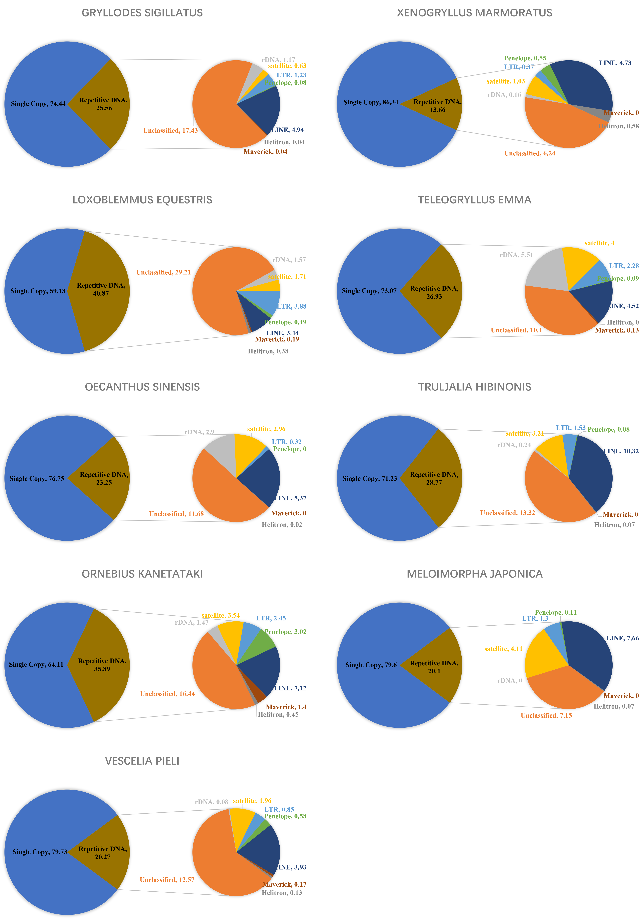
Fig. S2. The proportion of repetitive DNA in genome of nine species of Grylloidea.

Fig. S3. Phylogeny of Ensifera inferred from maximum likelihood analysis using the mitogenome sequences of 13 PCGs and two rRNAs (rrnL and rrnS). Values indicated on nodes represent bootstrap support (1,000 replications).

Fig. S4. Phylogeny of Ensifera based on Bayesian inference analysis using the mitogenome sequences of 13 PCGs and two rRNAs (rrnL and rrnS). Values indicated on nodes represent Bayesian posterior probabilities (100,000,000 generations; sample frequency = 5,000 generations; burn-in = 25%).

Fig. S5. Time-divergence estimates of Ensifera lineages using four fossil calibration points. Blue bars indicate 95% median confidence intervals.

Fig. S6. The size of the RE fraction (A), the TE fraction (B), the LINE fraction (C), or the LTR fraction (D) in the genome in pg is plotted against genome size on a log scale. It can be observed that the fitted line follows a linear regression relationship. The black line represents the fitted curvilinear model, with the light gray shadow indicating the 95% CI. Both adjusted R2 and p-values are plotted in the graph.

Fig. S7. TEs divergence landscape of Ensifera, the y-axis represents genome coverage of various types of TE, and the x-axis represents Kimura substitution level % (TE divergence based on the Kimura distance of TE copies to the corresponding consensus sequences).

