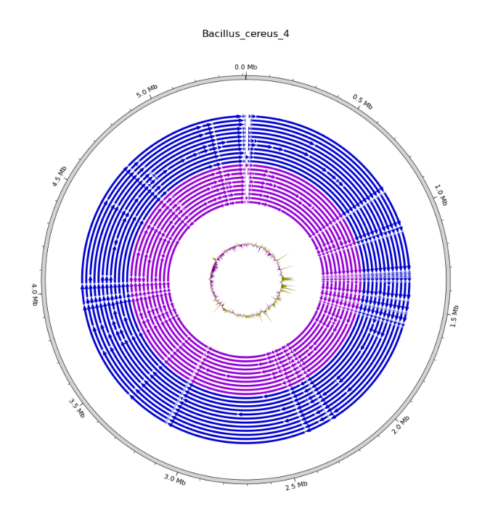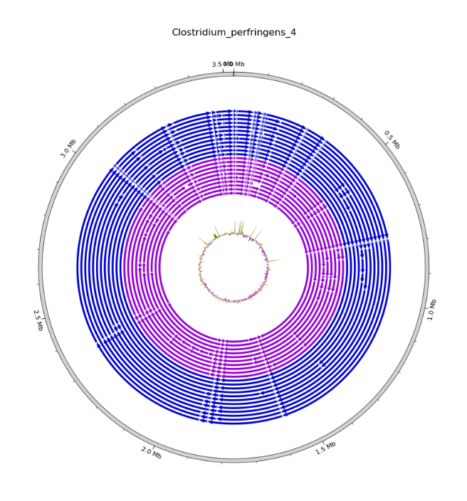
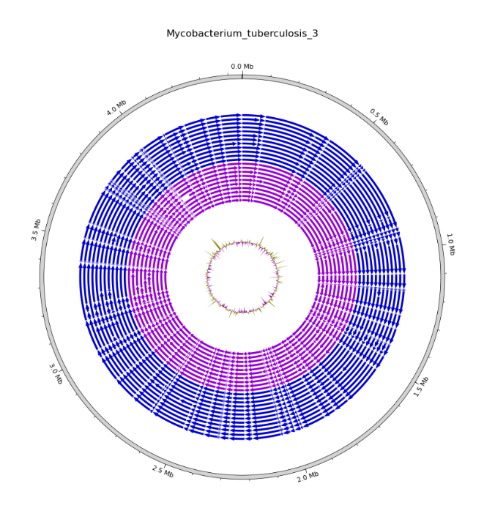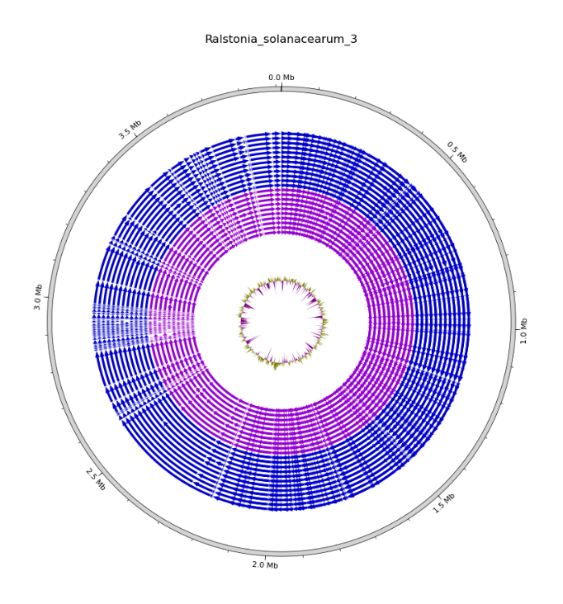
Supplementary data S2: Circos representations of alignments of obtained contigs to the reference genome, for the four species for which genome parts are lacking. The results obtained from high Quality data (Q>40) are shown in blue, the results obtained from poor Quality data (Q < 40) are shown in pink. Only assemblies obtained from SPAdes and unicycler are shown, as Shovill analyses didn’t perform on poor Quality data

