SUPPLEMENT

Supplemental Figure 1
BlobTools plots showing GC content of sequencing reads from Dovetail’s PacBio sequencing reads of B. impatiens DNA. These plots demonstrate low contamination of samples from non-Arthropod sources of DNA.
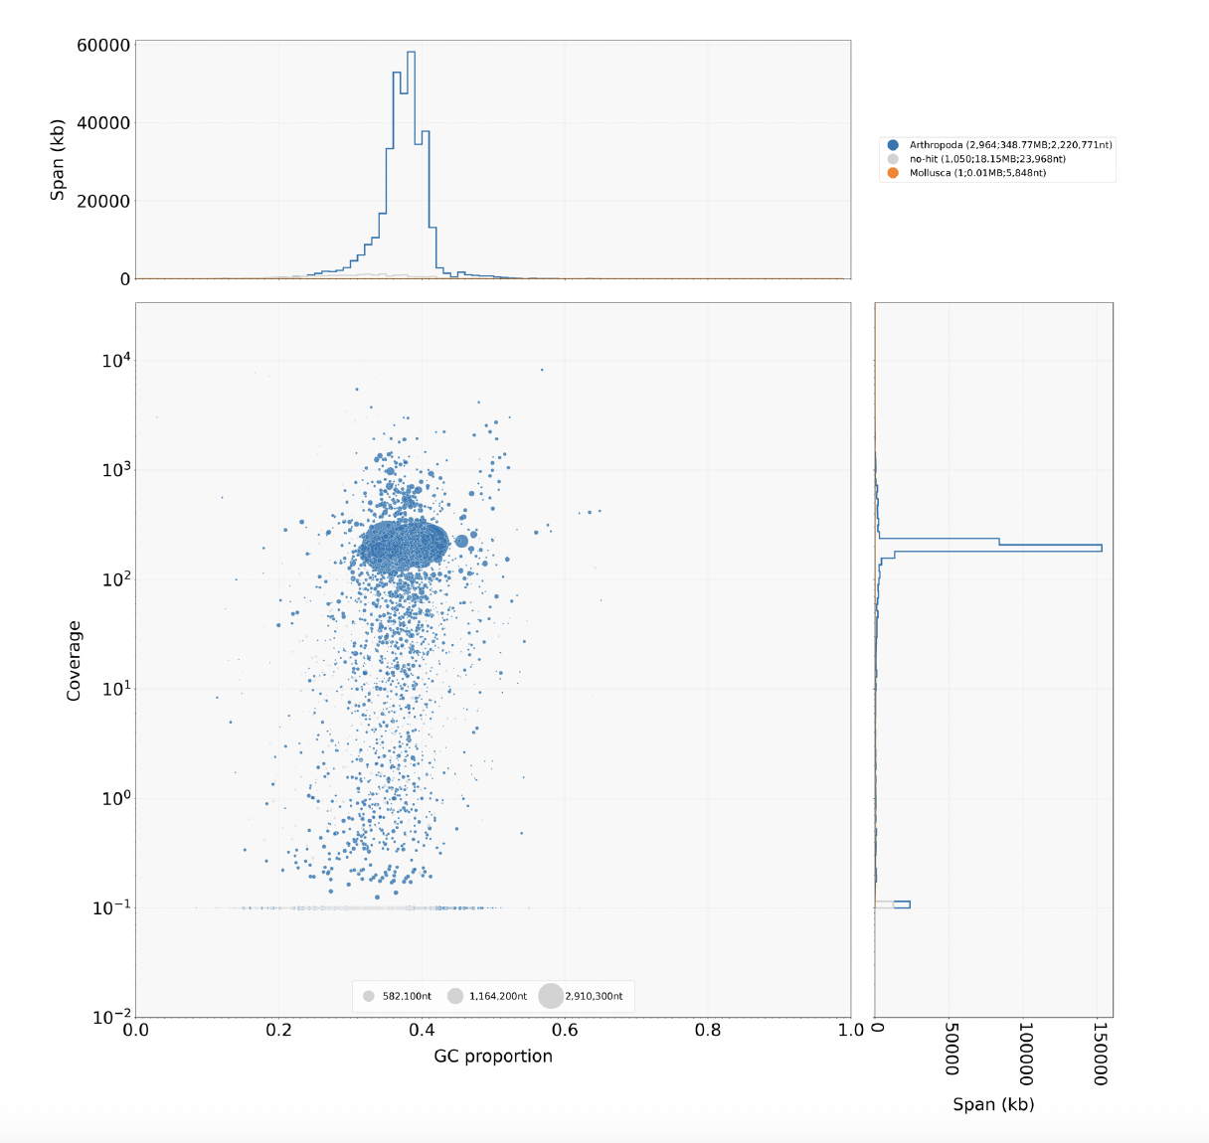

Supplemental Figure S2
Length distribution (log scale) of B. impatiens DNA reads from PacBio Sequencing used for the genome assembly.

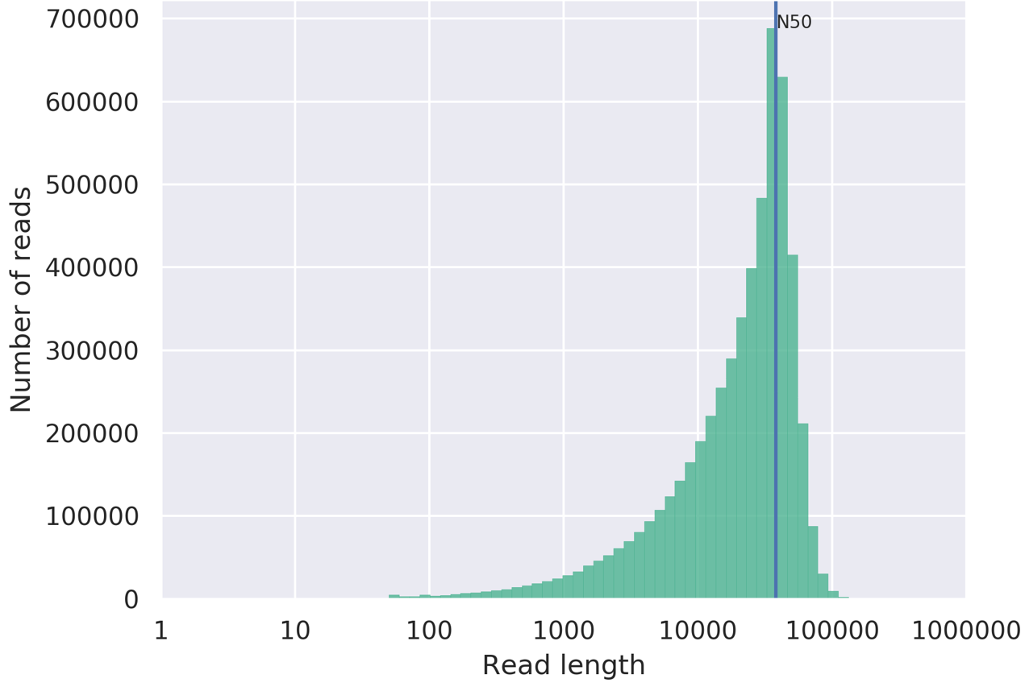

Supplemental Figure S3
Volcano plot of RNA-sequencing data from the brains of B. impatiens workers exposed to the heavy metal cocktail vs. controls, showing log₂ fold change vs -log₁₀ P value.

Supplemental Figure S4
MA plot of RNA-sequencing data from the brains of B. impatiens workers exposed to the heavy metal cocktail vs. controls, showing the log ratio of expression between the two groups compared to the mean average read counts (after normalization).

Supplemental Figure S5
Volcano plot of RNA-sequencing data from the fat bodies of B. impatiens workers exposed to the heavy metal cocktail vs. controls, showing log₂ fold change vs -log₁₀ P value.

Supplemental Figure S6
MA plot of RNA-sequencing data from the fat bodies of B. impatiens workers exposed to the heavy metal cocktail vs. controls, showing the log ratio of expression between the two groups compared to the mean average read counts (after normalization).

Supplemental Table S1
Assembly statistics, comparing the initial assembly and final assembly BIMP_3.0, demonstrating substantial improvements from using Juicer and manual curation. nt = nucleotides

Assembly | Initial Assembly (Dovetail) | Final Assembly BIMP3.0 (Juicer)
Number of scaffolds | 786 | 210
Total size of scaffolds (nt) | 266,302,045 | 266,606,045
Longest scaffold (nt) | 18,540,056 | 20,973,032
Shortest scaffold (nt) | 89 | 15,040
Number of scaffolds > 1K nt | 782 (99.5%) | 210 (100%)
Number of scaffolds > 10K nt | 589 (74.9%) | 210 (100%)
Number of scaffolds > 100K nt | 47 (6%) | 19 (9%)
Number of scaffolds > 1M nt | 19 (2.4%) | 18 (8.6%)
Number of scaffolds > 10M nt | 15 (1.9%) | 16 (7.6%)
Mean scaffold size (nt) | 338,807 | 1,269,553
Median scaffold size (nt) | 20,575 | 28,615
N50 scaffold length (nt) | 15,710,883 | 16,149,712
L50 scaffold count | 8 | 8
n90 scaffold length (nt) | 3,147,645 | 11,380,321
L90 scaffold count | 19 | 16
scaffold %A | 31.28 | 31.26
scaffold %C | 18.73 | 18.7
scaffold %G | 18.71 | 18.69
scaffold %T | 31.28 | 31.22
scaffold %N | 0.01 | 0.12
scaffold %non-ACGTN | 0 | 0
Number of scaffold non-ACGTN (nt) | 0 | 0
Percentage of assembly in scaffolded contigs | 91.40% | 97.80%
Percentage of assembly in unscaffolded contigs | 8.60% | 2.20%
Average number of contigs per scaffold | 1.2 | 4.6
Average length of break (> 25 Ns) between contigs in scaffold | 100 | 422

Supplemental Table S2
BUSCO statistics for the assemblies produced by the data generated in this project (initial from Dovetail HiRise and final using Juicer, designated as BIMP_3.0) and annotation.

 | Initial Assembly  (Dovetail) |  | Final Assembly  BIMP_3.0 (Juicer) |  | Annotation  (Braker)
 | Eukaryota (n=255) | Hymenoptera (n=5991) | Eukaryota (n=255) | Hymenoptera (n=5991) | Eukaryota (n=255) | Hymenoptera (n=5991)
Complete BUSCOs | 97.60% | 95.80% | 97.60% | 96.00% | 96.1% | 93.6%
Complete and single-copy BUSCOs | 97.6% | 95.6% | 97.6% | 95.8% | 73.7% | 61.0%
Complete and duplicated BUSCOs | 0.00% | 0.20% | 0.00% | 0.20% | 22.4% | 32.6%
Fragmented BUSCOs | 1.6% | 1.5% | 1.6% | 1.3% | 2.4% | 2.9%
Missing BUSCOs | 0.80% | 2.70% | 0.80% | 2.70% | 1.5% | 3.5%

Supplemental Table S3
Annotation statistics for the BIMP_3.0 annotation, CDS = coding sequence.

 | Gene | Transcript | CDS
Total bp aligned to genome | 106,795,928 | 181,541,756 | 31,263,898
Count | 14,011 | 21,127 | 138,723
Mean size (bp) | 7,626 | 8,592 | 225
Median size (bp) | 2,065 | 2,418 | 165
Min size (bp) | 115 | 115 | 2
Max size (bp) | 433,285 | 433,285 | 9,818

Supplemental Table S4
Repetitive and transposable elements uncovered by Repeatmasker in the BIMP_3.0 annotation.

Type | Number of | Length (bp) | Percentage (%)
Retroelements | 19,208 | 14,934,750 | 5.6
SINEs: | 0 | 0 | 0
Penelope | 0 | 0 | 0
LINEs: | 8,490 | 6,033,403 | 2.26
CRE/SLACS | 0 | 0 | 0
L2/CR1/Rex | 285 | 75,841 | 0.03
R1/LOA/Jockey | 2,677 | 1,700,468 | 0.64
R2/R4/NeSL | 257 | 453,758 | 0.17
RTE/Bov-B | 475 | 292,825 | 0.11
L1/CIN4 | 110 | 68,253 | 0.03
LTR | 10,718 | 8,901,347 | 3.34
BEL/Pao | 3,422 | 1,733,717 | 0.65
Ty1/Copia | 881 | 732,789 | 0.27
Gypsy/DIRS1 | 5,619 | 6,315,652 | 2.37
Retroviral | 203 | 12,161 | 0
DNA transposons | 12,728 | 3,074,277 | 1.15
hobo-Activator | 1048 | 31,5203 | 0.12
Tc1-IS630-Pogo | 7455 | 168,3366 | 0.63
En-Spm | 0 | 0 | 0
MuDR-IS905 | 0 | 0 | 0
PiggyBac | 2,072 | 740,702 | 0.28
Tourist/Harbinger | 109 | 2,5334 | 0.01
Other (Mirage, P-element, Transib) | 0 | 0 | 0
Rolling-circles | 239 | 82,433 | 0.03
Unclassified | 137,962 | 33,197,315 | 12.45
Total interspersed repeats | not quantified | 51,206,342 | 19.21
Small RNA | 0 | 0 | 0
Satellites | 0 | 0 | 0
Simple repeats | 86,408 | 4,229,641 | 1.59
Low complexity | 19,172 | 1,018,525 | 0.38

Supplemental Table S5
Information on samples used for Brain RNA-sequencing. ctrl= control treatment, metal = heavy metal exposed treatment

Well | Sample ID | Treatment | Filename | Tissue | Colony | Read length
A01 | A1 | ctrl | 1-A01-A1_S7_L002_R1_001.fastq | brain | A | 50
A02 | A2 | ctrl | 1-A02-A2_S8_L002_R1_001.fastq | brain | A | 50
A03 | A3 | ctrl | 1-A03-A3_S9_L002_R1_001.fastq | brain | A | 50
A04 | A4 | ctrl | 1-A04-A4_S10_L002_R1_001.fastq | brain | A | 50
A05 | A5 | ctrl | 1-A05-A5_S11_L002_R1_001.fastq | brain | A | 50
A06 | A6 | ctrl | 1-A06-A6_S12_L002_R1_001.fastq | brain | A | 50
A07 | A7 | ctrl | 1-A07-A7_S13_L002_R1_001.fastq | brain | A | 50
A08 | A8 | ctrl | 1-A08-A8_S14_L002_R1_001.fastq | brain | A | 50
A09 | A9 | ctrl | 1-A09-A9_S15_L002_R1_001.fastq | brain | A | 50
A10 | A10 | ctrl | 1-A10-A10_S16_L002_R1_001.fastq | brain | A | 50
A11 | A11 | ctrl | 1-A11-A11_S17_L002_R1_001.fastq | brain | A | 50
A12 | A12 | ctrl | 1-A12-A12_S18_L002_R1_001.fastq | brain | A | 50
B01 | A13 | ctrl | 1-B01-A13_S19_L002_R1_001.fastq | brain | A | 50
B02 | A14 | ctrl | 1-B02-A14_S20_L002_R1_001.fastq | brain | A | 50
B03 | A16 | ctrl | 1-B03-A16_S21_L002_R1_001.fastq | brain | A | 50
B04 | A17 | ctrl | 1-B04-A17_S22_L002_R1_001.fastq | brain | A | 50
B05 | A18 | ctrl | 1-B05-A18_S23_L002_R1_001.fastq | brain | A | 50
B06 | A19 | ctrl | 1-B06-A19_S24_L002_R1_001.fastq | brain | A | 50
B07 | B2 | metal | 1-B07-B2_S25_L002_R1_001.fastq | brain | B | 50
B08 | B3 | metal | 1-B08-B3_S26_L002_R1_001.fastq | brain | B | 50
B09 | B4 | metal | 1-B09-B4_S27_L002_R1_001.fastq | brain | B | 50
B10 | B5 | metal | 1-B10-B5_S28_L002_R1_001.fastq | brain | B | 50
B11 | B6 | metal | 1-B11-B6_S29_L002_R1_001.fastq | brain | B | 50
B12 | B7 | metal | 1-B12-B7_S30_L002_R1_001.fastq | brain | B | 50
C01 | B8 | metal | 1-C01-B8_S31_L002_R1_001.fastq | brain | B | 50
C02 | B10 | metal | 1-C02-B10_S32_L002_R1_001.fastq | brain | B | 50
C03 | C1 | ctrl | 1-C03-C1_S33_L002_R1_001.fastq | brain | C | 50
C04 | C2 | ctrl | 1-C04-C2_S34_L002_R1_001.fastq | brain | C | 50
C05 | C3 | ctrl | 1-C05-C3_S35_L002_R1_001.fastq | brain | C | 50
C06 | C4 | ctrl | 1-C06-C4_S36_L002_R1_001.fastq | brain | C | 50
C07 | C6 | ctrl | 1-C07-C6_S37_L002_R1_001.fastq | brain | C | 50
C08 | C7 | ctrl | 1-C08-C7_S38_L002_R1_001.fastq | brain | C | 50
C09 | C8 | ctrl | 1-C09-C8_S39_L002_R1_001.fastq | brain | C | 50
C10 | C9 | ctrl | 1-C10-C9_S40_L002_R1_001.fastq | brain | C | 50
C11 | D1 | metal | 1-C11-D1_S41_L002_R1_001.fastq | brain | D | 50
C12 | D2 | metal | 1-C12-D2_S42_L002_R1_001.fastq | brain | D | 50
D01 | D5 | metal | 1-D01-D5_S43_L002_R1_001.fastq | brain | D | 50
D02 | D6 | metal | 1-D02-D6_S44_L002_R1_001.fastq | brain | D | 50
D03 | D7 | metal | 1-D03-D7_S45_L002_R1_001.fastq | brain | D | 50
D04 | D8 | metal | 1-D04-D8_S46_L002_R1_001.fastq | brain | D | 50
D05 | D9 | metal | 1-D05-D9_S47_L002_R1_001.fastq | brain | D | 50
D06 | D10 | metal | 1-D06-D10_S48_L002_R1_001.fastq | brain | D | 50
D07 | D11 | metal | 1-D07-D11_S49_L002_R1_001.fastq | brain | D | 50
D08 | E1 | metal | 1-D08-E1_S50_L002_R1_001.fastq | brain | E | 50
D09 | E2 | metal | 1-D09-E2_S51_L002_R1_001.fastq | brain | E | 50
D10 | E5 | metal | 1-D10-E5_S52_L002_R1_001.fastq | brain | E | 50
D11 | E7 | metal | 1-D11-E7_S53_L002_R1_001.fastq | brain | E | 50
D12 | E8 | metal | 1-D12-E8_S54_L002_R1_001.fastq | brain | E | 50
E01 | E9 | metal | 1-E01-E9_S55_L002_R1_001.fastq | brain | E | 50
E02 | E10 | metal | 1-E02-E10_S56_L002_R1_001.fastq | brain | E | 50
E03 | F1 | metal | 1-E03-F1_S57_L002_R1_001.fastq | brain | F | 50
E04 | F2 | metal | 1-E04-F2_S58_L002_R1_001.fastq | brain | F | 50
E05 | F3 | metal | 1-E05-F3_S59_L002_R1_001.fastq | brain | F | 50
E06 | F4 | metal | 1-E06-F4_S60_L002_R1_001.fastq | brain | F | 50
E07 | F5 | metal | 1-E07-F5_S61_L002_R1_001.fastq | brain | F | 50
E08 | F6 | metal | 1-E08-F6_S62_L002_R1_001.fastq | brain | F | 50
E09 | F7 | metal | 1-E09-F7_S63_L002_R1_001.fastq | brain | F | 50
E10 | F8 | metal | 1-E10-F8_S64_L002_R1_001.fastq | brain | F | 50
E11 | F9 | metal | 1-E11-F9_S65_L002_R1_001.fastq | brain | F | 50
E12 | F10 | metal | 1-E12-F10_S66_L002_R1_001.fastq | brain | F | 50

Supplemental Table S6
Information on samples used for Fat body RNA-sequencing. ctrl= control treatment, metal = heavy metal exposed treatment

Well | Sample ID | Treatment | Filename | Tissue | Colony | Read length
A01 | A3 | ctrl | 1-A01-A3_S1_L002_R1_001.fastq | fat body | A | 100
A02 | E4 | metal | 1-A02-E4_S2_L002_R1_001.fastq | fat body | E | 100
A03 | E5 | metal | 1-A03-E5_S3_L002_R1_001.fastq | fat body | E | 100
A04 | A15 | ctrl | 1-A04-A15_S4_L002_R1_001.fastq | fat body | A | 100
A05 | F8 | metal | 1-A05-F8_S5_L002_R1_001.fastq | fat body | F | 100
A06 | D2 | metal | 1-A06-D2_S6_L002_R1_001.fastq | fat body | D | 100
A07 | D1 | metal | 1-A07-D1_S7_L002_R1_001.fastq | fat body | D | 100
A08 | A2 | ctrl | 1-A08-A2_S8_L002_R1_001.fastq | fat body | A | 100
A09 | F9 | metal | 1-A09-F9_S9_L002_R1_001.fastq | fat body | F | 100
A10 | B9 | metal | 1-A10-B9_S10_L002_R1_001.fastq | fat body | B | 100
A11 | B7 | metal | 1-A11-B7_S11_L002_R1_001.fastq | fat body | B | 100
A12 | A13 | ctrl | 1-A12-A13_S12_L002_R1_001.fastq | fat body | A | 100
B01 | A14 | ctrl | 1-B01-A14_S13_L002_R1_001.fastq | fat body | A | 100
B02 | A1 | ctrl | 1-B02-A1_S14_L002_R1_001.fastq | fat body | A | 100
B03 | F10 | metal | 1-B03-F10_S15_L002_R1_001.fastq | fat body | F | 100
B04 | B8 | metal | 1-B04-B8_S16_L002_R1_001.fastq | fat body | B | 100
B05 | B11 | metal | 1-B05-B11_S17_L002_R1_001.fastq | fat body | B | 100
B06 | F10 | metal | 1-B06-F10_S18_L002_R1_001.fastq | fat body | F | 100
B07 | C1 | ctrl | 1-B07-C1_S19_L002_R1_001.fastq | fat body | C | 100
B08 | D5 | metal | 1-B08-D5_S20_L002_R1_001.fastq | fat body | D | 100
B09 | C3 | ctrl | 1-B09-C3_S21_L002_R1_001.fastq | fat body | C | 100
B10 | A4 | ctrl | 1-B10-A4_S22_L002_R1_001.fastq | fat body | A | 100
B11 | A5 | ctrl | 1-B11-A5_S23_L002_R1_001.fastq | fat body | A | 100
B12 | C2 | ctrl | 1-B12-C2_S24_L002_R1_001.fastq | fat body | C | 100
C01 | E7 | metal | 1-C01-E7_S25_L002_R1_001.fastq | fat body | E | 100
C02 | D4 | metal | 1-C02-D4_S26_L002_R1_001.fastq | fat body | D | 100
C03 | A17 | ctrl | 1-C03-A17_S27_L002_R1_001.fastq | fat body | A | 100
C04 | A6 | ctrl | 1-C04-A6_S28_L002_R1_001.fastq | fat body | A | 100
C05 | A16 | ctrl | 1-C05-A16_S29_L002_R1_001.fastq | fat body | A | 100
C06 | D3 | metal | 1-C06-D3_S30_L002_R1_001.fastq | fat body | D | 100
C07 | A18 | ctrl | 1-C07-A18_S31_L002_R1_001.fastq | fat body | A | 100
C08 | E8 | metal | 1-C08-E8_S32_L002_R1_001.fastq | fat body | E | 100
C09 | B10 | metal | 1-C09-B10_S33_L002_R1_001.fastq | fat body | B | 100
C10 | E6 | metal | 1-C10-E6_S34_L002_R1_001.fastq | fat body | E | 100
C11 | C6 | ctrl | 1-C11-C6_S35_L002_R1_001.fastq | fat body | C | 100
C12 | D9 | metal | 1-C12-D9_S36_L002_R1_001.fastq | fat body | D | 100
D01 | F7 | metal | 1-D01-F7_S37_L002_R1_001.fastq | fat body | F | 100
D02 | D7 | metal | 1-D02-D7_S38_L002_R1_001.fastq | fat body | D | 100
D03 | C8 | ctrl | 1-D03-C8_S39_L002_R1_001.fastq | fat body | C | 100
D04 | B6 | metal | 1-D04-B6_S40_L002_R1_001.fastq | fat body | B | 100
D05 | A12 | ctrl | 1-D05-A12_S41_L002_R1_001.fastq | fat body | A | 100
D06 | E1 | metal | 1-D06-E1_S42_L002_R1_001.fastq | fat body | E | 100
D07 | A9 | ctrl | 1-D07-A9_S43_L002_R1_001.fastq | fat body | A | 100
D08 | C9 | ctrl | 1-D08-C9_S44_L002_R1_001.fastq | fat body | C | 100
D09 | B3 | metal | 1-D09-B3_S45_L002_R1_001.fastq | fat body | B | 100
D10 | A11 | ctrl | 1-D10-A11_S46_L002_R1_001.fastq | fat body | A | 100
D11 | F4 | metal | 1-D11-F4_S47_L002_R1_001.fastq | fat body | F | 100
D12 | E2 | metal | 1-D12-E2_S48_L002_R1_001.fastq | fat body | E | 100
E01 | E3 | metal | 1-E01-E3_S49_L002_R1_001.fastq | fat body | E | 100
E02 | B4 | metal | 1-E02-B4_S50_L002_R1_001.fastq | fat body | B | 100
E03 | C7 | ctrl | 1-E03-C7_S51_L002_R1_001.fastq | fat body | C | 100
E04 | A8 | ctrl | 1-E04-A8_S52_L002_R1_001.fastq | fat body | A | 100
E05 | B1 | metal | 1-E05-B1_S53_L002_R1_001.fastq | fat body | B | 100
E06 | E9 | metal | 1-E06-E9_S54_L002_R1_001.fastq | fat body | F | 100
E07 | F5 | metal | 1-E07-F5_S55_L002_R1_001.fastq | fat body | F | 100
E08 | F6 | metal | 1-E08-F6_S56_L002_R1_001.fastq | fat body | F | 100
E09 | B5 | metal | 1-E09-B5_S57_L002_R1_001.fastq | fat body | B | 100
E10 | A10 | ctrl | 1-E10-A10_S58_L002_R1_001.fastq | fat body | A | 100
E11 | C4 | ctrl | 1-E11-C4_S59_L002_R1_001.fastq | fat body | C | 100
E12 | E10 | metal | 1-E12-E10_S60_L002_R1_001.fastq | fat body | E | 100
F01 | F3 | metal | 1-F01-F3_S61_L002_R1_001.fastq | fat body | F | 100
F02 | A7 | ctrl | 1-F02-A7_S62_L002_R1_001.fastq | fat body | A | 100
F03 | F2 | metal | 1-F03-F2_S63_L002_R1_001.fastq | fat body | F | 100
F04 | D8 | metal | 1-F04-D8_S64_L002_R1_001.fastq | fat body | D | 100
F05 | C5 | ctrl | 1-F05-C5_S65_L002_R1_001.fastq | fat body | C | 100
F06 | B2 | metal | 1-F06-B2_S66_L002_R1_001.fastq | fat body | B | 100
F07 | D6 | metal | 1-F07-D6_S67_L002_R1_001.fastq | fat body | D | 100

Supplemental Table S7

Summary of RNA-seq differential expression analysis, comparing control vs metal exposed brains and fat bodies. Results for two different significance thresholds are shown, adjusted p-value cutoff < 0.1 or <0.05.

Tissue | Brain (p<0.1) | Fat Body (p<0.1) | Brain (p<0.05) | Fat Body (p<0.05)
Total transcripts with nonzero read count | 13,113 | 13,502 | 13114 | 13502
Differentially expressed transcript count (% of total nonzero) | 999 (7.6%) | 57 (0.4%) | 603 (4.6%) | 34 (0.23%)
Upregulated transcript count | 542 | 36 | 319 | 23
Downregulated transcript count | 457 | 21 | 284 | 11
Outlier transcript count | 0 | 0 | 0 | 0
Low reads (<1 mean reads) transcript count | 6,859 | 4,447 | 6859 | 4708
Total transcripts analyzed | 20,971 | 18,006 | 19973 | 18210

Supplemental Datasets

Supplemental Dataset 1
Single file containing a conversion list of new BIMP_3.0 annotation to previous annotation BIMP_2.2, functional annotations for the annotated genes from the BIMP_3.0 annotation, RNA-seq statistical results from DESeq2 for both fat body and brain tissues
https://github.com/ISUgenomics/2024_Toth_Bimpatiens/blob/main/Supplementary_Data_File_All.xlsx

Supplemental Dataset 2
Conversion list for annotations from BIMP_3.0 compared to the earlier annotation NCBI Release 103, associated with BIMP_2.2 genome.
https://github.com/ISUgenomics/2024_Toth_Bimpatiens/blob/main/Notebook_Masonbrink/05_AlignNCBIAnnotation.md

Supplemental Dataset 3
Quality statistics on brain RNA-sequencing data
https://github.com/ISUgenomics/2024_Toth_Bimpatiens/blob/main/Notebook_Chris/data/multiqc/multiqc_brain_report.html.gz

Supplemental Dataset 4
Quality statistics on fat body RNA-sequencing data
https://github.com/ISUgenomics/2024_Toth_Bimpatiens/blob/main/Notebook_Chris/data/multiqc/multiqc_fatbody_report.html.gz

