Supplementary Table 1. A list of bioinformatic tools and resources used in the genome assembly and annotation of Microsporidia MB
Annotation Type | Software | URL | Reference
Genome assembly and annotation | FASTQC | https://www.bioinformatics.babraham.ac.uk/projects/fastqc/ | (1)
Genome assembly and annotation | MULTIQC | https://github.com/MultiQC/MultiQC | (2)
Genome assembly and annotation | BWA-MEM | https://github.com/lh3/bwa | (3)
Genome assembly and annotation | SAMTOOLS | https://github.com/samtools/ | (4)
Genome assembly and annotation | KRAKEN2 | https://github.com/DerrickWood/kraken2 | (5)
Genome assembly and annotation | UNICYCLER v0.4.9 | https://github.com/rrwick/Unicycler | (6)
Genome assembly and annotation | QUAST | https://github.com/ablab/quast | (7)
Genome assembly and annotation | GeneMark-ES v2.5p | https://github.com/gatech-genemark/GeneMark-EP-plus | (8)
Genome assembly and annotation | OrthoFinder v2.5.4 | https://github.com/davidemms/OrthoFinder | (9)
Genome assembly and annotation | BUSCOPhylo | https://pypi.org/project/buscophylo/ | (10)
Gene Ontology | BLAST2GO | https://www.blast2go.com/
Subcellular localization | DeepTMHMM v1.0.24 | http://www.cbs.dtu.dk/services/TMHMM/ | (11)
Subcellular localization | TargetP v2.0 | http://www.cbs.dtu.dk/services/TargetP/ | (12)
Subcellular localization | SignalP v6.0 | http://www.cbs.dtu.dk/services/SignalP/ | (13)
Sequence retrieval and similarity search | NCBI-BLAST | https://blast.ncbi.nlm.nih.gov/Blast.cgi | (14)
Sequence retrieval and similarity search | MicrosporidiaDB v10 | https://microsporidiadb.org/ | (15)
Programming languages for script generation | Python v. 3.8 | https://www.python.org/ | (16)
Programming languages for script generation | Jupyter Notebook | https://jupyter.org/ | (17)
Characterization of physicochemical properties | EXPASY-PROTPARAM | https://web.expasy.org/protparam/ | (18)
Protein family classification | InterProScan |  | (19)
Protein family classification | Pfam | http://pfam.xfam.org | (20)
Protein family classification | InterPro | https://www.ebi.ac.uk/interpro/ | (21)
Protein family classification | HMMer | https://www.ebi.ac.uk/Tools/hmmer/ | (22)
Protein family classification | PANTHER | http://www.pantherdb.org | (23)
Protein family classification | PRINTS | http://130.88.97.239/PRINTS/index.php | (24)
Protein family classification | PIRSF | https://proteininformationresource.org/pirsf/ | (25)
Sequence alignment and phylogenetic analysis | MEGA X | https://www.megasoftware.net/ | (26,27)
Sequence alignment and phylogenetic analysis | MUSCLE | (https://www.ebi.ac.uk/Tools/msa/muscle/ ) | (28)
Sequence alignment and phylogenetic analysis | Dendroscope v. 3.7.4 | https://uni-tuebingen.de/en/fakultaeten/mathematisch-naturwissenschaftliche-fakultaet/fachbereiche/informatik/lehrstuehle/algorithms-in-bioinformatics/software/dendroscope/ | (29)
Motif analysis and domain functional annotation | MEME Suite (MEME & MAST) | https://meme-suite.org | (30)
Motif analysis and domain functional annotation | EXPASY-ScanProsite | https://prosite.expasy.org/scanprosite/ | (31)
Motif analysis and domain functional annotation | CDD Search | https://www.ncbi.nlm.nih.gov/Structure/bwrpsb/bwrpsb.cgi | (32)
Motif analysis and domain functional annotation | SMART | https://smart.embl.de | (33)
Metabolic pathway analysis | KEGG | https://www.genome.jp/kegg/ | (34)
Homology Modeling | PRIMO | https://primo-oligo.rubi.ru.ac.za/ | (35)
Homology Modeling | MODELLER | https://salilab.org/modeller/ | (36)
Homology Modeling | PROSA-web | https://prosa.services.came.sbg.ac.at/prosa.php | (37)
Homology Modeling | Verfy3D | https://saves.mbi.ucla.edu/ | (38)
Homology Modeling | QMEAN | http://swissmodel.expasy.org/qmean | (39)

Supplementary Table 2. Subcellular localization prediction of MB Leucine-rich repeat proteins using SignalP, TargetP and DeepTMHMM. The hydrophilic proteins < 0 GRAVY score also had membrane-spanning regions.
Sequence ID | Gene ID | GRAVY Score | SignalP | TargetP | DeepTMHMM | Protein length
NODE_405_length_6958_cov_65.2561 | gene_679 | Hydrophilic | Present | Present | Present | 2046
NODE_405_length_6958_cov_65.2561 | gene_680 | Hydrophilic | Present | Present | Present | 678
NODE_896_length_4075_cov_112.633 | gene_1299 | Hydrophilic | Absent | Absent | Absent | 315
NODE_1118_length_3304_cov_76.4631 | gene_1460 | Hydrophilic | Absent | Absent | Absent | 1443
NODE_1214_length_3045_cov_87.7886 | gene_1506 | Hydrophilic | Absent | Absent | Absent | 1239
NODE_1665_length_2269_cov_102.303 | gene_1719 | Hydrophilic | Present | Present | Present | 1473
NODE_1722_length_2205_cov_70.7865 | gene_1735 | Hydrophilic | Absent | Present | Absent | 1287
NODE_1928_length_1951_cov_33.5833 | gene_1799 | Hydrophilic | Absent | Absent | Absent | 669
NODE_2458_length_1489_cov_104.416 | gene_1894 | Hydrophobic | Absent | Absent | Absent | 957
NODE_2894_length_1255_cov_86.6858 | gene_1933 | Hydrophilic | Absent | Absent | Absent | 663

Supplementary Table 3. Distribution of signal peptides, transmembrane regions and GRAVY scores in selected Microsporidia sp. MB putative proteins. Positive samples are highlighted in pink.
Gene ID | SignalP Signal Peptides Prediction | Number of predicted Transmembrane Regions (TMRs) | GRAVY | GRAVY score
# gene_1004|GeneMark.hmm|328_aa|-|505|1491 Number of predicted TMRs: 0 | Present | 0 | -0.13415 | Hydrophilic
# gene_1012|GeneMark.hmm|166_aa|+|4603|5103 Number of predicted TMRs: 0 | Present | 0 | -0.46145 | Hydrophilic
# gene_1025|GeneMark.hmm|459_aa|-|3688|5067 Number of predicted TMRs: 0 | Present | 0 | -0.37211 | Hydrophilic
# gene_1026|GeneMark.hmm|293_aa|-|257|1138 Number of predicted TMRs: 1 | Present | 1 | -0.36416 | Hydrophilic
# gene_1034|GeneMark.hmm|263_aa|-|3326|4117 Number of predicted TMRs: 0 | Present | 0 | -0.28859 | Hydrophilic
# gene_1068|GeneMark.hmm|828_aa|-|166|2652 Number of predicted TMRs: 1 | Present | 1 | -0.8064 | Hydrophilic
# gene_1103|GeneMark.hmm|424_aa|-|658|1932 Number of predicted TMRs: 1 | Present | 1 | -0.50778 | Hydrophilic
# gene_1104|GeneMark.hmm|512_aa|+|3277|4815 Number of predicted TMRs: 1 | Present | 1 | -0.21816 | Hydrophilic
# gene_1148|GeneMark.hmm|212_aa|+|3680|4318 Number of predicted TMRs: 0 | Present | 0 | -0.13774 | Hydrophilic
# gene_1166|GeneMark.hmm|486_aa|-|3168|4628 Number of predicted TMRs: 0 | Present | 0 | -0.53272 | Hydrophilic
# gene_1204|GeneMark.hmm|304_aa|+|988|1902 Number of predicted TMRs: 0 | Present | 0 | -0.00559 | Hydrophilic
# gene_1216|GeneMark.hmm|313_aa|+|3254|4195 Number of predicted TMRs: 0 | Present | 0 | -0.23355 | Hydrophilic
# gene_1264|GeneMark.hmm|688_aa|+|1640|3706 Number of predicted TMRs: 0 | Present | 0 | -0.21599 | Hydrophilic
# gene_1291|GeneMark.hmm|496_aa|-|2330|3820 Number of predicted TMRs: 0 | Present | 0 | -0.49657 | Hydrophilic
# gene_1315|GeneMark.hmm|433_aa|+|501|1802 Number of predicted TMRs: 0 | Present | 0 | -0.31617 | Hydrophilic
# gene_1354|GeneMark.hmm|403_aa|+|2490|3701 Number of predicted TMRs: 0 | Present | 0 | -0.52705 | Hydrophilic
# gene_1390|GeneMark.hmm|345_aa|+|2182|3219 Number of predicted TMRs: 0 | Present | 0 | -0.29391 | Hydrophilic
# gene_1423|GeneMark.hmm|164_aa|-|738|1232 Number of predicted TMRs: 0 | Present | 0 | -0.00671 | Hydrophilic
#gene_143|GeneMark.hmm|840_aa|-|10659|13181 Number of predicted TMRs: 1 | Present | 1 | -0.03417 | Hydrophilic
# gene_1482|GeneMark.hmm|275_aa|+|1308|2135 Number of predicted TMRs: 0 | Present | 0 | -0.19418 | Hydrophilic
# gene_1526|GeneMark.hmm|399_aa|-|502|1701 Number of predicted TMRs: 1 | Present | 1 | -0.299 | Hydrophilic
# gene_1553|GeneMark.hmm|452_aa|-|579|1937 Number of predicted TMRs: 0 | Present | 0 | -0.59889 | Hydrophilic
# gene_1555|GeneMark.hmm|275_aa|+|1452|2279 Number of predicted TMRs: 0 | Present | 0 | -0.32764 | Hydrophilic
# gene_1568|GeneMark.hmm|359_aa|-|101|1180 Number of predicted TMRs: 0 | Present | 0 | -0.30501 | Hydrophilic
# gene_1590|GeneMark.hmm|326_aa|+|1000|1980 Number of predicted TMRs: 5 | Present | 5 | -0.16687 | Hydrophilic
# gene_1626|GeneMark.hmm|469_aa|-|383|1792 Number of predicted TMRs: 0 | Present | 0 | -0.19787 | Hydrophilic
# gene_1703|GeneMark.hmm|111_aa|-|1798|2133 Number of predicted TMRs: 0 | Present | 0 | -0.25766 | Hydrophilic
# gene_1804|GeneMark.hmm|239_aa|-|243|962 Number of predicted TMRs: 0 | Present | 0 | -0.20795 | Hydrophilic
# gene_1851|GeneMark.hmm|249_aa|-|1|747 Number of predicted TMRs: 0 | Present | 0 | -0.27269 | Hydrophilic
# gene_1876|GeneMark.hmm|249_aa|-|54|803 Number of predicted TMRs: 0 | Present | 0 | -0.1494 | Hydrophilic
# gene_1907|GeneMark.hmm|282_aa|-|231|1079 Number of predicted TMRs: 0 | Present | 0 | -0.45248 | Hydrophilic
# gene_1913|GeneMark.hmm|170_aa|-|1|510 Number of predicted TMRs: 0 | Present | 0 | -0.56118 | Hydrophilic
# gene_1922|GeneMark.hmm|133_aa|+|328|729 Number of predicted TMRs: 0 | Present | 0 | -1.36241 | Hydrophilic
# gene_194|GeneMark.hmm|1052_aa|-|179|3337 Number of predicted TMRs: 0 | Present | 0 | -0.27148 | Hydrophilic
# gene_1944|GeneMark.hmm|169_aa|-|287|796 Number of predicted TMRs: 0 | Present | 0 | -0.70592 | Hydrophilic
# gene_217|GeneMark.hmm|639_aa|-|5148|7067 Number of predicted TMRs: 1 | Present | 1 | -0.248 | Hydrophilic
# gene_22|GeneMark.hmm|219_aa|-|1951|2610 Number of predicted TMRs: 1 | Present | 1 | -0.26164 | Hydrophilic
# gene_221|GeneMark.hmm|365_aa|+|5450|6547 Number of predicted TMRs: 0 | Present | 0 | -0.46548 | Hydrophilic
# gene_222|GeneMark.hmm|303_aa|+|8112|9023 Number of predicted TMRs: 0 | Present | 0 | -0.5703 | Hydrophilic
# gene_239|GeneMark.hmm|1183_aa|+|743|4294 Number of predicted TMRs: 0 | Present | 0 | -0.30871 | Hydrophilic
# gene_242|GeneMark.hmm|412_aa|-|9238|10476 Number of predicted TMRs: 1 | Present | 1 | -0.17063 | Hydrophilic
# gene_249|GeneMark.hmm|478_aa|+|8761|10197 Number of predicted TMRs: 0 | Present | 0 | -0.74728 | Hydrophilic
# gene_260|GeneMark.hmm|205_aa|-|9521|10138 Number of predicted TMRs: 1 | Present | 1 | -0.48 | Hydrophilic
# gene_273|GeneMark.hmm|283_aa|+|8984|9835 Number of predicted TMRs: 0 | Present | 0 | -0.59046 | Hydrophilic
# gene_274|GeneMark.hmm|395_aa|+|560|1747 Number of predicted TMRs: 0 | Present | 0 | -0.86354 | Hydrophilic
# gene_275|GeneMark.hmm|712_aa|-|2696|4834 Number of predicted TMRs: 0 | Present | 0 | -0.76896 | Hydrophilic
# gene_323|GeneMark.hmm|184_aa|+|1651|2205 Number of predicted TMRs: 0 | Present | 0 | -0.76793 | Hydrophilic
# gene_328|GeneMark.hmm|474_aa|-|2290|3714 Number of predicted TMRs: 0 | Present | 0 | -0.61561 | Hydrophilic
# gene_35|GeneMark.hmm|678_aa|-|16382|18418 Number of predicted TMRs: 0 | Present | 0 | -0.40428 | Hydrophilic
# gene_358|GeneMark.hmm|306_aa|-|1882|2802 Number of predicted TMRs: 0 | Present | 0 | -1.64477 | Hydrophilic
# gene_402|GeneMark.hmm|402_aa|-|991|2199 Number of predicted TMRs: 1 | Present | 1 | -0.36119 | Hydrophilic
# gene_491|GeneMark.hmm|910_aa|-|693|3425 Number of predicted TMRs: 0 | Present | 0 | -0.09165 | Hydrophilic
# gene_557|GeneMark.hmm|659_aa|+|475|2454 Number of predicted TMRs: 1 | Present | 1 | -0.2352 | Hydrophilic
# gene_562|GeneMark.hmm|260_aa|+|6080|6862 Number of predicted TMRs: 0 | Present | 0 | -0.02846 | Hydrophilic
# gene_572|GeneMark.hmm|245_aa|+|3471|4208 Number of predicted TMRs: 0 | Present | 0 | -0.22041 | Hydrophilic
# gene_626|GeneMark.hmm|307_aa|+|6373|7296 Number of predicted TMRs: 0 | Present | 0 | -0.17459 | Hydrophilic
# gene_629|GeneMark.hmm|605_aa|-|3548|5365 Number of predicted TMRs: 0 | Present | 0 | -0.73554 | Hydrophilic
# gene_721|GeneMark.hmm|432_aa|-|4419|5717 Number of predicted TMRs: 0 | Present | 0 | -0.17176 | Hydrophilic
# gene_768|GeneMark.hmm|411_aa|+|405|1640 Number of predicted TMRs: 0 | Present | 0 | -0.22068 | Hydrophilic
# gene_874|GeneMark.hmm|132_aa|-|256|654 Number of predicted TMRs: 0 | Present | 0 | -0.04318 | Hydrophilic
# gene_879|GeneMark.hmm|109_aa|-|5023|5352 Number of predicted TMRs: 0 | Present | 0 | -0.55963 | Hydrophilic
# gene_912|GeneMark.hmm|587_aa|-|251|2014 Number of predicted TMRs: 0 | Present | 0 | -0.31295 | Hydrophilic
# gene_942|GeneMark.hmm|184_aa|-|3728|4282 Number of predicted TMRs: 0 | Present | 0 | -0.3212 | Hydrophilic
# gene_955|GeneMark.hmm|158_aa|+|2189|2665 Number of predicted TMRs: 0 | Present | 0 | -0.75063 | Hydrophilic
# gene_961|GeneMark.hmm|1389_aa|-|567|4736 Number of predicted TMRs: 0 | Present | 0 | -0.52102 | Hydrophilic
# gene_97|GeneMark.hmm|482_aa|-|3731|5179 Number of predicted TMRs: 0 | Present | 0 | -0.85664 | Hydrophilic
# gene_971|GeneMark.hmm|737_aa|-|1069|3282 Number of predicted TMRs: 0 | Present | 0 | -0.29824 | Hydrophilic
# gene_98|GeneMark.hmm|576_aa|-|6415|8145 Number of predicted TMRs: 0 | Present | 0 | -0.83351 | Hydrophilic
# gene_99|GeneMark.hmm|493_aa|-|9601|11082 Number of predicted TMRs: 0 | Present | 0 | -0.72657 | Hydrophilic
# gene_1226|GeneMark.hmm|171_aa|-|2007|2522 Number of predicted TMRs: 1 | Present | 1 | 0.092982 | Hydrophobic
# gene_1306|GeneMark.hmm|386_aa|+|621|1781 Number of predicted TMRs: 5 | Present | 5 | 0.339119 | Hydrophobic
# gene_1378|GeneMark.hmm|567_aa|-|825|2528 Number of predicted TMRs: 0 | Present | 0 | 0.027337 | Hydrophobic
# gene_139|GeneMark.hmm|343_aa|+|740|1771 Number of predicted TMRs: 6 | Present | 6 | 0.207872 | Hydrophobic
# gene_1393|GeneMark.hmm|251_aa|+|2395|3150 Number of predicted TMRs: 1 | Present | 1 | 0.06255 | Hydrophobic
# gene_1578|GeneMark.hmm|247_aa|-|1144|1887 Number of predicted TMRs: 6 | Present | 6 | 1.048178 | Hydrophobic
# gene_1581|GeneMark.hmm|193_aa|+|2009|2590 Number of predicted TMRs: 1 | Present | 1 | 0.139378 | Hydrophobic
# gene_1692|GeneMark.hmm|404_aa|-|335|1549 Number of predicted TMRs: 2 | Present | 2 | 0.408663 | Hydrophobic
# gene_1776|GeneMark.hmm|221_aa|+|843|1508 Number of predicted TMRs: 0 | Present | 0 | 0.259276 | Hydrophobic
# gene_178|GeneMark.hmm|181_aa|-|5371|5916 Number of predicted TMRs: 1 | Present | 1 | 0.117127 | Hydrophobic
# gene_1882|GeneMark.hmm|148_aa|-|2|445 Number of predicted TMRs: 0 | Present | 0 | 0.078378 | Hydrophobic
# gene_2178|GeneMark.hmm|123_aa|-|3|371 Number of predicted TMRs: 0 | Present | 0 | 0.322764 | Hydrophobic
# gene_43|GeneMark.hmm|233_aa|-|20842|21543 Number of predicted TMRs: 5 | Present | 5 | 1.007296 | Hydrophobic
# gene_51|GeneMark.hmm|261_aa|-|5524|6309 Number of predicted TMRs: 7 | Present | 7 | 0.890805 | Hydrophobic

Supplementary Figure 1. (a) Multiple sequence alignment of the leucine-rich repeat (LRR) domain of APL1 and Microsporidia sp. MB LRR gene_679. Conservation of amino acids across sequences is visualized with color coding, where green represents highly conserved residues and yellow indicates moderate conservation. This alignment highlights structurally important regions that may contribute to functional similarities between the two proteins.
(b) 3D model of APL1 as visualized on the RCSB Protein Data Bank (PDB) website PDB ID: 3O6N, showcasing the spatial arrangement of the LRR domains, which are critical for protein-protein interactions.
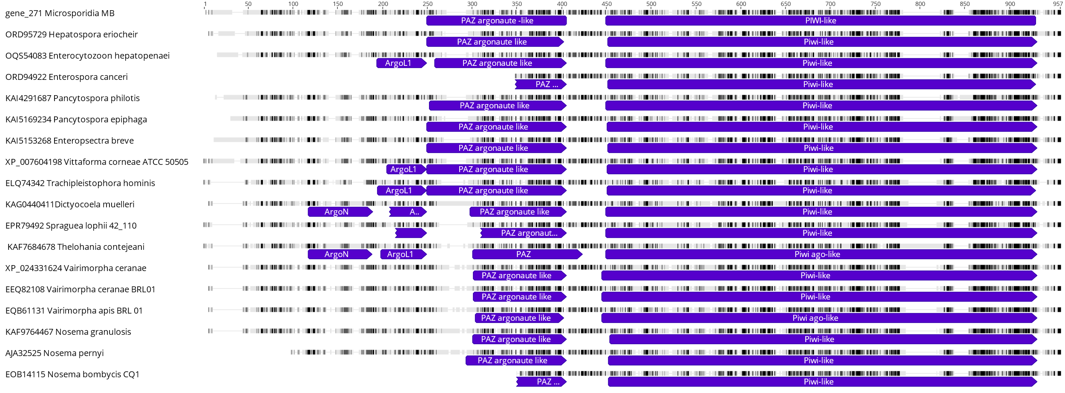
Supplementary Figure 2. Multiple sequence alignment of Argonaute orthologs in 18 species. Mapping of conserved PAZ and Piwi-like domains onto the alignment shows preservation of the positions of these domains in these microsporidia species. Alignments visualization was done using Geneious Prime®.
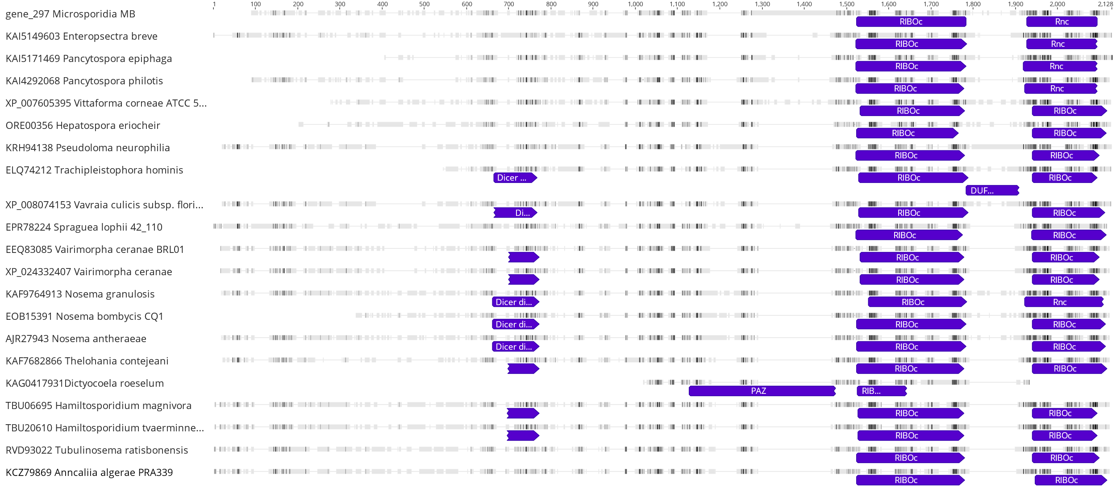
Supplementary Figure 3. Multiple sequence alignment of the Dicer gene in microsporidia containing 2 main conserved domains. The Ribonuclease III C terminal (RIBOc) and the dsRNA-specific ribonuclease (Rnc) domains. Microsporidia MB contained an insert between these two domains as highlighted by a red box. Visualization of the alignments was done using Geneious Prime®.

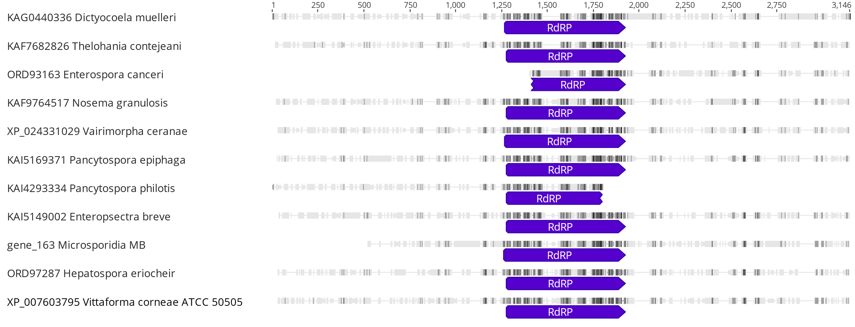
Supplementary Figure 4. Multiple sequence alignment of the RNA-dependent RNA Polymerase (RdRP) ortholog in microsporidia, containing the RdRP domain. Visualization of the alignments was done using Geneious Prime®.

References
1. Andrews S. FastQC a Quality Control Tool for High Throughput Sequence Data [Internet]. 2010 [cited 2023 Jun 27]. Available from: http://www.bioinformatics.babraham.ac.uk/projects/fastqc/
2. Ewels P, Magnusson M, Lundin S, Käller M. MultiQC: Summarize analysis results for multiple tools and samples in a single report. Bioinformatics. 2016;32(19):3047–8.
3. Li H, Durbin R. Fast and accurate short read alignment with Burrows-Wheeler transform. Bioinformatics. 2009;25(14):1754–60.
4. Danecek P, Bonfield JK, Liddle J, Marshall J, Ohan V, Pollard MO, et al. Twelve years of SAMtools and BCFtools. Gigascience. 2021;10(2):1–4.
5. Wood DE, Lu J, Langmead B. Improved metagenomic analysis with Kraken 2. Genome Biol. 2019;20(1):1–13.
6. Wick RR, Judd LM, Gorrie CL, Holt KE. Unicycler: Resolving bacterial genome assemblies from short and long sequencing reads. PLoS Comput Biol. 2017;13(6):1–22.
7. Gurevich A, Saveliev V, Vyahhi N, Tesler G. QUAST : quality assessment tool for genome assemblies. Bioinformatics. 2013;29(8):1072–5.
8. Besemer J, Lomsadze A, Borodovsky M. GeneMarkS: A self-training method for prediction of gene starts in microbial genomes. Implications for finding sequence motifs in regulatory regions. Nucleic Acids Res. 2001;29(12):2607–18.
9. Emms DM, Kelly S. OrthoFinder: Phylogenetic orthology inference for comparative genomics. Genome Biol. 2019;20(1):1–14.
10. Sahbou AE, Iraqi D, Mentag R, Khayi S. BuscoPhylo: a webserver for Busco-based phylogenomic analysis for non-specialists. Sci Rep [Internet]. 2022;12(1):1–5. Available from: https://doi.org/10.1038/s41598-022-22461-0
11. Sonnhammer ELL, Krogh A. A hidden Markov model for predicting transmembrane helices in protein sequence. Sixth Int Conf on Intelligent Systems for Molecular Biology. 2008;8.
12. Armenteros JJA, Salvatore M, Emanuelsson O, Winther O, Von Heijne G, Elofsson A, et al. Detecting sequence signals in targeting peptides using deep learning. Life Sci Alliance. 2019;2(5):1–14.
13. Teufel F, Almagro Armenteros JJ, Johansen AR, G\’\islason MH, Pihl SI, Tsirigos KD, et al. SignalP 6.0 predicts all five types of signal peptides using protein language models. Nat Biotechnol. 2022;40(7):1023–5.
14. Johnson M, Zaretskaya I, Raytselis Y, Merezhuk Y, McGinnis S, Madden TL. NCBI BLAST: a better web interface. Nucleic Acids Res. 2008;36(Web Server issue):5–9.
15. Aurrecoechea C, Barreto A, Brestelli J, Brunk BP, Caler E V., Fischer S, et al. AmoebaDB and MicrosporidiaDB: Functional genomic resources for Amoebozoa and Microsporidia species. Nucleic Acids Res. 2011;39(SUPPL. 1):612–9.
16. Rossum G Van, Drake FL. Python Tutorial. Vol. 42, Python Software Foundation. 2017. p. 1–122.
17. Silaparasetty N. Python Programming in Jupyter Notebook. In: Machine Learning Concepts with Python and the Jupyter Notebook Environment. Berkeley: Apress; 2020. p. 119–45.
18. Gasteiger E, Hoogland C, Gattiker A, Duvaud S, Wilkins MR, Appel RD, et al. The Proteomics Protocols Handbook. The Proteomics Protocols Handbook. 2005;571–608.
19. Blum M, Chang HY, Chuguransky S, Grego T, Kandasaamy S, Mitchell A, et al. The InterPro protein families and domains database: 20 years on. Nucleic Acids Res. 2021;49(D1):D344–54.
20. Mistry J, Chuguransky S, Williams L, Qureshi M, Salazar GA, Sonnhammer ELL, et al. Pfam: The protein families database in 2021. Nucleic Acids Res. 2021;49(D1):D412–9.
21. Blum M, Chang HY, Chuguransky S, Grego T, Kandasaamy S, Mitchell A, et al. The InterPro protein families and domains database: 20 years on. Nucleic Acids Res. 2021;49(D1):D344–54.
22. Potter SC, Luciani A, Eddy SR, Park Y, Lopez R, Finn RD. HMMER web server: 2018 update. Nucleic Acids Res. 2018;46(W1):W200–4.
23. Mi H, Ebert D, Muruganujan A, Mills C, Albou LP, Mushayamaha T, et al. PANTHER version 16: A revised family classification, tree-based classification tool, enhancer regions and extensive API. Nucleic Acids Res. 2021;49(D1):D394–403.
24. Attwood TK. The PRINTS database: a resource for identification of protein families. Brief Bioinform. 2002;3(3):252–63.
25. Wu CH, Nikolskaya A, Huang H, Yeh LS, Natale DA, Vinayaka CR, et al. PIRSF: Family classification system at the Protein Information Resource. Nucleic Acids Res. 2004;32(DATABASE ISS.):112–4.
26. Kumar S, Stecher G, Li M, Knyaz C, Tamura K. MEGA X: Molecular evolutionary genetics analysis across computing platforms. Mol Biol Evol. 2018;35(6):1547–9.
27. Kumar S, Stecher G, Peterson D, Tamura K. MEGA-CC: Computing core of molecular evolutionary genetics analysis program for automated and iterative data analysis. Bioinformatics. 2012;28(20):2685–6.
28. Edgar RC. MUSCLE: Multiple sequence alignment with high accuracy and high throughput. Nucleic Acids Res. 2004;32(5):1792–7.
29. Huson DH, Richter DC, Rausch C, Dezulian T, Franz M, Rupp R. Dendroscope: An interactive viewer for large phylogenetic trees. BMC Bioinformatics. 2007;8:1–6.
30. Bailey TL, Johnson J, Grant CE, Noble WS. The MEME Suite. Nucleic Acids Res. 2015;43(W1):W39–49.
31. de Castro E, Sigrist CJA, Gattiker A, Bulliard V, Langendijk-Genevaux PS, Gasteiger E, et al. ScanProsite: Detection of PROSITE signature matches and ProRule-associated functional and structural residues in proteins. Nucleic Acids Res. 2006;34(WEB. SERV. ISS.):362–5.
32. Lu S, Wang J, Chitsaz F, Derbyshire MK, Geer RC, Gonzales NR, et al. CDD/SPARCLE: The conserved domain database in 2020. Nucleic Acids Res. 2020;48(D1):D265–8.
33. Letunic I, Khedkar S, Bork P. SMART: Recent updates, new developments and status in 2020. Nucleic Acids Res. 2021;49(D1):D458–60.
34. Kanehisa M, Sato Y, Kawashima M, Furumichi M, Tanabe M. KEGG as a reference resource for gene and protein annotation. Nucleic Acids Res. 2016;44(D1):D457–62.
35. Hatherley R, Brown DK, Glenister M, Bishop ÖT. PRIMO: An interactive homology modeling pipeline. PLoS One. 2016;11(11):1–20.
36. Söding J, Biegert A, Lupas AN. The HHpred interactive server for protein homology detection and structure prediction. Nucleic Acids Res. 2005;33(SUPPL. 2):244–8.
37. Wiederstein M, Sippl MJ. ProSA-web: Interactive web service for the recognition of errors in three-dimensional structures of proteins. Nucleic Acids Res. 2007;35(SUPPL.2):407–10.
38. Luthy R, Bowei J, Einsenberg D. Verify3D: Assessment of protein models with three-dimensional profiles. Methods Enzymol. 1997;277:396–404.
39. Benkert P, Biasini M, Schwede T. Toward the estimation of the absolute quality of individual protein structure models. Bioinformatics. 2011;27(3):343–50.

