Figure 1S: Distribution of the four indicator used in this study
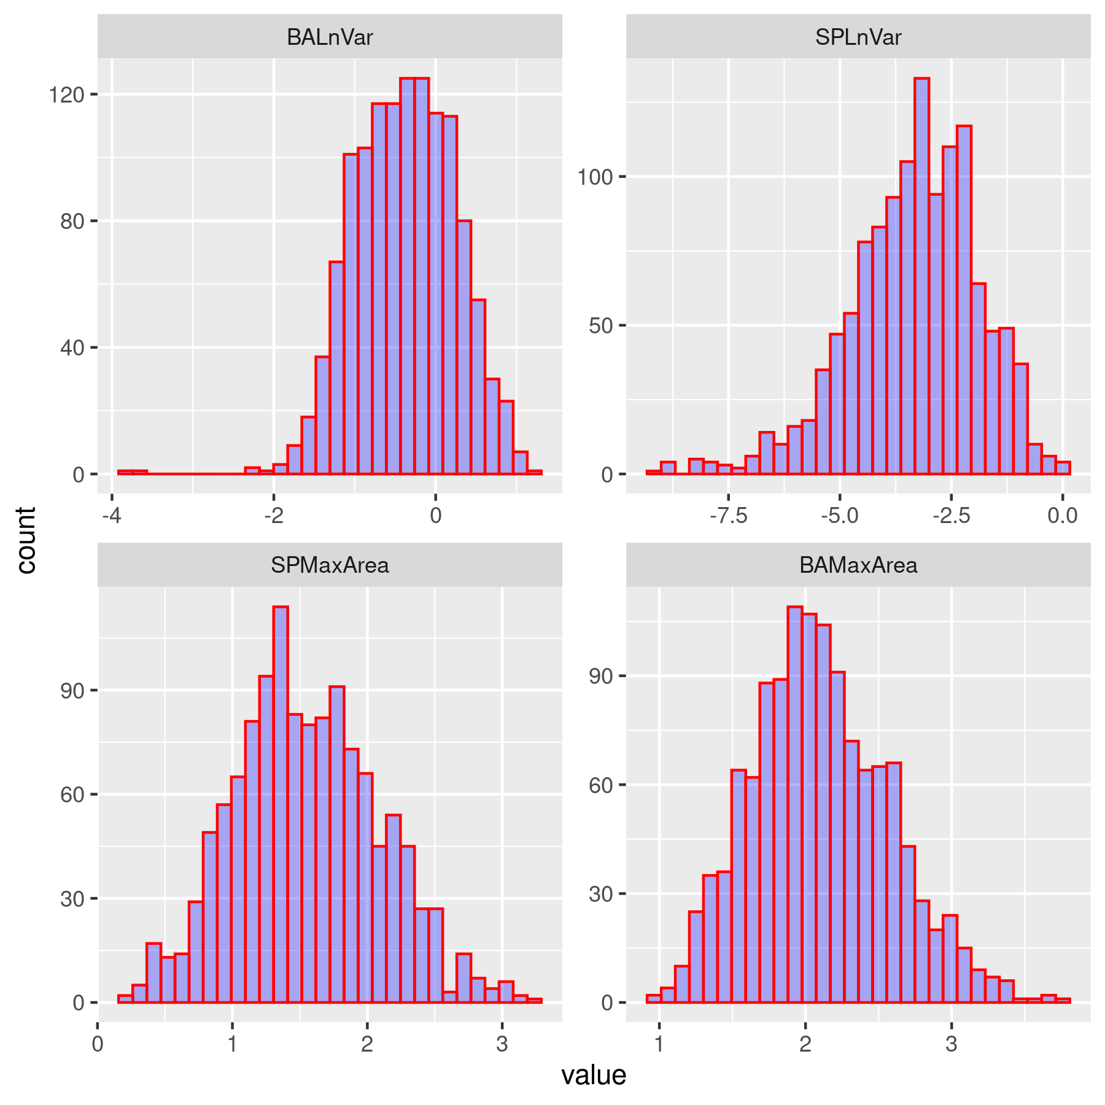
BALnVar: Logarithm of residual variance without adjustment, BAMaxArea: area under the curve for periods with the largest consecutive negative errors without adjustment SPLnVar: Logarithm of residual variance with Spline adjustment, SPMaxArea: area under the curve for periods with the largest consecutive negative errors with spline adjustment AFC:

Figure 2S: Genomic Wide Analysis for growth-related traits investigated in this study, including BW, BckFat, and rBckfat,
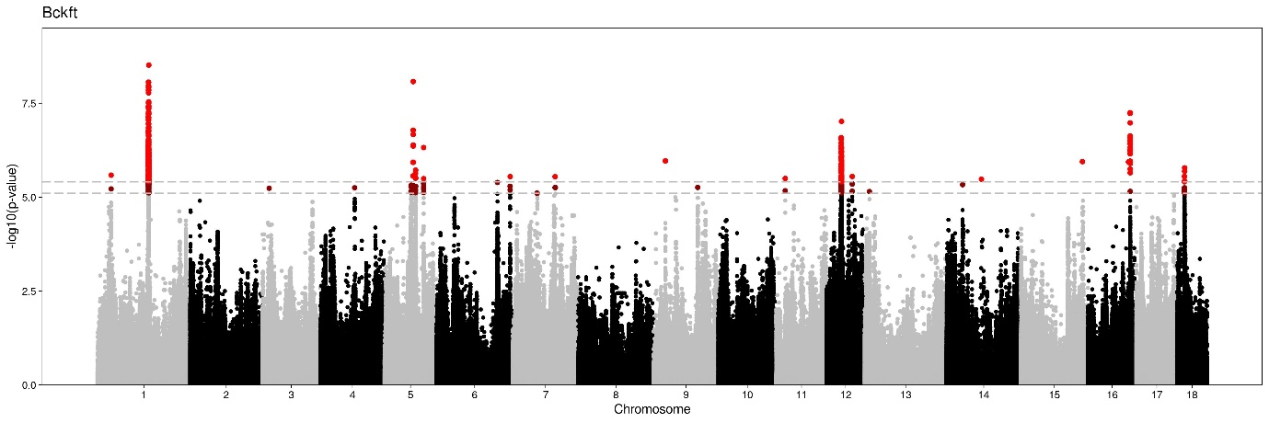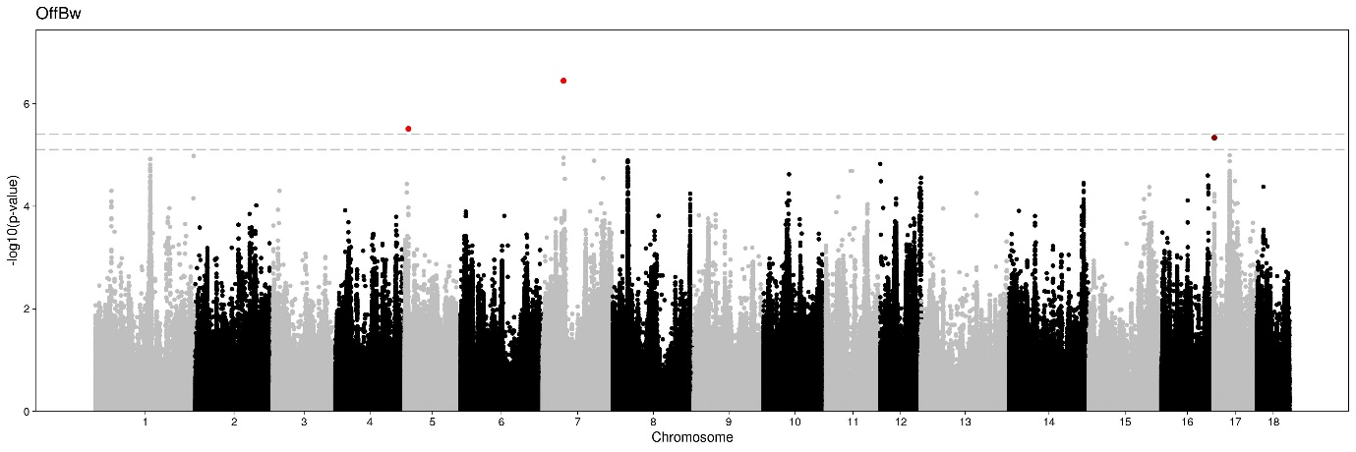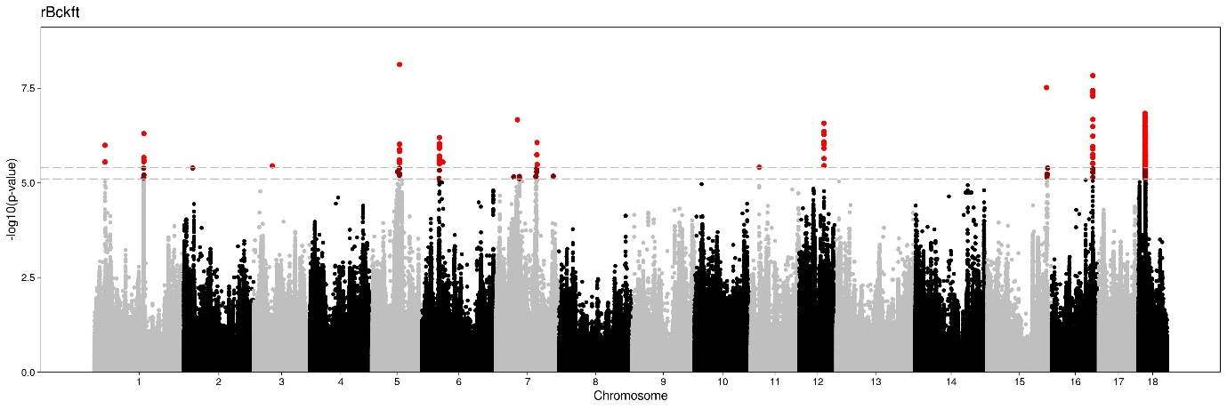
,OffBW: Offtest-Body Weight Bckfit: Backfat, rBckfit: Backfat ratio

S3 Quantile plot and inflation values for the four resilience indicator (A) LnVar (B) BAMaxArea (C) SPLnVar (D) SPMaxArea. Inflation values was reported on the left of the plot (λ). BALnVar: Logarithm of residual variance without adjustment, BAMaxArea: area under the curve for periods with the largest consecutive negative errors without adjustment, SPLnVar: Logarithm of residual variance with Spline adjustment, SPMaxArea: area under the curve for periods with the largest consecutive negative errors with spline adjustment,
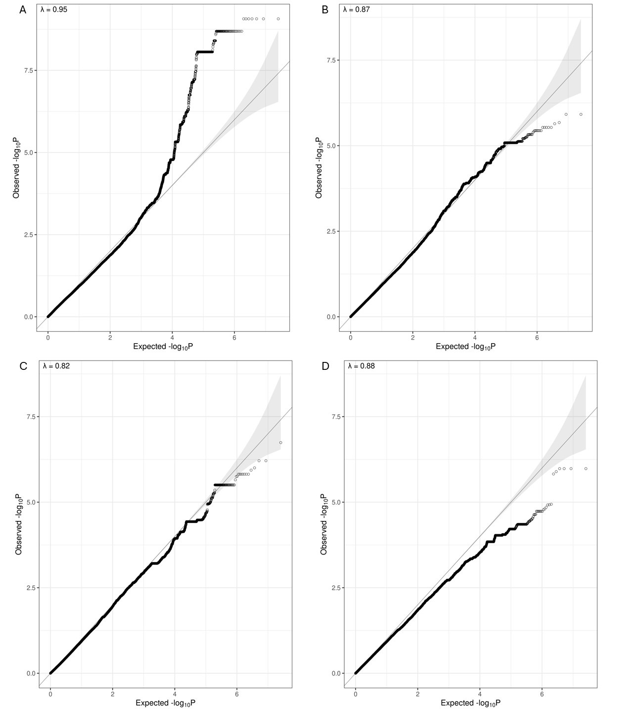

S4 Descriptive statistics after quality control and standardization are presented in the following plots: (A): The bar plot illustrates the number of animals at each minimum age of entry and maximum age of exit from the performance test station. (B): The horizontal line plot displays the number of data points recorded for each animal throughout the age range during their time at the performance test station. (C): The final plot represents the number of animals corresponding to each data point collected across the testing period.

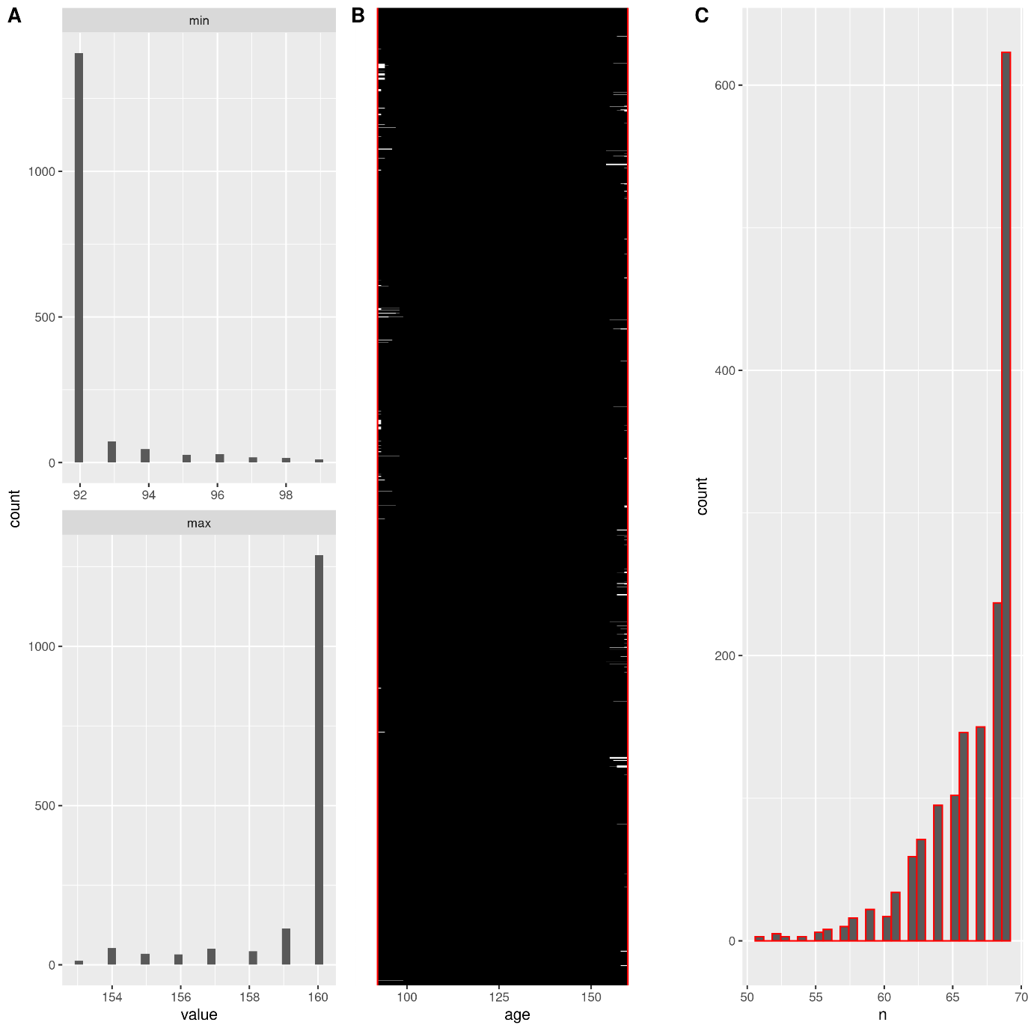

Table 1S: Estimated variance components for the traits considered in this study

Traits | Residual Variance | Genetic Variance
FCD | 0.053 | 0.023
OffBW | 429.642 | 93.626
Bckft | 0.003 | 0.003
Muscle | 0.031 | 0.007
rBckft | 0.000 | 0.000
rMusc | 0.000 | 0.000
BALnVar | 0.075 | 0.015
BAMaxArea | 0.081 | 0.007
SPLnVar | 1.214 | 0.163
SPMaxArea | 0.157 | 0.016

