Supplemental Files

Figure S1. Heat map of protein vs metabolite correlation.
Figure S2. Heat map of gene vs metabolite correlation.
Figure S3. Heat map of gene vs protein correlation.
Figure S4. Gene quantitative result.
Figure S5. Data analysis process.

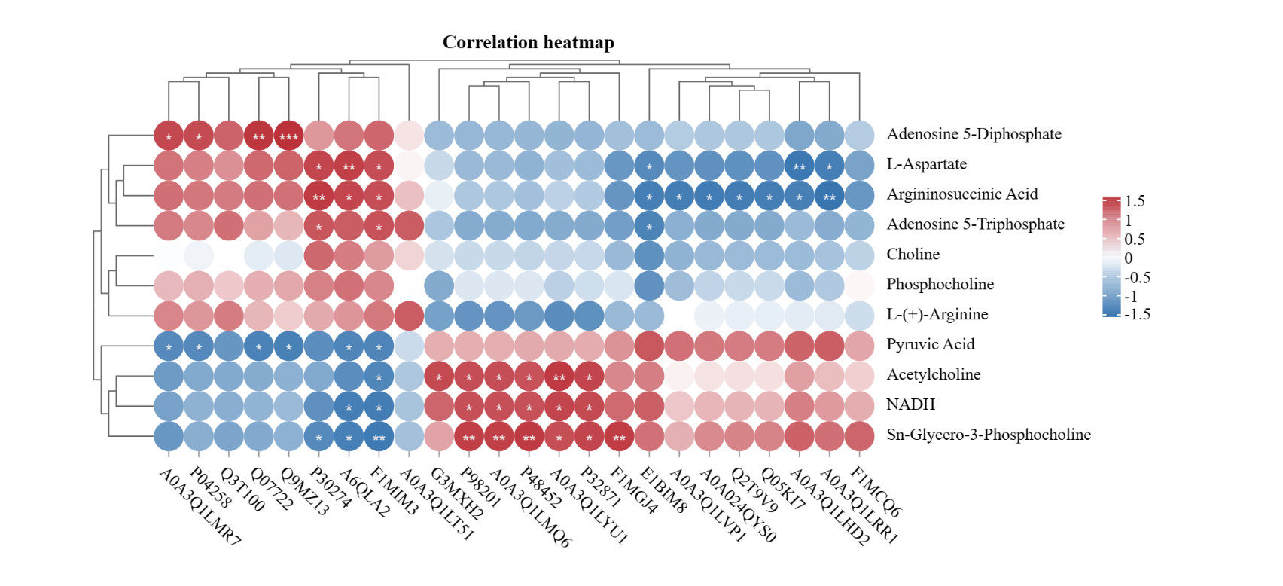
Figure S1. Heat map of protein vs metabolite correlation. The colors indicate the strength of the correlation: red denotes a positive correlation, and blue signifies a negative correlation. Darker colors represent stronger correlations. Significance levels are marked as follows: no marking indicates p ≥ 0.05; a single asterisk (*) represents 0.01 < p < 0.05; a double asterisk (**) indicates 0.001 < p < 0.01; and a triple asterisk (***) indicates p ≤ 0.001.

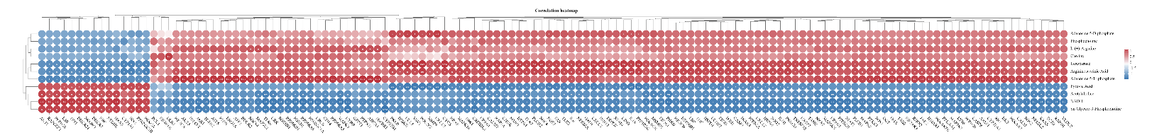
Figure S2. Heat map of gene vs metabolite correlation. The colors indicate the strength of the correlation: red denotes a positive correlation, and blue signifies a negative correlation. Darker colors represent stronger correlations. Significance levels are marked as follows: no marking indicates p ≥ 0.05; a single asterisk (*) represents 0.01 < p < 0.05; a double asterisk (**) indicates 0.001 < p < 0.01; and a triple asterisk (***) indicates p ≤ 0.001.

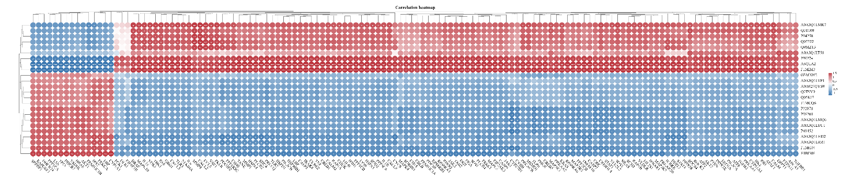
Figure S3. Heat map of gene vs protein correlation. The colors indicate the strength of the correlation: red denotes a positive correlation, and blue signifies a negative correlation. Darker colors represent stronger correlations. Significance levels are marked as follows: no marking indicates p ≥ 0.05; a single asterisk (*) represents 0.01 < p < 0.05; a double asterisk (**) indicates 0.001 < p < 0.01; and a triple asterisk (***) indicates p ≤ 0.001.

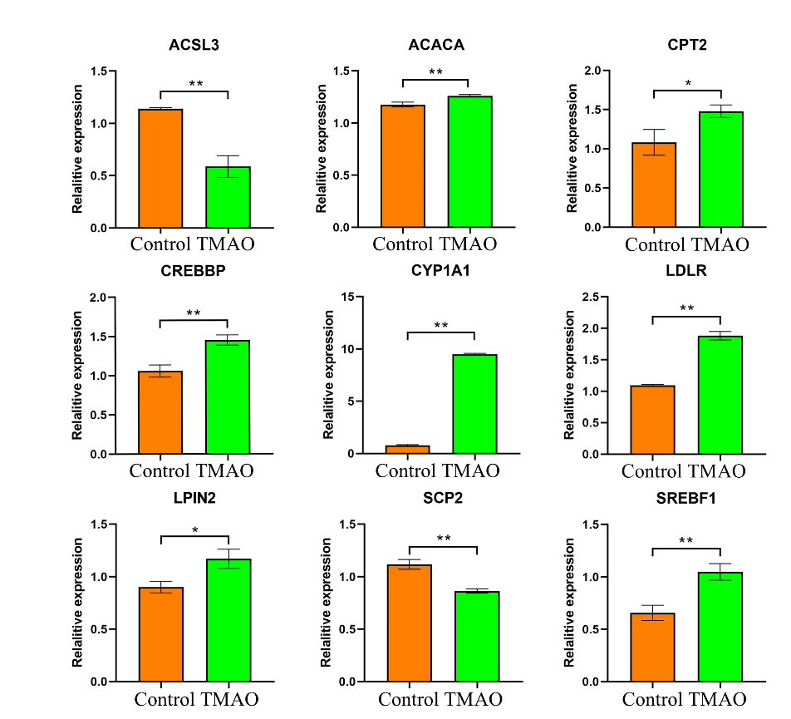
Figure S4. Gene quantitative result. * indicates p < 0.05, ** indicates p < 0.01.

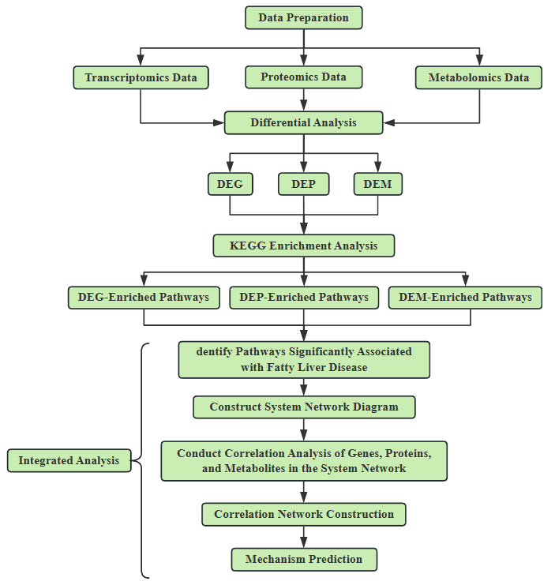
Figure S5. Data analysis process.

