Supplementary figures

Figure S1 Expression profiling of CD8⁺ T cells after carcinogen treatment
Figure S2 Characteristics of identified eQTL
Figure S3 Trait associated e²QTL
a
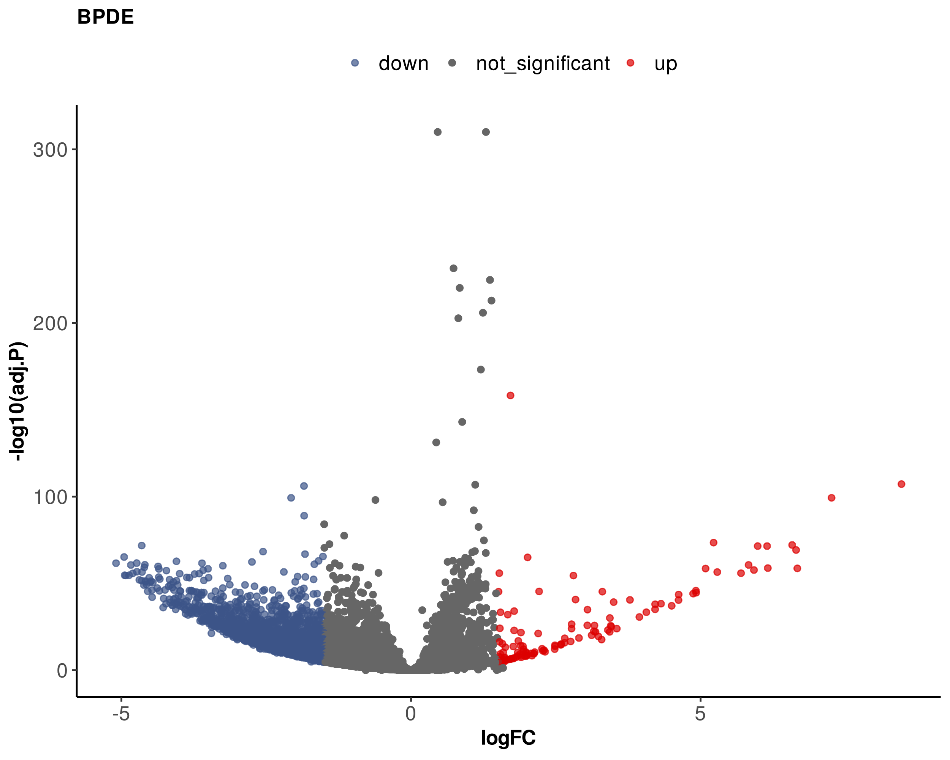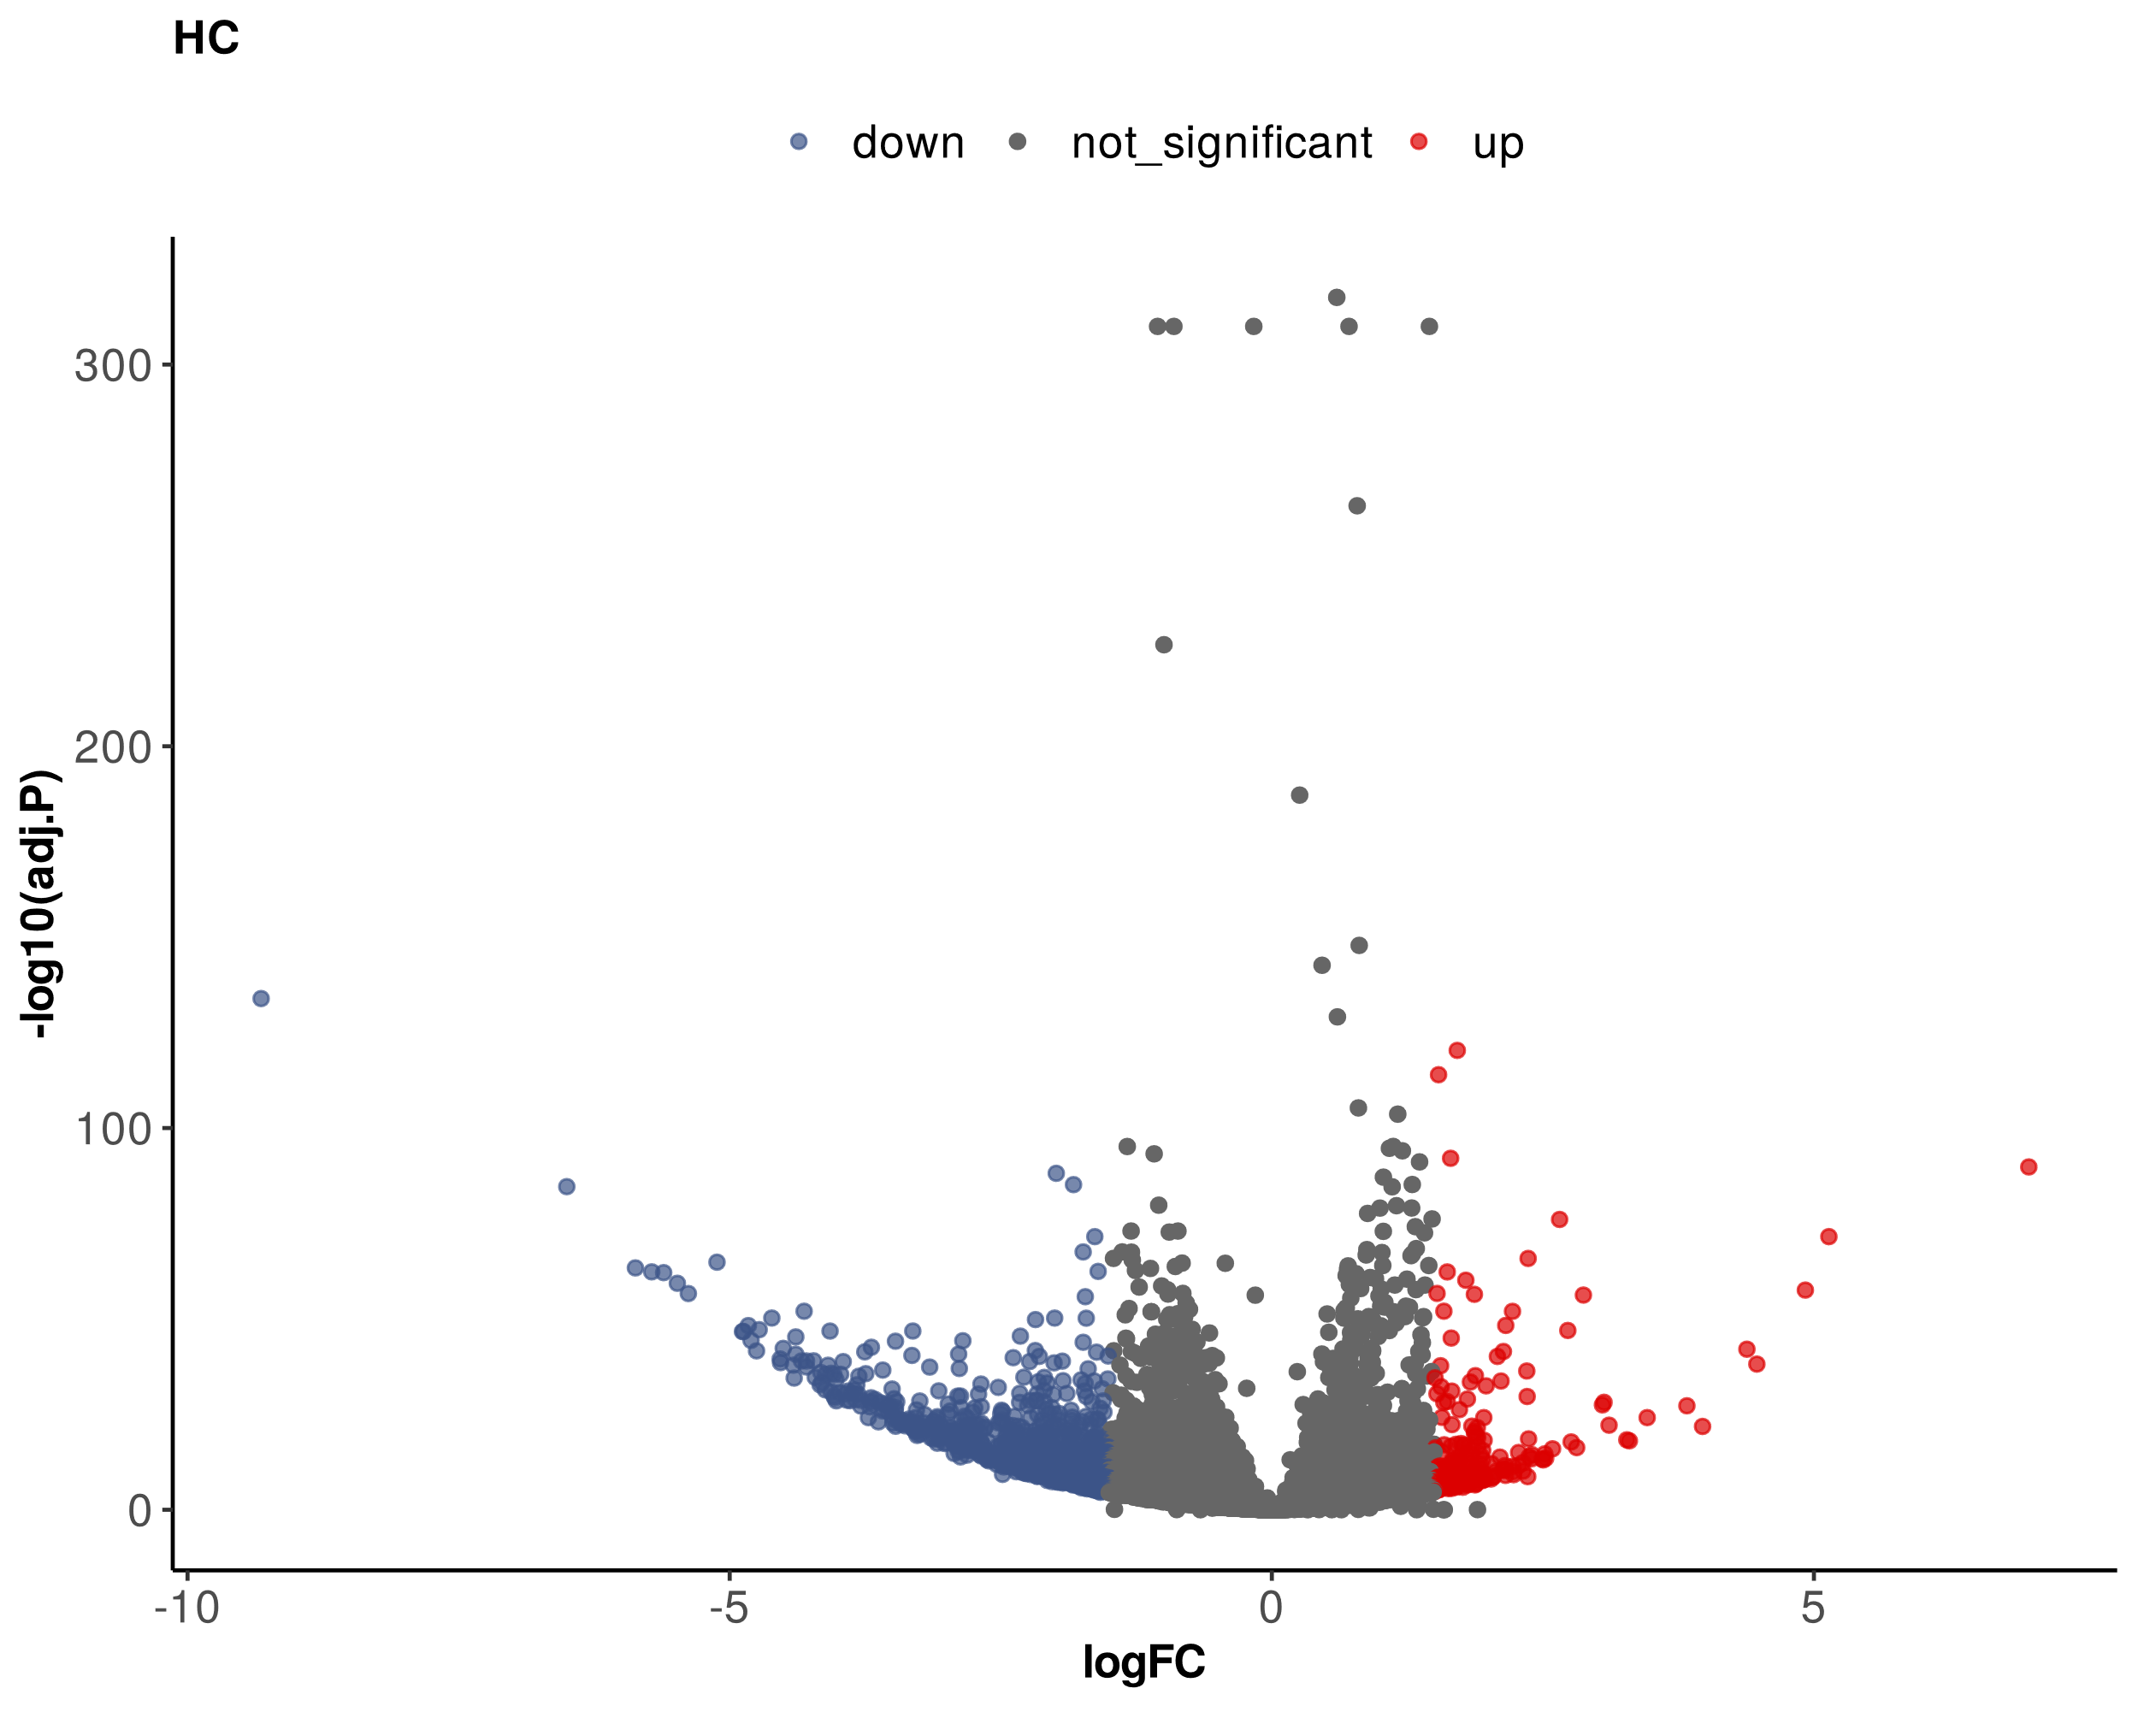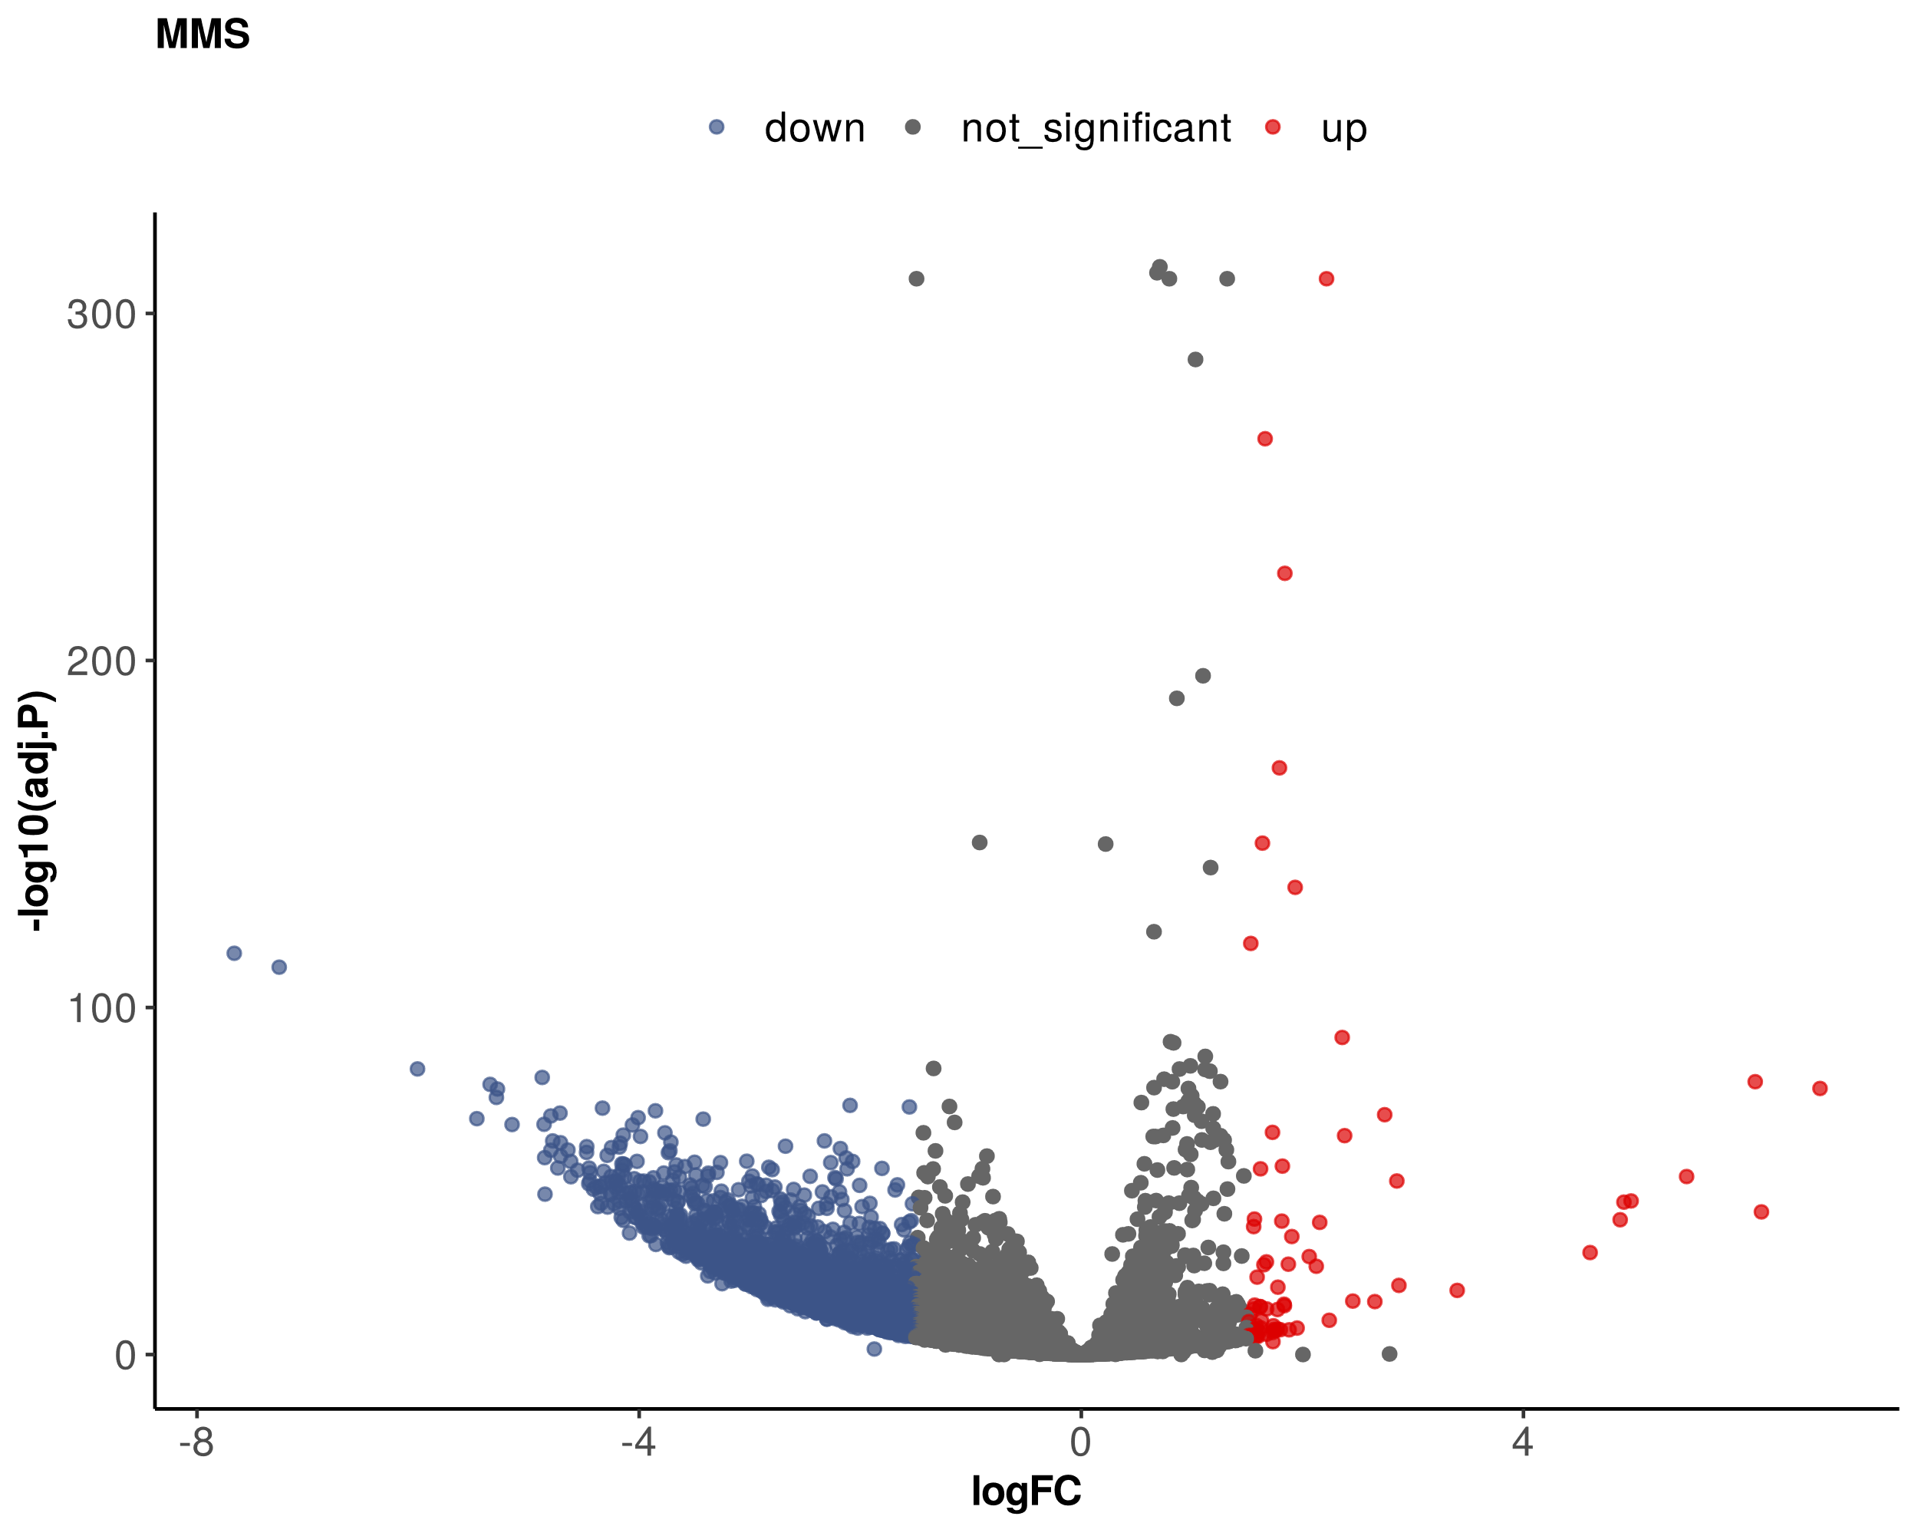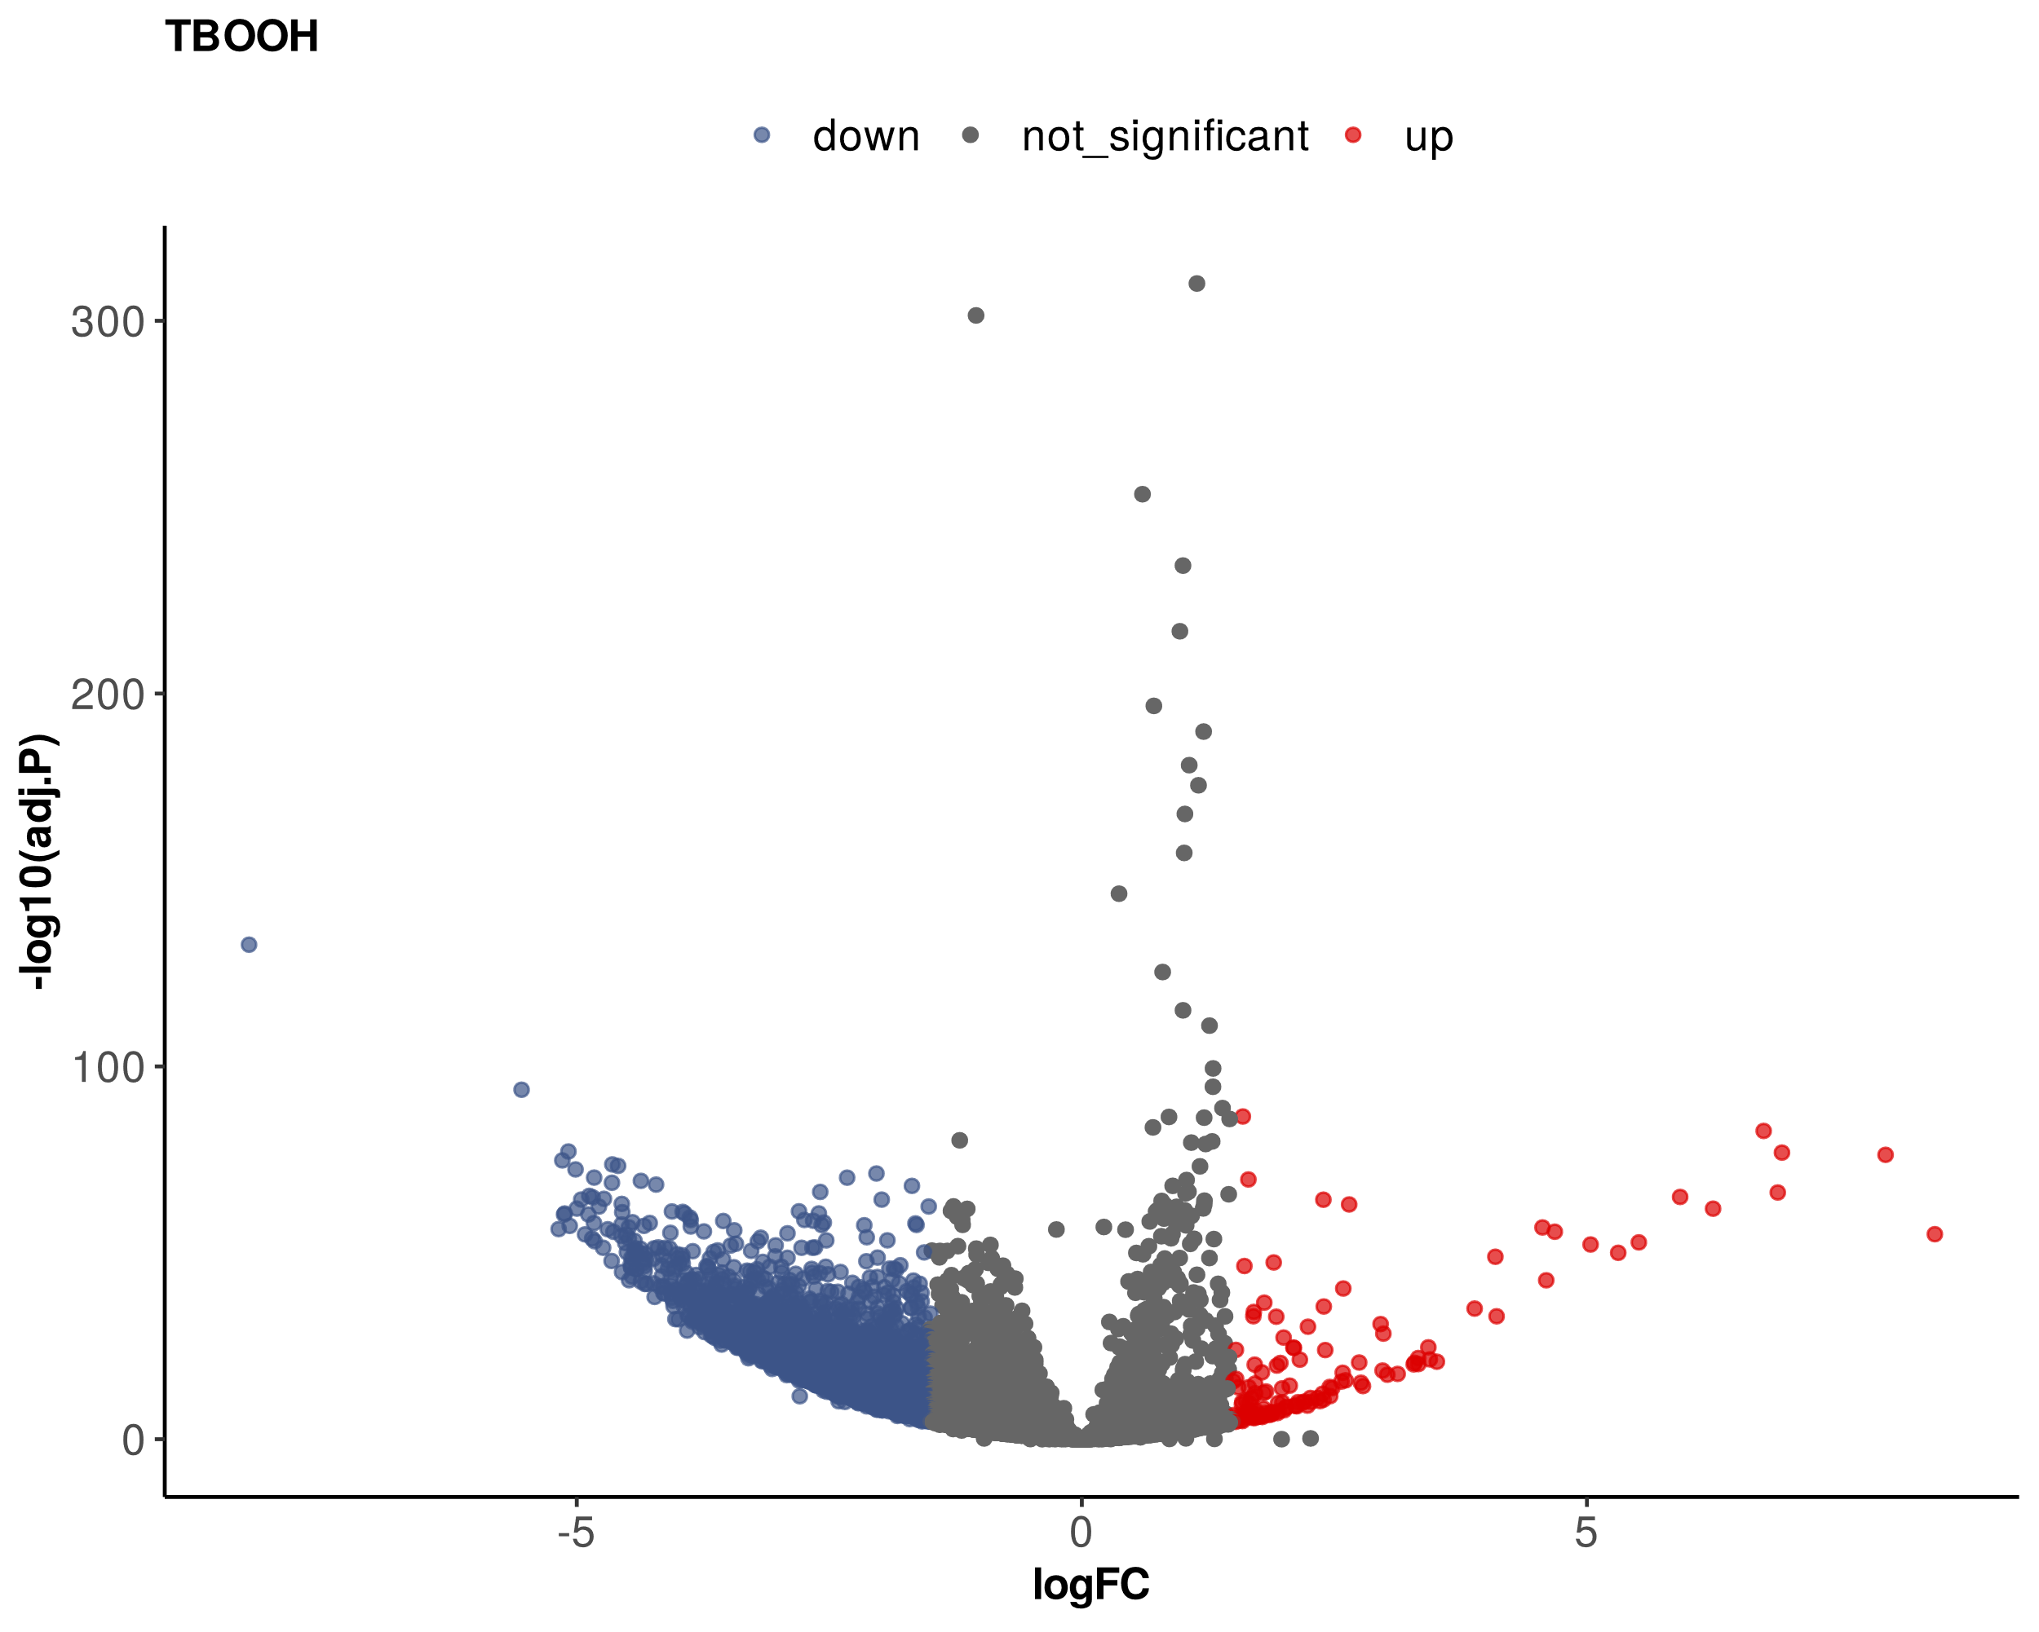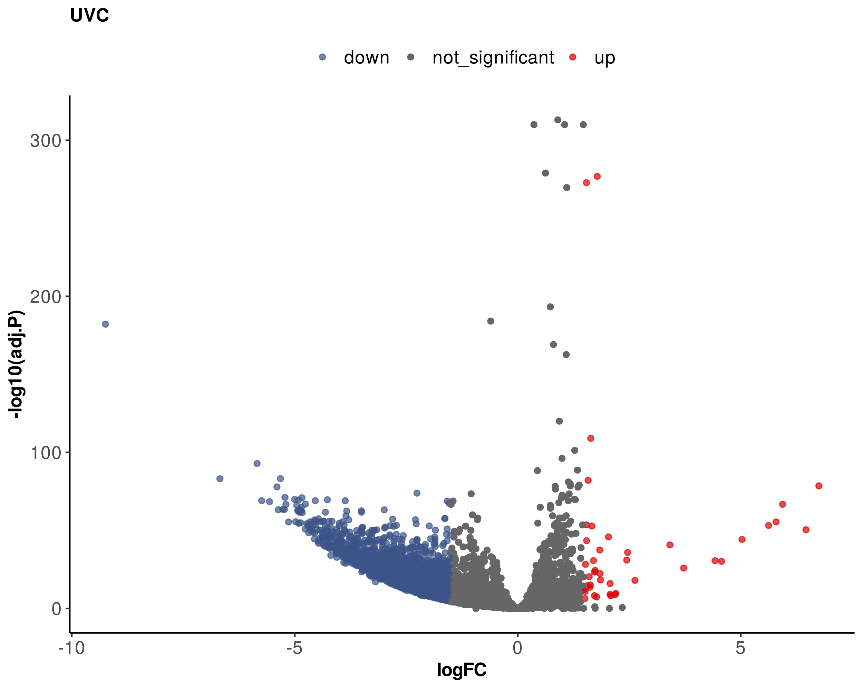
b

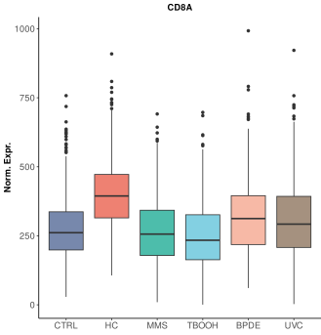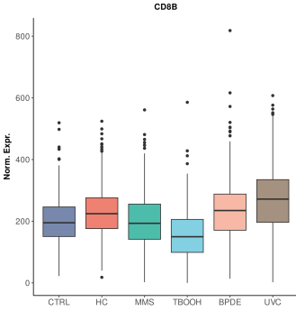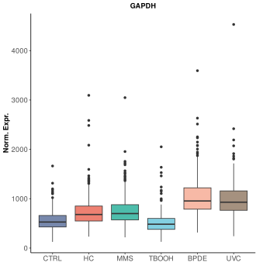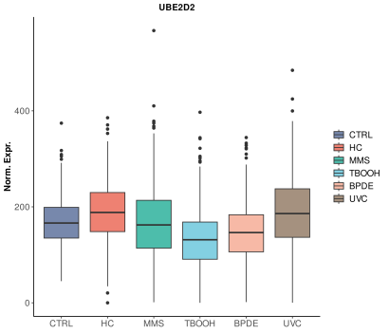
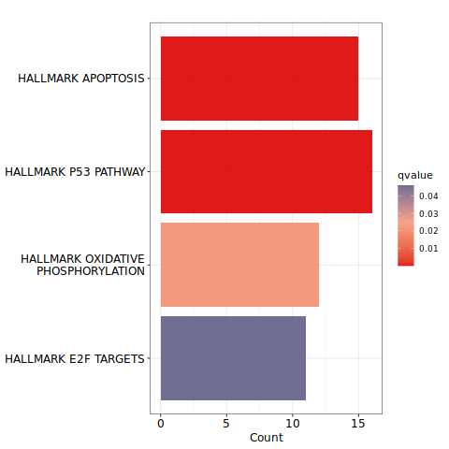
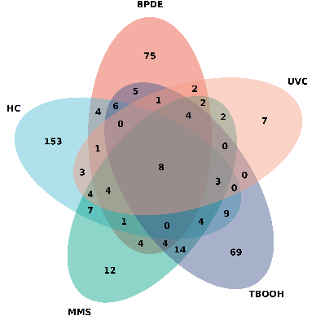
d
c

SNORD3A
RNUV1-27
RNU4-2
SDR42E2
U2
ENSG00000279602
ENSG00000242299
ENSG00000213315

Figure S1 Expression profiling of CD8⁺ T cells after carcinogen treatment (a) Volcano plots of differential expression analysis. Significantly upregulated genes (adj. p < 0.05 and logFC > 1.5) are indicated in red and significantly downregulated genes (adj. p < 0.05 and logFC < -1.5) are indicated in blue. Multiple testing correction was performed using the Benjamini-Hochberg method. (b) Boxplots representing the normalized count distribution (TMM adjusted CPM) for CD8A, CD8B, GAPDH and UBE2D. (c) Venn diagram of significantly upregulated DEG. (d) GSEA of Molecular Signatures Database (MSigDB) hallmarks for all significantly upregulated DEG.
BPDE - benzo(a)pyrene-7,8-diol-9,10-epoxide, CTRL – control, HC - 4-hydroxycyclophosphamide, MMS - Methyl-methanesulfonate, TBOOH - tert-butyl-hydroperoxide, UVC - ultraviolet radiation

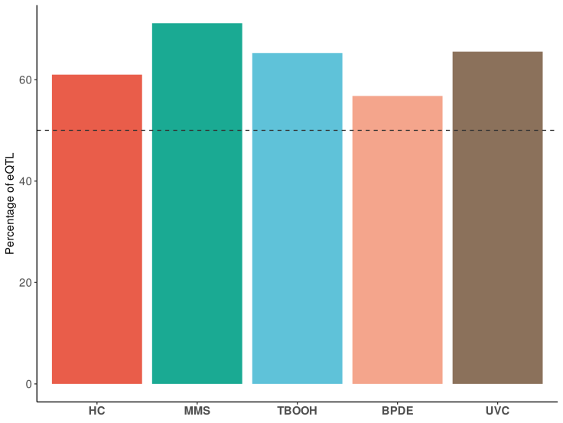
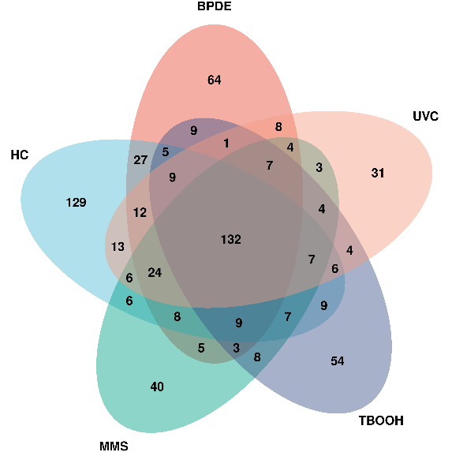
a
b

Figure S2 Characteristics of identified eQTL (a) Venn diagram of significant eQTL eGenes. (b) Fraction of eQTL with reduced effect size after treatment for each stimulus.
BPDE - benzo(a)pyrene-7,8-diol-9,10-epoxide, HC - 4-hydroxycyclophosphamide, MMS - Methyl-methanesulfonate, TBOOH - tert-butyl-hydroperoxide, UVC - ultraviolet radiation

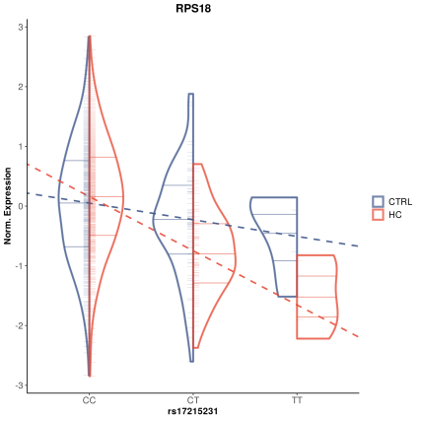
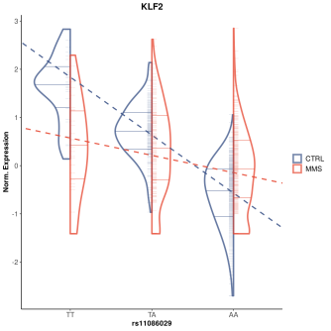
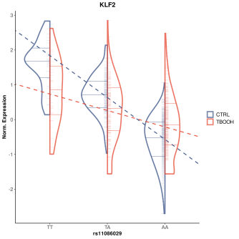
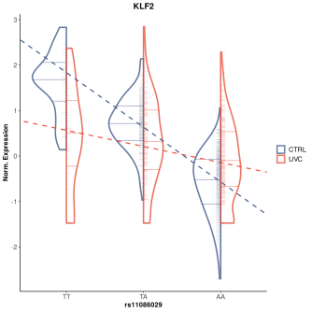
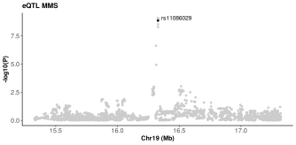
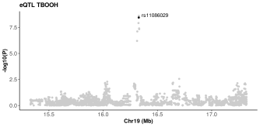
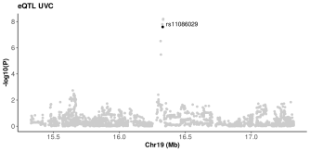
a
b

Figure S3 Trait associated e²QTL (a) Violin plot of RPS18 and the GWAS lead variant for breast cancer before treatment (CTRL, blue) and after HC treatment (red). Individuals are indicated by small ticks and horizontal lines represent the median as well as the 25 % and 75 % quartiles in each violin. The dashed lines indicate the linear regression for the effect of the genotype on gene expression. (b) Violin plots for KLF2 and the GWAS lead variant for MM before treatment (CTRL, blue) and after treatment (red) with TBOOH (1), MMS (2) and HC (3). Scatter plots below show regional association of common variants in our eQTL data and the GWAS for MM. The lead variant of the MM GWAS is annotated and highlighted in black.
CTRL – control, HC - 4-hydroxycyclophosphamide, MM – Multiple Myeloma, MMS - Methyl-methanesulfonate, TBOOH - tert-butyl-hydroperoxide, UVC - ultraviolet radiation

