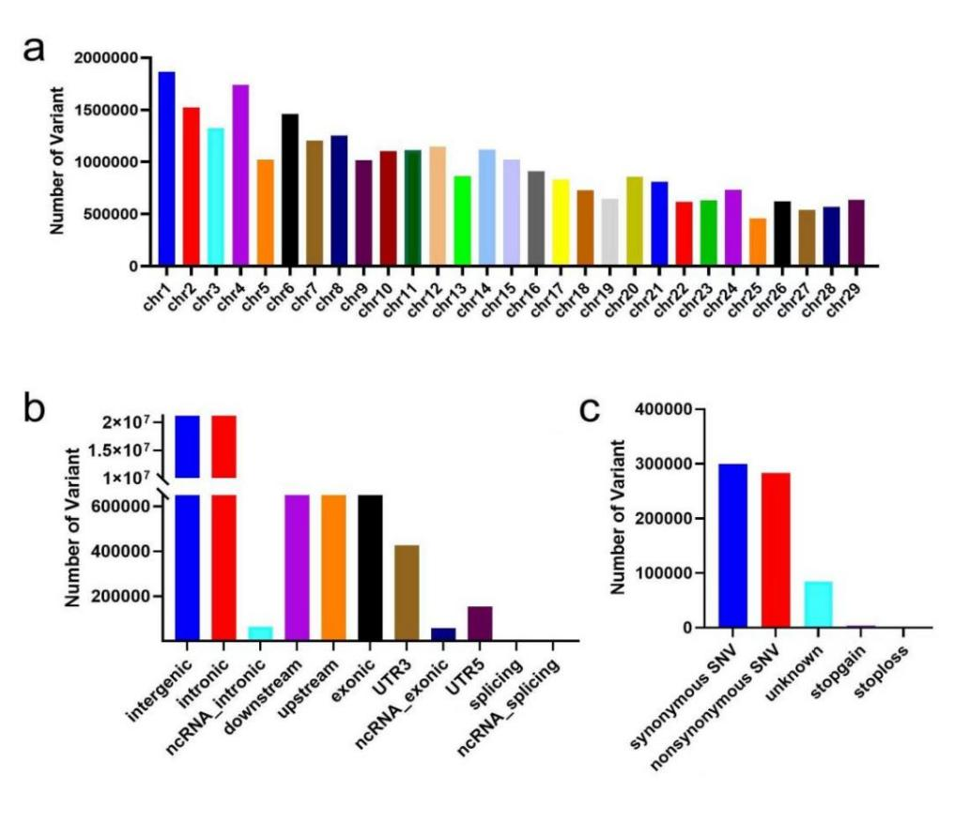
Figure S1 Variants characteristics of Zhongwei goats population. (a) Genome-wide distribution of detected variants on 29 chromosomes for Zhongwei goats. X-axis represents 29 autosomes. Y-axis represents the number of variants (b) Genome-wide annotation of Zhongwei goats genetic variations. X-axis represents various functional regions.Y-axis represents the number of genetic variations within various functional regions. (c) Statistics of variants functional annotation results in CDS region. X-axis represents various functions. Y-axis represents the number of genetic variations within various functions

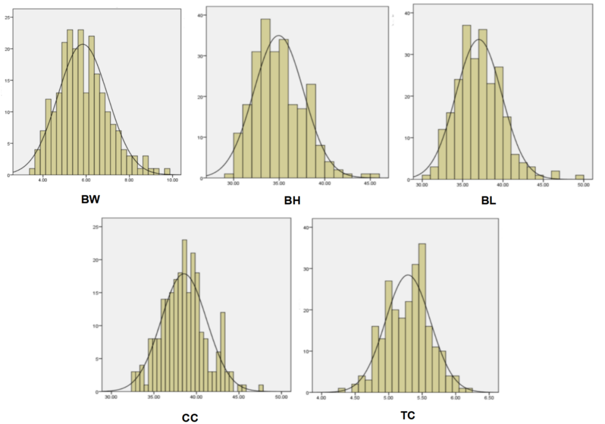
Figure S2A Normal distribution Plot of body size traits of 40-day-old Zhongwei goats

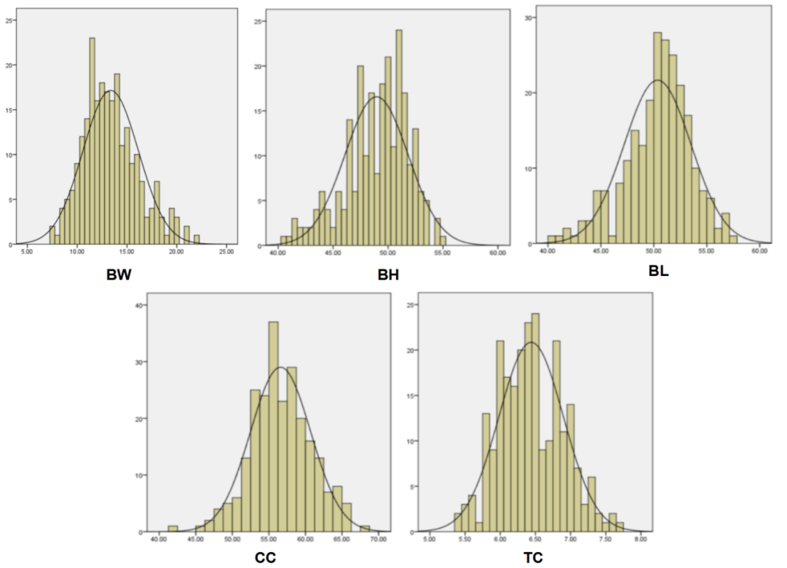

Figure S2B Normal distribution Plot of body size traits of 6-months-old Zhongwei goats.

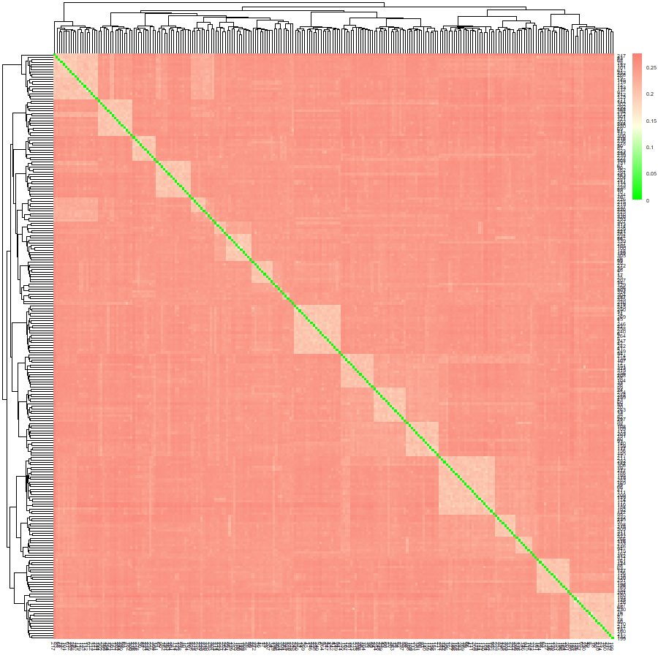
Figure S3 IBS Matrix visualization. Each small square represents the kinship value between the first and the last sample, which is closer to orange, where the two bodies are closer, and vice versa.

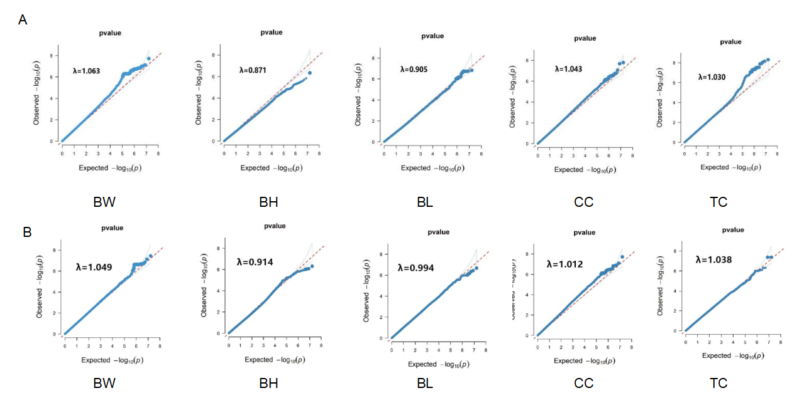
Figure S4 Q-Q plots of body conformation traits at 40d (A) and 6m (B)for Zhongwei goats..

CODE INFORMATION

Quality control
plink --bfile binary_yuanshi --geno 0.05 --recode --allow-extra-chr --chr-set 29 --out ../file name/file name
wc -l qc_SNP.
plink --file qc_SNP --maf 0.05 --hwe 1e-6 --mind 0.1 --recode --allow-extra-chr --chr-set 29 --out file name
wc -l file name.

Genotype data were converted into a binary format
plink --file file name --make-bed --allow-extra-chr --chr-set 29 --file name

Distribution of Snp on the chromosome
library(CMplot)
library(data.table)
library(tidyverse)
map1 = fread("file name.map",header = F)
head(map1)
mm = map1 %>% select(SNP = 2,Chromosome=1,Position = 4) CMplot(mm,plot.type="d",bin.size=1e6,col=c("darkgreen", "yellow", "red"), file="jpg",memo="",dpi=300,file.output=TRUE, verbose=TRUE)

Percentage of the variance explained by the individual PCA
library(scatterplot3d)
library(data.table)

re1b = fread("3d_plink_filter.eigenvec")
re1b[1:10,1:5]

x=re1b$V3
y=re1b$V4
z=re1b$V5

dat <- data.frame(x,y,z)
plot3d <- scatterplot3d(x,y,z,pch=1,xlab="PC1",ylab="PC2",zlab="PC3")

Matrix of relationship
plink --bfile file name --make-rel square --allow-extra-chr --chr-set 29 --out ../stat_IBS/Gmatrix plink --bfile file name --distance square ibs --allow-extra-chr --chr-set 29 --out ../stat_IBS/IBS plink --bfile file name --distance square 1-ibs --allow-extra-chr --chr-set 29 --out ../stat_IBS/1-IBS
plink --bfile file name --genome --allow-extra-chr --chr-set 29 --out ../stat_IBS/stat_IBS

library(data.table)
library(tidyverse)
gmatrix = as.matrix(fread("Gmatrix.rel", head = F))
gid = fread("Gmatrix.rel.id",header = F)
rownames(gmatrix) = colnames(gmatrix) = gid$V2
gmatrix[1:10,1:10]
heatmap(gmatrix)
tiff("heatmap.tiff",width = 12, height = 8, units = "in",compression = "lzw",res=300) heatmap(gmatrix)
dev.copy(pdf, "heatmap.pdf")
dev.off()

G matrix
install.packages("pheatmap")
library(pheatmap)
gmat=read.table(file="ibs.mibs")
id=read.table(file="ibs.mibs.id")
colnames(gmat)=id$V2
rownames(gmat)=id$V2
dim(gmat)
gmat[1:225,1:225]
#pheatmap(gmat,fontsize=5,border_color=NA) pheatmap(gmat,fontsize=3,border_color=NA,color=colorRampPalette(c("LightGreen","Orange","Red"))(300),width = 300, height = 301, res = 600)
dev.copy(pdf, "pheatmap3.pdf") dev.off()

Genome-wide association study
gcta --bfile ../../file name/file name --make-grm --out geno_grm -make-grm-alg 1 --autosome-num 29
gcta --grm geno_grm --make-bK-sparse 0.05 --out sp_grm
gcta --bfile file name --pheno file name.txt --qcovar num_cov.txt --covar fac_cov.txt --fastGWA-mlm --out result_file name --grm-sparse sp_grm --autosome-num 29

library(data.table)
library(tidyverse)
library(CMplot)
library(openxlsx)

d1 = fread("file name.fastGWA")
head(d1)
dat = d1 %>% dplyr::select(SNP = SNP,
Chromosome = CHR,
Position = POS,
pvalue = P) %>% drop_na(pvalue)
head(dat)
dim(dat)[1]
pvalue1 = 1e-5
pvalue1
-log10(pvalue1)
dat_sig=dat %>% filter(pvalue < pvalue1)
write.xlsx(dat_sig,"file name.xlsx")

p_value=dat$pvalue
z = qnorm(p_value/ 2)
lambda = round(median(z^2, na.rm = TRUE) / 0.454, 3)

CMplot(dat,plot.type = "q",threshold = 1e-6,file="jpg")

CMplot(dat,plot.type="m",LOG10=TRUE,ylim=NULL,threshold=c(1e-6),threshold.lt=c(1,2),
threshold.lwd=c(1,1),threshold.col=c("black","grey"),amplify=TRUE,
bin.size=1e6,chr.den.col=c("darkgreen","yellow","red"),signal.col=c("red","orange"),
signal.cex=c(1,1),signal.pch=c(19,19),file="jpg",
dpi=600,file.output=TRUE,verbose=TRUE)

