Table of contents
Fig. S1 Frequency distribution histogram of survival rate of the RIL population. ST, salt stress trials. DT, drought stress trials.
Fig. S2 Recombinant bins and bin markers on the 12 chromosomes. A, Recombinant bins of the 201 individuals in RIL population. B, Bin markers on the 12 chromosomes.
Fig. S3 Identification of candidate gene SlHAK5 in qST12 region. A, Local manhattan plot surrounding SlHAK5. B, Box plot of the survival rate of two genotypes tagged with SNP_365326 in salt stress trials. C, Gene structure and potential causal polymorphisms in SlHAK5. D, Interaction network for SlHAK5 (https://cn.string-db.org/). E, Changes in the frequency of SNP_365326 during tomato breeding.
Fig. S4 Identification of candidate gene SlGRAS4 in qDT1-3 region. A, Local manhattan plot surrounding SlGRAS4. B, Box plot of the survival rate of two genotypes tagged with SNP_82529246 in drought stress trials. C, Gene structure and potential causal polymorphisms in SlGRAS4. D, Interaction network for SlGRAS4 (https://cn.string-db.org/). E, Changes in the frequency of SNP_82529246 during tomato breeding.
Fig. S5 Polymorphisms of SlBRL1 in the 33 tomato accessions. The polymorphisms position and predicted domains by SMART (https://smart.embl.de/) are shown in the top region. The potential causal variations are indicated by red color. The predicted amino acid changes are marked by different shapes in the bottom region. The 33 accessions consist Solanum pimpinellifolium (SP), cherry-sized early domesticates S. lycopersicum var. cerasiforme (SLC) and large-fruited tomatoes S. lycopersicum var. lycopersicum (SLL).
Fig. S6 Expression change of candidate genes in RIL parents under control and treatment. A, Expression of SlMSRB1 under control and salt treatment. B, Expression of SlGRAS4 under control and drought treatment. C, Expression of SlBRL1 under control and drought treatment. P value is calculated using two-tailed t-test.

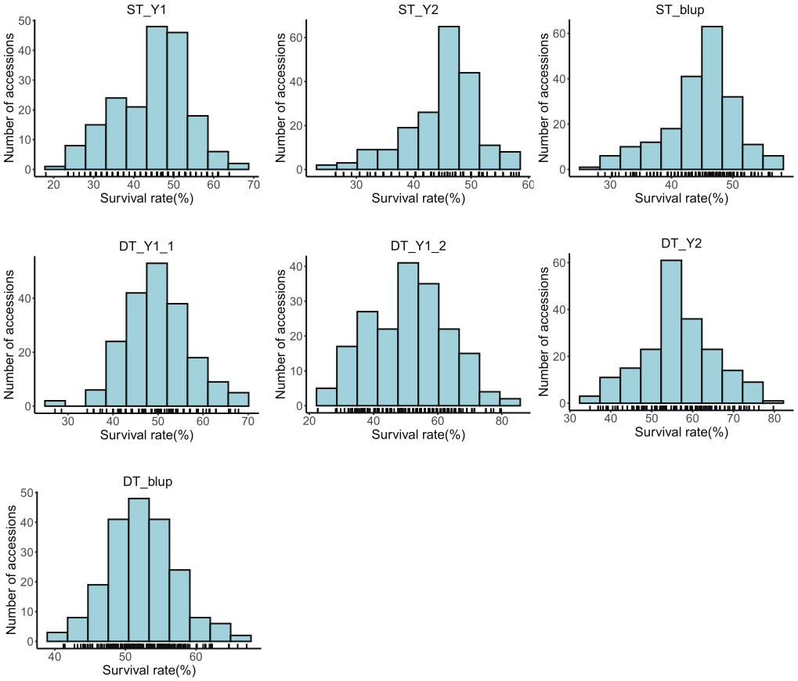
Fig. S1 Frequency distribution histogram of survival rate of the RIL population. ST, salt stress trials. DT, drought stress trials.

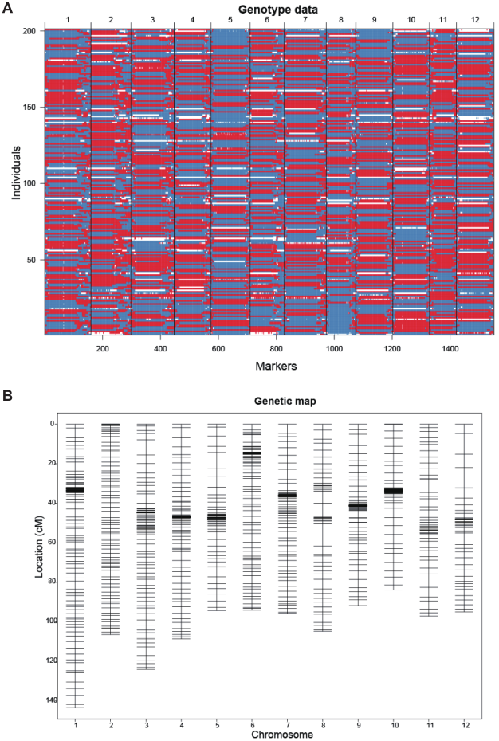
Fig. S2 Recombinant bins and bin markers on the 12 chromosomes. A, Recombinant bins of the 201 individuals in RIL population. B, Bin markers on the 12 chromosomes.

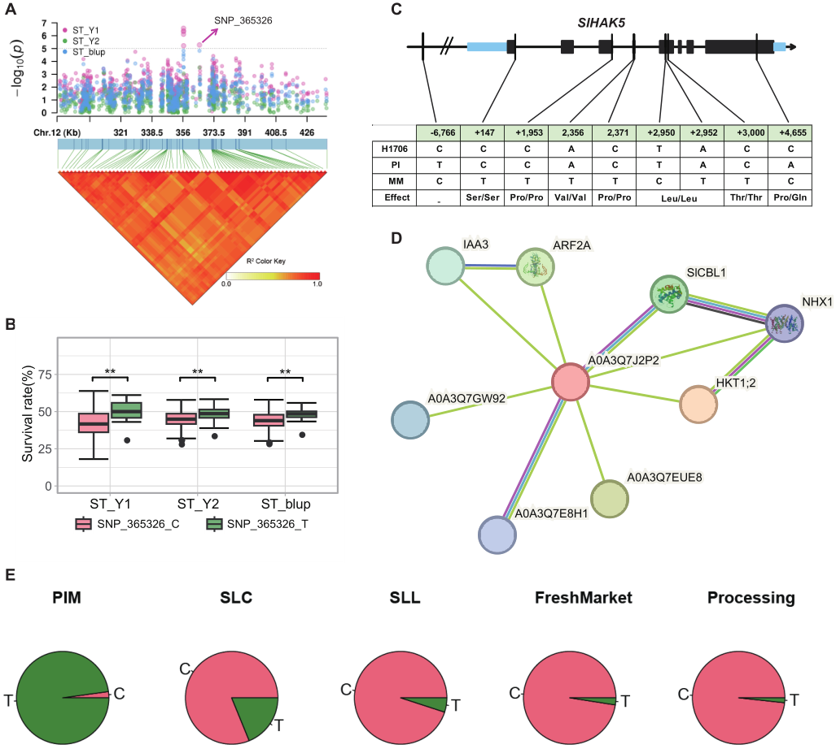
Fig. S3 Identification of candidate gene SlHAK5 in qST12 region. A, Local manhattan plot surrounding SlHAK5. B, Box plot of the survival rate of two genotypes tagged with SNP_365326 in salt stress trials. C, Gene structure and potential causal polymorphisms in SlHAK5. D, Interaction network for SlHAK5 (https://cn.string-db.org/). E, Changes in the frequency of SNP_365326 during tomato breeding.

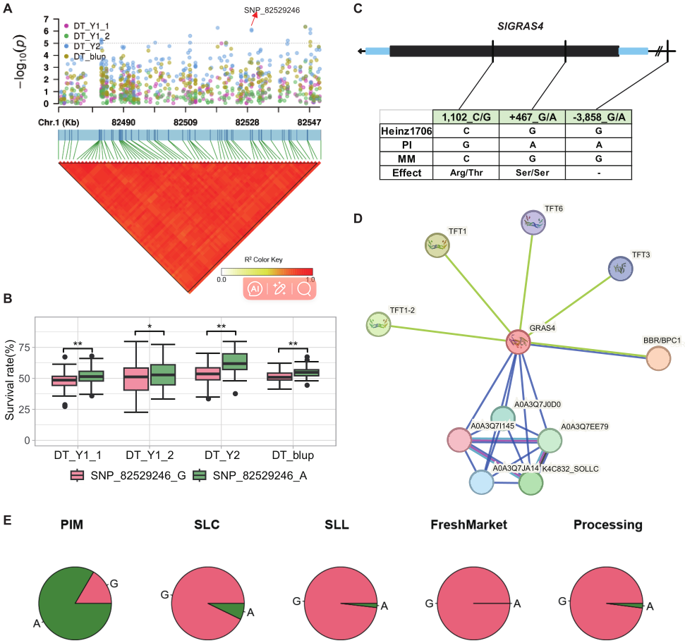
Fig. S4 Identification of candidate gene SlGRAS4 in qDT1-3 region. A, Local manhattan plot surrounding SlGRAS4. B, Box plot of the survival rate of two genotypes tagged with SNP_82529246 in drought stress trials. C, Gene structure and potential causal polymorphisms in SlGRAS4. D, Interaction network for SlGRAS4 (https://cn.string-db.org/). E, Changes in the frequency of SNP_82529246 during tomato breeding.

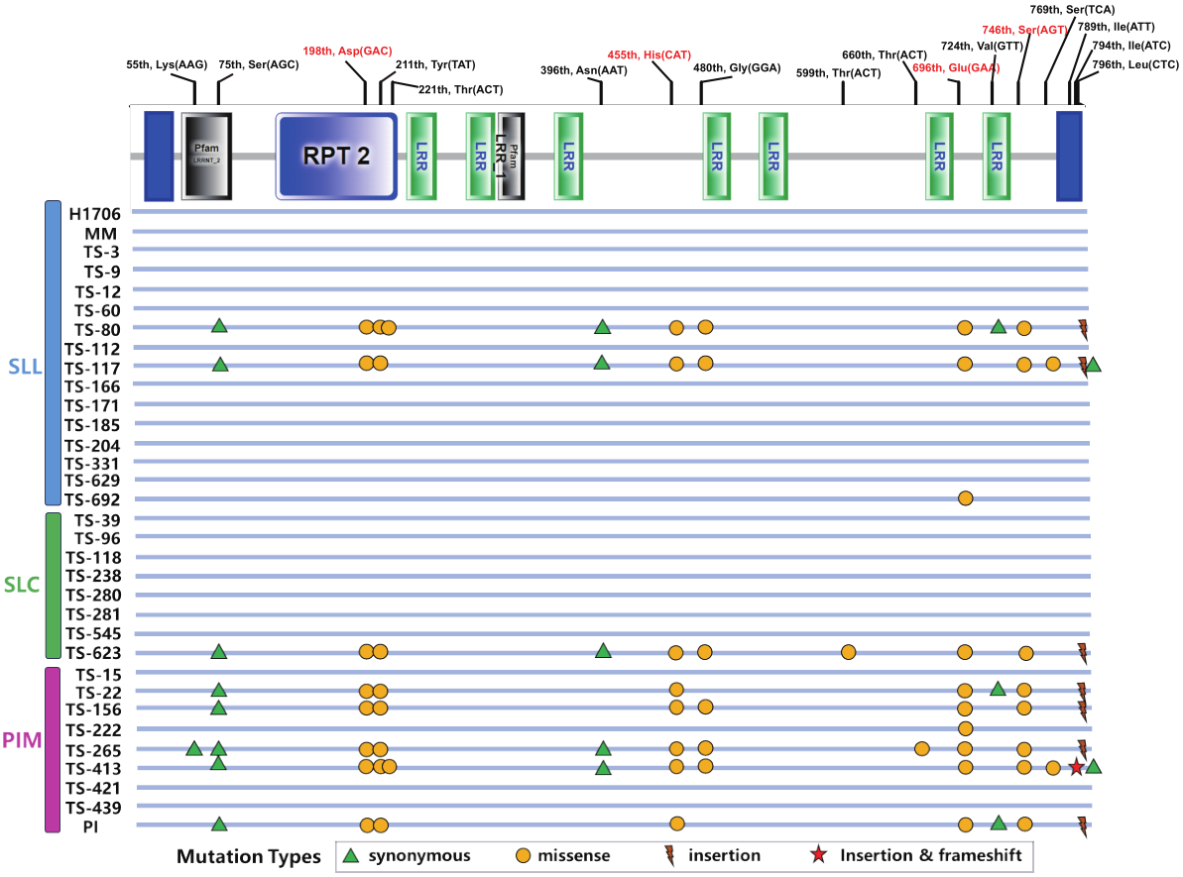
Fig. S5 Polymorphisms of SlBRL1 in the 33 tomato accessions. The polymorphisms position and predicted domains by SMART (https://smart.embl.de/) are shown in the top region. The potential causal variations are indicated by red color. The predicted amino acid changes are marked by different shapes in the bottom region. The 33 accessions consist Solanum pimpinellifolium (SP), cherry-sized early domesticates S. lycopersicum var. cerasiforme (SLC) and large-fruited tomatoes S. lycopersicum var. lycopersicum (SLL) (ref. [1], ref. [2]).

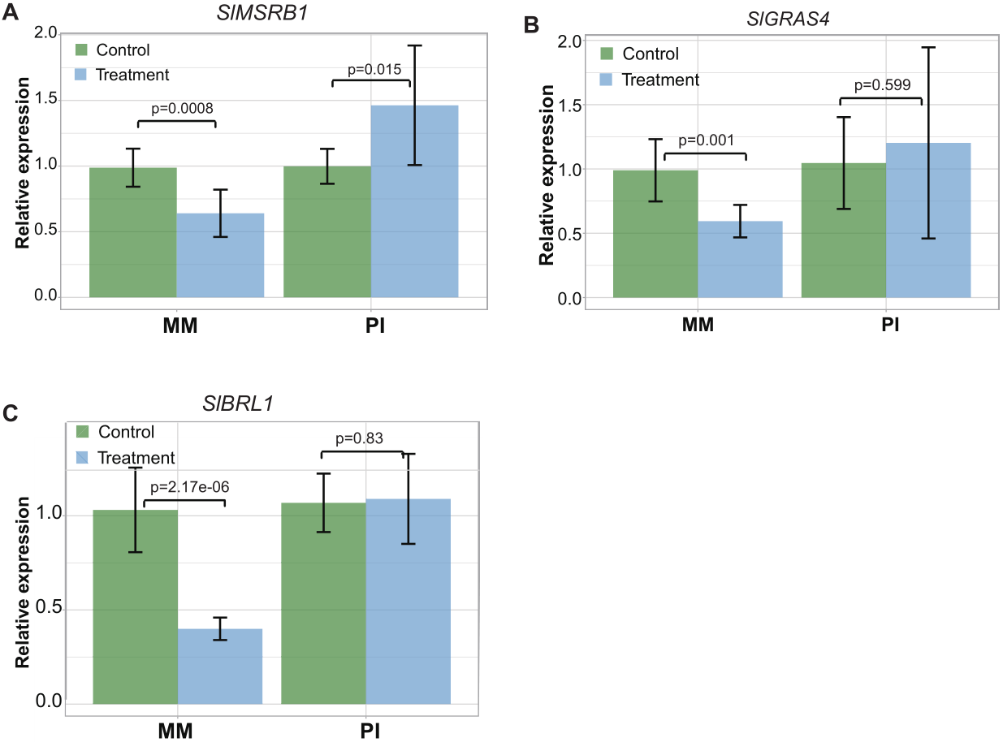
Fig. S6 Expression change of candidate genes in RIL parents under control and treatment. A, Expression of SlMSRB1 under control and salt treatment. B, Expression of SlGRAS4 under control and drought treatment. C, Expression of SlBRL1 under control and drought treatment. p value is calculated using two-tailed t-test.

References
[1] Zhou Y, Zhang ZY, Bao ZG, Li HB, Lyu YQ, Zan YJ, Wu YY, Cheng L, Fang YH, Wu K, et al. Graph pangenome captures missing heritability and empowers tomato breeding. Nature. 2022;606(7914):527–34.
[2] Liu ZQ, Cai HQ, Cui X. A chromosome-level genome assembly of Solanum pimpinellifolium. Acta Hortic Sin. 2022;49:2263–72.

