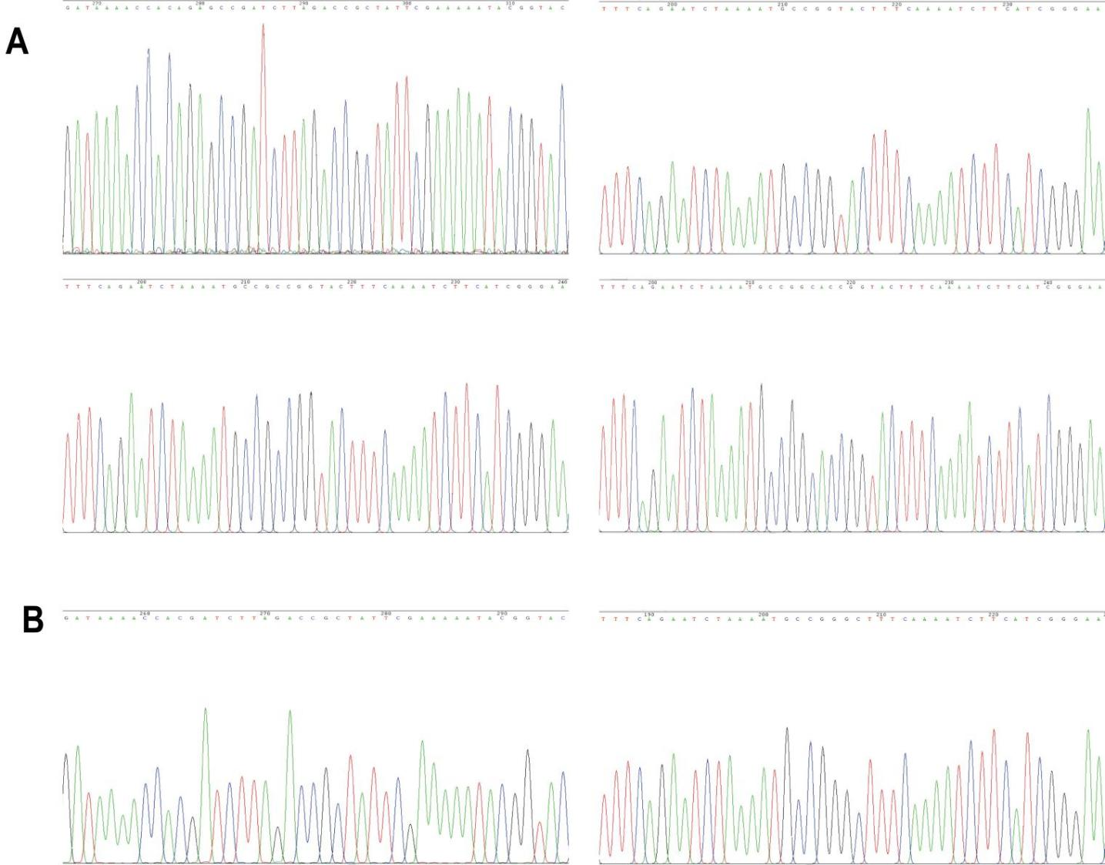
Supplementary Figure S1. Sequencing maps of Bmlark^{-/-} with different mutation. (A) Sequencing maps of Bmlark^{-/-} with mutation at target site1. (B) Sequencing maps of Bmlark^{-/-} with mutation at target site2.
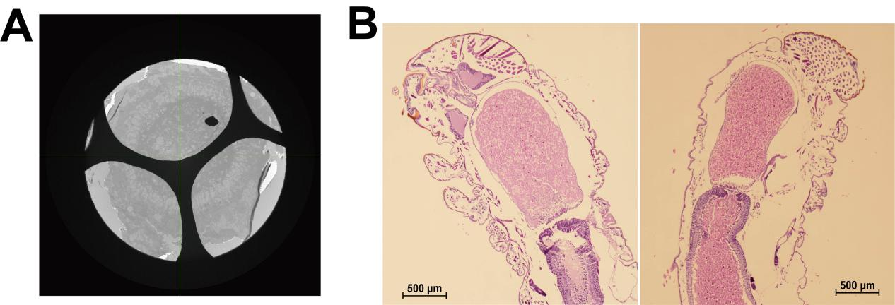
Supplementary Figure S2. Original images of Figure 2A and Figure 2E. (A) The original TEM image showed a complete cross-section of Bmlark^{-/-} mutant. (B) The enlarged original HE stained images of the heads of WT and Bmlark^{-/-} mutant which were cropped and showed in Figure 2E. Before cropping, image of WT was flipped side-to-side in equal proportions to better compare with Bmlark^{-/-} in the same direction in Figure 2E.

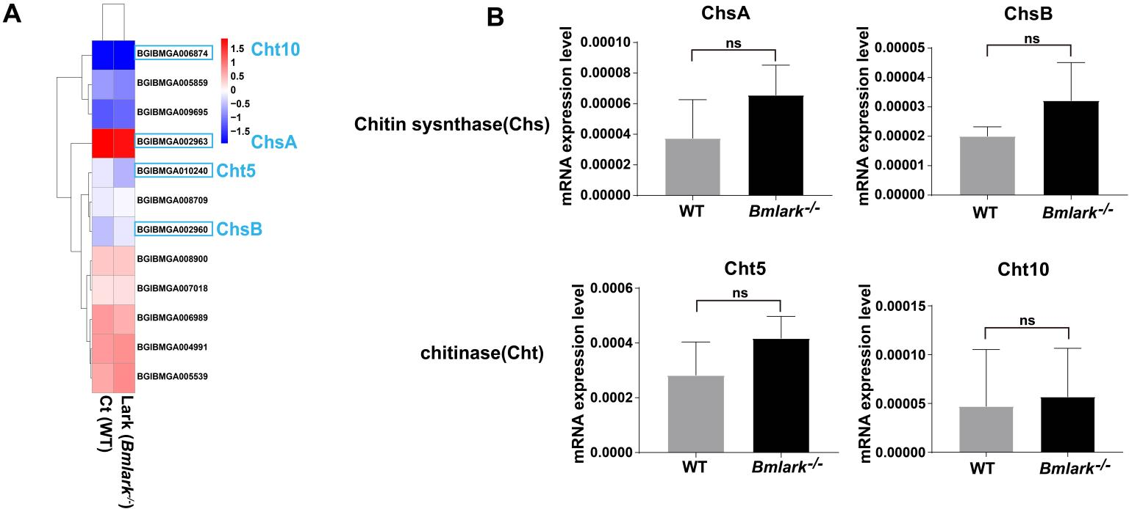
Supplementary Figure S3. The expression level analysis of chitin synthase and chitinase in Bmlark^{-/-} vs WT. Ct: the WT group; Lark: the Bmlark^{-/-} group. ns: not significance.
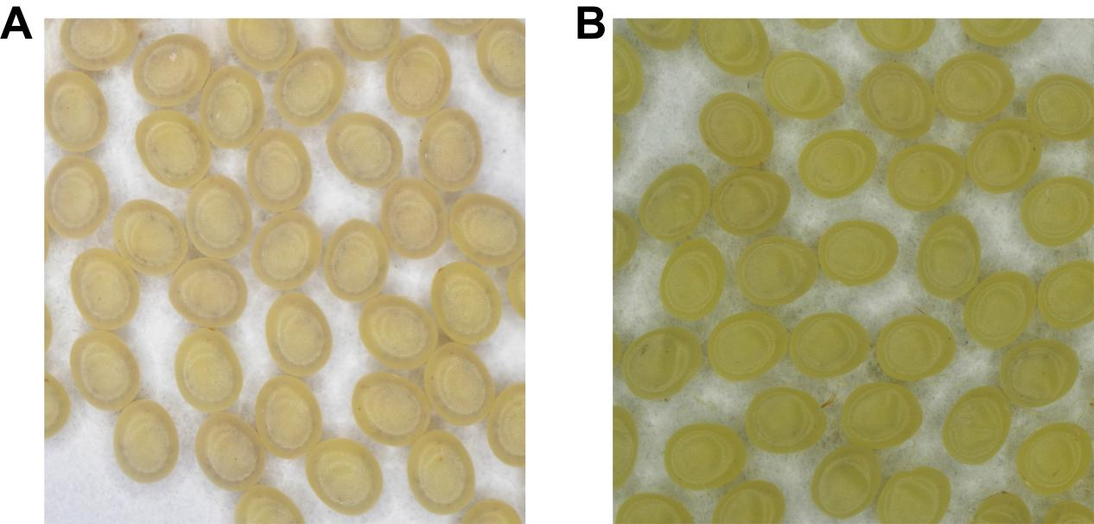
Supplementary Figure S4. The original images of embryos 144 h post oviposition in Figure 1B.

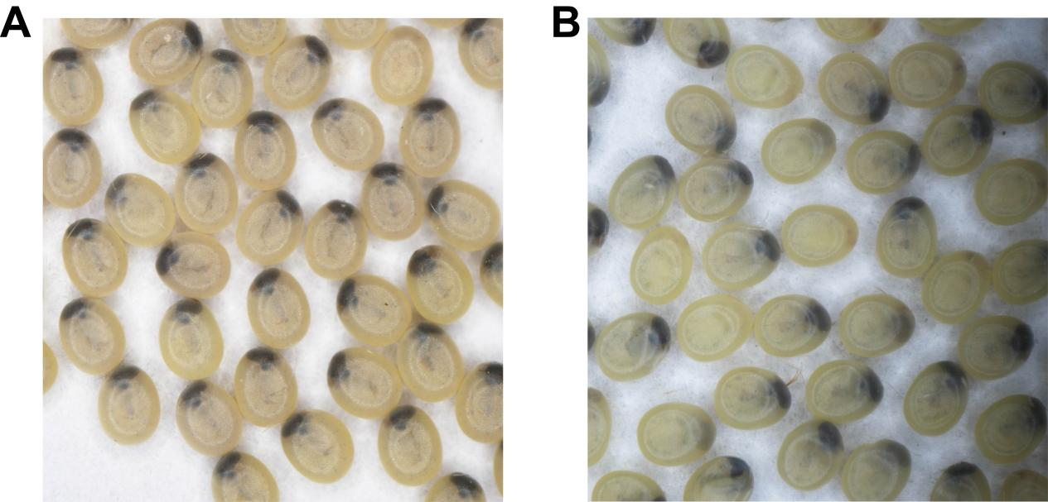
Supplementary Figure S5. The original images of embryos 168 h post oviposition in Figure 1B.

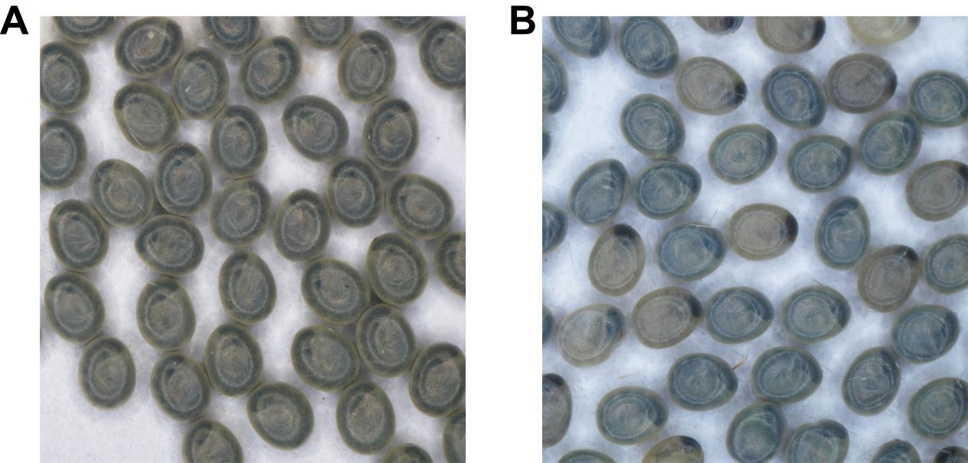
Supplementary Figure S6. The original images of embryos 188 h post oviposition in Figure 1B.

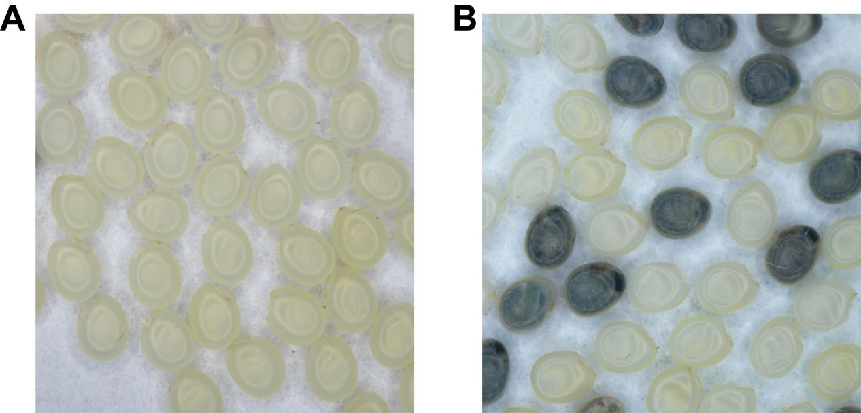
Supplementary Figure S7. The original images of embryos 216 h post oviposition in Figure 1B.

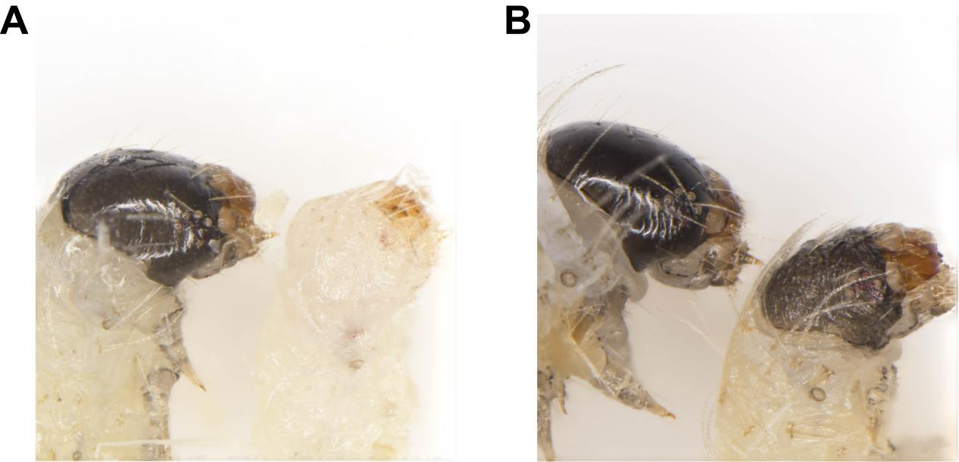
Supplementary Figure S8. The original images of the heads of WT and Bmlark^{-/-} embryos in Figure 1D.

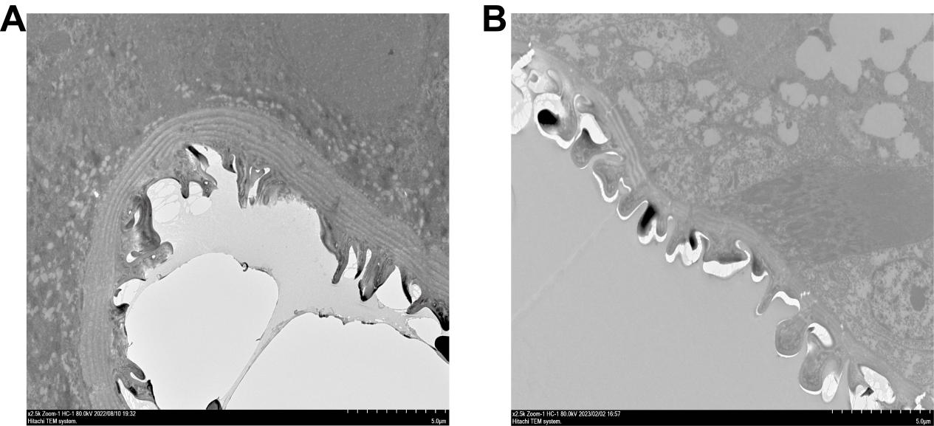
Supplementary Figure S9. The original TEM images of cuticles of WT(A) and Bmlark^{-/-}(B) embryos in Figure 2A.

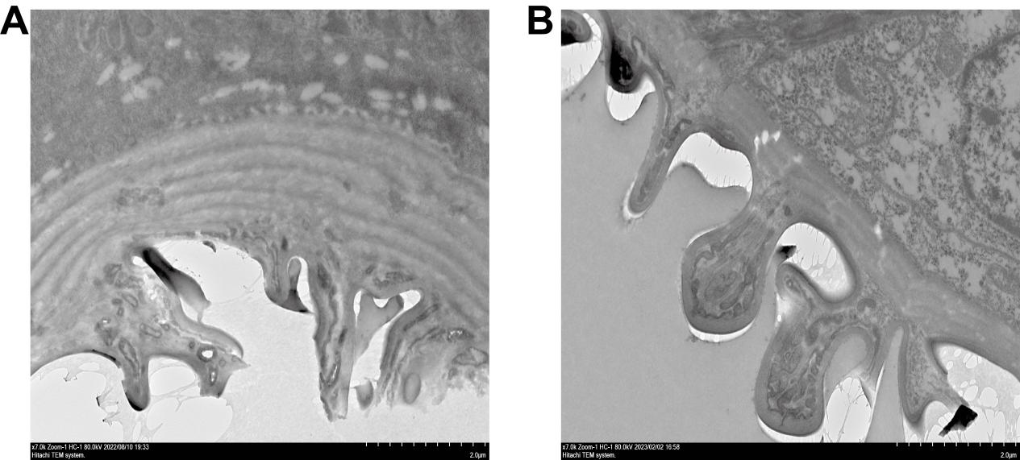
Supplementary Figure S10. The enlarged original TEM images of the cuticle of the heads of WT(A) and Bmlark^{-/-}(B) embryos in Figure 2A.

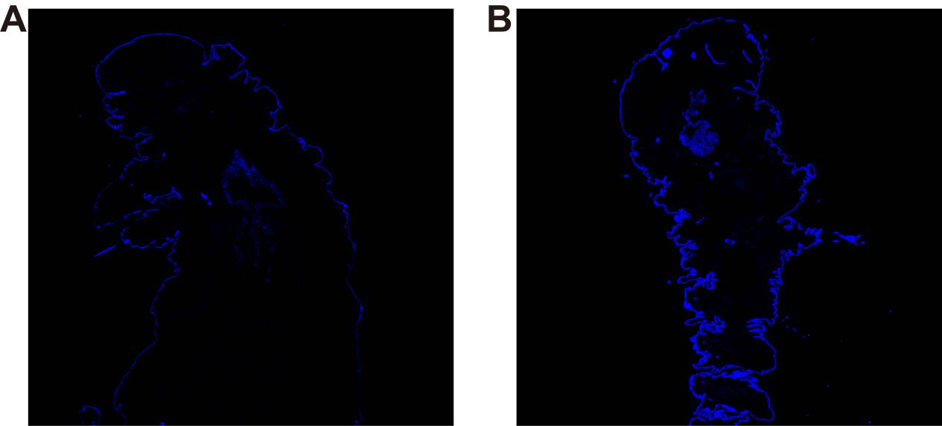
Supplementary Figure S11. The original chitin stained images of WT (A) and Bmlark^{-/-}(B) embryos in Figure 2D. Image of WT was flipped side-to-side in equal proportions to better compare with Bmlark^{-/-} in the same direction in Figure 2D.

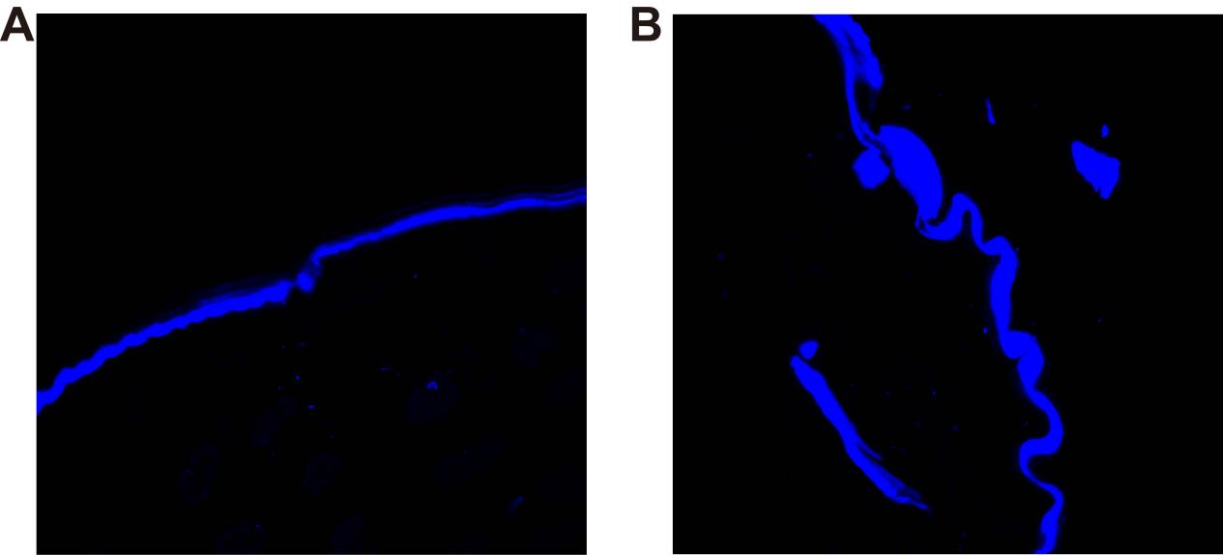
Supplementary Figure S12. The enlarged original chitin stained images of the cuticle of the head of WT(A) and Bmlark^{-/-}(B) embryos in Figure 2D. Image of WT was flipped side-to-side in equal proportions to better compare with Bmlark^{-/-} in the same direction in Figure 2D.

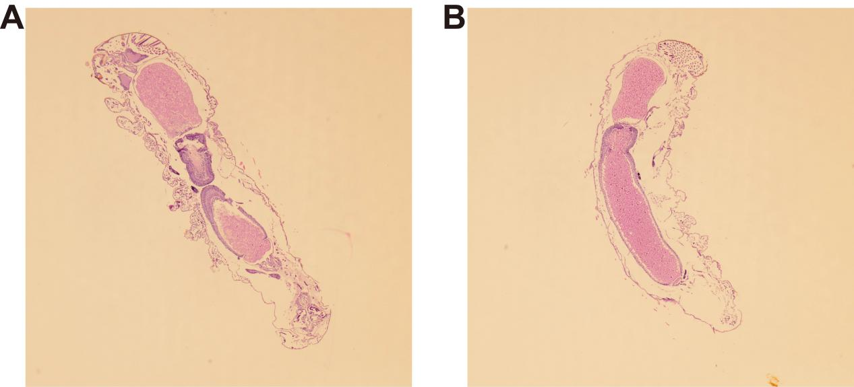
Supplementary Figure S13. Original HE stained images of WT(A) and Bmlark^{-/-}(B) embryos in Figure 2E. Image of WT was flipped side-to-side in equal proportions to better compare with Bmlark^{-/-} in the same direction in Figure 2E. E nlarged original HE stained images of the heads in Figure 2E were showed in Supplementary Figure S3B.

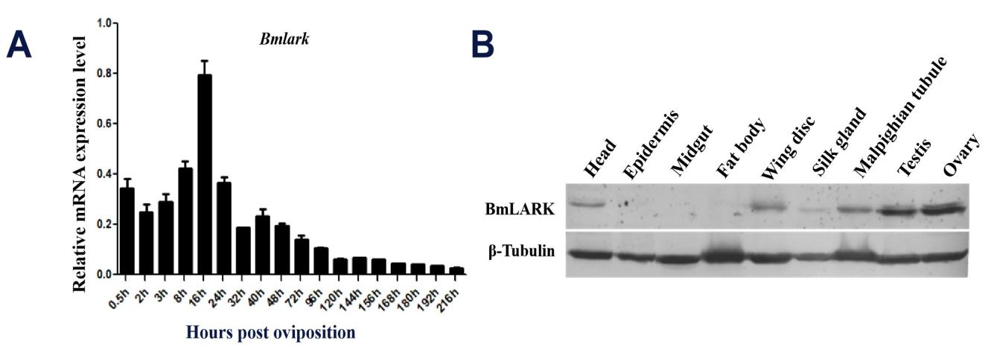
Supplementary Figure S14. The expression level analysis of Bmlark in WT larvae. (A) mRNA expression level of Bmlark during embryonic development. (B) Western blot analysis of BmLARK protein and β-tubulin in different tissues at the first day of wandering stage.

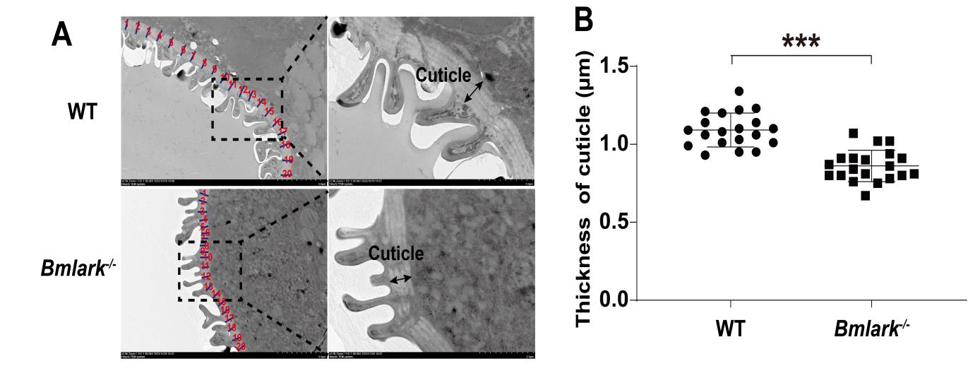
Supplementary Figure S15. TEM analysis of the epidermic cuticle of the abdomen of the WT and Bmlark^{-/-} embryos，a biological replicate of Fig.2A and 2B. (A) TEM images of the cross sections of the WT and Bmlark^{-/-} embryos at the head pigmentation stage (168 h post oviposition). The blue lines with red numerical numbers, which are perpendicular to the tangent lines along the cuticle, represent the thickness of the cuticle at 20 randomly selected regions. (B) Comparison of the thickness of the epidermic cuticles of the abdomen of the WT and Bmlark^{-/-} embryos. The length of red lines at 20 different regions per individual in Figure (A) was calculated using Nano Measurer 1.2 software (Supplementary Table S13), representing the thickness of the epidermic cuticles of the abdomen of the WT and Bmlark^{-/-} embryos. Student’s t-test was used to evaluate statistical significance. The results are presented as mean ± SE. ***p≤0.001.

