Supplementary File
Table S1 Best-fit models for the phylogenetic trees construction of eight genes of the novel H3N3 isolate.
Gene | Best-fit model | Parameters | BICª | AICc^{b}
PB2 | GTR^{c}+G^{d}+Ie | 143 | 41456.128 | 40034.969
PB1 | GTR+G | 148 | 35921.176 | 34445.134
PA | GTR+G | 156 | 33670.560 | 32112.491
HA | GTR+G+I | 195 | 39374.316 | 37430.459
NP | GTR+G+I | 155 | 23953.950 | 22466.495
NA | T92^{f}+G | 174 | 23913.567 | 22231.247
M | GTR+G+I | 165 | 14049.292 | 12528.350
NS | GTR+G | 148 | 13999.407 | 12670.023
ªBayesian Information Criterion; ^{b}Akaike Information Criterion; ^{c}General Time Reversible; ^{d}Gamma distributed; ^{e}Invariant sites; ^{f}Tamura 3-parameter;

Table S2 Analysis of potential glycosylation sites in the HA protein of A/chicken/China/16/2023(H3N3) isolate.
Strains | Potential glycosylation sites of HA protein
Strains | 24 | 38 | 54 | 61 | 79 | 138 | 174 | 181 | 301 | 499
A/chicken/China/16/2023(H3N3) | - | NGT | NAT | NSS | - | - | - | NVT | NGS | NGT
A/China/ZMD-22-2/2022(H3N8)ª | - | NGT | NAT | NSS | - | - | - | NVT | NGS | NGT
A/China/CSKFQ-22-5/2022(H3N8)ª | - | NGT | NAT | NSS | - | - | - | NVT | NGS | NGT
A/Iran/Clinical Sample/2019(H3N3)ª | NST | NGT | NAT | NSS | NCT | NES | NYT | NVT | NGS | NET
A/bantam/Nanchang/9-366/2000(H3N3) | NNT | NGT | NAT | - | - | - | - | NVT | NGS | NGT
A/duck/Zhejiang/D16/2013(H3N3) | NST | NGT | NAT | - | - | - | - | NVT | NGS | NGT
A/chicken/China/NXFWB5/2022(H3N8) | - | NGT | NAT | NSS | - | - | - | NVT | NGS | NGT
A/chicken/Shantou/481/2022(H3N8) | - | NGT | NAT | NSS | - | - | - | NVT | NGS | NGT
A/duck/Hunan/199/2014(H3N8) | NST | NGT | NAT | - | - | - | - | NVT | NGS | NGT
ªThe strain was originated from human.
Table S3 Analysis of potential glycosylation sites in the NA protein of A/chicken/China/16/2023(H3N3) isolate
Strains | Potential glycosylation sites of NA protein
Strains | 14 | 57 | 66 | 72 | 146 | 308 | 387 | 401
A/chicken/China/16/2023(H3N3) | NTT | NCS | NNT | NIT | NGT | NET | NHT | NWS
A/Pigeon/Nanchang/9-058/2000(H3N3) | NTT | NCS | NNT | NIT | NGT | NET | - | -
A/bantam/Nanchang/9-366/2000(H3N3) | NTT | NCS | NNT | NIT | NGT | NET | - | -
A/aquatic bird/Korea/CN-4/2006(H3N3) | NTT | NCS | NNT | NIT | NGT | NET | - | -
A/duck/Zhejiang/D18/2013(H3N3) | NTT | NCS | NNT | NIT | NGT | NET | - | -
A/duck/Fujian/SD063/2017(H3N3) | - | NCS | NNT | NIT | NGT | NET | - | -
A/Environment/China/04940NA/2021(H10N3) | NTT | NCS | NNT | NIT | NGT | NET | NHT | -
A/China/0428NA/2021(H10N3)ª | NTT | NCS | NNT | NIT | NGT | NET | NHT | -
A/chicken/Zhejiang/516100/2017(H10N3) | NTT | NCS | NNT | NIT | NGT | NET | - | -
A/chicken/China/146-6/2021(H10N3) | NTT | NCS | NNT | NIT | NGT | NET | NHT | -
ªThe strain was originated from human.

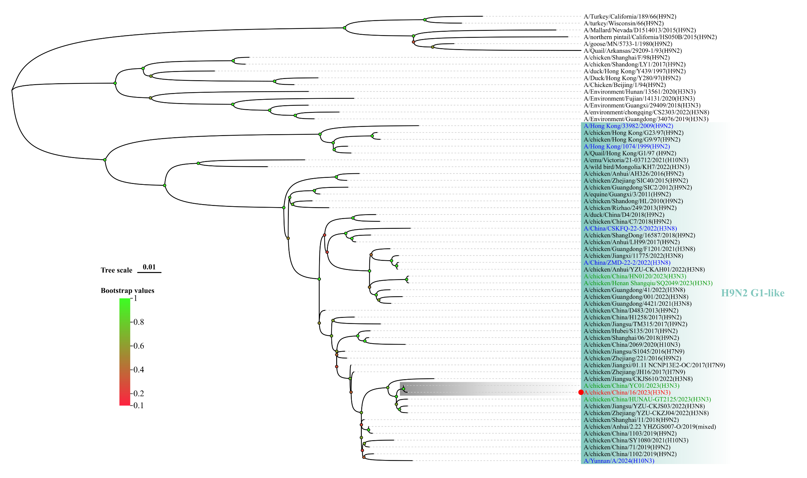
Fig. S1 Phylogenetic analysis of the PB2 gene of A/chicken/China/16/2023(H3N3). The ML tree of the PB2 gene was constructed using MEGA software (Version 11.0.11) with 1000 bootstrap replicates. The H3N3 virus from this study was highlighted using red text, the human-derived viruses were marked in blue, and the other H3N3 AIVs identified in 2023 were marked in green.

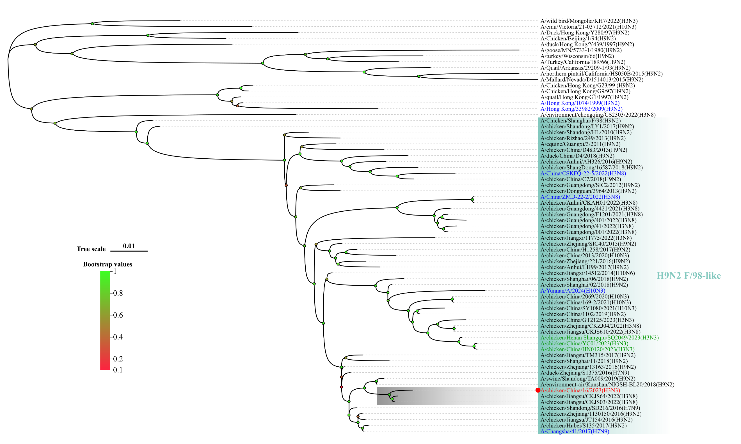
Fig. S2 Phylogenetic analysis of the PB1 gene of A/chicken/China/16/2023(H3N3). The ML tree of the PB1 gene was constructed using MEGA software (Version 11.0.11) with 1000 bootstrap replicates. The H3N3 virus from this study was highlighted using red text, the human-derived viruses were marked in blue, and the other H3N3 AIVs identified in 2023 were marked in green.

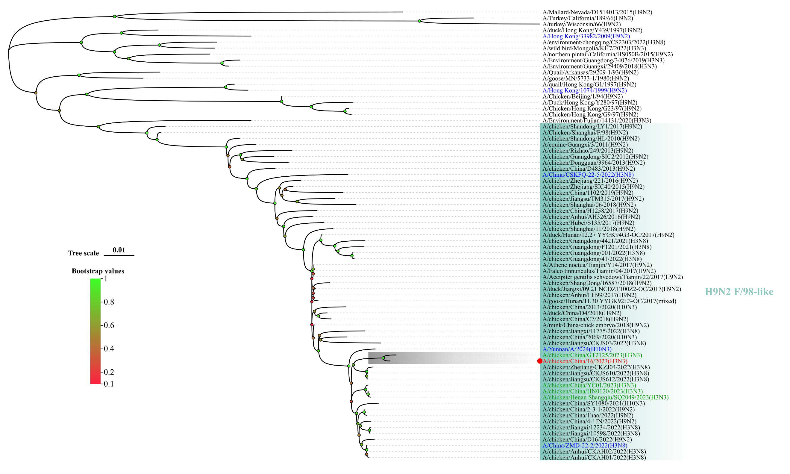
Fig. S3 Phylogenetic analysis of the PA gene of A/chicken/China/16/2023(H3N3). The ML tree of the PA gene was constructed using MEGA software (Version 11.0.11) with 1000 bootstrap replicates. The H3N3 virus from this study was highlighted using red text, the human-derived viruses were marked in blue, and the other H3N3 AIVs identified in 2023 were marked in green.

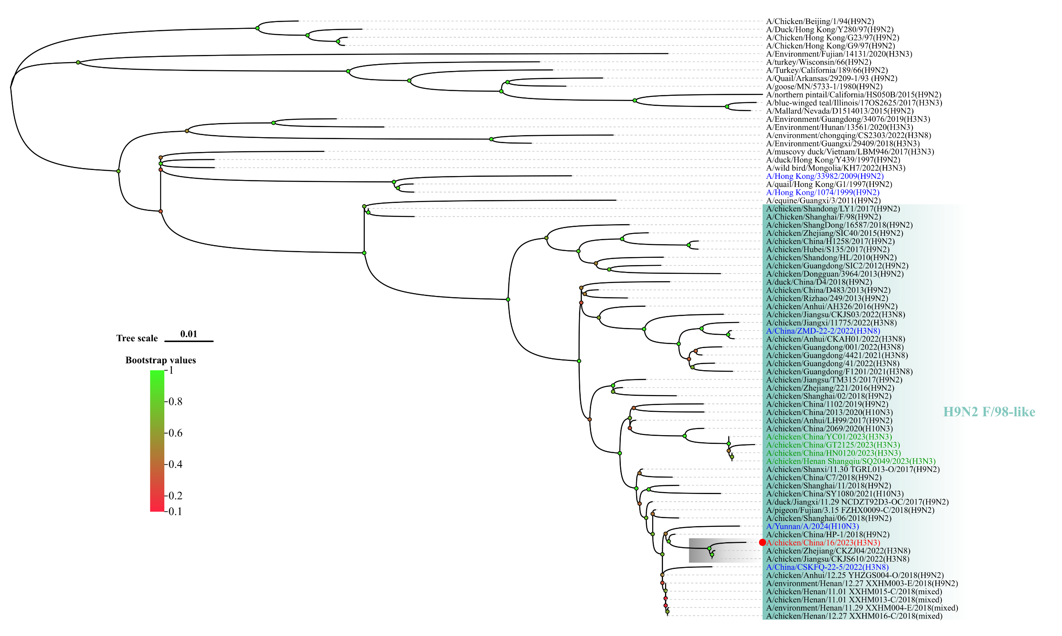
Fig. S4 Phylogenetic analysis of the NP gene of A/chicken/China/16/2023(H3N3). The ML tree was constructed using MEGA software (Version 11.0.11) with 1000 bootstrap replicates. The H3N3 virus from this study was highlighted using red text, the human-derived viruses were marked in blue, and the other H3N3 AIVs identified in 2023 were marked in green.

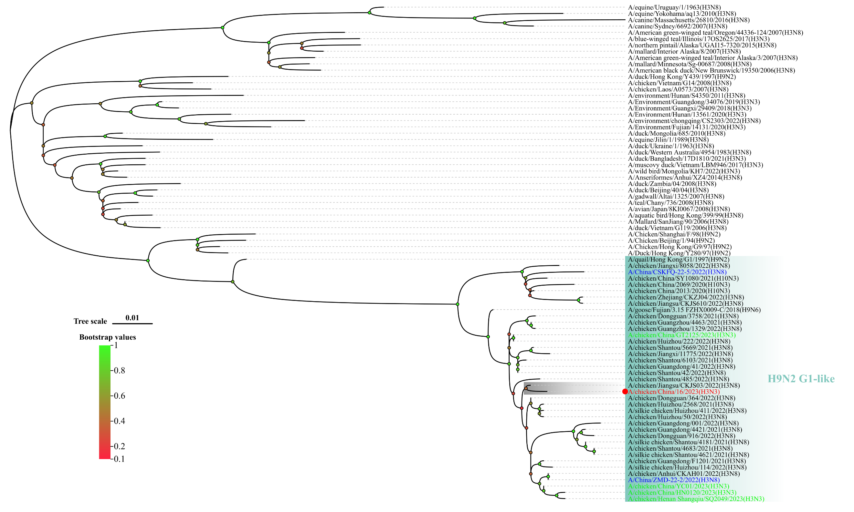
Fig. S5 Phylogenetic analysis of the M gene of A/chicken/China/16/2023(H3N3). The ML tree of the M gene was constructed using MEGA software (Version 11.0.11) with 1000 bootstrap replicates. The H3N3 virus from this study was highlighted using red text, the human-derived viruses were marked in blue, and the other H3N3 AIVs identified in 2023 were marked in green.

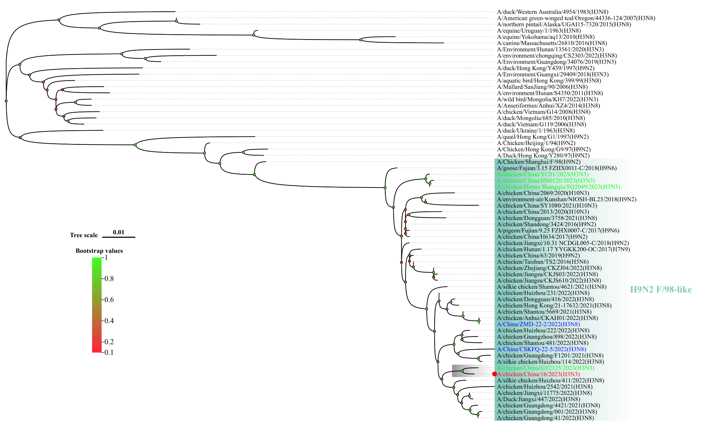
Fig. S6 Phylogenetic analysis of the NS gene of A/chicken/China/16/2023(H3N3). The ML tree of the NS gene was constructed using MEGA software (Version 11.0.11) with 1000 bootstrap replicates. The H3N3 virus from this study was highlighted using red text, the human-derived viruses were marked in blue, and the other H3N3 AIVs identified in 2023 were marked in green.

