SUPPLEMENTARY MATERIAL

Galaxy @Sciensano: A comprehensive bioinformatics portal for genomics-based microbial typing, characterization, and outbreak detection

Supplementary Tables

Table S1: Overview of all available tools on Galaxy @Sciensano

Section | Tools
Annotation | Prodigal Gene Predictor, Prokka
Bedtools | bedtools AnnotateBed, bedtools BAM to BED, bedtools BED to BAM, bedtools BED to IGV, bedtools BED12 to BED6, bedtools BEDPE to BAM, bedtools ClosestBed, bedtools ClusterBed, bedtools ComplementBed, bedtools Compute both the depth and breadth of coverage, bedtools ExpandBed, bedtools FisherBed, bedtools FlankBed, bedtools Genome Coverage, bedtools GetFastaBed, bedtools GroupByBed, bedtools Intersect intervals, bedtools JaccardBed, bedtools LinksBed, bedtools MakeWindowsBed, bedtools MapBed, bedtools MaskFastaBed, bedtools Merge BedGraph files, bedtools MergeBED, bedtools MultiCovBed, bedtools Multiple Intersect, bedtools NucBed, bedtools OverlapBed, bedtools RandomBed, bedtools ReldistBed, bedtools ShuffleBed, bedtools SlopBed, bedtools SortBED, bedtools SpacingBed, bedtools SubtractBed, bedtools TagBed, bedtools WindowBed
Blast | BLAST XML to tabular, NCBI BLAST+ blastdbcmd entry(s), NCBI BLAST+ blastn, NCBI BLAST+ blastp, NCBI BLAST+ blastx, NCBI BLAST+ convert2blastmask, NCBI BLAST+ database info, NCBI BLAST+ dustmasker, NCBI BLAST+ makeblastdb, NCBI BLAST+ makeprofiledb, NCBI BLAST+ rpsblast, NCBI BLAST+ rpstblastn, NCBI BLAST+ segmasker, NCBI BLAST+ tblastn, NCBI BLAST+ tblastx, NCBI get species taxids
Collection Operations | Apply rules, Build list, Duplicate file to collection, Extract dataset, Filter collection, Filter empty datasets, Filter failed datasets, Flatten collection, Harmonize two collections, Merge collections, Relabel identifiers, Sort collection, Tag elements, Unzip collection, Zip collection
Convert Formats | BAM-to-SAM, BED-to-BigBed, BED-to-GFF, GFF-to-BED, MAF to BED, MAF to FASTA, MAF to Interval, SAM-to-BAM, SFF converter, WIG-to-BigWig
Emboss | antigenic, backtranseq, banana, biosed, btwisted, cai, cai custom, chaos, charge, checktrans, chips, cirdna, codcmp, coderet, compseq, cpgplot, cpgreport, cusp, cutseq, dan, degapseq, descseq, diffseq, digest, dotmatcher, dotpath, dottup, dreg, einverted, epestfind, equicktandem, est2genome, etandem, extractfeat, extractseq, freak, fuzznuc, fuzzpro, fuzztran, garnier, geecee, getorf, helixturnhelix, hmoment, iep, infoseq, isochore, lindna, marscan, maskfeat, maskseq, matcher, megamerger, merger, msbar, needle, newcpgreport, newcpgseek, newseq, noreturn, notseq, nthseq, octanol, oddcomp, palindrome, pasteseq, patmatdb, pepcoil, pepinfo, pepnet, pepstats, pepwheel, pepwindow, pepwindowall, plotcon, plotorf, polydot, preg, prettyplot, prettyseq, primersearch, revseq, seqmatchall, seqret, showfeat, shuffleseq, sigcleave, sirna, sixpack, skipseq, splitter, supermatcher, syco, tcode, textsearch, tmap, tranalign, transeq, trimest, trimseq, twofeat, union, vectorstrip, water, wobble, wordcount, wordmatch
Expression Tools | param_value_from_file
Fetch Alignments/Sequences | Extract MAF by block number, Extract Pairwise MAF blocks, Filter MAF, Filter MAF blocks (by size), Filter MAF blocks (by species), Join MAF blocks (by species), MAF Coverage Stats, Reverse complement, Stitch Gene blocks, Stitch MAF blocks
Filter and Sort | Extract features from GFF data, Filter, Filter GFF data by attribute, Filter GFF data by attribute values_list, Filter GFF data by feature count, Select, Sort
Get Data | EBI SRA, EuPathDB, Flymine, HbVar, InterMine, ModMine, MouseMine, NCBI Datasets Genomes, RatMine, SRA, UCSC Archea, UCSC Main, Upload, WormBase, YeastMine, modENCODE fly, modENCODE worm, zebrafishmine
Graph/Display Data | VCF to MAF Custom Track
ITS | ITSx
Join, Subtract and Group | Compare two Datasets, FASTQ interlacer, Group, Join two Datasets
Lift-Over | Convert genome coordinates
Mothur | Align.seqs, Chimera.uchime, Chimera.vsearch, Classify.otu, Classify.seqs, Cluster, Cluster.split, Count.groups, Count.seqs, Dist.seqs, Filter.seqs, Get.group, Get.oturep, Make.contigs, Make.shared, Pairwise.seqs, Pcr.seqs, Pre.cluster, Rarefaction.single, Remove.groups, Remove.lineage, Remove.rare, Remove.seqs, Screen.seqs, Seq.error, Sub.sample, Summary.seqs, Unique.seqs
NGS: Assembly | Create assemblies with Unicycler, Flye, SPAdes, Shovill, VelvetOptimiser, plasmidSPAdes, velvetg, velveth
NGS: Decontamination | human reads scrubbing pipeline 0.2
NGS: Picard | AddCommentsToBam, AddOrReplaceReadGroups, BedToIntervalList, CleanSam, Collect Alignment Summary Metrics, CollectBaseDistributionByCycle, CollectGcBiasMetrics, CollectHsMetrics, CollectInsertSizeMetrics, CollectRnaSeqMetrics, CollectWgsMetrics, Downsample SAM/BAM, EstimateLibraryComplexity, FastqToSam, FilterSamReads, FixMateInformation, MarkDuplicates, MarkDuplicatesWithMateCigar, MeanQualityByCycle, MergeBamAlignment, MergeSamFiles, NormalizeFasta, Picard Collect Sequencing Artifact Metrics, QualityScoreDistribution, ReorderSam, ReplaceSamHeader, RevertOriginalBaseQualitiesAndAddMateCigar, RevertSam, SamToFastq, SortSam, ValidateSamFile
NGS: Pipelines | Amplicon GMO detection Pipeline, Enterococcus pipeline 1.1, Hybrid assembly pipeline 0.1, Klebsiella pipeline 1.0, Listeria pipeline 1.3, Mycobacterium pipeline 1.2, Neisseria pipeline 1.3, Pipeline combine, SARS-CoV-2 LoFreq pipeline, STEC pipeline 1.1, Salmonella pipeline 0.3, Shigella pipeline 1.1, Staphylococcus pipeline 1.1, Viral consensus pipeline (Illumina), Viral consensus pipeline (ONT), Viral consensus pipeline - Extract sequences, Yersinia pipeline 1.0
NGS: QC and manipulation | Barcode Splitter, Busco, CheckM - Lineage workflow, CheckV, Clip, Collapse, Compute quality statistics, ConFindr, Download and Extract Reads in BAM, Download and Extract Reads in FASTA/Q, Draw nucleotides distribution chart, Draw quality score boxplot, FASTA Width, FASTQ to FASTA, FastANI, FastQC, Faster Download and Extract Reads in FASTQ, Filter by quality, Length Distribution, MultiQC, NanoFilt - local version, NanoPlot - local install, Quality format converter, Quast, RNA/DNA, Remove sequencing artifacts, Rename sequences, Reverse-Complement, Trim sequences, Trim sequences, Trimmomatic, fastp, fq2fa
NGS: Read mapping | Bowtie2, Map with BWA, Map with BWA-MEM, Samtools depth
NGS: SNP phylogeny | MEGA Model selection and tree construction, PACU, PACU - mapping, SNP Phylogeny: CFSAN, SNP Phylogeny: Samtools, snp-dists
NGS: Taxonomic classification | Kraken 2, Krona pie chart, Pangolin
NGS: Variant Analysis | Add LoFreq alignment quality scores, Call variants, Clair3 variant calling, Insert indel qualities, Lofreq filter, Realign reads, Samtools variant calling, SnpEff build:, SnpEff chromosome-info:, SnpEff databases:, SnpEff download:, SnpEff eff:, SnpSift Annotate, SnpSift CaseControl, SnpSift Extract Fields, SnpSift Filter, SnpSift Intervals, SnpSift Variant Type, SnpSift rmInfo, SnpSift vcfCheck, Variant filtering, bcftools consensus, bcftools csq
Operate on Genomic Intervals | Aggregate datapoints, Gene BED to Exon/Intron/Codon BED, Wiggle-to-Interval
Phenotype Association | DAVID, LD, MasterVar to pgSNP, SIFT, g:Profiler
QIIME | Closed-reference OTU picking, Make OTU table, Perform OTU picking, Perform open-reference OTU picking, Pick representative set of sequences, Run join_paired_ends on multiple files, Split fastq libraries, Summarize taxa
Resistance characterization | NCBI AMRFinder, ResFinder4, abritAMR
SCREENED | SCREENED
SCREENED2 | SCREENED2
Send Data | Export datasets, Send to cloud
Seqtk | seqtk comp, seqtk cutN, seqtk dropse, seqtk fqchk, seqtk hety, seqtk mergefa, seqtk mergepe, seqtk mutfa, seqtk randbase, seqtk sample, seqtk seq, seqtk subseq, seqtk telo, seqtk trimfq, seqtky listhet
Sequence Analysis | Integron Finder, Phage Term Virome
Sequence alignment | ClustalW, Convert XMFA to gapped GFF3, DNAdiff, MUSCLE, Samtools Chromosome Sizes, Samtools Index, Samtools sort, Samtools view, progressiveMauve
Sequence typing | BTyper3, Gene detection (BLAST), Gene detection (KMA), Gene detection (SRST2), Gene detection - create database, MLST phylogeny, MOB-Recon, MOB-Typer, Multi Locus Sequence Typing (MLST) - BLAST, Multi Locus Sequence Typing (MLST) - KMA, Multi Locus Sequence Typing (MLST) - SRST2, S. aureus SCCmecFinder, S. aureus spa typing, SRST2 base (Gene detection), SRST2 base (Sequence typing), sistr_cmd
Statistics | Count, Summary Statistics
Text Manipulation | Add column, Change case, Column Regex Find And Replace, Concatenate datasets, Convert, Create single interval, Cut, Datamash, Datamash, Link/Word/Character count, Merge columns, Regex Find And Replace, Regex Find And Replace, Remove beginning, Reverse, Reverse, Select first, Select last, Select random lines, Transpose, Transpose, Trim, pasteseq

Overview of all the tools available in the Galaxy @Sciensano instance grouped by section as indicated in the first column.

Table S2: Accession number for the datasets used in the example analyses

Analysis | Name | SRA accession | Description
Escherichia coli outbreak | TIAC1151 | SRR10201424 | Illumina WGS data for E. coli ST11 strain from food, part of the outbreak
Escherichia coli outbreak | TIAC1152 | SRR10201464 | Illumina WGS data for E. coli ST11 strain from food, part of the outbreak
Escherichia coli outbreak | TIAC1153 | SRR10201455 | Illumina WGS data for E. coli ST11 strain from food, not part of the outbreak
Escherichia coli outbreak | TIAC1165 | SRR10201438 | Illumina WGS data for E. coli ST11 strain from human, part of the outbreak
Escherichia coli outbreak | TIAC1169 | SRR10201412 | Illumina WGS data for E. coli ST11 strain from human, part of the outbreak
Escherichia coli outbreak | TIAC1638 | SRR10201405 | Illumina WGS data for E. coli ST11 strain, not part of the outbreak
Escherichia coli outbreak | TIAC1660 | SRR10201393 | Illumina WGS data for E. coli ST223 strain, not part of the outbreak
Methicillin-resistant Staphylococcus aureus (MRSA) from hospitals | SA_0680 | SRR23547075 | Illumina WGS data for S. aureus from patient, contaminated with Enterococcus
 | SA_0998 | SRR23547066 | Illumina WGS data for S. aureus from care giver
 | SA_1053 | SRR23547063 | Illumina WGS data for S. aureus from care giver
 | SA_1405 | SRR23547060 | Illumina WGS data for S. aureus from care giver
 | SA_2777 | SRR23547055 | Illumina WGS data for S. aureus from patient

SRA accession numbers for the datasets used in the example analyses.

Table S3: Assembly statistics for the example STEC outbreak analysis
Isolate | Nb. of contigs | Total length | N50 | Median depth
TIAC1151 | 181 | 5,301,807 | 149,902 | 41
TIAC1152 | 243 | 5,269,832 | 110,594 | 34
TIAC1153 | 245 | 5,323,477 | 101,789 | 50
TIAC1165 | 231 | 5,285,502 | 100,061 | 37
TIAC1169 | 255 | 5,260,854 | 99,970 | 56
TIAC1638 | 258 | 5,358,696 | 111,111 | 37
TIAC1660 | 137 | 5,024,438 | 116,573 | 54

This table shows the assembly statistics for the example analysis on the STEC datasets. The number of contigs, total length and N50 were calculated using QUAST and only include contigs larger than 500 bp. Median depth was calculated by mapping the processed reads to the assembled contigs using Bowtie2 and then using the 'depth' command in samtools.

Table S4: NCBI AMRFinder+ output for all STEC isolates
Antibiotic (subclass) | TIAC1151 | TIAC1152 | TIAC1153 | TIAC1165 | TIAC1169 | TIAC1638 | TIAC1660
Beta-Lactam |  |  | blaTEM-1
Fosfomycin | glpT E448K | glpT E448K | glpT E448K | glpT E448K | glpT E448K | glpT E448K | glpT E448K
Kanamycin |  |  | aph(3')-Ia
Streptomycin |  |  | aph(3'')-Ib
Streptomycin |  |  | aph(6)-Id
Sulfonamide |  |  | sul2
Tetracycline |  |  | tet(A)
Trimethoprim |  |  | dfrA8

Genes and mutations detected by NCBI AMRFinder+ on the STEC assemblies. Each row corresponds to a feature associated with AMR, with the antibiotic indicated in the first column. The color coding from the output report is used, with perfect hits indicated in dark green, and full-length imperfect hits in light green (i.e., sequence identity <100%).

Table S5: Virulence genes detected in the STEC isolates

ST | ST11 |  |  |  |  |  | ST223
Gene | TIAC1151 | TIAC1152 | TIAC1153 | TIAC1165 | TIAC1169 | TIAC1638 | TIAC1660
anr | 1 | 1 | 1 | 1 | 1 | 1 | 0
AslA | 1 | 1 | 1 | 1 | 1 | 1 | 0
astA | 1 | 1 | 1 | 1 | 1 | 1 | 0
cdt-VB | 0 | 0 | 0 | 0 | 0 | 0 | 1
cea | 0 | 0 | 0 | 0 | 0 | 0 | 1
chuA | 1 | 1 | 1 | 1 | 1 | 1 | 0
cia | 0 | 0 | 0 | 0 | 0 | 0 | 1
cib | 0 | 0 | 0 | 0 | 0 | 0 | 1
csgA | 1 | 1 | 1 | 1 | 1 | 1 | 1
eae-g01-gamma_1 | 1 | 1 | 1 | 1 | 1 | 1 | 0
ehxA | 1 | 1 | 1 | 1 | 1 | 1 | 1
epeA | 0 | 0 | 0 | 0 | 0 | 0 | 1
espA | 1 | 1 | 1 | 1 | 1 | 1 | 0
espB | 1 | 1 | 1 | 1 | 1 | 1 | 0
espF | 1 | 1 | 1 | 1 | 1 | 1 | 0
espJ | 1 | 1 | 1 | 1 | 1 | 0 | 0
espP | 1 | 1 | 1 | 1 | 1 | 1 | 1
espY2 | 1 | 1 | 1 | 1 | 1 | 1 | 0
etpD | 1 | 1 | 1 | 1 | 1 | 1 | 0
fdeC | 1 | 1 | 1 | 1 | 1 | 1 | 1
fimH | 1 | 1 | 1 | 1 | 1 | 1 | 1
gad | 1 | 1 | 1 | 1 | 1 | 1 | 1
hha | 0 | 0 | 1 | 0 | 0 | 0 | 1
hlyE | 1 | 1 | 1 | 1 | 1 | 1 | 1
iha | 1 | 1 | 1 | 1 | 1 | 1 | 1
iss | 1 | 1 | 1 | 1 | 1 | 1 | 1
katP | 1 | 1 | 1 | 1 | 1 | 1 | 0
lpfA | 0 | 0 | 0 | 0 | 0 | 0 | 1
nleA | 1 | 1 | 1 | 1 | 1 | 1 | 0
nleB | 1 | 1 | 1 | 1 | 1 | 1 | 0
nleC | 1 | 1 | 1 | 1 | 1 | 1 | 0
nlpI | 1 | 1 | 1 | 1 | 1 | 1 | 1
ompT | 1 | 1 | 1 | 1 | 1 | 1 | 1
stx1 | 1 | 1 | 1 | 1 | 1 | 1 | 1
stx2 | 1 | 1 | 1 | 1 | 1 | 1 | 1
subA | 0 | 0 | 0 | 0 | 0 | 0 | 1
tccP | 1 | 1 | 1 | 1 | 1 | 1 | 0
terC | 1 | 1 | 1 | 1 | 1 | 1 | 1
tir | 1 | 1 | 1 | 1 | 1 | 1 | 0
toxB | 1 | 1 | 0 | 1 | 1 | 0 | 0
traT | 1 | 1 | 1 | 1 | 1 | 1 | 1
yehA | 0 | 0 | 0 | 0 | 0 | 0 | 1
yehB | 0 | 0 | 0 | 0 | 0 | 0 | 1
yehC | 0 | 0 | 0 | 0 | 0 | 0 | 1
yehD | 0 | 0 | 0 | 0 | 0 | 0 | 1
yghJ | 0 | 0 | 0 | 0 | 0 | 0 | 1

Virulence genes detected in the STEC assemblies. Isolates were grouped by sequence type, as indicated in the top row. Genes were merged by gene name. Genes present are marked with a '1' on a green background, while absent genes are denoted by a '0'.Note that all hits are reported, including imperfect identity (i.e., sequence identity <100%) and imperfect length (i.e., coverage <100%) hits.

Table S6: Assembly statistics for the example MRSA analysis
Isolate | Nb. of contigs | Total length | N50 | Median depth
sa_0680 | 350 | 5,884,220 | 86,684 | 30
sa_0998 | 208 | 2,947,847 | 298,346 | 55
sa_1053 | 52 | 2,860,765 | 195,727 | 87
sa_1405 | 35 | 2,840,494 | 275,295 | 87
sa_2777 | 59 | 2,872,591 | 147,242 | 42

This table shows the assembly statistics for the example analysis on the MRSA datasets. The number of contigs, total length and N50 were calculated using QUAST and only include contigs larger than 500 bp. Median depth was calculated by mapping the processed reads to the assembled contigs using Bowtie2 and then using the 'depth' command in samtools. Note that the increased total assembly length of the sa_0680 dataset stands out.

Table S7: Quality control metrics used in the pathogen characterization pipelines

Quality check | Description
Kraken 2: contaminants | Percentage of the reads assigned to a species other than the targeted species.
ConFindr: number of contaminating SNPs | Number of contaminated SNP positions identified by ConFindr.
Typing loci detected (%) | Percentage of cgMLST loci identified.
Reads mapping to the assembled contigs (Illumina) | Percentage of reads mapping back to the assembled contigs.
Coverage against the assembled contigs (Illumina) | Median depth of the reads mapped back to the assembled contigs.
Total assembly length deviation | Percentage of deviation from the expected genome length of the corresponding organism.
Percentage of complete BUSCO genes | Percentage of Benchmarking Universal Single-Copy Orthologs (BUSCO) genes identified.
FastQC: Average quality score^{(a)} | Average Phred quality score of the reads.
FastQC: GC-content deviation^{(a)} | Percentage deviation from the expected %GC-content for the corresponding organism.
FastQC: Max. N-fraction^{(a)} | Maximal N fraction at any position in the reads.
FastQC: Per-base sequence content^{(a)} | Variations in the per-base sequence content per position.
FastQC: Q-score drop^{(a)} | Position in the reads were the Q-score drops below a given threshold.
FastQC: Sequence length distribution^{(a)} | Checks the median read length of the trimmed reads.

Quality checks used by the pathogen characterization pipelines. Thresholds may vary between pipelines and are listed in the output reports.
Notes: (a) These checks are performed separately for the forward and reverse reads.

Table S8: Output of the ‘Pipeline combine’ tool for the detected AMR genes in the S. aureus isolates
sample | ncbi_amr_Cluster_101 | ncbi_amr_Cluster_1045 | ncbi_amr_Cluster_1072 | ncbi_amr_Cluster_124 | ncbi_amr_Cluster_128 | ncbi_amr_Cluster_129 | ncbi_amr_Cluster_23 | ncbi_amr_Cluster_42 | ncbi_amr_Cluster_560 | ncbi_amr_Cluster_772 | ncbi_amr_Cluster_92 | ncbi_amr_Cluster_963 | ncbi_amr_Cluster_977
sa_2777 |  | fosB | blaI | tet(K) | mepA | tet(38) | mecA | blaR1 | blaZ |  |  | dfrG
sa_1405 | aac(6')-Ie / aph(2'')-Ia | fosB | blaI |  | mepA | tet(38) | mecA | blaR1 | blaZ |  |  | dfrG | dfrS1
sa_1053 |  | fosB | blaI |  | mepA | tet(38) | mecA | blaR1 | blaZ |  |  | dfrG | dfrS1
sa_0998 | aac(6')-Ie / aph(2'')-Ia | fosB | blaI | tet(K) | mepA | tet(38) | mecA | blaR1 | blaZ |  |  | dfrG | dfrS1
sa_0680 | aac(6')-Ie / aph(2'')-Ia | fosB | blaI |  | mepA | tet(38) | mecA | blaR1 | blaZ | erm(C) | lsa(A) | dfrG | dfrS1

Output of the ‘pipeline combine’ tool, containing the detected AMR genes in tabular form. The rows correspond to the five S. aureus samples that were analyzed. The columns correspond to the clusters in the database. For each cluster, the detected gene (if any) is shown.

Table S9: Overview of the assays included in the ‘push-button’ pipelines
Pipeline | Category | Tool(s) | Database(s)¹
Enterococcus | AMR detection | LRE-Finder [1]
Enterococcus | AMR detection | NCBI AMRFinder+ [2]
Enterococcus | AMR detection | ResFinder4 [3]
Enterococcus | Biocide and metal resistance | Prodigal [4] + blastn [5] | BacMet database [6]
Enterococcus | Plasmid characterization | Gene detection (in-house) | PlasmidFinder [7]
Enterococcus | Plasmid characterization | MOB-suite [8]
Enterococcus | Sequence typing | Typing (in-house) | MLST (E. faecium), MLST (E. faecalis), cgMLST (E. faecium), cgMLST (E. faecalis), rMLST
Enterococcus | Virulence detection | Gene detection (in-house) | VFDB core
Enterococcus | Virulence detection | Gene detection (in-house) | VirulenceFinder
Klebsiella | AMR detection | NCBI AMRFinder+ [2]
Klebsiella | AMR detection | ResFinder4 [3]
Klebsiella | Biocide and metal resistance | Prodigal [4] | BacMet database [6]
Klebsiella | Plasmid characterization | Gene detection (in-house) | PlasmidFinder [7]
Klebsiella | Plasmid characterization | MOB-suite [8]
Klebsiella | Sequence typing | Typing (in-house) | MLST, cgMLST, scgMLST, rMLST
Klebsiella | Virulence detection | Gene detection (in-house) | VFDB core
Listeria | AMR detection | NCBI AMRFinder+ [2]
Listeria | AMR detection | ResFinder4 [3]
Listeria | Plasmid characterization | Gene detection (in-house) | PlasmidFinder [7]
Listeria | Plasmid characterization | MOB-suite [8]
Listeria | Sequence typing | Typing (in-house) | rMLST, Classic MLST, cgMLST, PCR-serogroup, species confirmation, AMR typing, virulence typing
Listeria | Virulence detection | Gene detection (in-house) | VFDB core, VirulenceFinder Listeria
Mycobacterium | AMR detection | AMR detection based on WHO guidelines (in-house)
Mycobacterium | Sequence typing | Typing (in-house) | Classic MLST, cgMLST
Mycobacterium | Species identification | 16S species identification (in-house)
Mycobacterium | Species identification | 51 SNP classification (in-house)
Mycobacterium | Species identification | csb / region of difference classification (in-house)
Mycobacterium | Species identification | hsp65 species differentiation (blastn)
Mycobacterium | Species identification | SNP-IT
Mycobacterium | Spoligotyping and lineage determination | SNP-based lineage identification (in-house)
Mycobacterium | Spoligotyping and lineage determination | SpoTyping [9]
Neisseria | AMR detection | NCBI AMRFinder+ [2]
Neisseria | AMR detection | ResFinder4 [3]
Neisseria | Antigen typing | gMATS [10]
Neisseria | Antigen typing | MenDeVAR [11]
Neisseria | Antigen typing | Typing (in-house) | BAST
Neisseria | Sequence typing | Typing (in-house) | Classic MLST, cgMLST, rMLST, rpLF, porA, porB, fetA, fHbp, AMR, vaccine targets
Neisseria | Serogroup determination | characterize_neisseria_capsule
Neisseria | Serogroup determination | Neisseria serotyping (In-house)
Salmonella | AMR detection | abritAMR [12]
Salmonella | AMR detection | NCBI AMRFinder+ [2]
Salmonella | AMR detection | ResFinder4 [3]
Salmonella | Pathogenicity island determination | SPIFinder [13]
Salmonella | Plasmid characterization | MOB-suite [8]
Salmonella | Serotyping | Mykrobe [14]
Salmonella | Serotyping | SeqSero2
Salmonella | Serotyping | SISTR
Salmonella | Virulence detection | Gene detection (in-house) | VFDB core
Shigella | AMR detection | NCBI AMRFinder+ [2]
Shigella | AMR detection | ResFinder4 [3]
Shigella | Plasmid characterization | Gene detection (in-house) | PlasmidFinder
Shigella | Plasmid characterization | MOB-suite [8]
Shigella | Sequence typing | Typing (in-house) | Classic MLST (Warwick), Classic MLST (Pasteur), cgMLST, rMLST
Shigella | Serotyping | Mykrobe [14]
Shigella | Serotyping | ShigaTyper [15]
Shigella | Serotyping | ShigEiFinder
Shigella | Virulence detection | Gene detection (in-house) | VirulenceFinder E. coli, VirulenceFinder Shiga-toxins
Staphylococcus | AMR detection | LRE-Finder [1]
Staphylococcus | AMR detection | NCBI AMRFinder+ [2]
Staphylococcus | AMR detection | ResFinder4 [3]
Staphylococcus | Biocide and metal resistance | Prodigal [4] | BacMet database
Staphylococcus | Plasmid characterization | Gene detection (in-house) | PlasmidFinder
Staphylococcus | Plasmid characterization | MOB-suite [8]
Staphylococcus | Sequence typing | SCCmecTyping (in-house) | SCCmecFinder
Staphylococcus | Sequence typing | spa typing (in-house) | Ridom SeqSphere spa type database
Staphylococcus | Sequence typing | Typing (in-house) | MLST (E. faecium), MLST (E. faecalis), cgMLST (E. faecium), cgMLST (E. faecalis), rMLST
Staphylococcus | Virulence detection | Gene detection (in-house) | VFDB core, VirulenceFinder S. aureus, S. aureus toxins
STEC | AMR detection | NCBI AMRFinder+ [2]
STEC | AMR detection | ResFinder4 [3]
STEC | Plasmid characterization | Gene detection (in-house) | PlasmidFinder
STEC | Plasmid characterization | MOB-suite [8]
STEC | Sequence typing | Typing (in-house) | Classic MLST (Warwick), Classic MLST (Pasteur), cgMLST, rMLST
STEC | Serotyping | Gene detection (in-house) | SerotypeFinder
STEC | Virulence detection | Gene detection (in-house) | VirulenceFinder E. coli, VirulenceFinder Shiga-toxins
Yersinia | AMR detection | ampC detection (in-house)
Yersinia | AMR detection | NCBI AMRFinder+ [2]
Yersinia | AMR detection | ResFinder4 [3]
Yersinia | Sequence typing | Typing (in-house) | MLST (Achtman), MLST (McNally), cgMLST, cgMLST-YE, cgMLST-YP, cgMLST-Yersinia, rMLST
Yersinia | Species identification | cgMLST-based identification (in-house)
Yersinia | Virulence detection | Gene detection (in-house) | VFDB core

All pipelines also include common pre-processing and quality control steps as shown in Figure S3. More information and citations for the databases is available in Table 2 in the main manuscript.
Notes: (1) Databases are only listed if multiple databases are available for the corresponding tool.

Supplementary Figures

Figure S1: Screenshots for example analysis – STEC outbreak analysis

Figure S1a: FastQC interface in Galaxy
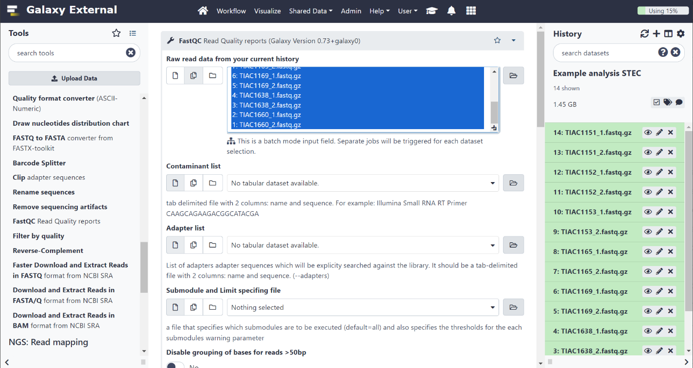
FastQC interface in Galaxy. In this example, the tool is run in batch mode on the 14 input files, triggering a separate job for each input dataset.

Figure S1b: Trimmomatic interface in Galaxy

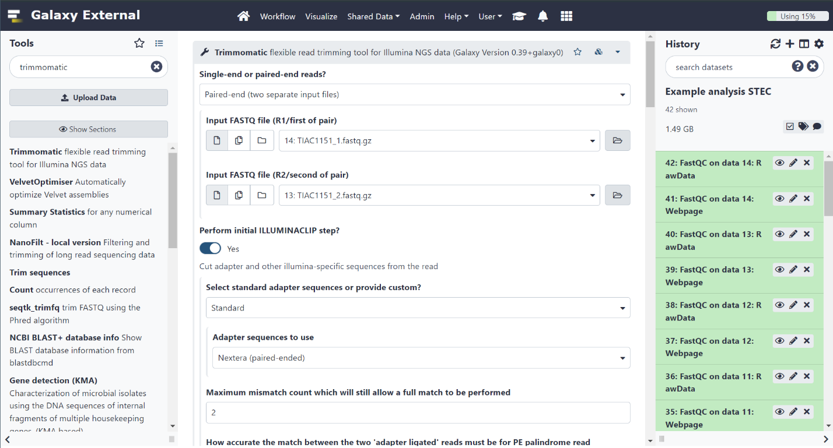
Trimmomatic interface to perform read trimming in Galaxy. This tool also supports batch input mode so the trimming jobs for all dataset can be launched simultaneously.

Figure S1c: MultiQC report of the FastQC output

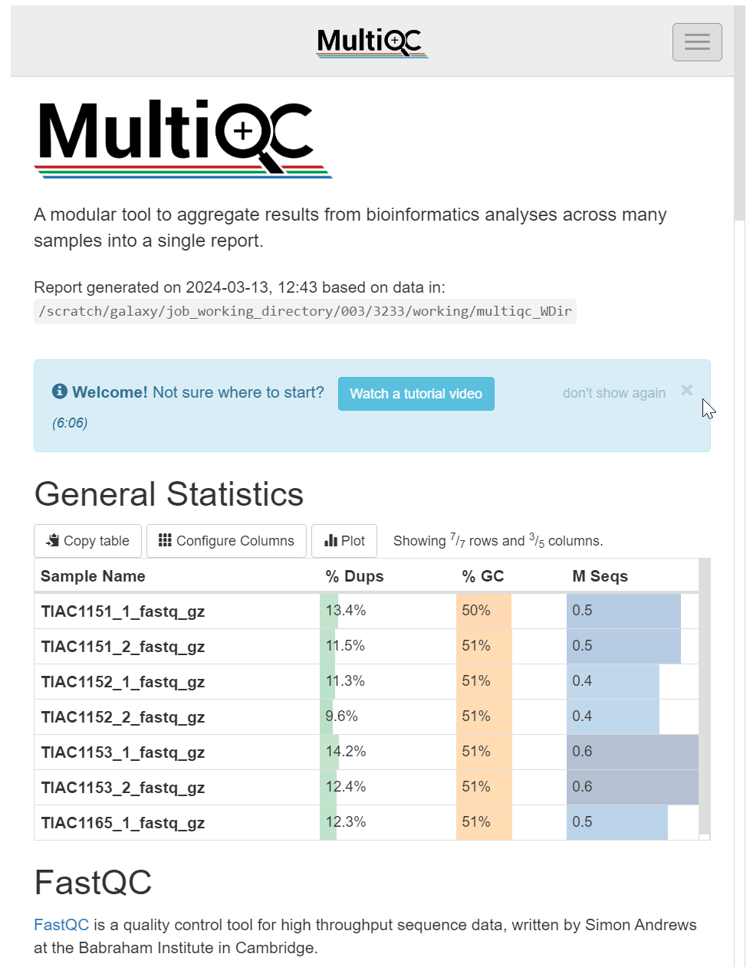
This image shows a part of the MultiQC output for the STEC example analysis. The tool combines the FastQC results for the 14 FASTQ datasets (i.e., forward and reverse reads for seven isolates) into a single report. The report includes summary tables with the metrics calculated by FastQC and graphs containing the data for all the datasets. This makes it easy to spot outliers without having to check each individual report.

Figure S1d: Interactive Krona visualization of the Kraken 2 taxonomic classification

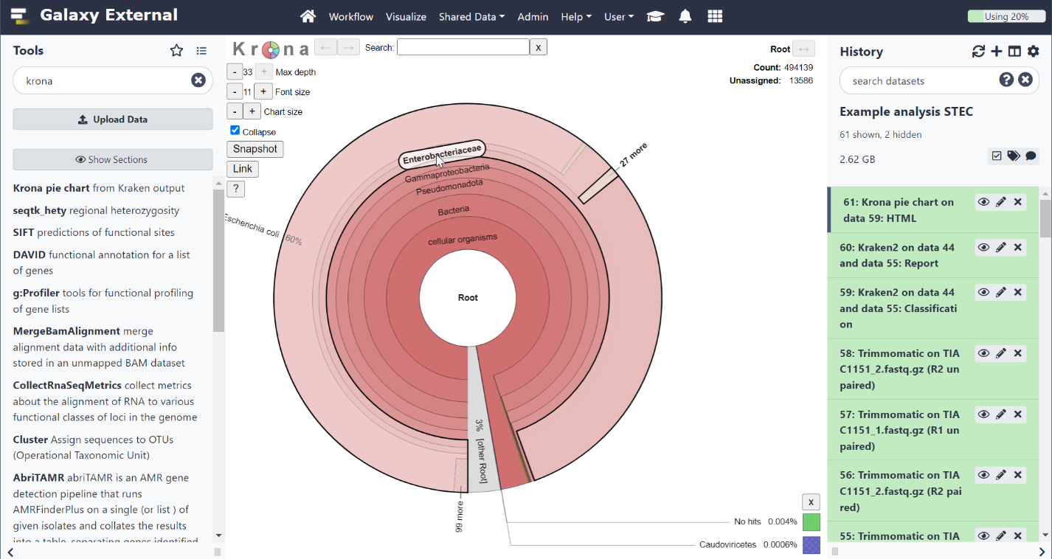
Interactive visualization of the Kraken 2 taxonomic classification on the E. coli strain TIAC1151 reads using Krona [16]. Each sector in the pie chart represents a taxonomic group that was detected in a hierarchical structure and can be clicked to zoom in on the corresponding descendant taxonomic groups.

Figure S1e: ConFindr interface in Galaxy

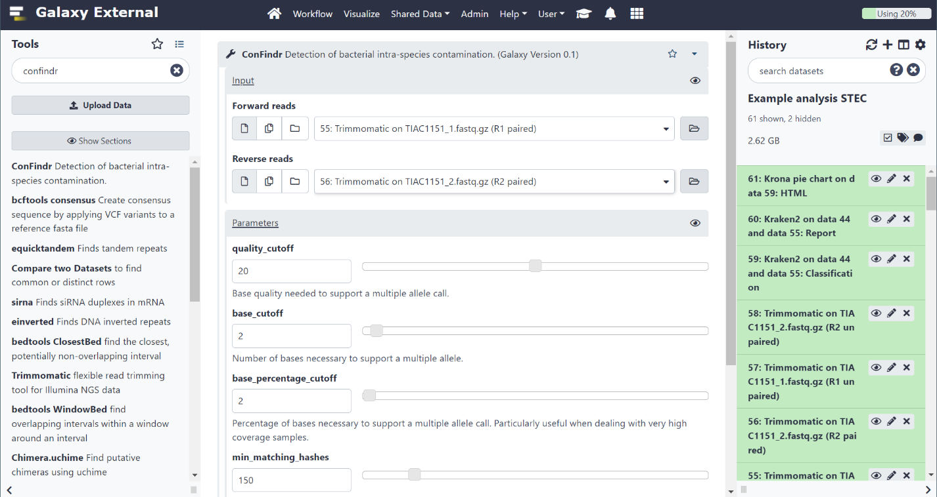
Interface for the in-house wrapper for the ConFindr tool [17]. The tool supports batch mode input so multiple jobs can be launched simultaneously.

Figure S1f: ConFindr output report

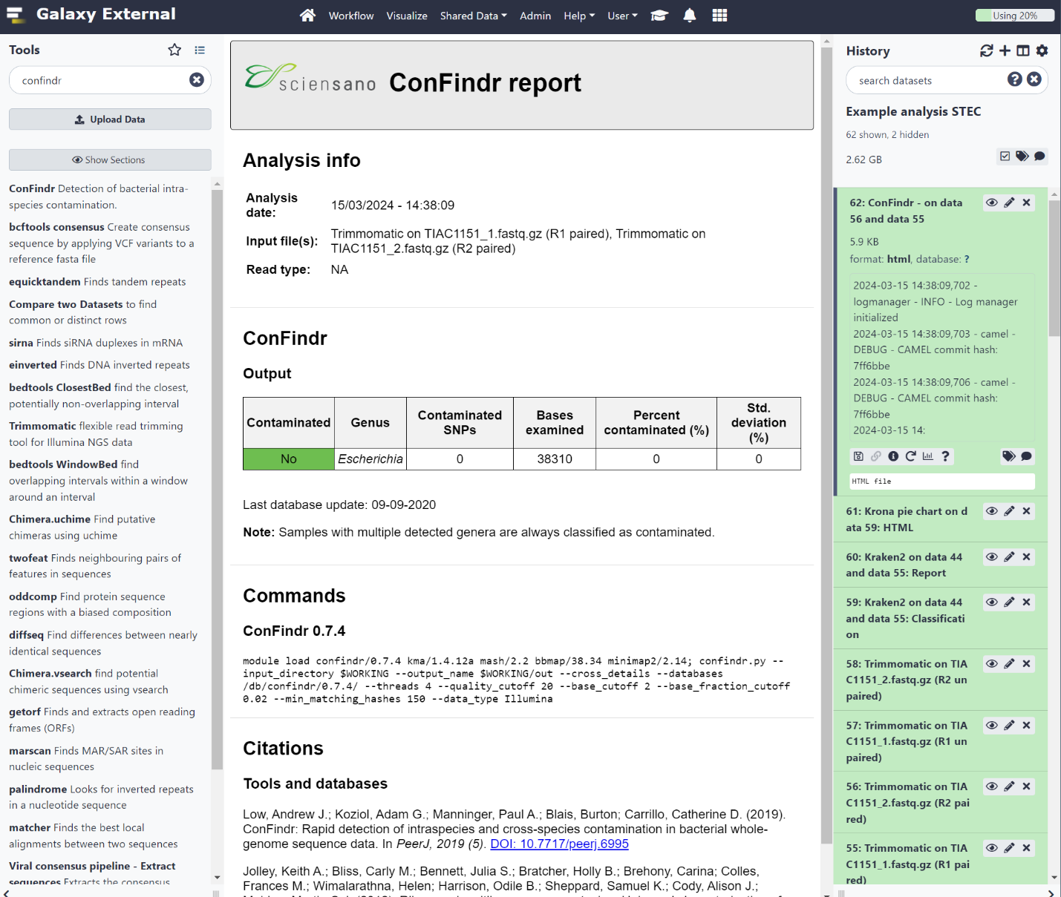
The output of the in-house developed wrapper for the ConFindr tool in Galaxy on the E. coli TIAC1151 dataset. In this example, no contaminated SNP positions were detected, suggesting that there is no inter-species contamination in this dataset.

Figure S1g: ‘QC and pre-processing for microbial Illumina data’ workflow
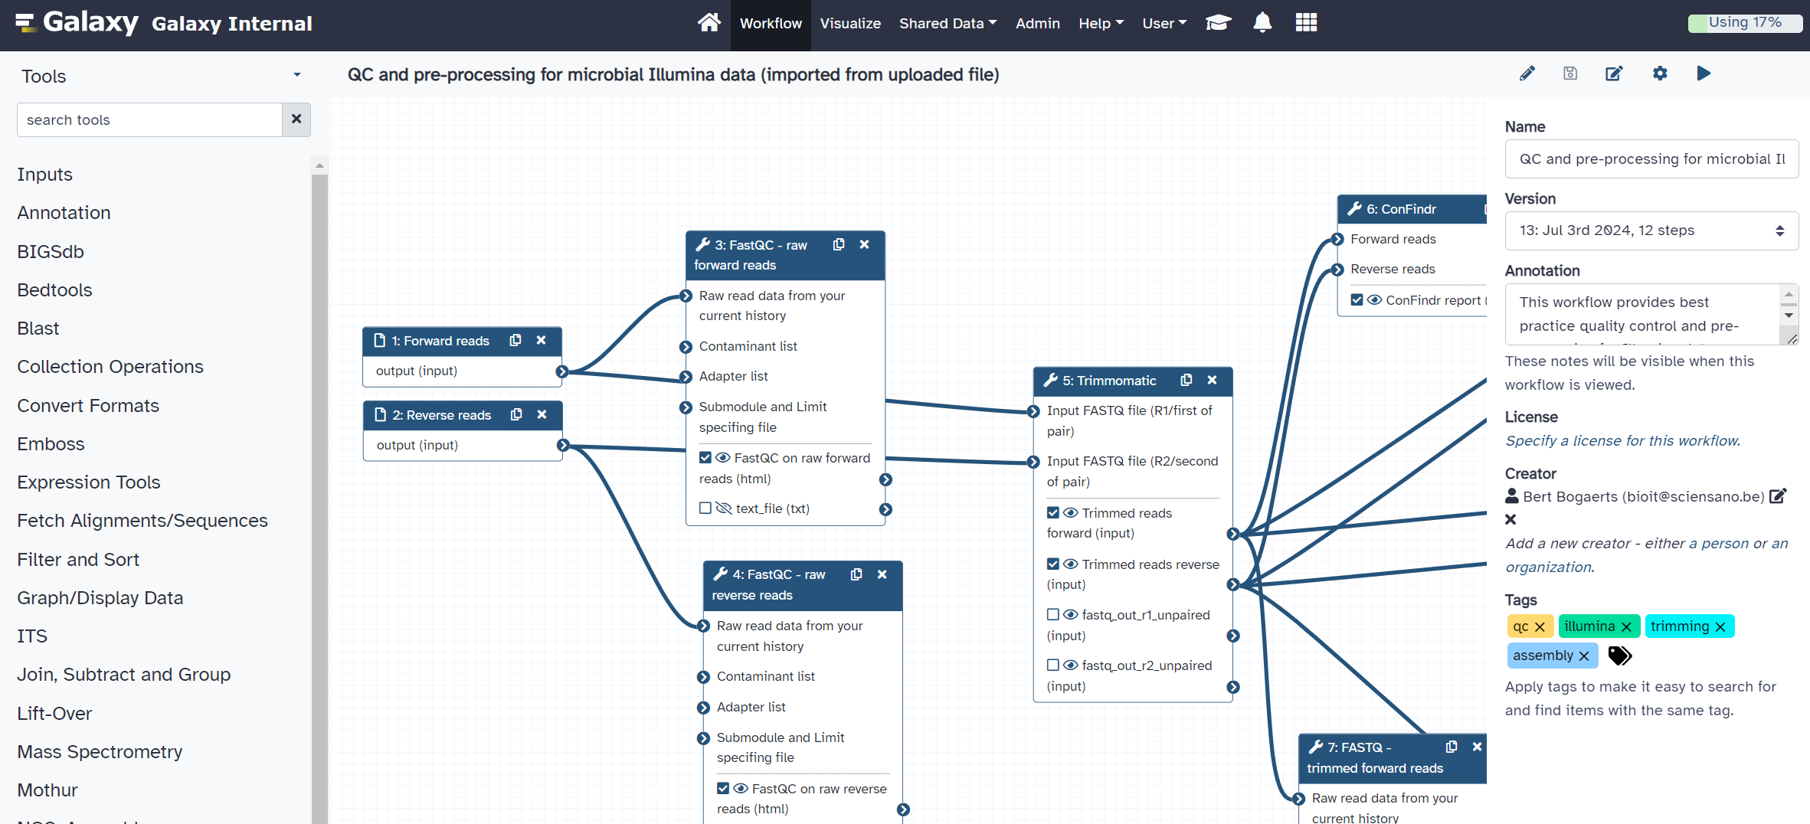
Part of the ‘QC and pre-processing for microbial Illumina data’ workflow. The workflow is available to all users under ‘Workflows’ in the ‘Shared Data’ menu.

Figure S1h: Combined QUAST output report

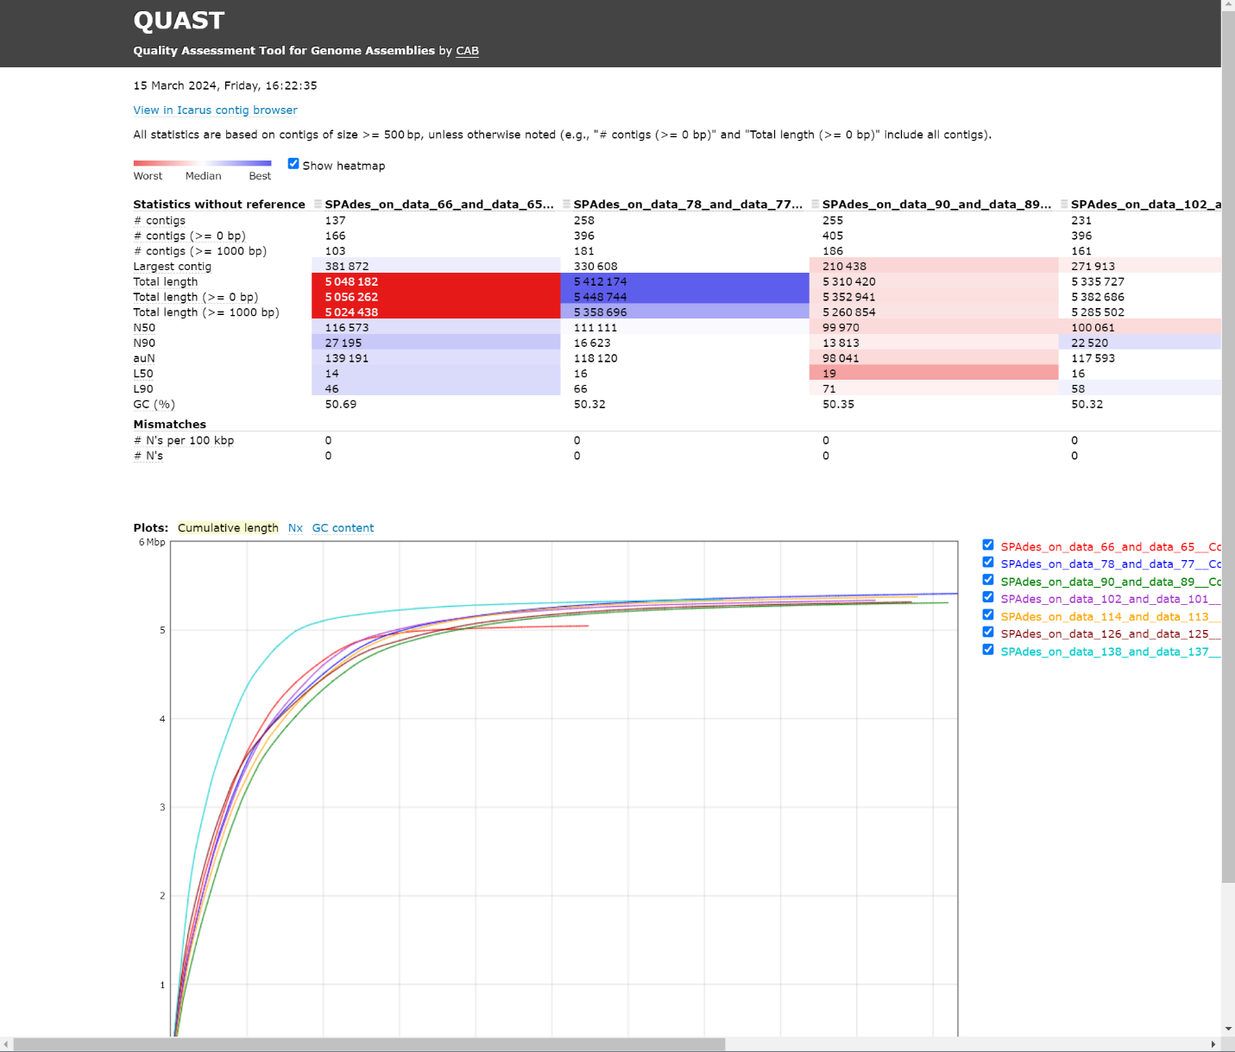
The combined QUAST output report for the assembled contigs of the seven E. coli datasets. The top table shows the assembly metrics for each dataset. The cumulative length plot below shows the number of contigs on the x-axis and the cumulative contig length on the y-axis. The report is interactive, with alternative plots that can be activated and datasets that can be hidden from the plots and/or tables.

Figure S1i: CheckM output report

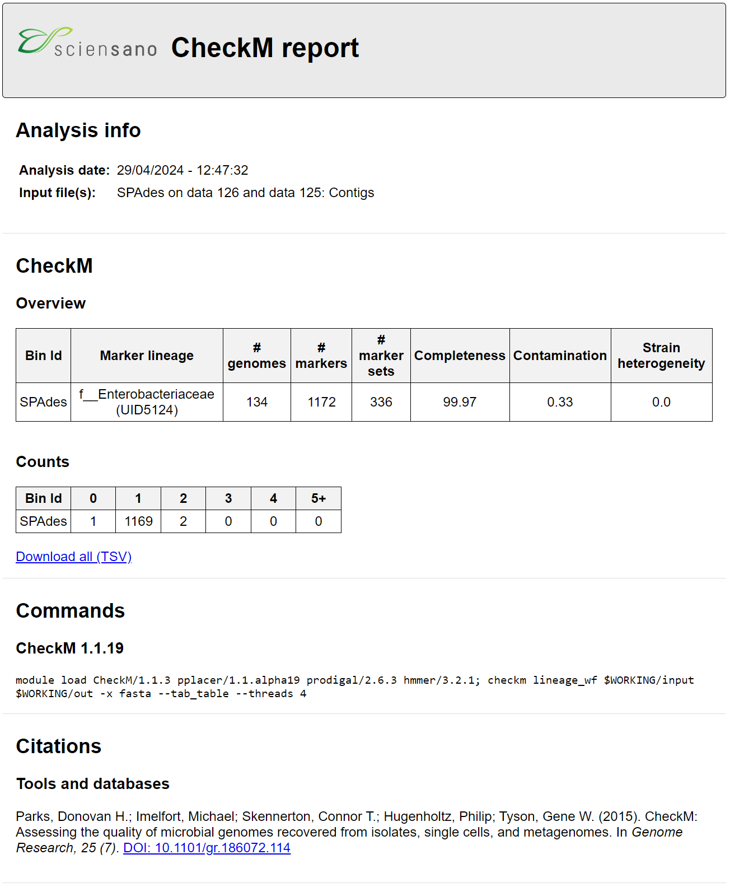
Output report of the ‘CheckM - Lineage workflow’ tool. The top section contains metadata information about the analysis. The CheckM section contains the results of the analysis, with an overview table and a count of the different bins, where each bin corresponds to a ‘core’ gene. In this case, there is little evidence of contamination, with only two genes having multiple copies. In addition, the genome is complete, with only one of the core genes missing. We can therefore assume that this is a highly complete and uncontaminated genome assembly.

Figure S1j: NCBI AMRFinder+ interface in galaxy

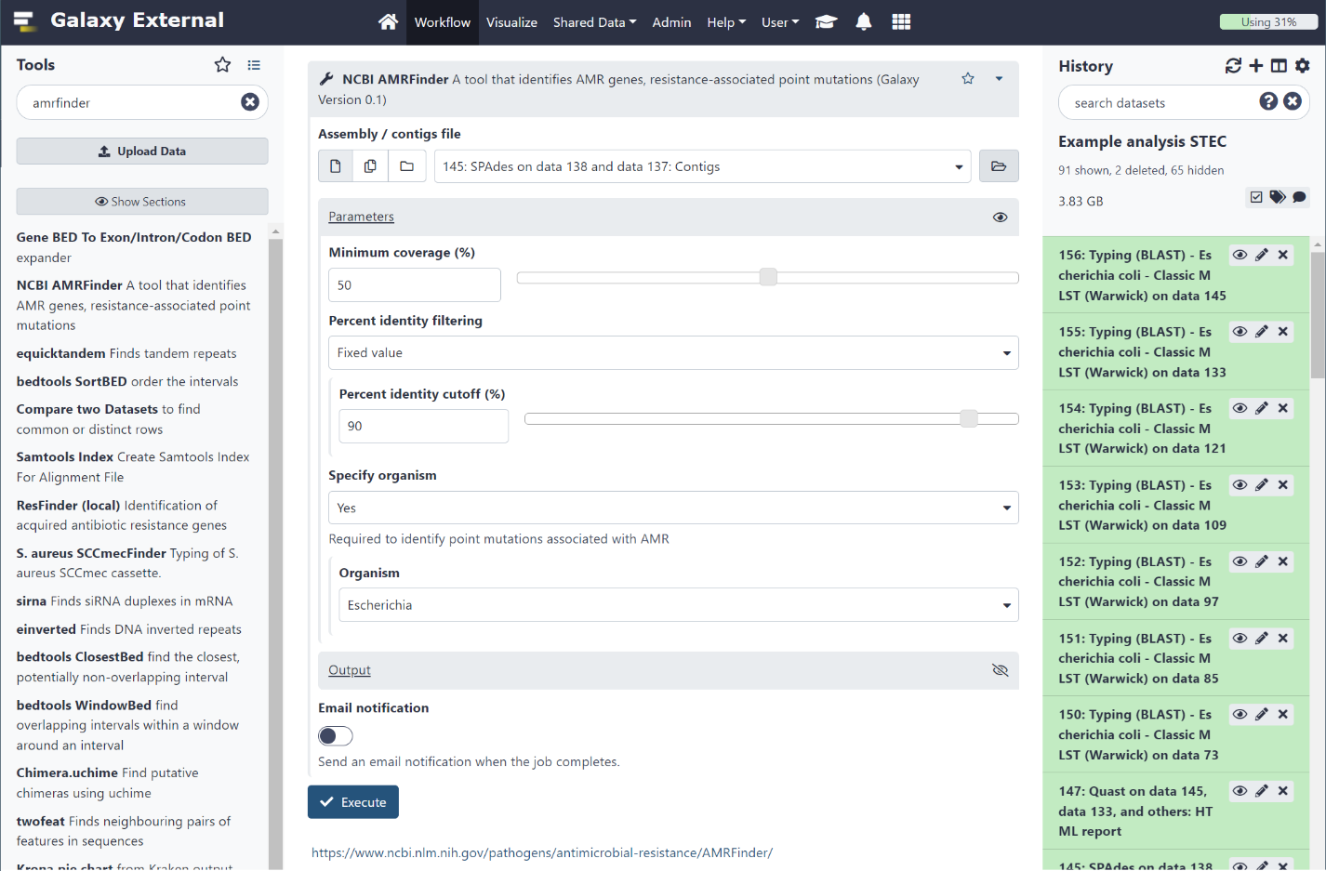
The interface of the in-house developed wrapper for the NCBI AMRFinder+ [2] tool in Galaxy. The tool supports batch mode input so multiple jobs can be launched simultaneously.

Figure S1k: ‘Gene detection – BLAST’ tool output report

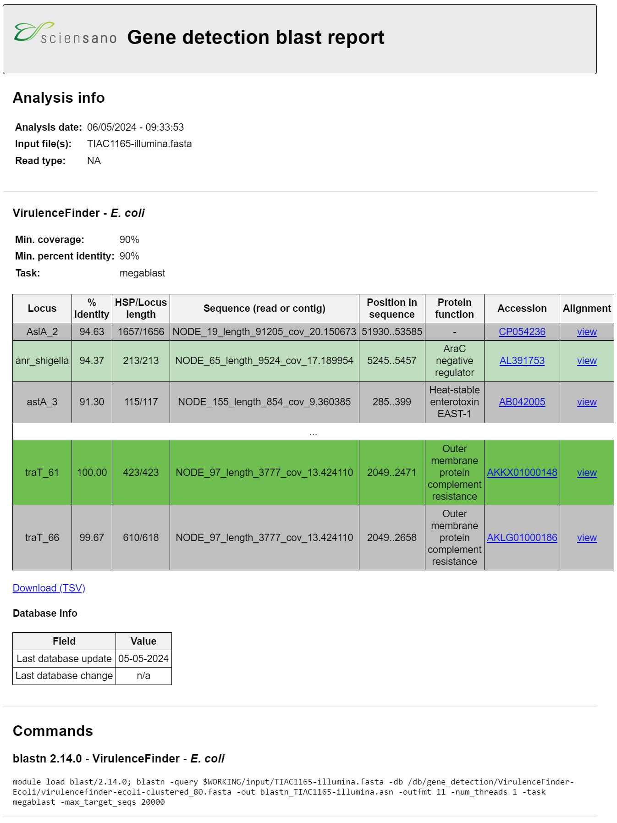
Output of the ‘Gene detection – BLAST’ tool with the VirulenceFinder E. coli database [18]. The top section shows the analysis information. The table shows the detected hits, color coded as follows: dark green (perfect hits, 100% identity over the full length), light green (full length hits with more than 90% and less than 100% sequence identity), and grey (partial hits with more than 90% identity). Note that some lines were omitted from the output to limit the size of the image, as indicated by the white row with the ‘…’. The date of the last database update is listed below the table.

Figure S1l: Output report for the ‘Sequence typing – BLAST’ tool

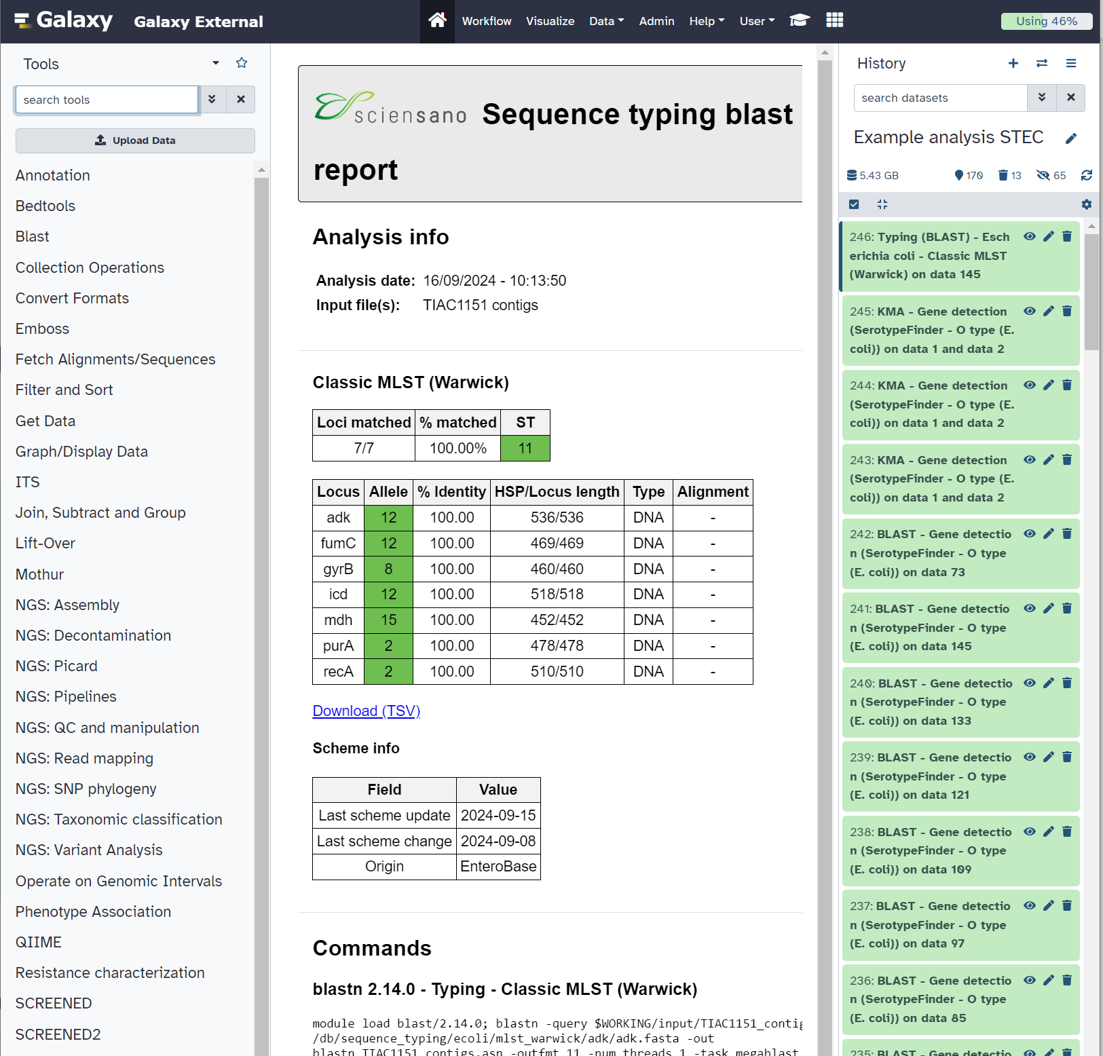
Output report of the in-house sequence typing tool for the TIAC1151 E. coli isolate using the Warwick seven-gene MLST scheme [19]. The top table shows the detected sequence type (ST) and information about the loci that matched. The lower table shows the detected alleles, together with statistics on the detected hits. The allele column is color coded as follows: dark green (perfect hits, 100% identity over the full length), light green (full length hits with more than 90% and less than 100% sequence identity), grey (partial hits with more than 90% identity), yellow (loci where multiple alleles have identical alignment scores), and red (missing alleles). The last column contains a link to a visualization of the alignment of the detected allele against the contigs, which can be used to investigate potential mismatches. The tool supports the detection of novel alleles, which can be downloaded in FASTA format for submission to the corresponding database. The dates of the last database update and the last database modification ware listed below the table. The command that was used to align the contigs to the allele sequences is provided at the bottom of the report.

Figure S1m: The ‘MLST phylogeny’ tool output report

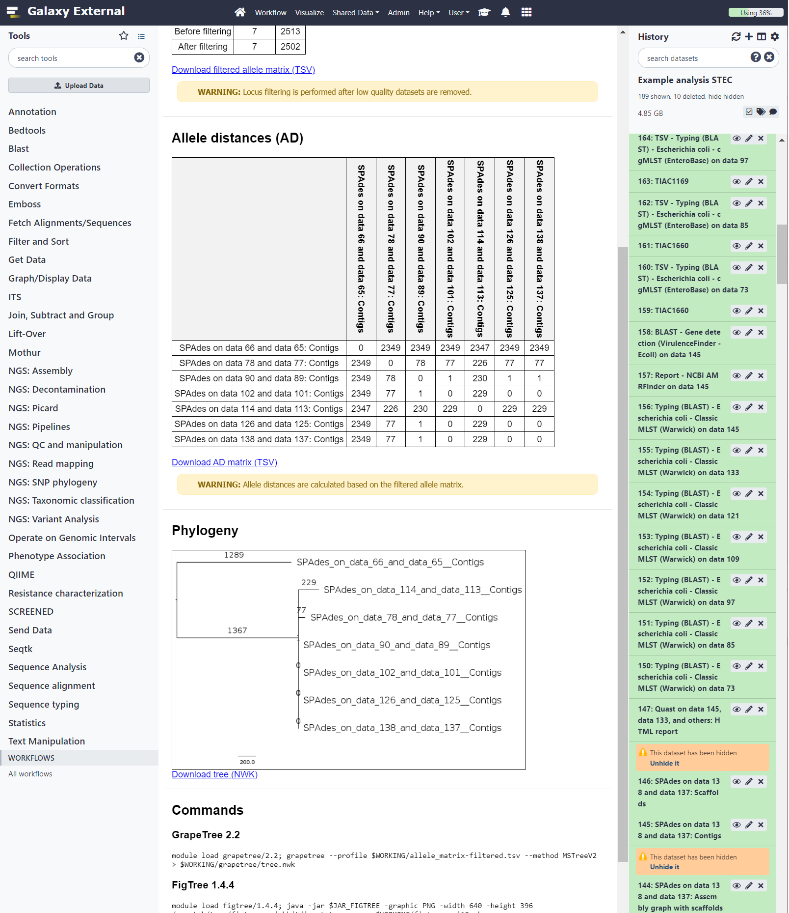
Output report for the ‘MLST phylogeny’ tool. The top two sections contain the basic analysis information and the allele matrix filtering section, which were not shown for this example. The allele distances (AD) section shows the pairwise allele distances between the tested strains expressed as the number of cgMLST alleles. The phylogeny section shows a visualization of the phylogeny. The ‘commands’ and ‘citations’ (not shown) sections refer to the commands that were used and the citations for the corresponding tools, respectively.

Figure S1n: Galaxy visualization of MLST phylogeny output

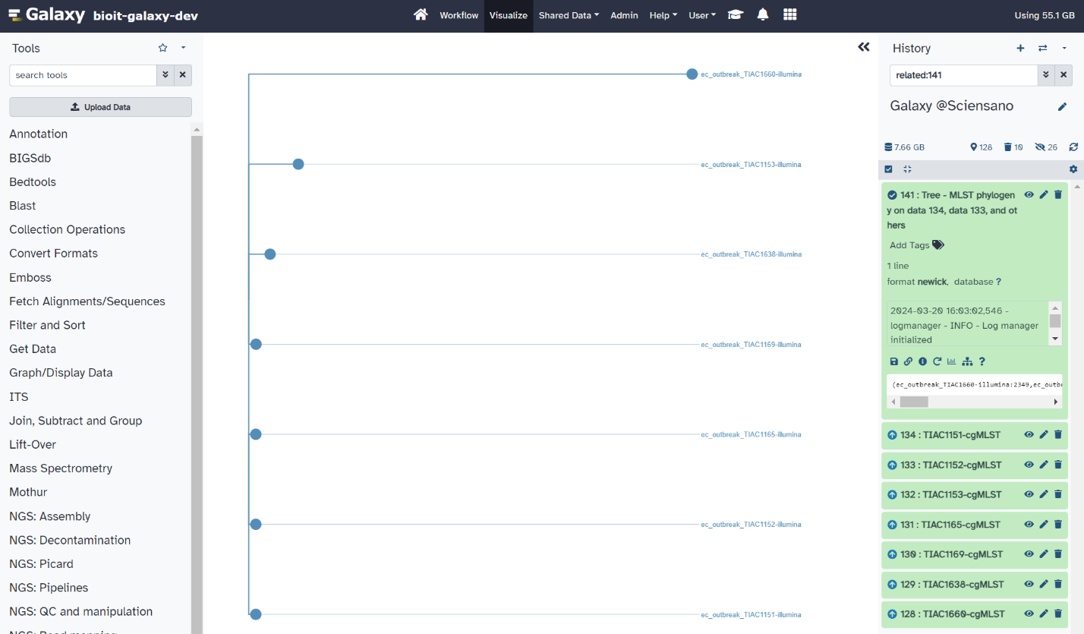
Visualization of the phylogeny using Galaxy's built-in tree visualization functionality. Note that the tool's output report also includes a rendered image of the phylogeny with branch lengths.

Figure S1o: Read mapping using the ‘PACU mapping’ tool

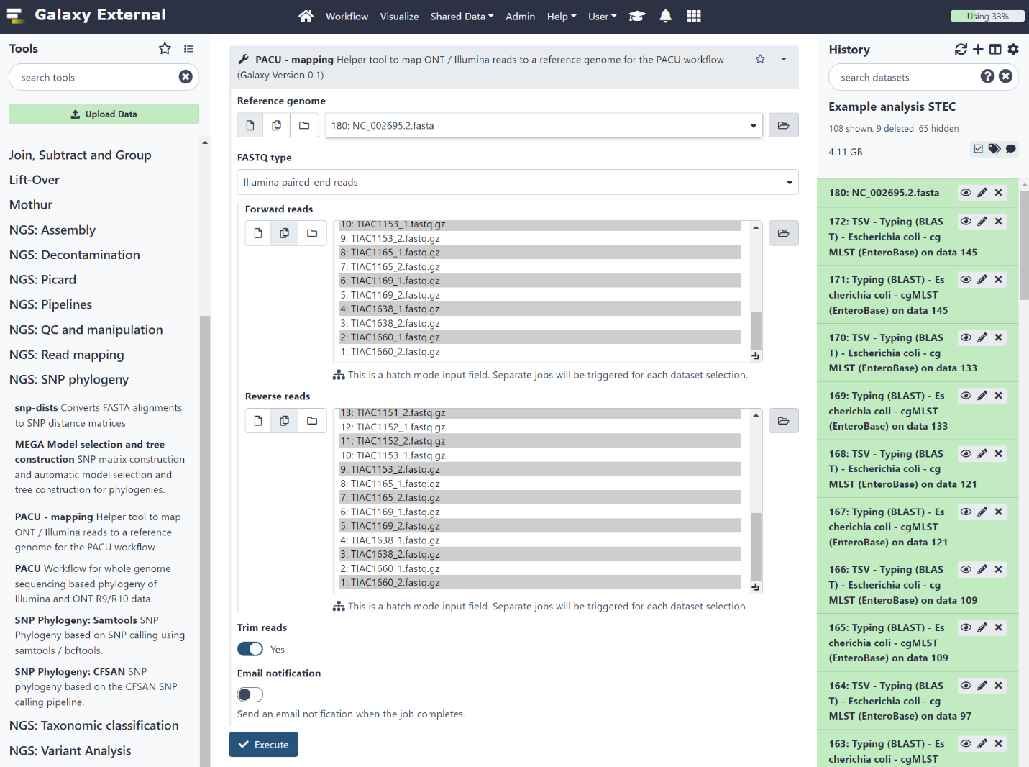

The interface for the ‘PACU mapping’ tool, which can be used to map Illumina or ONT reads to a reference genome. In this example, the tool is run on the raw data with read trimming enabled. Alternatively, the tool can be run on trimmed reads with trimming disabled. The tool supports batch mode input, triggering a separate job for each input dataset (taking into account the correct pairing of the input datasets). The tool outputs a BAM file with the mapped reads for each of the input datasets.

Figure S1p: PACU SNP phylogeny output report

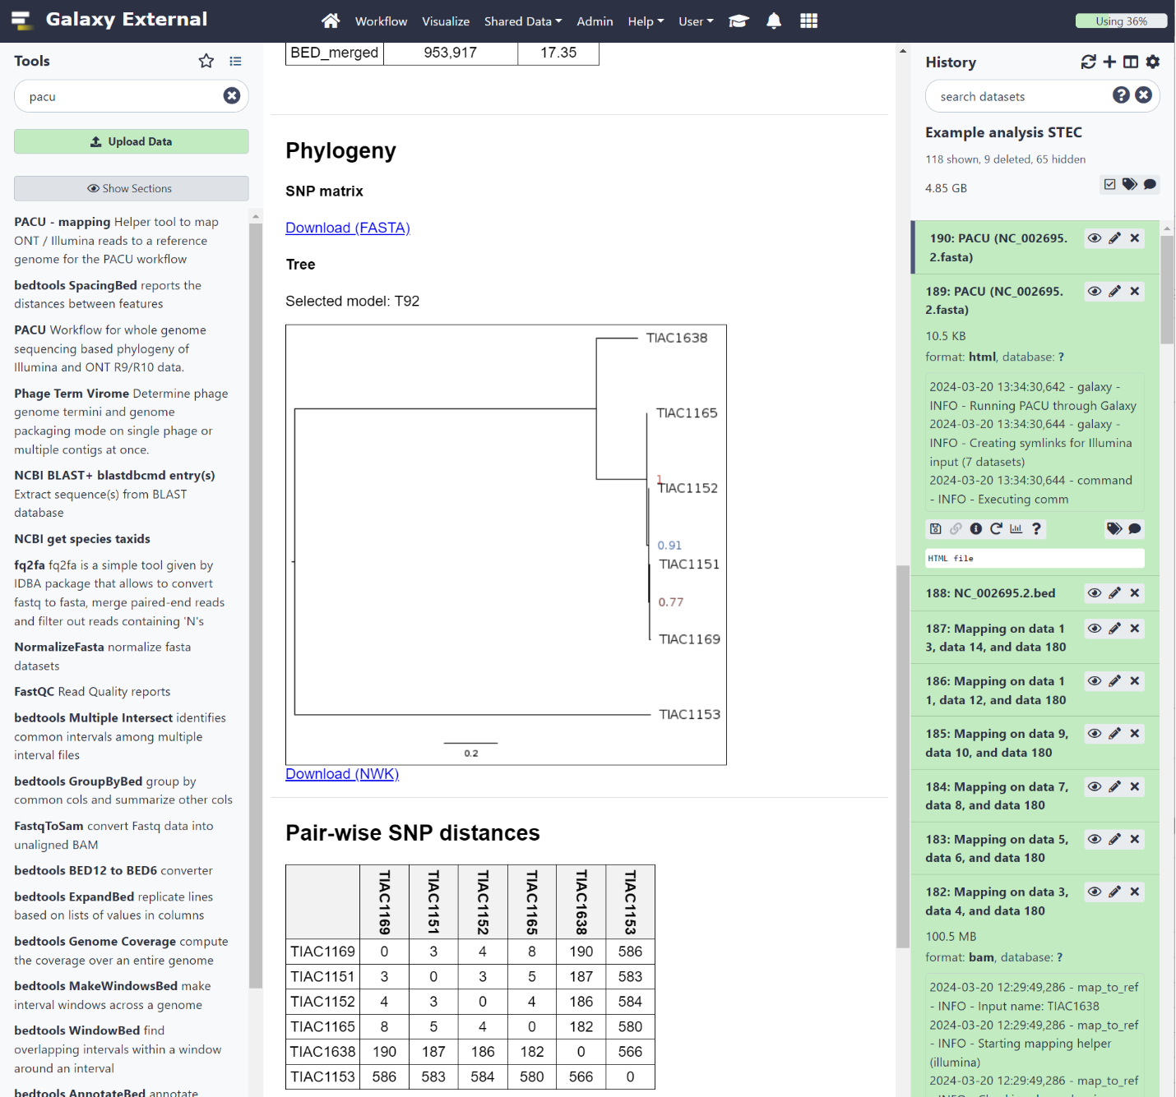

Output report for the PACU SNP phylogeny workflow [20]. The report contains the following sections: analysis info, parameters, read mapping statistics, variant calling & filtering statistics, region filtering, phylogeny, pairwise SNP distances, and citations. The SNP matrix and the phylogeny in Newick format can be downloaded from the report for further processing. Note that the TIAC1660 dataset was excluded from the analysis as it was too distant from the reference genome and the other datasets.

Figure S1q: STEC pipeline interface in Galaxy
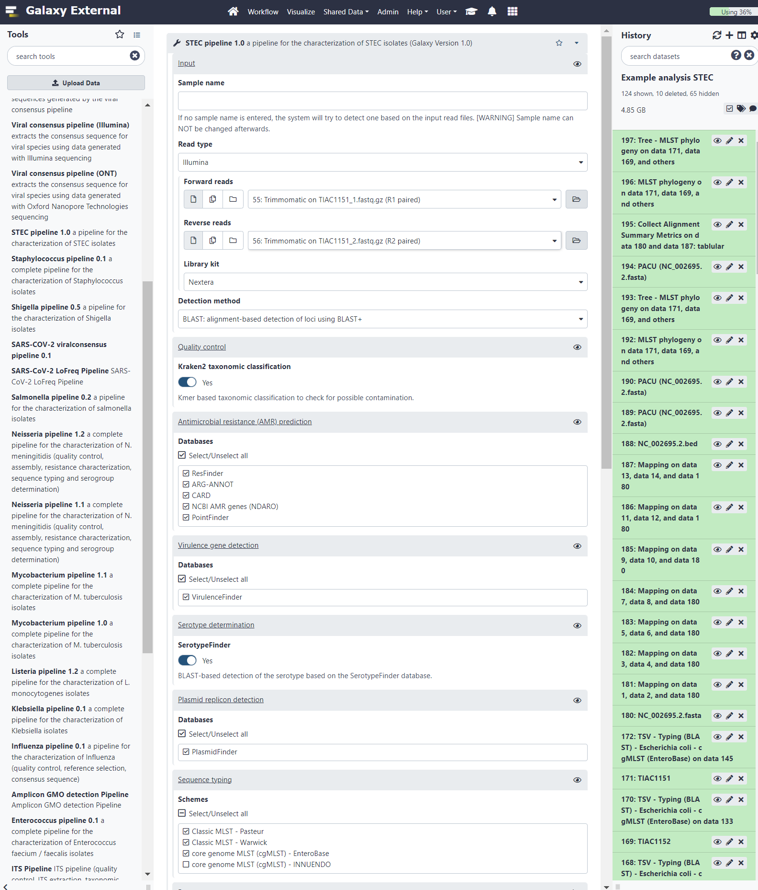
Interface of the STEC pipeline in Galaxy. The top section contains the input files and basic parameters. The remaining sections contain the assays, which can be activated or deactivated.

Figure S1r: STEC pipeline output report
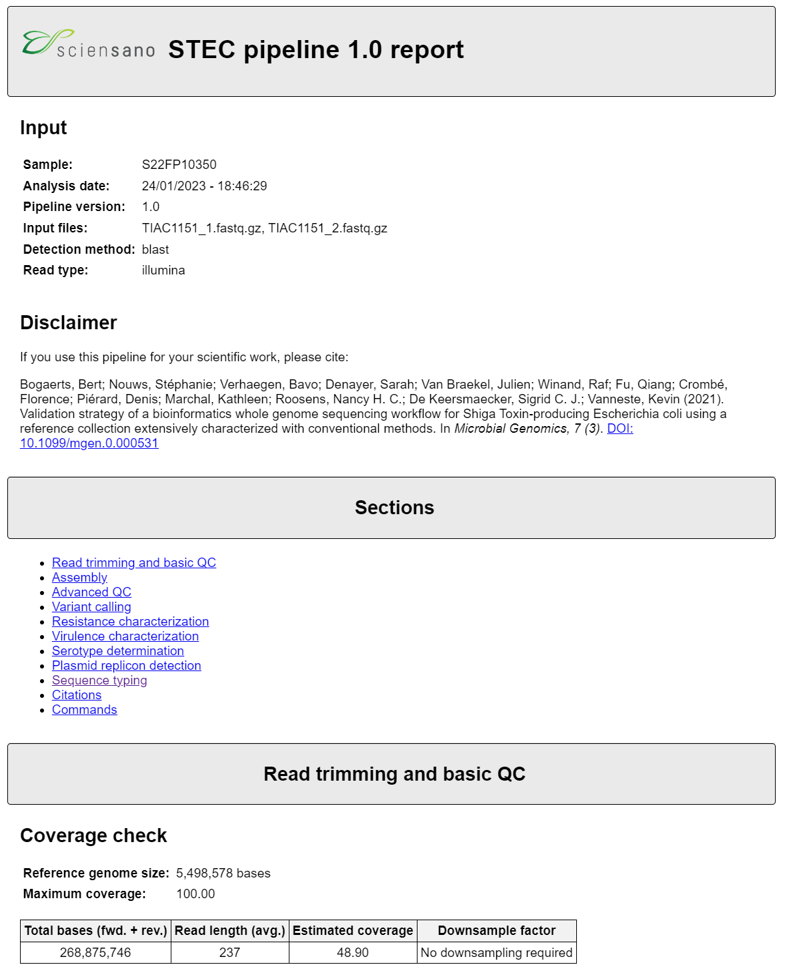
The top part of a STEC pipeline output report. The top section contains basic information about the analysis itself. The following section contains hyperlinks to navigate to the corresponding sections of the output report.

Figure S1s: Output of the ‘Pipeline combine’ tool
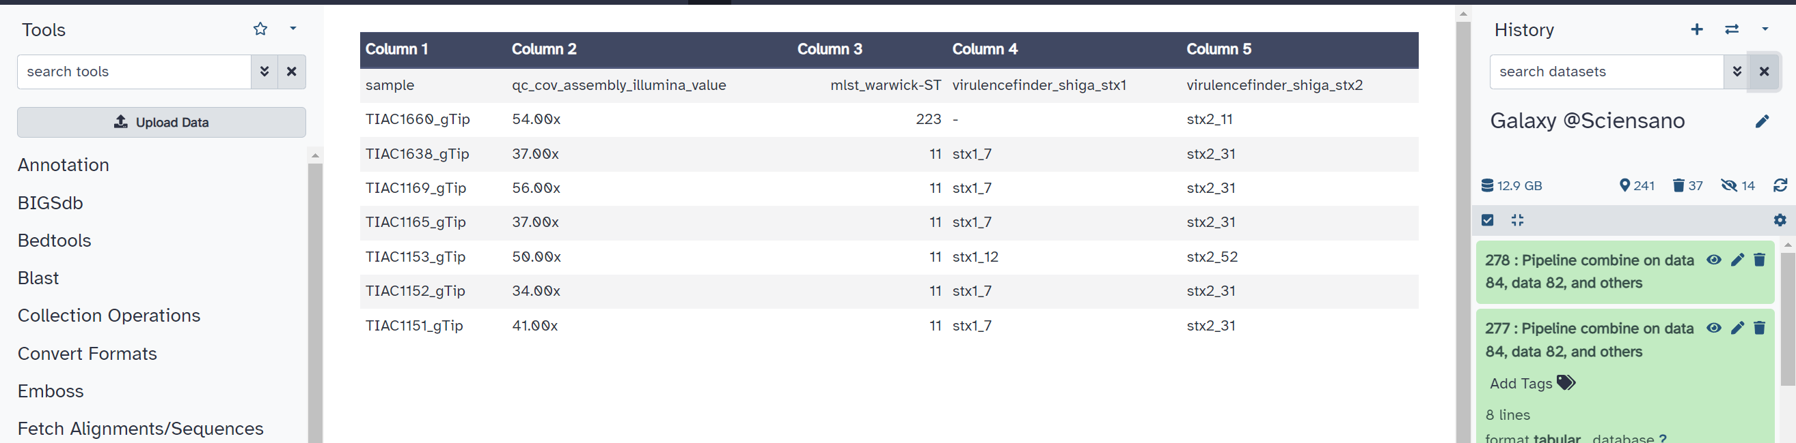
Output of the ‘Pipeline combine’ tool on the summary output files of the STEC pipeline. In this example, the ‘keys to include’ parameter has been set to ‘sample,mlst_warwick-ST,qc_cov_assembly_illumina_value,hits_virulencefinder_shiga’ with gene formatting enabled and set to ‘Group by gene name’. The columns in the tabular output file correspond to the keys in the pipeline summary output, which are combined across the seven input datasets of the STEC example, represented by the rows in the table. Note that this example uses only a few keys from the summary files, any key that appears in the output file can be used with this tool. The tool can combine any number of TSV files generated by the push-button pipelines, whether or not they have been run in batch mode. Errors are raised if the requested keys are not found, and warnings are issued if the pipeline name is not available in an input TSV file, or if results are combined across different pipelines.

Figure S2: Screenshots for example analysis – MRSA from hospitals in Benin

Figure S2a: Schematic overview of the complete analysis

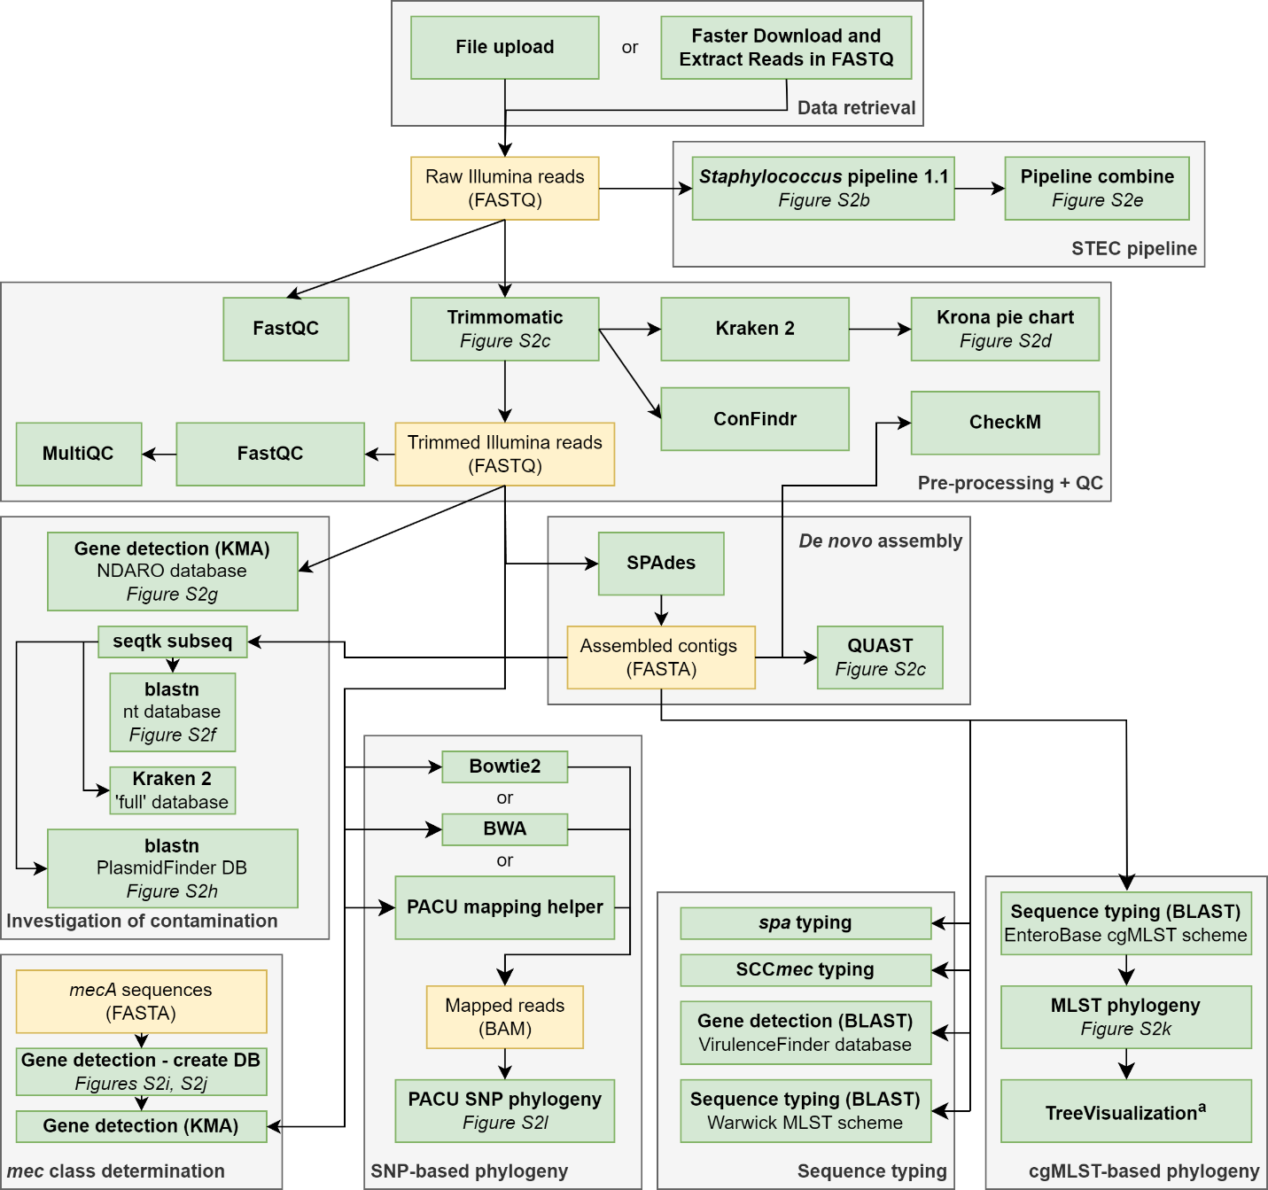
Overview of the steps involved in the Staphylococcus analysis (Section 3.2.2). Green boxes correspond to tools in Galaxy. Yellow boxes represent datasets with the file format indicated between brackets. Note that, for visual clarity, only output files that are used for further processing are shown. Arrows indicate the data flow. Analyses are grouped by category as indicated by the text at the bottom of the grey boxes.
Notes: (a) the ‘Tree Visualization’ tool is not available in the tool panel, but is built-in as a visualization option within Galaxy.

Figure S2b: Staphylococcus pipeline interface in Galaxy

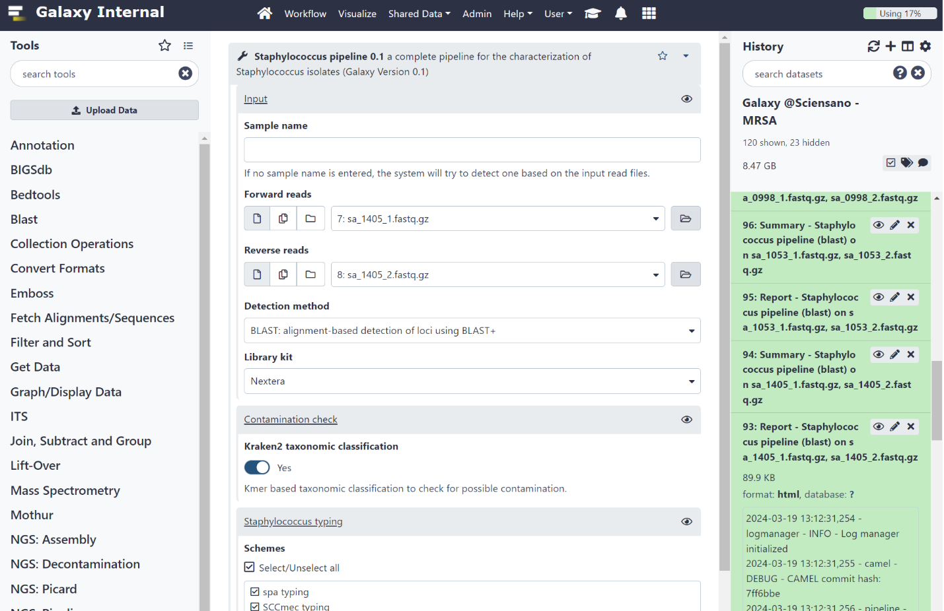
The Staphylococcus pipeline interface in Galaxy. The input section contains a field for the sample name (optional), inputs for the forward and reverse reads, and the detection method parameter (BLAST+, KMA, or SRST2). Assays can be enabled or disabled in the remaining sections of the wrapper. The antimicrobial resistance (AMR) prediction, virulence gene detection, plasmid characterization, and sequence typing sections are not shown.

Figure S2c: Combined QUAST output report

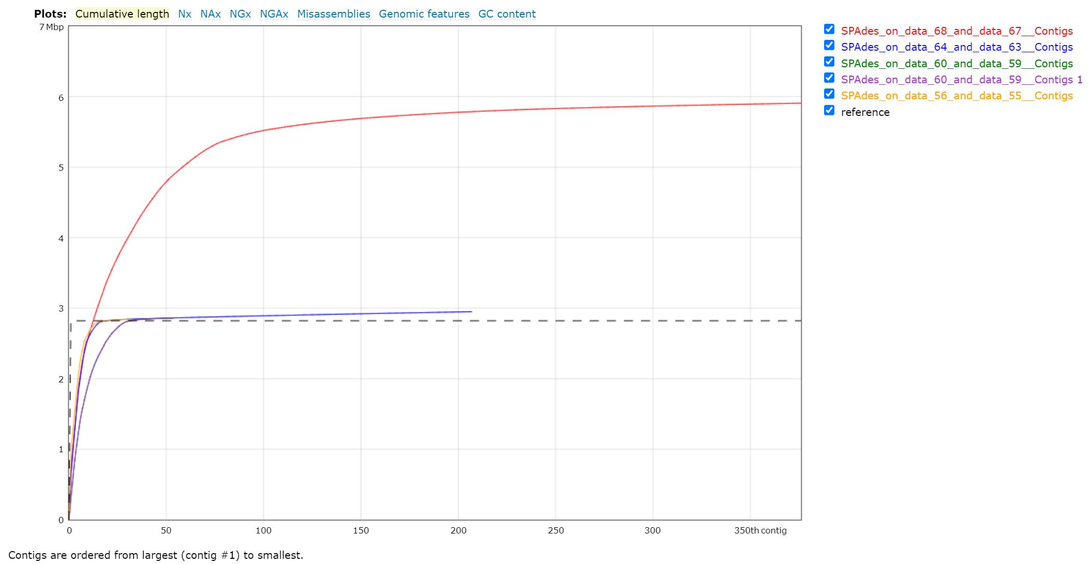
The combined QUAST output for the assembled contigs from the S. aureus dataset and the NC_007795.1 reference genome. The total assembly length of the reference genome is indicated by the dashed black line. The red line corresponds to the sa_0998 dataset, which has a total assembly length twice that of the other datasets.

Figure S2d: Krona visualization of the Kraken 2 taxonomic classification of the sa_0998 reads

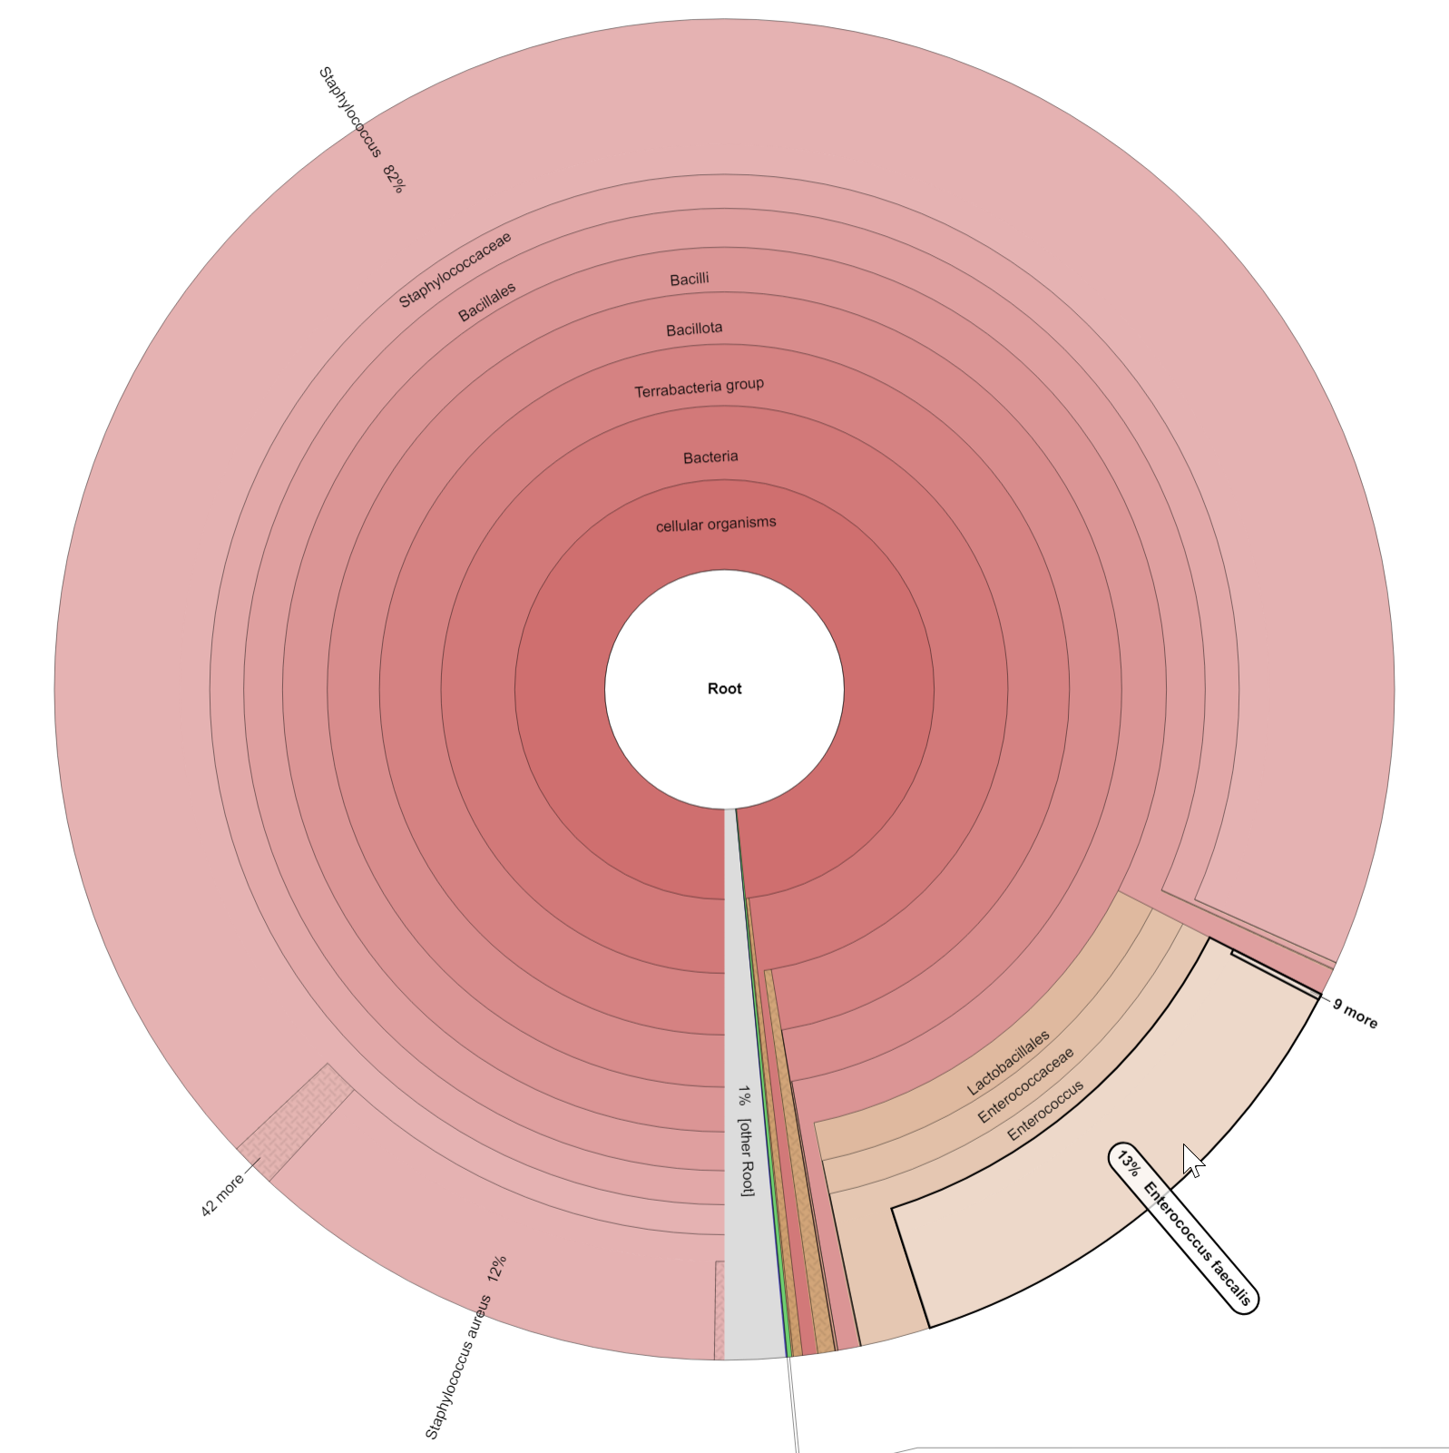
Visualization of the Krona results for the sa_0998 dataset. The Enterococcus faecalis contamination (~13% of the reads) is highlighted by the cursor.

Figure S2e: The ‘Pipeline combine’ tool interface in Galaxy

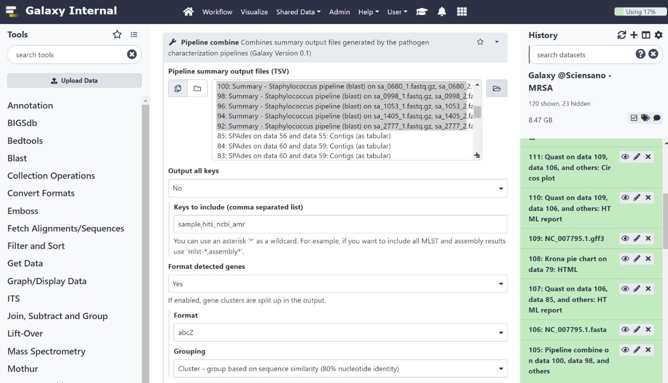
Output of the ‘Pipeline combine’ tool in Galaxy. The tool takes as input the tabular summary output files generated by the pathogen characterization pipelines, in this case the Staphylococcus pipeline. The keys to include parameter was set to ‘sample,hits_ncbi_amr’ to extract only those columns. The ‘format detected genes’ option was enabled to split the output into a separate column for each gene, as opposed to the default option of a comma-separated list of all detected genes per sample.

Figure S2f: Output of the blastn alignment of the extracted contigs to the ‘nt’ database

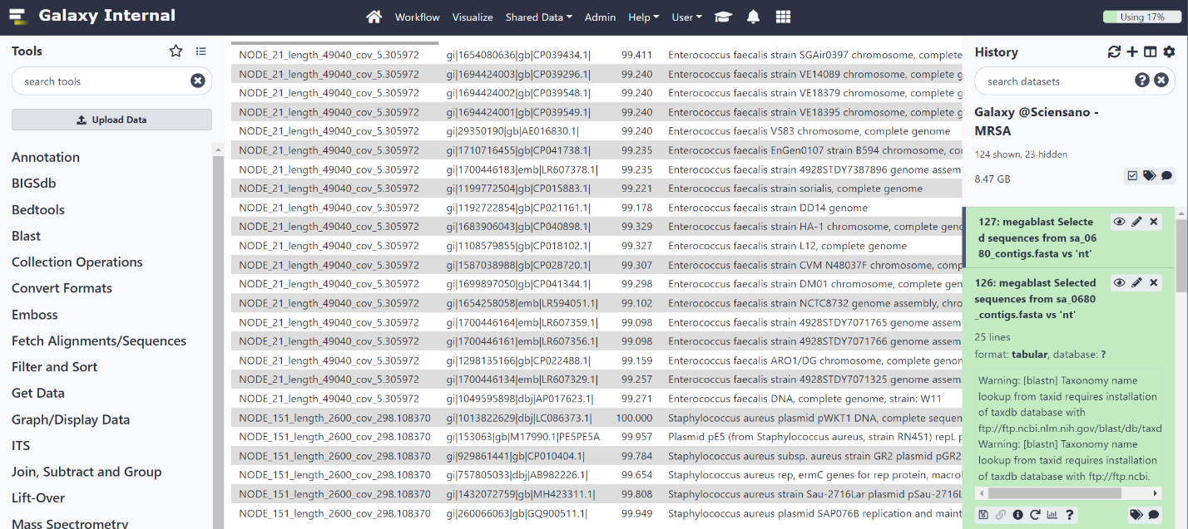

Tabular output of the blastn alignment of the contigs carrying the erm(C) and lsa(A) genes from the sa_0998 assemblies. The ‘stitle’ column was included in the output format parameter to have a human readable interpretation.

Figure S2g: ‘Gene detection (KMA)’ output report

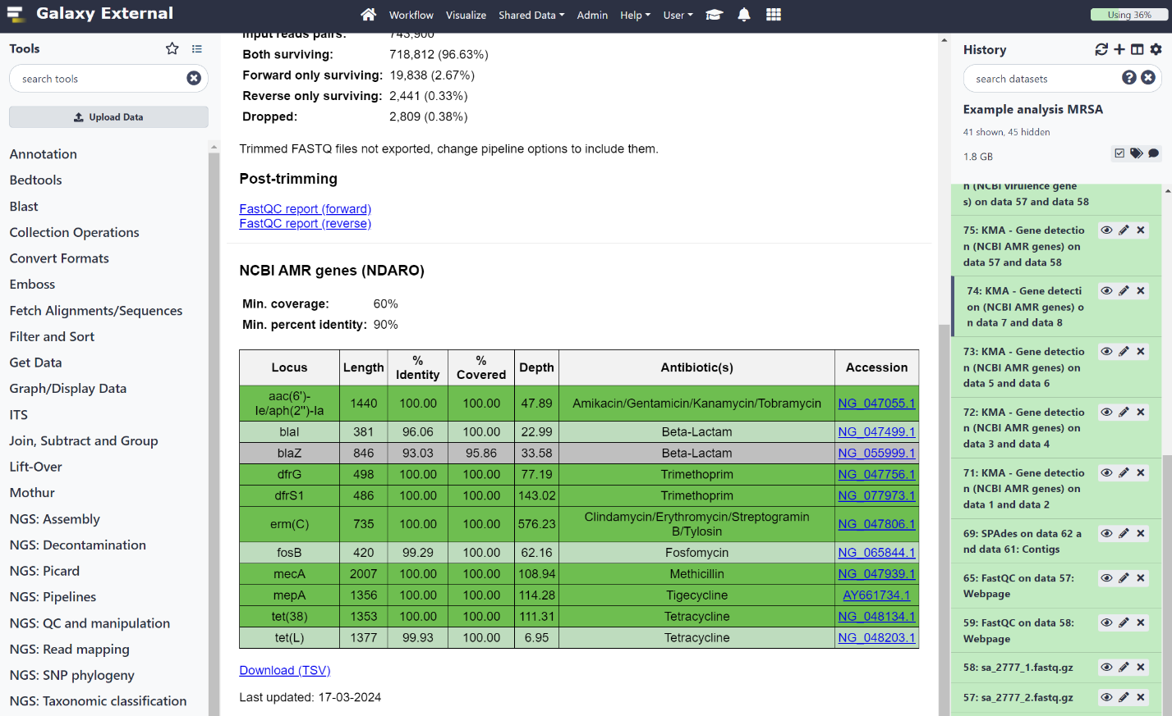

Output report of the ‘Gene detection (KMA)’ tool. The genes are color coded according to the hit status. The very high depth of coverage for the erm(C) locus stands out. The Isa(A) gene, identified by the pipeline through BLAST-based screening, was not detected by KMA. This discrepancy is due to a difference in percentage identity: KMA calculates it based on the total gene length rather than the total alignment length, resulting in an identity of approximately 84%, below the 90% threshold.

Figure S2h: Alignment of the contig carrying the erm(C) gene to the PlasmidFinder Gram-positive database

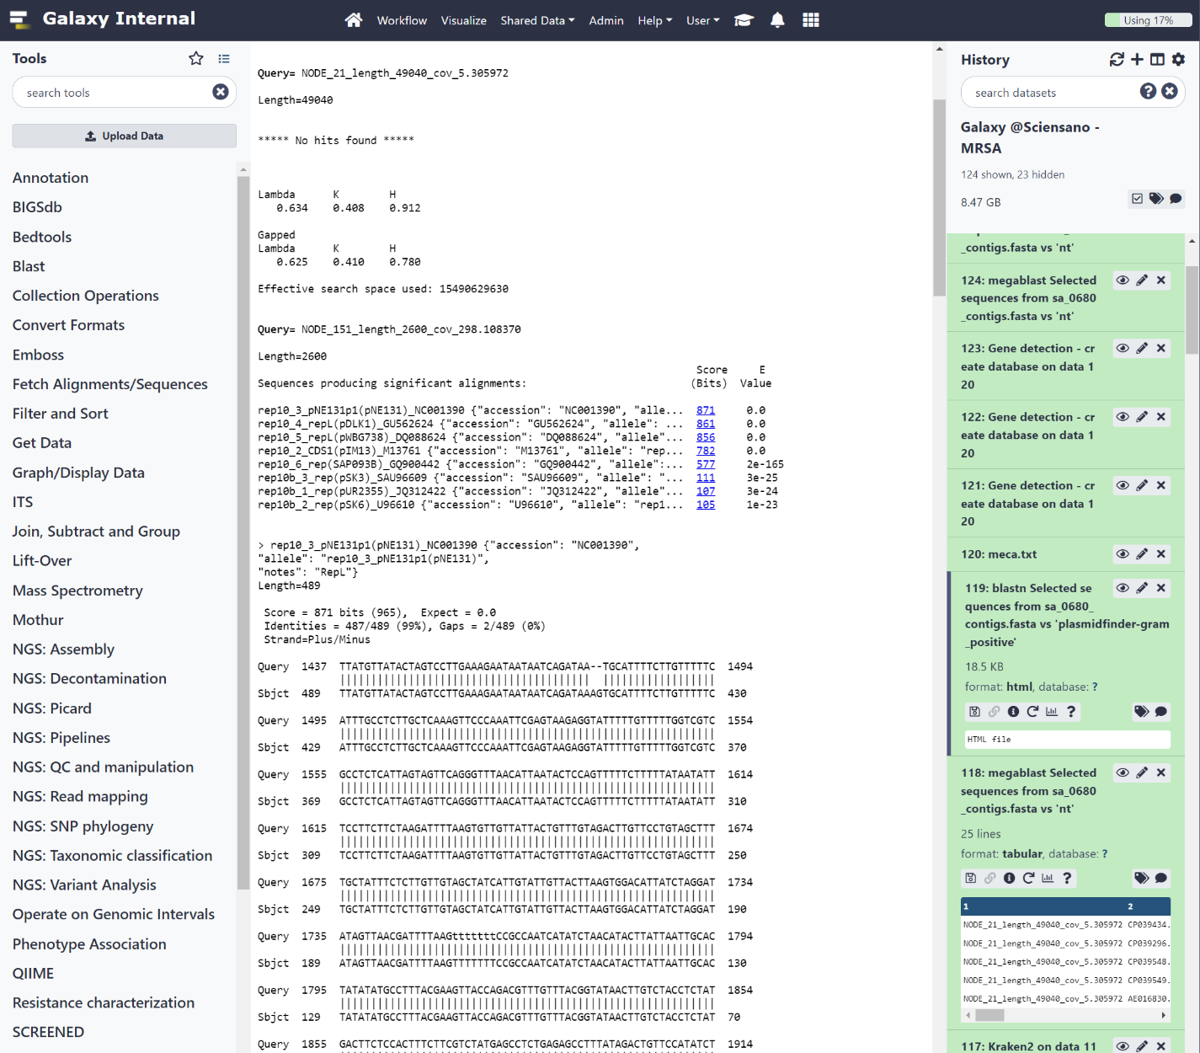

Blastn alignment of the contig carrying the erm(C) gene to the PlasmidFinder Gram-positive database [7]. The output shows a near perfect alignment to the rep10_3 (pNE131) replicon, indicating the plasmid origin of the contig.

Figure S2i: Interface of the ‘Gene detection - create database’ tool in Galaxy

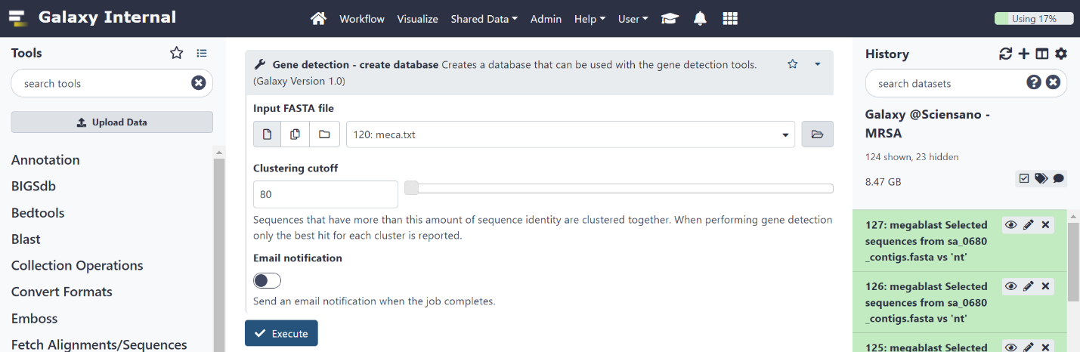

Interface for the ‘Gene detection – create database’ tool. The tool can create custom databases for the gene detection tool using sequences in FASTA format. The clustering cutoff can be adapted to control the strictness of the clustering.

Figure S2j: Output of the ‘Gene detection – create database’ tool

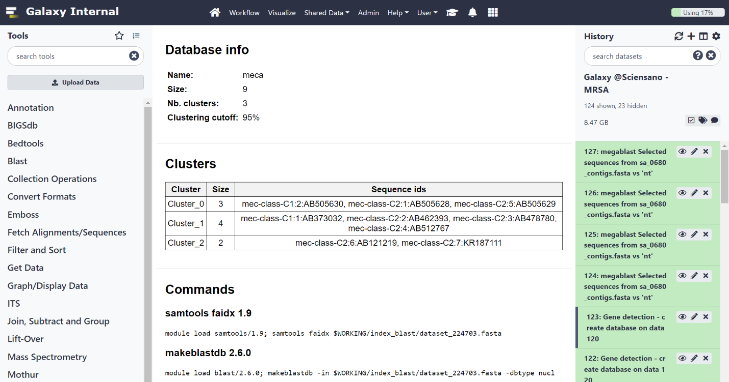
Output report of the ‘Gene detection – create database’ tool. The table lists the clusters and the sequences assigned to each cluster. The clustering and indexing commands are listed at the bottom of the report.

Figure S2k: Output of the MLST phylogeny tool

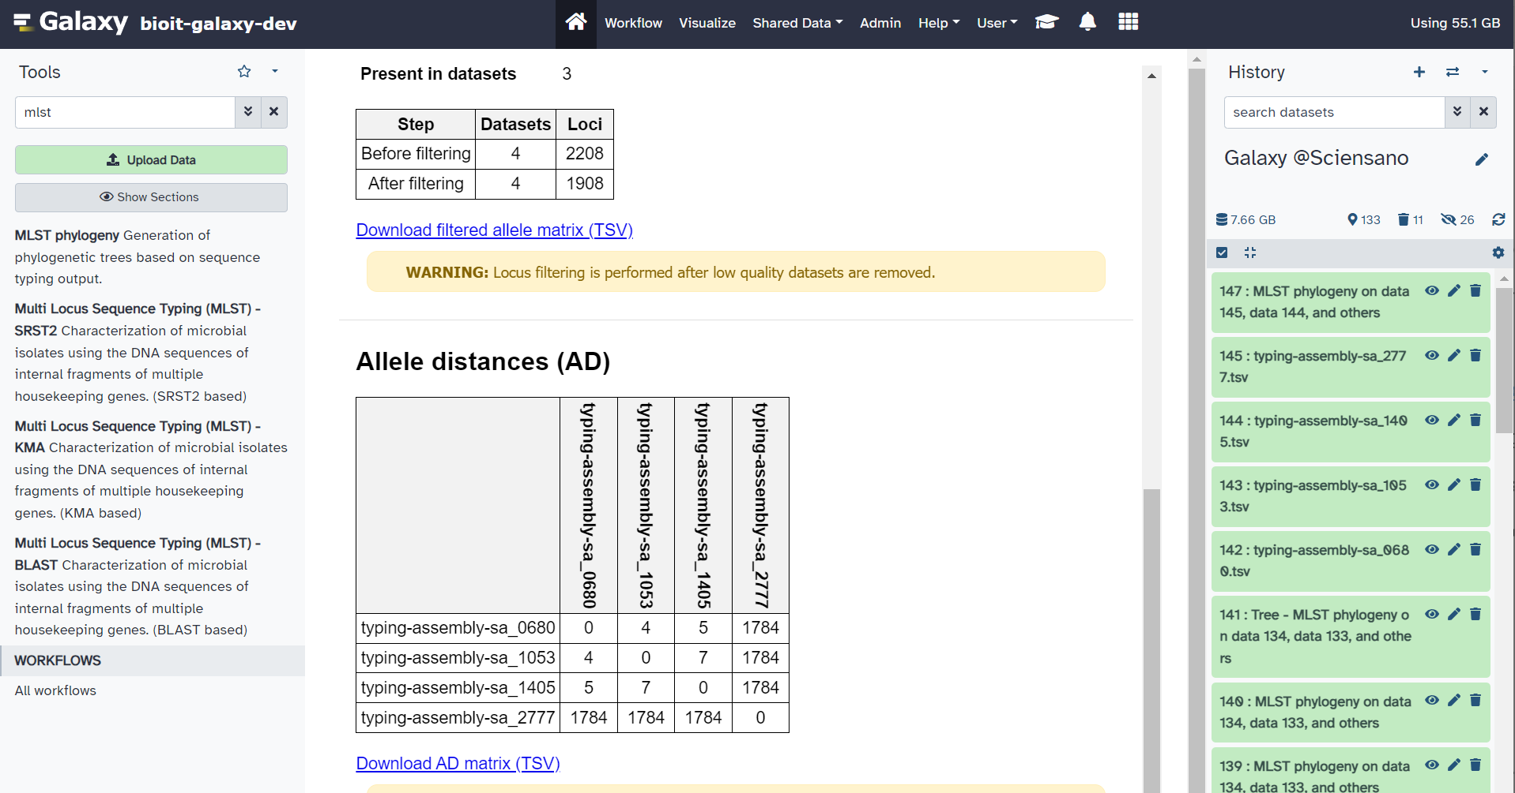
Output of the MLST phylogeny tool on the four MRSA datasets that passed the quality checks. The pairwise allele distances are shown in the lower table. The distances between the three ST8 isolates (i.e., sa_0680, sa_1053, and sa_1405) are relatively small, with ≤7 pairwise allele differences, while the distance to the sa_2777 strain (ST121) is very large with over 1,é700 allele differences.

Figure S2l: Output of the PACU SNP analysis

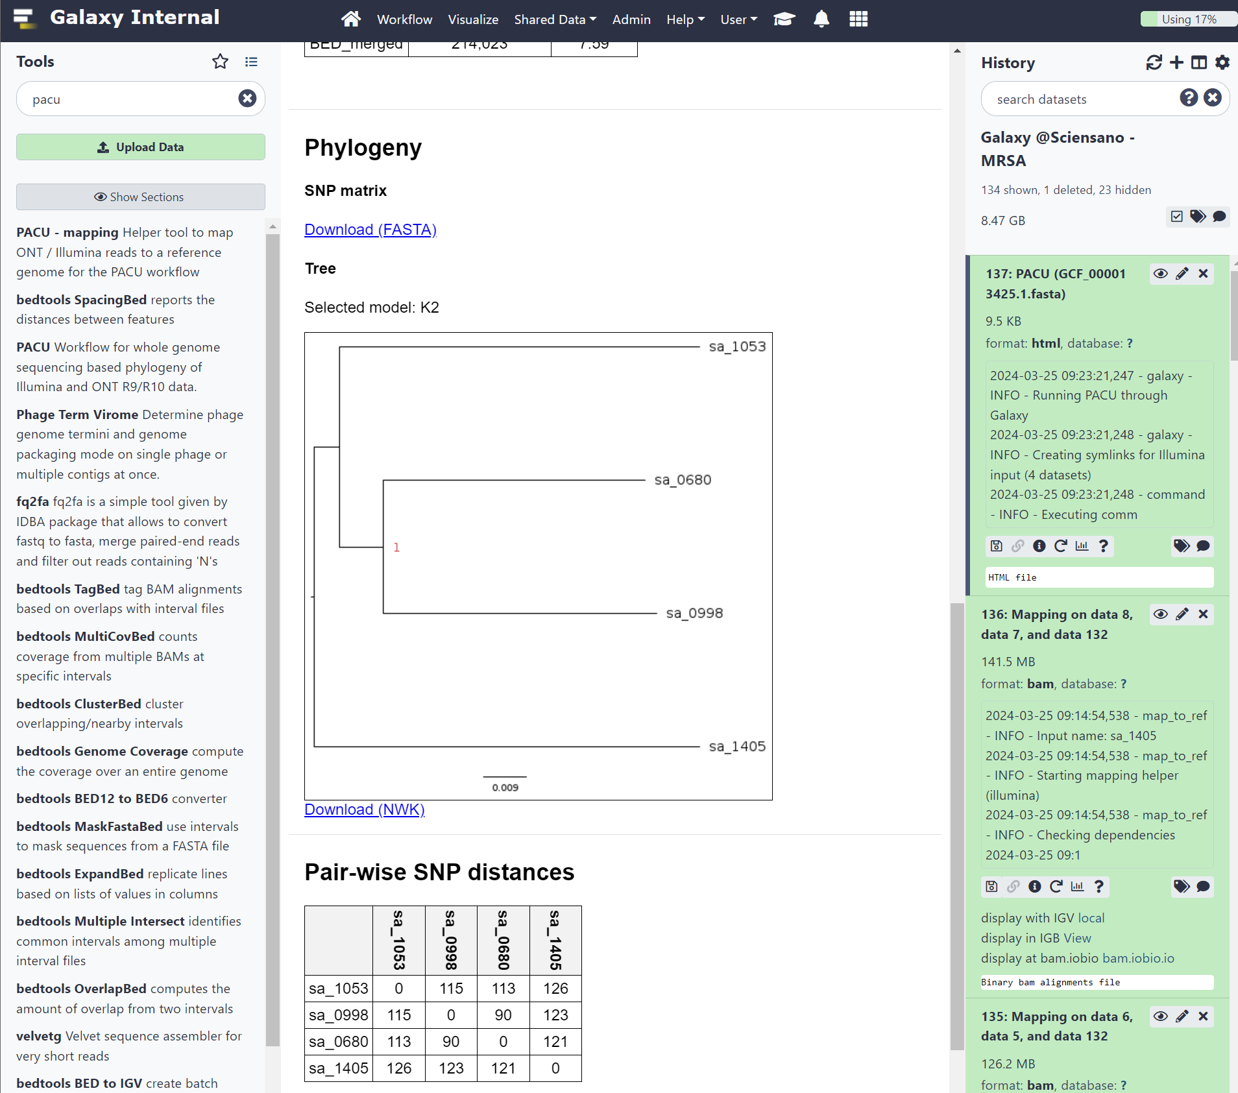
Output of the PACU SNP phylogeny tool. The isolates are located on separate branches. The relatively large pairwise SNP distances (shown in the lower table) indicate that a direct relationship between the isolates is unlikely.

Figure S3: Schematic overview of the ‘push-button’ pathogen characterization workflows

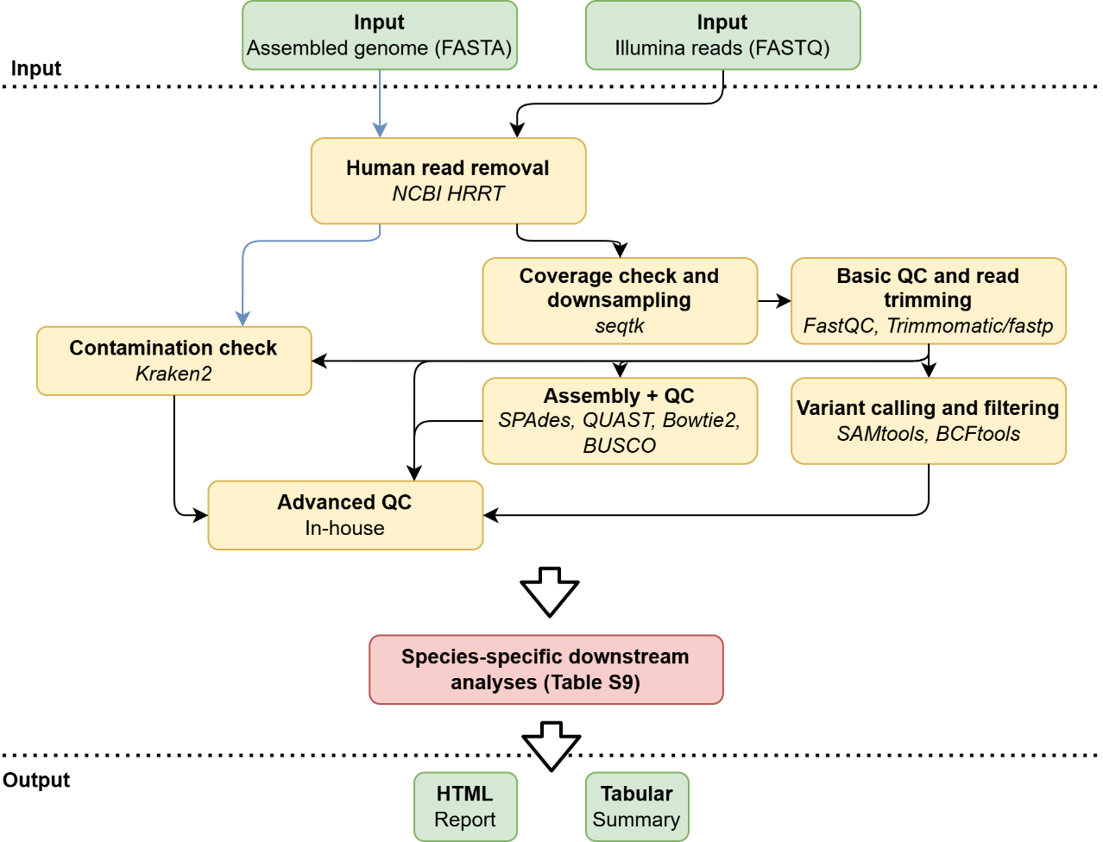

This figure shows a simplified overview of the 'push-button' pathogen characterization workflows. Green boxes correspond to pipeline input and output files. Green boxes correspond to common pre-processing and quality control steps. The red boxes corresponds to the species-specific assays, which are listed in Supplementary Table S9. The main bioinformatics software packages used in each module are also mentioned (in italics). Dataflow is indicated by the arrows. The blue arrows correspond to the modified data flow when starting from input in FASTA format. Notes: (1) the viral consensus pipeline has a different architecture due to the specific data analysis for viral genomes; (2) variant calling and filtering is not performed for all species; (3) for assays that rely on variant calling (e.g., AMR detection in Mycobacterium), paired-end reads are simulated using ART [21] and used for subsequent mapping and variant calling.
Abbreviations: quality control (QC)

References

[1] H. Hasman et al., “LRE-Finder, a Web tool for detection of the 23S rRNA mutations and the optrA, cfr, cfr(B) and poxtA genes encoding linezolid resistance in enterococci from whole-genome sequences,” Journal of Antimicrobial Chemotherapy, vol. 74, no. 6, pp. 1473–1476, Jun. 2019, doi: 10.1093/jac/dkz092.
[2] M. Feldgarden et al., “AMRFinderPlus and the Reference Gene Catalog facilitate examination of the genomic links among antimicrobial resistance, stress response, and virulence,” Sci Rep, vol. 11, no. 1, p. 12728, Dec. 2021, doi: 10.1038/s41598-021-91456-0.
[3] V. Bortolaia et al., “ResFinder 4.0 for predictions of phenotypes from genotypes,” Journal of Antimicrobial Chemotherapy, vol. 75, no. 12, pp. 3491–3500, Dec. 2020, doi: 10.1093/jac/dkaa345.
[4] D. Hyatt, G.-L. Chen, P. F. LoCascio, M. L. Land, F. W. Larimer, and L. J. Hauser, “Prodigal: prokaryotic gene recognition and translation initiation site identification,” BMC Bioinformatics, vol. 11, no. 1, p. 119, Dec. 2010, doi: 10.1186/1471-2105-11-119.
[5] C. Camacho et al., “BLAST+: architecture and applications,” BMC Bioinformatics, vol. 10, no. 1, p. 421, Dec. 2009, doi: 10.1186/1471-2105-10-421.
[6] C. Pal, J. Bengtsson-Palme, C. Rensing, E. Kristiansson, and D. G. J. Larsson, “BacMet: antibacterial biocide and metal resistance genes database,” Nucl. Acids Res., vol. 42, no. D1, pp. D737–D743, Jan. 2014, doi: 10.1093/nar/gkt1252.
[7] A. Carattoli et al., “In Silico Detection and Typing of Plasmids using PlasmidFinder and Plasmid Multilocus Sequence Typing,” Antimicrob Agents Chemother, vol. 58, no. 7, pp. 3895–3903, Jul. 2014, doi: 10.1128/AAC.02412-14.
[8] J. Robertson and J. H. E. Nash, “MOB-suite: software tools for clustering, reconstruction and typing of plasmids from draft assemblies,” Microbial Genomics, vol. 4, no. 8, Aug. 2018, doi: 10.1099/mgen.0.000206.
[9] E. Xia, Y.-Y. Teo, and R. T.-H. Ong, “SpoTyping: fast and accurate in silico Mycobacterium spoligotyping from sequence reads,” Genome Med, vol. 8, no. 1, p. 19, Dec. 2016, doi: 10.1186/s13073-016-0270-7.
[10] A. Muzzi et al., “Genetic Meningococcal Antigen Typing System (gMATS): A genotyping tool that predicts 4CMenB strain coverage worldwide.,” Vaccine, vol. 37, no. 7, pp. 991–1000, Feb. 2019, doi: 10.1016/j.vaccine.2018.12.061.
[11] C. M. C. Rodrigues, K. A. Jolley, A. Smith, J. C. Cameron, I. M. Feavers, and M. C. J. Maiden, “Meningococcal Deduced Vaccine Antigen Reactivity (MenDeVAR) Index: a Rapid and Accessible Tool That Exploits Genomic Data in Public Health and Clinical Microbiology Applications,” J Clin Microbiol, vol. 59, no. 1, pp. e02161-20, Dec. 2020, doi: 10.1128/JCM.02161-20.
[12] N. L. Sherry et al., “An ISO-certified genomics workflow for identification and surveillance of antimicrobial resistance,” Nat Commun, vol. 14, no. 1, p. 60, Jan. 2023, doi: 10.1038/s41467-022-35713-4.
[13] L. Roer et al., “Is the Evolution of Salmonella enterica subsp. enterica Linked to Restriction-Modification Systems?,” mSystems, vol. 1, no. 3, pp. e00009-16, Jun. 2016, doi: 10.1128/mSystems.00009-16.
[14] M. Hunt et al., “Antibiotic resistance prediction for Mycobacterium tuberculosis from genome sequence data with Mykrobe [version 1; peer review: 2 approved, 1 approved with reservations],” Wellcome Open Research, vol. 4, no. 191, 2019, doi: 10.12688/wellcomeopenres.15603.1.
[15] Wu Yun, Lau Henry K., Lee Teresa, Lau David K., and Payne Justin, “In Silico Serotyping Based on Whole-Genome Sequencing Improves the Accuracy of Shigella Identification,” Applied and Environmental Microbiology, vol. 85, no. 7, pp. e00165-19, Mar. 2019, doi: 10.1128/AEM.00165-19.
[16] B. D. Ondov, N. H. Bergman, and A. M. Phillippy, “Interactive metagenomic visualization in a Web browser,” BMC Bioinformatics, vol. 12, no. 1, p. 385, Dec. 2011, doi: 10.1186/1471-2105-12-385.
[17] A. J. Low, A. G. Koziol, P. A. Manninger, B. Blais, and C. D. Carrillo, “ConFindr: rapid detection of intraspecies and cross-species contamination in bacterial whole-genome sequence data,” PeerJ, vol. 7, p. e6995, May 2019, doi: 10.7717/peerj.6995.
[18] K. G. Joensen et al., “Real-Time Whole-Genome Sequencing for Routine Typing, Surveillance, and Outbreak Detection of Verotoxigenic Escherichia coli,” J Clin Microbiol, vol. 52, no. 5, pp. 1501–1510, May 2014, doi: 10.1128/JCM.03617-13.
[19] Z. Zhou, N.-F. Alikhan, K. Mohamed, Y. Fan, the Agama Study Group, and M. Achtman, “The EnteroBase user’s guide, with case studies on Salmonella transmissions, Yersinia pestis phylogeny, and Escherichia core genomic diversity,” Genome Res., vol. 30, no. 1, pp. 138–152, Jan. 2020, doi: 10.1101/gr.251678.119.
[20] B. Bogaerts et al., “Closing the gap: Oxford Nanopore Technologies R10 sequencing allows comparable results to Illumina sequencing for SNP-based outbreak investigation of bacterial pathogens,” J Clin Microbiol, pp. e01576-23, Mar. 2024, doi: 10.1128/jcm.01576-23.
[21] W. Huang, L. Li, J. R. Myers, and G. T. Marth, “ART: a next-generation sequencing read simulator.,” Bioinformatics, vol. 28, no. 4, pp. 593–594, Feb. 2012, doi: 10.1093/bioinformatics/btr708.

