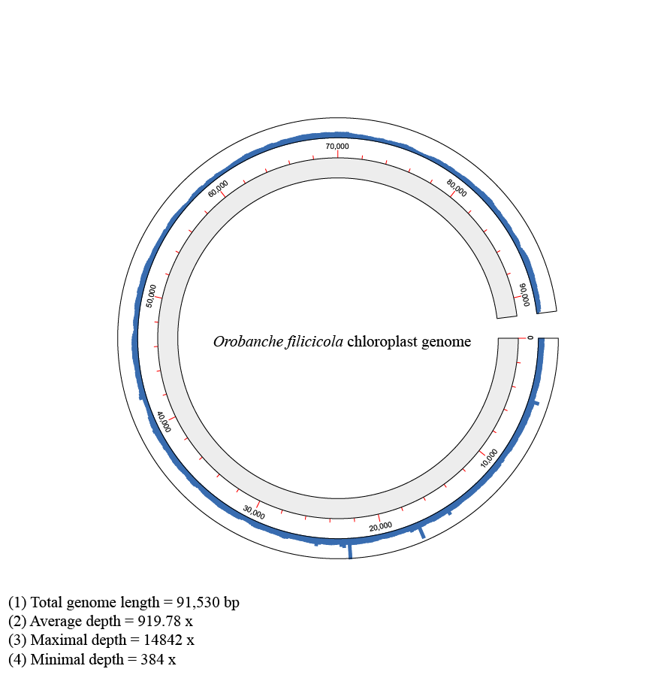
Figure S1. The sequencing depth and coverage map for Chloroplast genome of O. filicicola
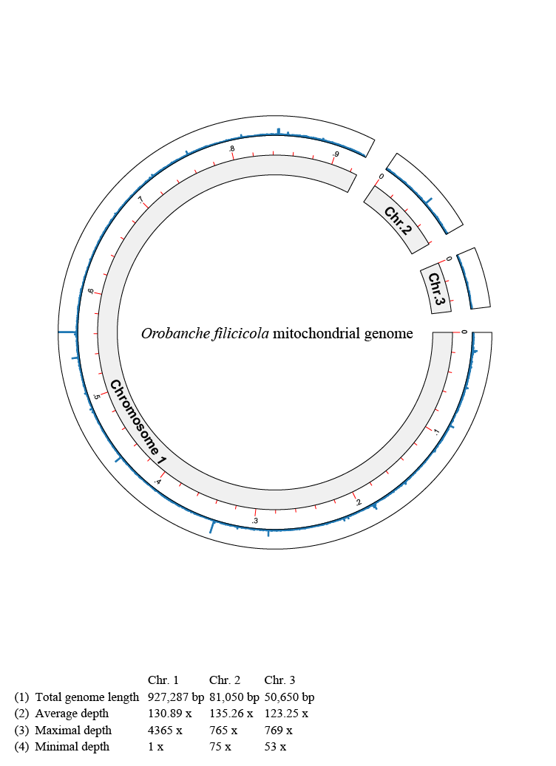
Figure S2. The sequencing depth and coverage map for mitochondrial genome of O. filicicola

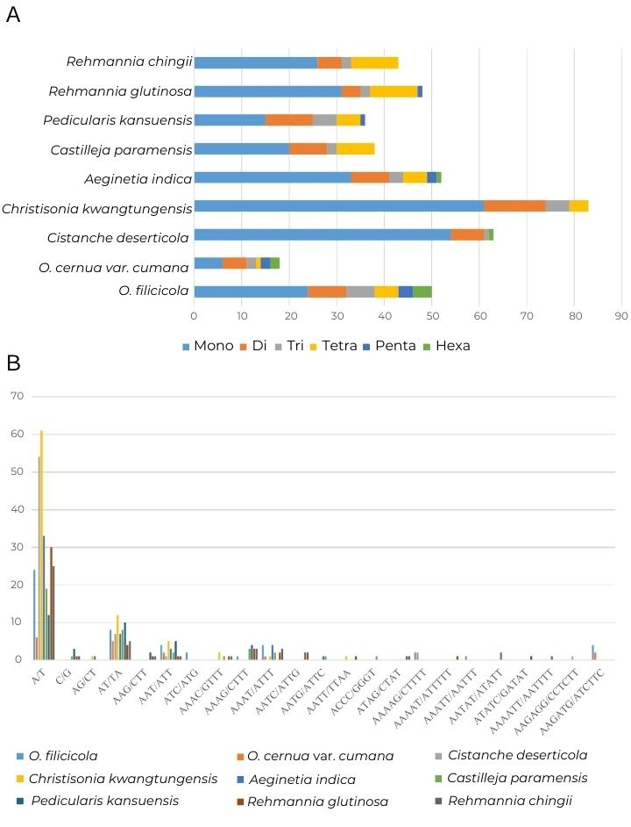
Figure S3. Analysis of simple sequence repeats (SSRs) in the chloroplast genomes of nine Orobanchaceae species. A. Frequency of different types of SSRs. B Number of six types of SSRs.

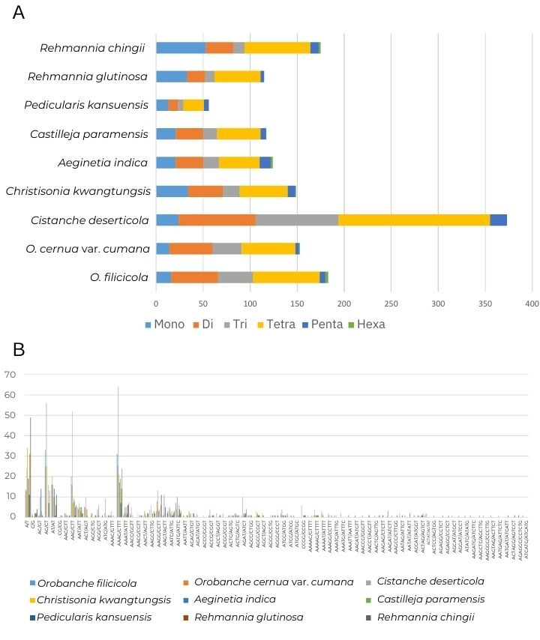
Figure S4. Analysis of simple sequence repeats (SSRs) in the mitochondria genomes of nine Orobanchaceae species. A. Frequency of different types of SSRs. B Number of six types of SSRs.

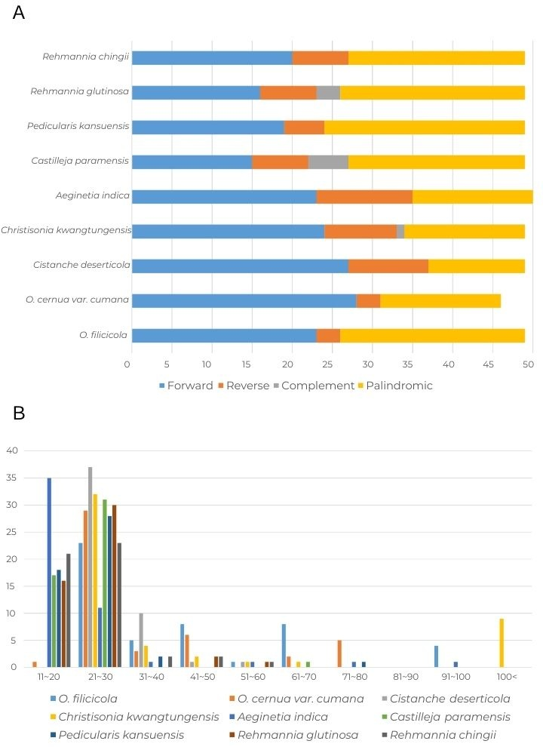
Figure S5. Comparison of long repeats in the chloroplast genomes of nine Orobanchaceae species. a. Number of different types of long repeats. b. Number of repeats of each length.

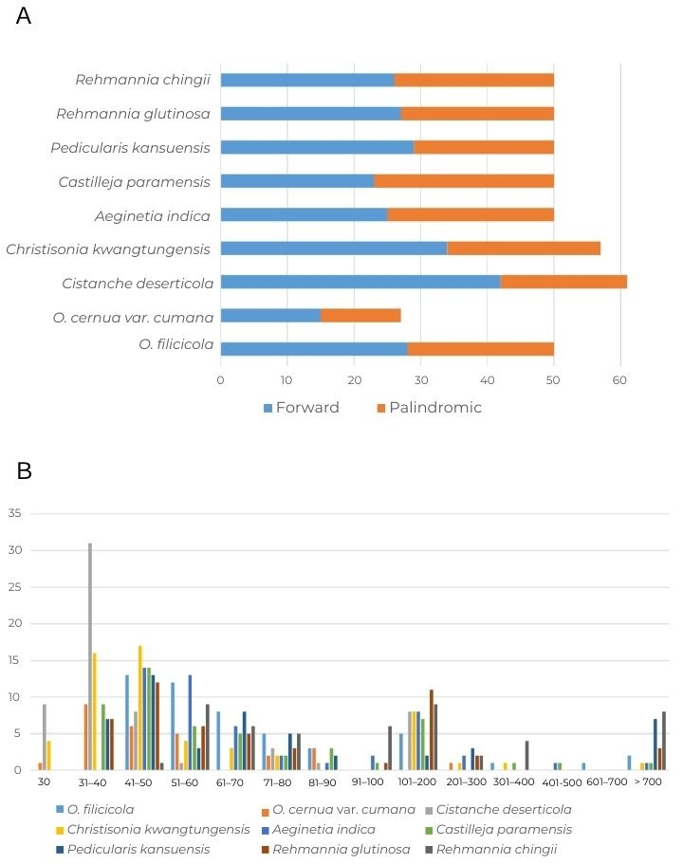
Figure S6. Comparison of long repeats in the mitochondria genomes of nine Orobanchaceae species. a. Number of different types of long repeats. b. Number of repeats of each length.

