Table. S1 The chemical forms of Cd in root and shoot under Cd stresses. The values come from three biological replicates.

 | Root (µg/g) |  |  |  |  | Shoot (µg/g)
 | DS | DT | TS | TT |  | DS | DT | TS | TT
F_{E} | 15.73 ± 5.32 | 17.25± 0.90 | 13.84 ± 1.55 | 14.04 ± 2.57 |  | 2.55 ± 0.65 | 1.66 ± 0.55 | 2.04 ± 0.31 | 0.81 ± 0.20
F_{W} | 53.01 ± 4.14 | 26.70 ± 3.31 | 44.48 ± 6.42 | 20.11 ± 1.13 |  | 3.20 ± 0.64 | 2.29 ± 0.32 | 2.04 ± 0.52 | 1.14 ± 0.42
F_{NaCl} | 247.67 ± 21.06 | 204.78 ± 11.04 | 161.43 ± 3.50 | 143.68 ± 4.26 |  | 13.75 ± 1.65 | 8.10 ± 0.10 | 6.74 ± 0.67 | 6.21 ± 0.27
F_{HAc} | 40.21 ± 2.73 | 23.47 ± 1.11 | 31.06 ± 1.13 | 17.56 ± 2.44 |  | 4.33 ± 0.95 | 2.61 ± 0.89 | 1.72 ± 0.30 | 1.79 ± 0.19
F_{HCl} | 2.50 ± 0.68 | 0.40 ± 0.09 | 1.18 ± 0.54 | 0.88 ± 0.41 |  | 0.25 ± 0.09 | 0.13 ± 0.047 | 0.13 ± 0.08 | 0.07 ± 0.02
F_{R} | 0.22 ± 0.16 | 0.08 ± 0.03 | 0.03 ± 0.03 | 0.08 ± 0.05 |  | 0.08 ± 0.03 | 0.07 ± 0.017 | 0.03 ± 0.039 | 0.06 ± 0.01

Table. S2. The Cd subcellular distribution in root and shoot under Cd stresses. The values come from three biological replicates.
 |  | Root (µg/g) |  |  |  |  | Shoot (µg/g)
 | DS |  | DT | TS | TT |  | DS | DT | TS | TT
F_{CW} | 115.24 ± 12.96 |  | 119.59 ± 7.45 | 112.69 ± 16.58 | 112.24 ± 7.07 |  | 16.59 ± 1.33 | 14.90 ± 1.17 | 13.16 ± 1.49 | 8.42 ± 0.42
F_{S} | 147.88 ± 8.74 |  | 121.04 ± 2.39 | 141.08 ± 3.23 | 81.51 ± 8.96 |  | 20.42 ± 1.20 | 18.39 ± 0.74 | 18.57 ± 1.88 | 13.72 ± 1.57
F_{Co} | 21.83 ± 0.17 |  | 25.06 ± 3.44 | 16.26 ± 2.07 | 10.65 ± 0.57 |  | 2.34 ± 0.25 | 1.30 ± 0.07 | 1.50 ± 0.21 | 1.15 ± 0.09

Table. S3. Statistical results of polymerase read of DT and TT.
Sample | Polymerase read bases(G) | Polymerase reads | Polymerase read length (mean) | Polymerase read N50
DT | 26.3 | 440626 | 59689 | 108435
TT | 39.06 | 617904 | 63218 | 117877
Polymerase read bases(G): The data size of polymerase read; Polymerase reads: number of Polymerase reads; Polymerase read length (mean): average length of Polymerase read; Polymerase read N50: sort the obtained polymerase reads in order of length from longest to shortest, and sequentially add up the length of the Polymerase read until the length of the Polymerase read is not less than 50% of the total length.

Table. S4. Statistical results of FLNC of DT and TT.
Sample | FLNC number | Min length | Max length | Mean length | N50
DT | 333697 | 50 | 14911 | 2139 | 2351
TT | 492615 | 50 | 14855 | 2225 | 2509
FLNC number: number of reads of consensus sequence obtained after clustering; Min length: the shortest FLNC length; Max length: the longest FLNC length; Mean length: Average length of FLNC; N50: sort the obtained FLNCs in order of length from longest to shortest, and accumulate the length of FLNC in turn until the length of FLNC is not less than 50% of the total length.

Table. S5. Statistical results of polished consensus of DT and TT.
Sample | Consensus number | Min length | Max length | Mean length | N50
DT | 33941 | 59 | 8436 | 2110 | 2312
TT | 48757 | 57 | 11629 | 2200 | 2458
FLNC number: number of polished consensus reads obtained after clustering; Min length: the shortest polished consensus length; Max length: The longest polished consensus length; Mean length: average length of polished consensus; N50: sort the obtained polished consensus in order of length from longest to shortest, and accumulate the length of FLNC in turn until the length of FLNC is not less than 50% of the total length.

Table. S6. Length distribution before and after transcript correction.
Sample | Type | Total nucleotides | Total number | Mean length | Min length | Max length | N50 | N90
DT | Before correction | 71604874 | 33941 | 2110 | 59 | 8436 | 2312 | 1331
DT | After correction | 71565584 | 33941 | 2109 | 59 | 8431 | 2311 | 1329
TT | Before correction | 107242337 | 48757 | 2200 | 57 | 11629 | 2458 | 1369
TT | After correction | 107180925 | 48757 | 2199 | 57 | 11625 | 2457 | 1367
Total nucleotides: the number of consensus bases; Total number: number of consensus; Min length: the shortest consensus length; Max length: The longest consensus length; Mean length: average length of consensus; N50/90: sort the obtained polished consensus in order of length from longest to shortest, and accumulate the length of FLNC in turn until the length of FLNC is not less than 50%/90% of the total length.

Table. S7. Frequency distribution of length before and after transcript de-redundancy.
Sample | Type |  | <500bp |  | 500-1kbp | 1k-2kbp | 2k-3kbp | >3kbp | Total
DT |  | Number of transcripts |  | 149 | 2014 | 16667 | 9498 | 5613 | 33941
 |  | Number of Genes |  | 45 | 1203 | 9385 | 5440 | 3272 | 19345
TT |  | Number of transcripts |  | 307 | 3011 | 21772 | 14006 | 9661 | 48757
 |  | Number of Genes |  | 77 | 1679 | 11630 | 7502 | 5075 | 25963

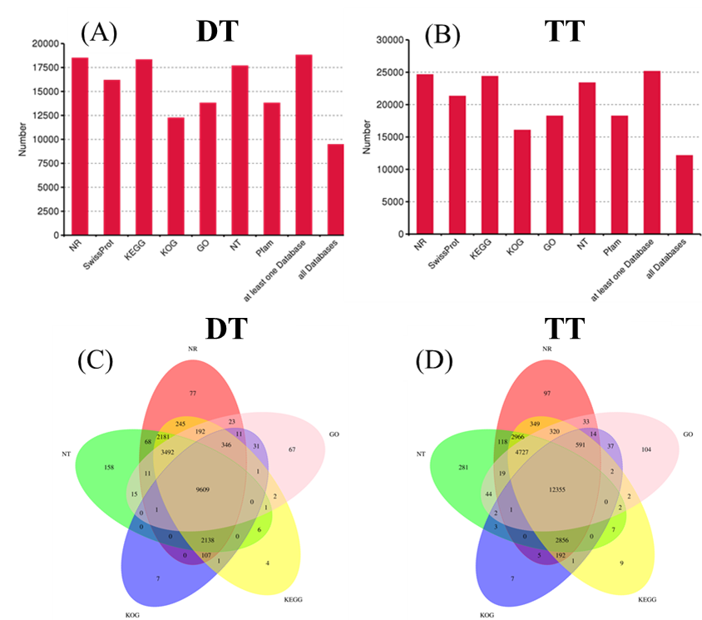
Fig. S1. Annotation of the full-length reference transcriptome.
A and B: Information of function annotation in DT (A) and TT (B). C and D: Venn diagram of all transcripts from the reference transcriptome hits of NR, NT, KOG, KEGG and GO in DT (C) and TT (D).

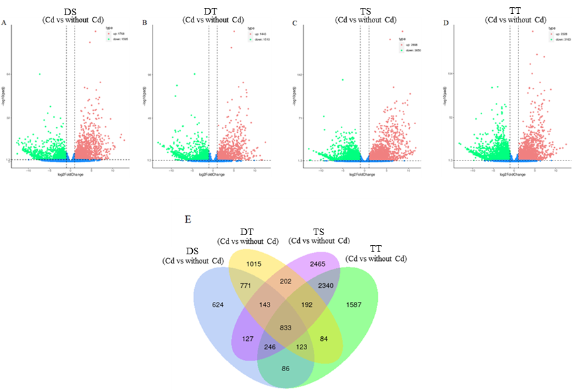
Fig. S2. Distribution and expression levels of DEGs in DS (A), DT (B), PI TS (C), and TT (D) exposed or not to Cd. Venn diagram of DEGs in all populations (E).

Supplementary File 1
ISO-seq Method
Sample collection and preparation
RNA extraction
Fresh roots were taken and frozen in liquid nitrogen for RNA isolation. Total RNA was isolated using Total RNA Kit II (Omega, USA).
Library preparation and sequencing
The Iso-Seq library was prepared according to the Isoform Sequencing protocol (Iso-Seq) using the Clontech SMARTer PCR cDNA Synthesis Kit and the BluePippin Size Selection System protocol as described by Pacific Biosciences (PN 100-092-800-03)
Data Analysis
Data processing
Sequence data were processed using the SMRTlink 5.0 software. Circular consensus sequence (CCS) was generated from subread BAM files, parameters: min_length 200, max_drop_fraction 0.8, no_polish TRUE, min_zscore-9999, min_passes 1, min_predicted_accuracy 0.8, max_length 18000. CCS.BAM files were output, which were then classified into full length and non-full length reads using pbclassify.py script, ignore polyA false, minSeq Length 200. Non full length and full-length fasta files produced were then fed into the cluster step, which does isoform-level clustering (ICE), followed by final Arrow polishing, hq_quiver_min_accuracy 0.99, bin_by_primer false, bin_size_kb 1, qv_trim_5p 100, qv_trim_3p 30.
Error correction using Illumina reads
Additional nucleotide errors in consensus reads were corrected using the Illumina RNA seq data with the software LoRDEC.
Gene structure analysis
Gene structure analysis was performed using TAPIS pipeline. The GMAP output bam format file and gff/gtf format genome annotation file were used for gene and transcript determination. Alternative splicing events and Alternative polyadenylation events were then analyzed. Fusion transcripts were determined as transcripts mapping to two or more long-distance range genes and was validated by at least two Illumina reads.
Unmapped transcripts and Novel gene transcripts functional annotation
Unmapped transcripts and Novel gene transcripts function were annotated based on the following databases: NR(NCBI non-redundant protein sequences); NT(NCBI non-redundant nucleotide sequences); Pfam (Protein family); KOG/COG(Clusters of Orthologous Groups of proteins); Swiss-Prot (A manually annotated and reviewed protein sequence database); KO(KEGGO rtholog database); GO(Gene Ontology).
We used the software of BLAST and set the e-value ‘1e-10’ in NT database analysis; We used the software of Diamond BLASTX and set the e-value ‘1e-10’ in NR KOG Swiss-Prot KEGG databases analysis; We used the software of Hmmscan in Pfam database analysis.

Supplementary File 2
RNA-seq Method
Sample collection and preparation
RNA extraction
Fresh roots were taken and frozen in liquid nitrogen for RNA isolation. Total RNA was isolated using Total RNA Kit II (Omega, USA).
RNA quantification and qualification
RNA integrity was assessed using the RNA Nano 6000 Assay Kit of the Bioanalyzer 2100 system (Agilent Technologies, CA, USA).
Library preparation for Transcriptome sequencing
Total RNA was used as input material for the RNA sample preparations. Briefly, mRNA was purified from total RNA using poly-T oligo-attached magnetic beads. Fragmentation was carried out using divalent cations under elevated temperature in First Strand Synthesis Reaction Buffer(5X). First strand cDNA was synthesized using random hexamer primer and M-MuLV Reverse Transcriptase, then use RNaseH to degrade the RNA. Second strand cDNA synthesis was subsequently performed using DNA Polymerase I and dNTP. Remaining overhangs were converted into blunt ends via exonuclease/polymerase activities. After adenylation of 3’ ends of DNA fragments, Adaptor with hairpin loop structure were ligated to prepare for hybridization. In order to select cDNA fragments of preferentially 370~420 bp in length, the library fragments were purified with AMPure XP system (Beckman Coulter, Beverly, USA). Then PCR was performed with Phusion High-Fidelity DNA polymerase, Universal PCR primers and Index (X) Primer.
At last, PCR products were purified (AMPure XP system) and library quality was assessed on the Qubit2.0 Fluorometer, Agilent Bioanalyzer 2100 system and qRT-PCR.
Clustering and sequencing
The clustering of the index-coded samples was performed on a cBot Cluster Generation System using TruSeq PE Cluster Kit v3-cBot-HS (Illumia) according to the manufacturer’s instructions. After cluster generation, the library preparations were sequenced on an Illumina Novaseq platform and 150 bp paired-end reads were generated.
Data Analysis
Quality control
Raw data (raw reads) of fastq format were firstly processed through in-house perl scripts. In this step, clean data (clean reads) were obtained by removing reads containing adapter, reads containing N base and low quality reads from raw data. At the same time, Q20, Q30 and GC content the clean data were calculated. All the downstream analyses were based on the clean data with high quality.
Transcriptome assembly
The left files (read1 files) from all libraries/samples were pooled into one big left.fq file, and right files (read2 files) into one big right.fq file. Transcriptome assembly was accomplished based on the left.fq and right.fq using Trinity with min_kmer_cov set to 2 by default and all other parameters set default.
Gene functional annotation
Gene function was annotated based on the following databases: Nr (NCBI non-redundant protein sequences); Nt (NCBI non-redundant nucleotide sequences); Pfam (Protein family); KOG/COG (Clusters of Orthologous Groups of proteins); Swiss-Prot (A manually annotated and reviewed protein sequence database); KO (KEGG Ortholog database) and GO (Gene Ontology).
Differential expression analysis
Differential expression analysis of two conditions/groups (two biological replicates per condition) was performed using the DESeq2 R package (1.20.0). DESeq2 provide statistical routines for determining differential expression in digital gene expression data using a model based on the negative binomial distribution. The resulting P-values were adjusted using the Benjamini and Hochberg’s approach for controlling the false discovery rate. Genes with an adjusted P-value <0.05 found by DESeq2 were assigned as differentially expressed.
GO and KEGG enrichment analysis of differentially expressed genes
Gene Ontology (GO) enrichment analysis of differentially expressed genes was implemented by the cluster Profiler R package, in which gene length bias was corrected. GO terms with corrected Pvalue less than 0.05 were considered significantly enriched by differential expressed genes. KEGG is a database resource for understanding high-level functions and utilities of the biological system, such as the cell, the organism and the ecosystem, from molecular-level information, especially large-scale molecular datasets generated by genome sequencing and other high-through put experimental technologies (http://www.genome.jp/kegg/). We used clusterProfiler R package to test the statistical enrichment of differential expression genes in KEGG pathways.

