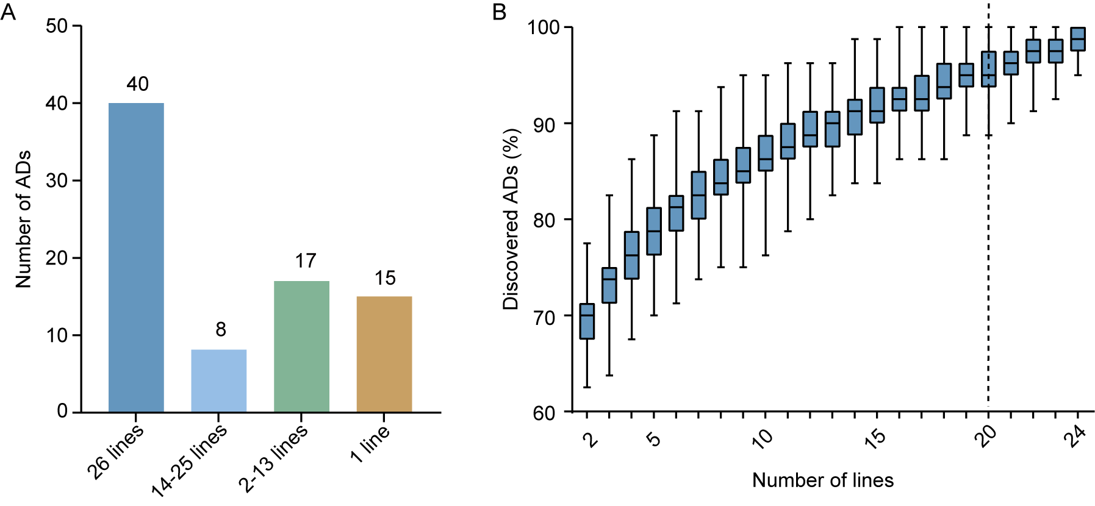 Fig. S1. AD distribution across NAM founders.
(A) Frequency of ADs in the NAM founders. (B) Saturation of AD discovery. Boxes indicate fractions of ADs that can be recovered from randomly drawn sets of lines of different sizes (1000 bootstraps). The horizontal lines at the top, in the middle and at the bottom of the box represent the maximum, median, and minimum values in each bootstrap set, respectively. The vertical dashed line indicates that 95% of the ADs can be recovered from sets of 20 lines.

Fig. S2. 3D protein structures of COP1 and PLRG1.
(A-B) The 3D structure of the WD40 domain of the COP1(A) and PLRG1 (B) protein were previously resolved by cryo-electron microscopy [67] and crystallographic methods [68], respectively. The 3D structure data in A and B is from the studies by Wang et al. 2022 [67] and Wang et al. 2021 [68], respectively. (C-D) The 3D structure of the COP1 (C) and PLRG1 (D) protein predicted by ESMfold. The numbers 1-7 represent β-propeller, and the letters A-D represent β-sheet. For each protein, a high level of similarity was observed between protein structure predicted via ESMfold and those experimentally validated.

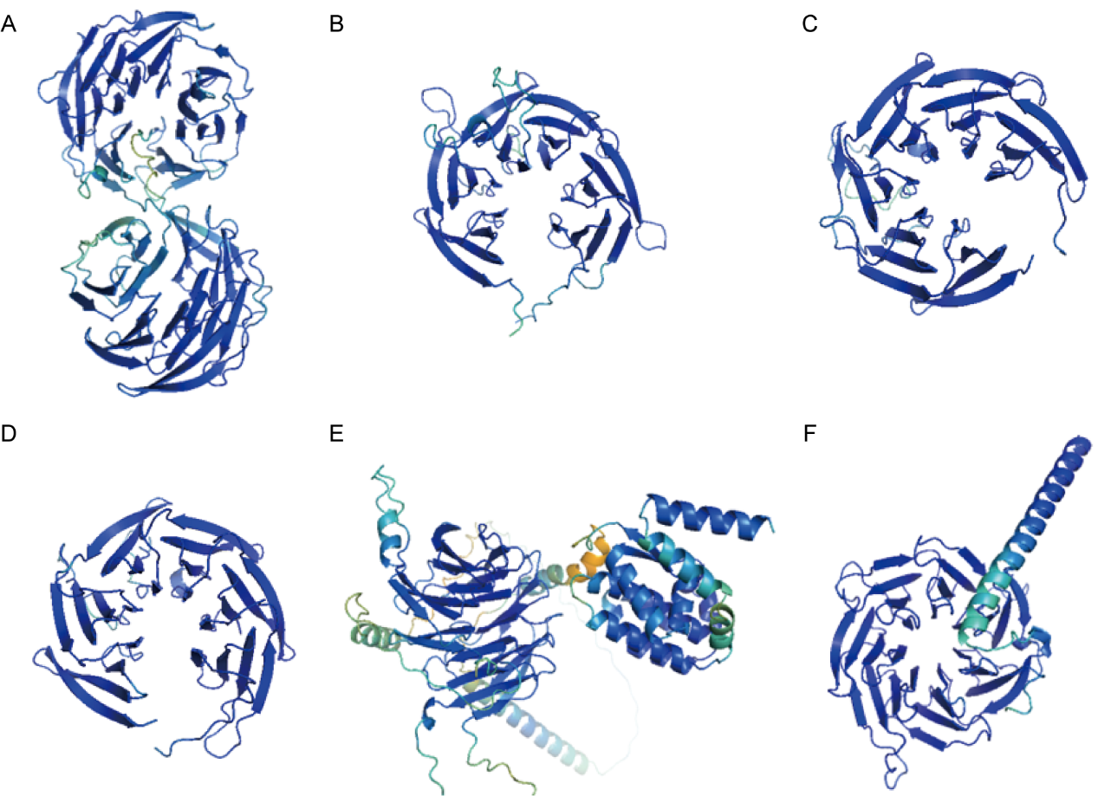
Fig. S3. 3D protein structures of some typical OGs.
OG:013_0 (Zm00001eb334960) (A), OG:117_0 (Zm00001eb159590) (B), OG:029_252_1 (Zm00001eb338610) (C), OG:006_0 (Zm00018ab460050) (D), OG:105_0 (Zm00001eb388650) (E), and OG:176_0 (Zm00001eb052290) (F). The protein structures are color-coded on the basis of per-residue confidence scores (pLDDT). Blue, high (average pLDDT > 75); turquoise, confident (50 < average pLDDT ≤ 75); orange, low (25 < average pLDDT ≤ 50); red, very low (average pLDDT ≤ 25).

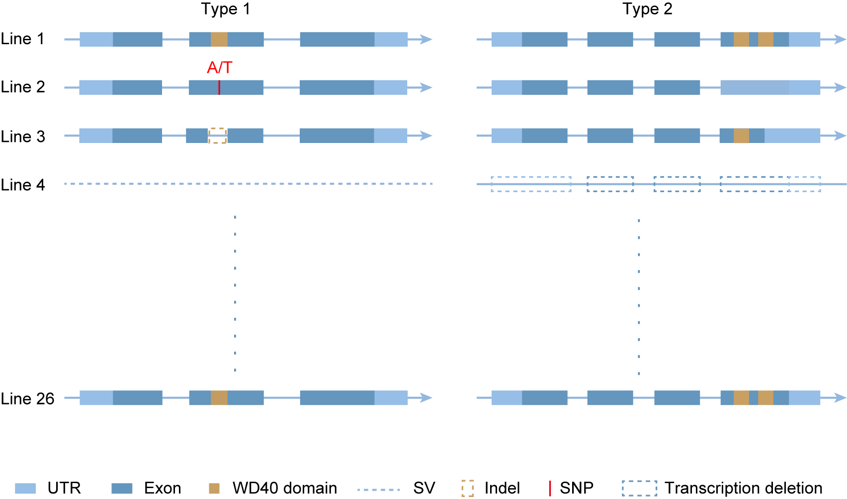 Fig. S4. Two types of loss of WD40 genes or WD40 functional domains in non-conserved collinear blocks.
Type 1: genomic variations. SV, insertion/deletion of >50 bp in the region encoding a WD40 gene. SNP and InDel (<50 bp) variations in the region encoding a WD40 gene across different genomes that lead to loss of WD40 domains. Type 2: transcript variations among the NAM founder genomes that resulted in loss of WD40 domain(s).

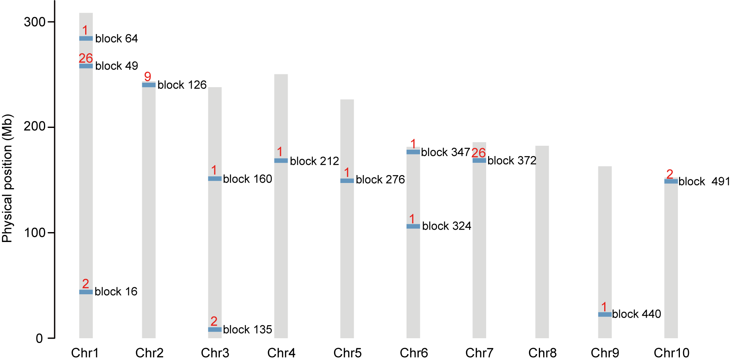
Fig. S5. Distribution of genomic blocks containing tandemly duplicated genes in the NAM founder genomes.
The blue boxes represent the genomic blocks, and the red numbers indicate the number of lines that contain tandemly duplicated genes in each block. Detailed information on all tandem duplicates is provided in Table S10.

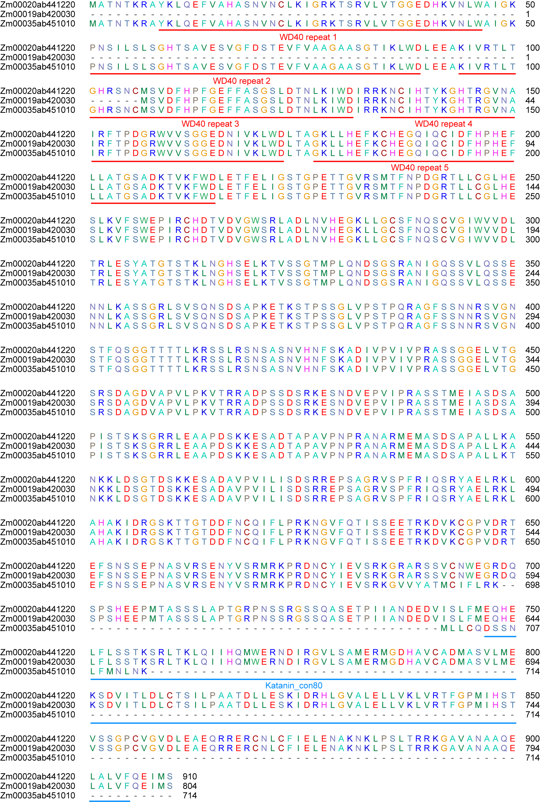
Fig. S6. Alignment of amino acid sequences of representative genes from OG:010_0-1 (Zm00020ab441220), OG:010_1 (Zm00019ab420030), and OG:010_2 (Zm00035ab451010).
The numbers on the right indicate amino acid sequence positions. WD40 repeat 1 to repeat 5 indicate five WD40 domain repeats, which are marked by red lines. Katanin_con80 is an AD predicted by Pfam and is indicated by a blue line.

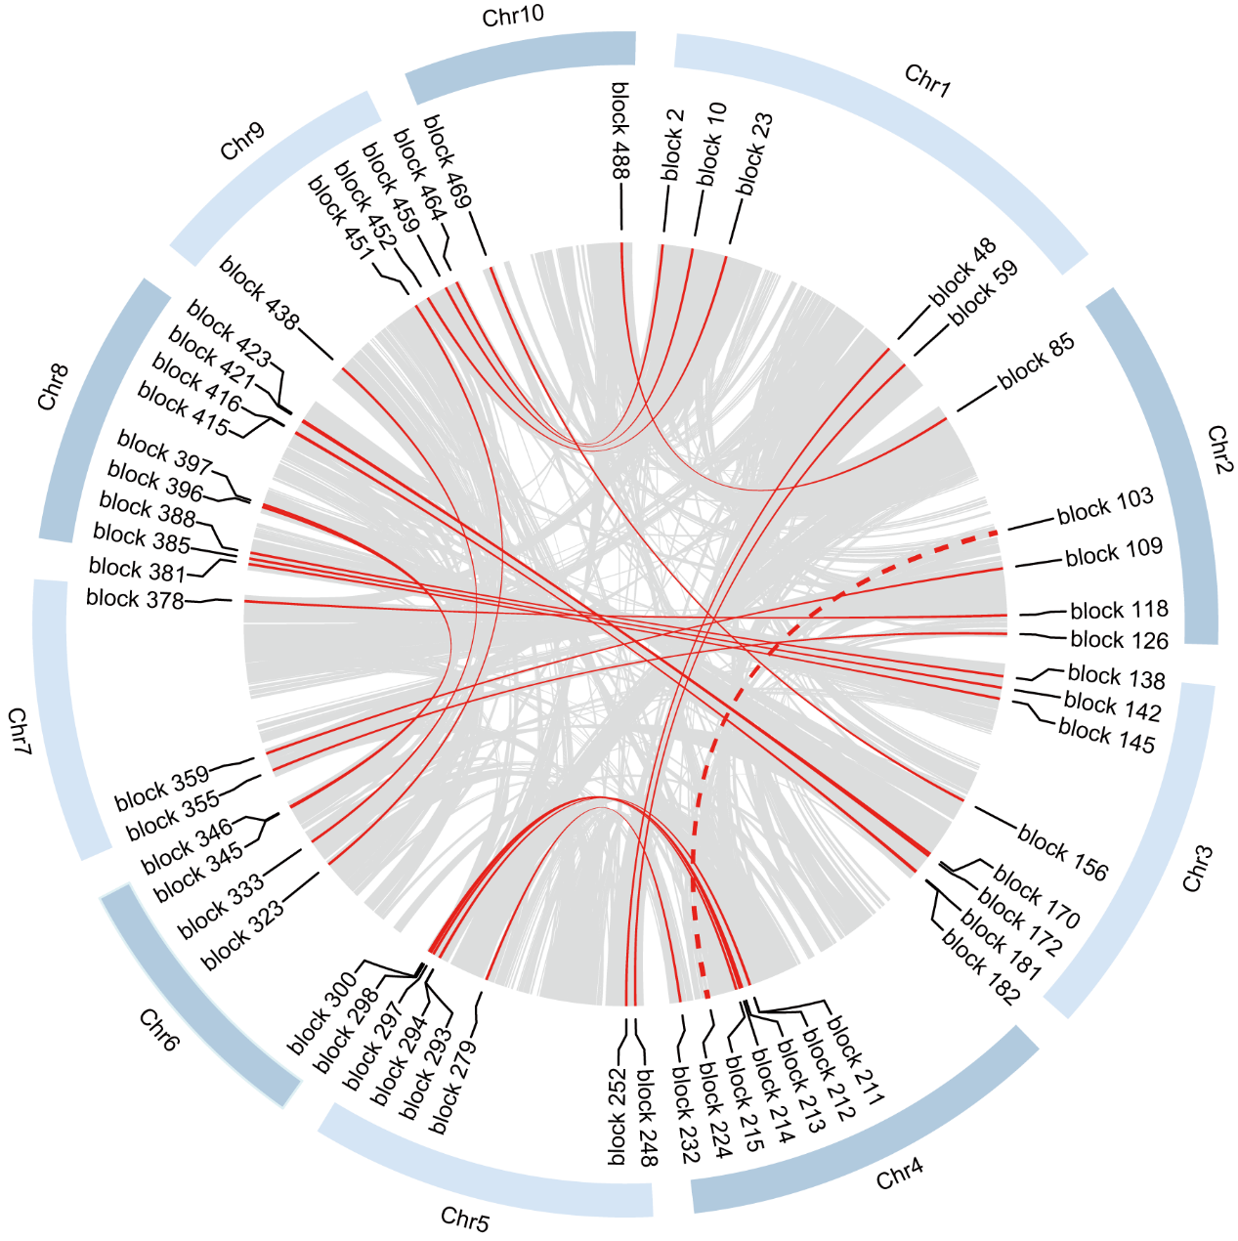
Fig. S7. Distribution of syntenic blocks with the same OG in 26 NAM founder genomes.
Gray lines indicate all syntenic blocks in the B73 genome, red lines indicate the syntenic blocks containing genes in the same core/near-core OG in all NAM founder genomes, and the red dashed line indicates a syntenic block containing genes in the same core/near-core OG in all NAM founder genomes except B73.

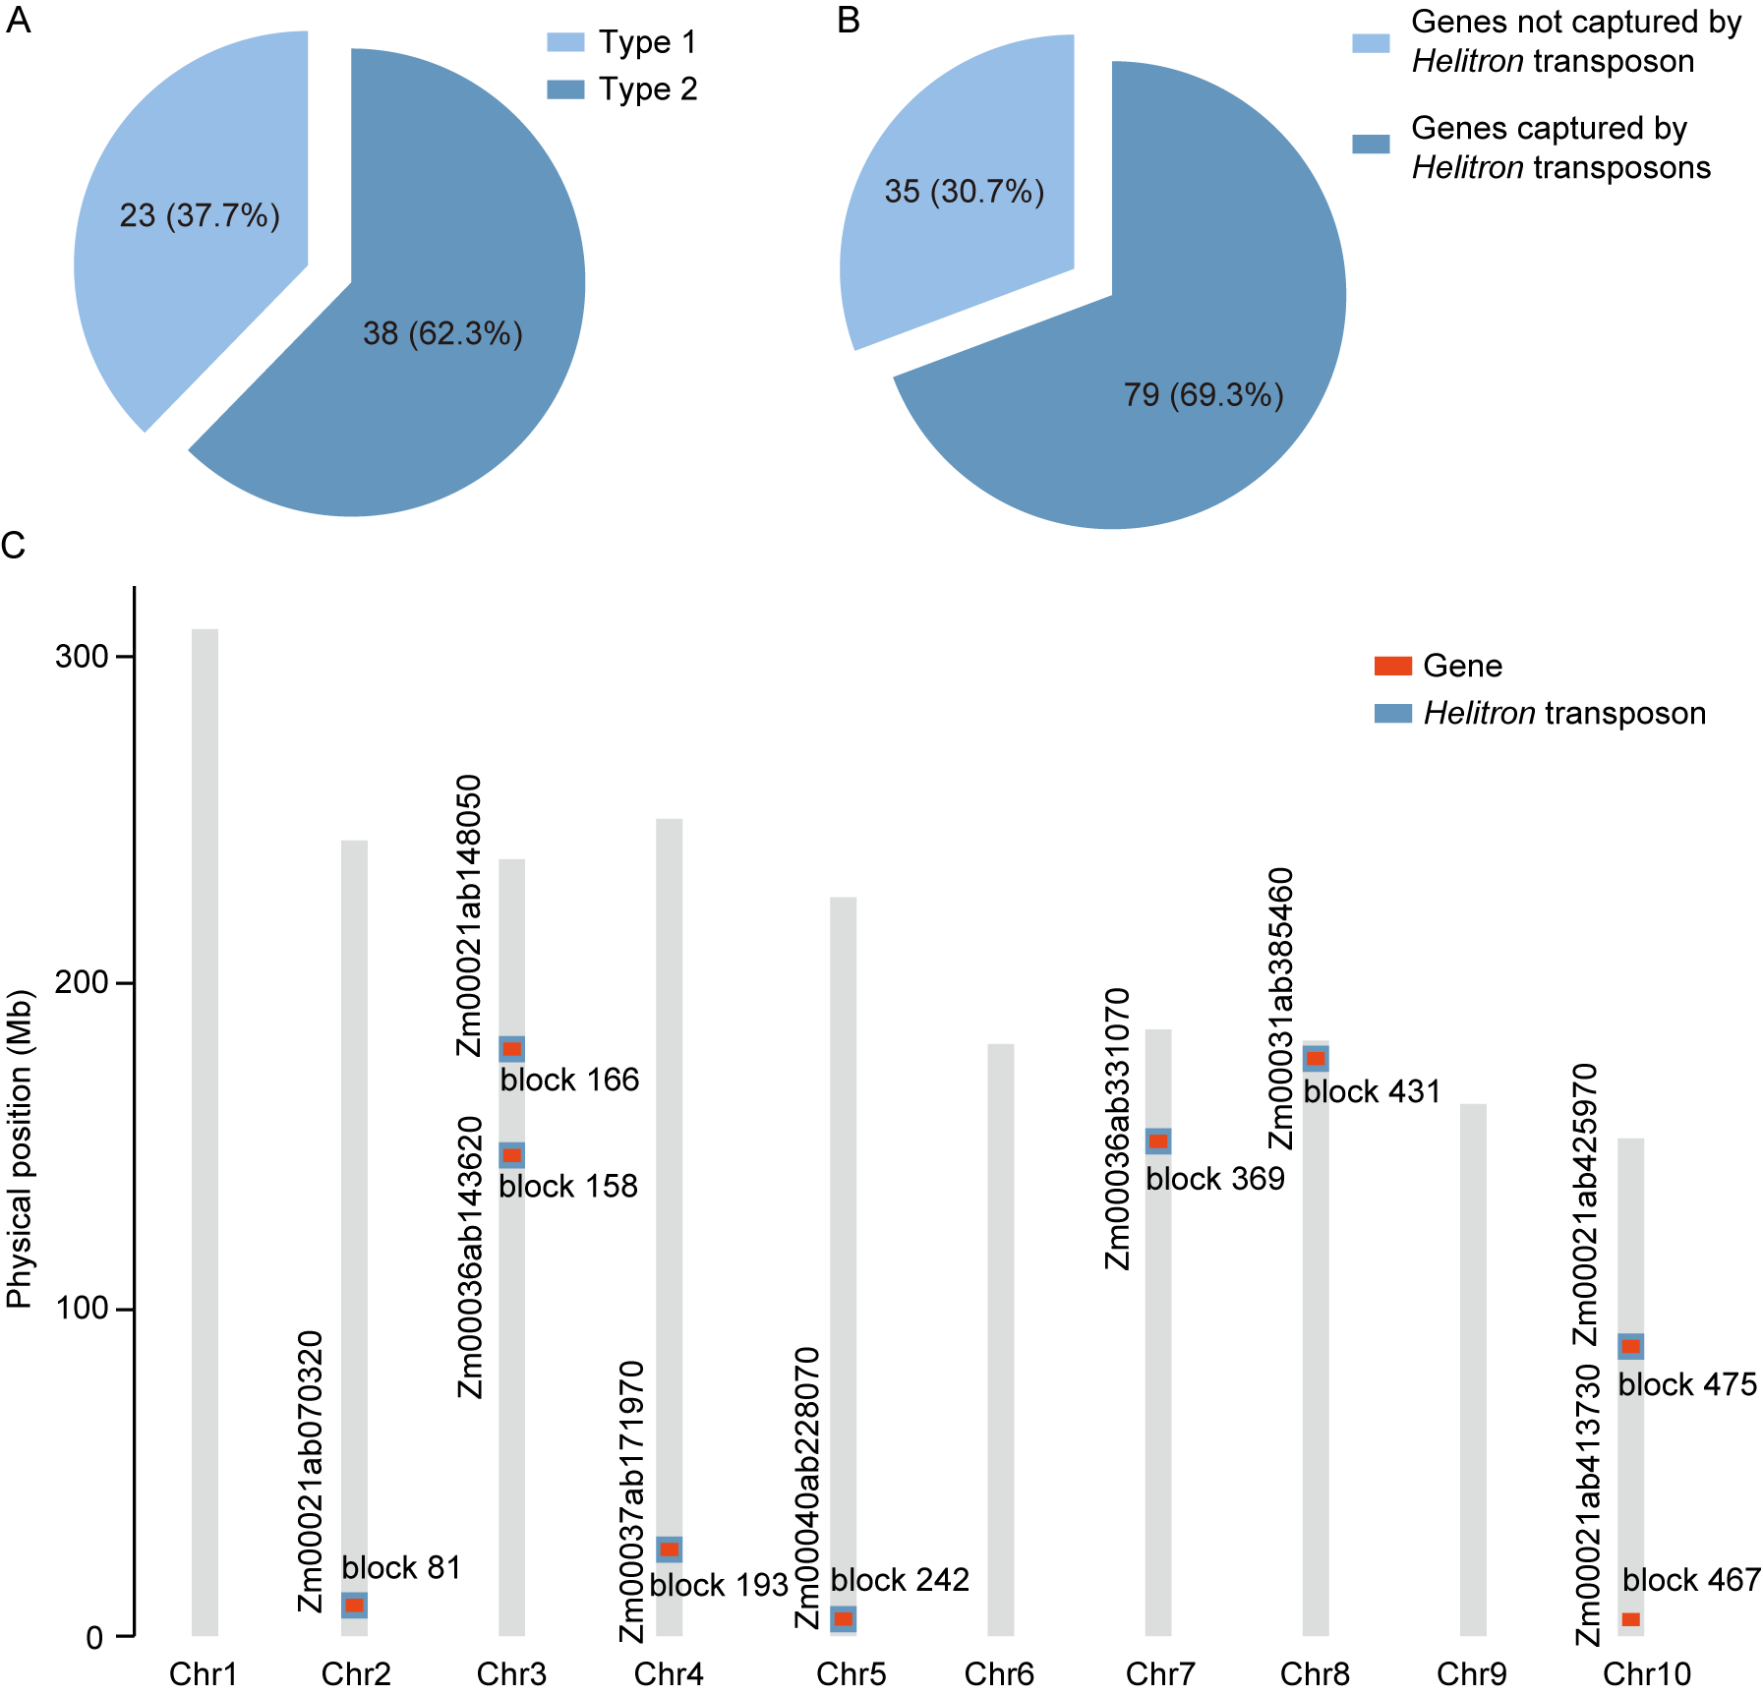
Fig. S8. Distribution of cloud OGs across 26 NAM founder genomes.
(A) Percentage of different types of cloud OGs that are located in 2 or more genomic blocks. Type 1: the OG which does not contain genes that have been captured by Helitron transposons; Type 2: the OG which contains genes that have been captured by Helitron transposons. (B) Percentage of genes in cloud OGs located in 2 or more genomic blocks that appear to have been captured by Helitron transposons. (C) Distribution of nine genes in OG:035_1 across 10 chromosomes. WD40 genes and Helitron transposons are represented with red and blue boxes, respectively. The sequences and physical locations of Helitron transposons in the NAM genome were downloaded from maizeGDB (https://www.maizegdb.org/).

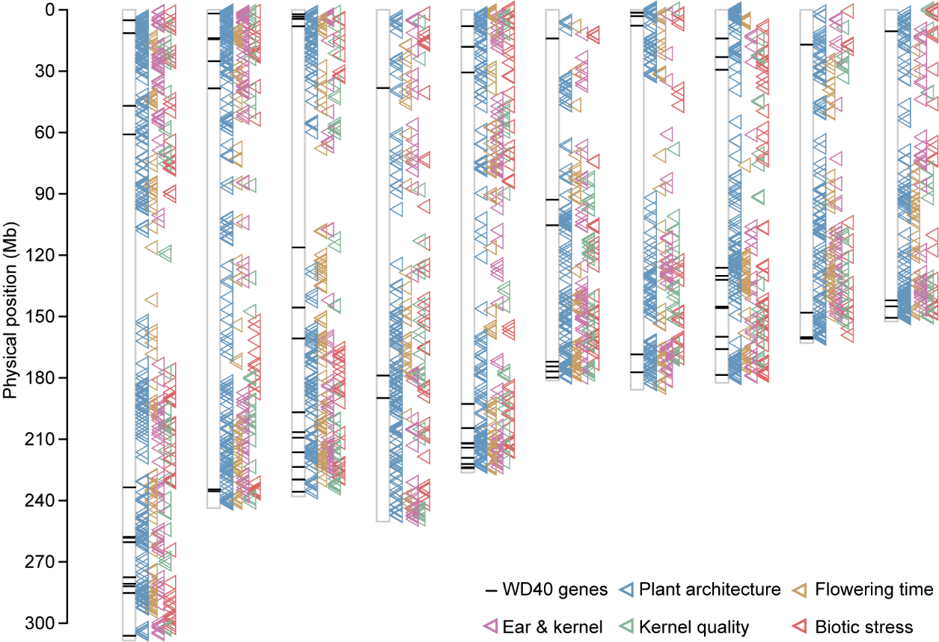
Fig. S9. Associations between WD40 genes and 25 tested traits identified in previous GWASs using the NAM population.
Horizontal lines on the chromosomes show the positions of 87 trait-associated WD40 genes. Triangles represent all significantly associated loci, with different colors indicating different trait types.

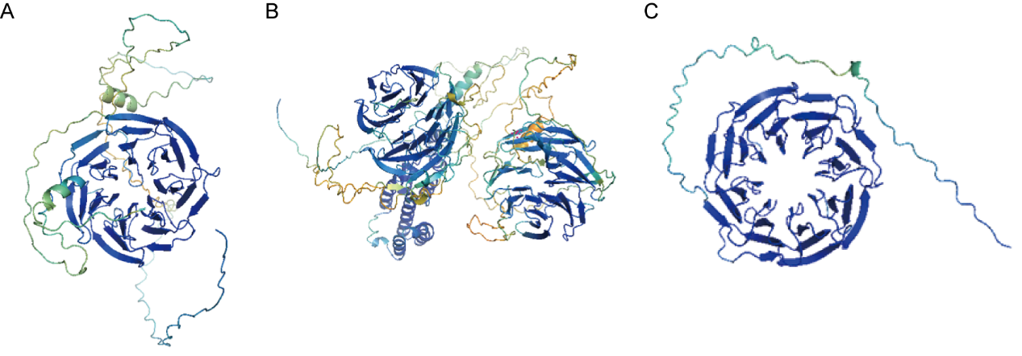
Fig. S10. 3D protein structures of four trait-associated WD40 genes.
Zm00001eb001710 and Zm00001eb403730 (OG:055_0/095_0) (A), Zm00001eb398420 (OG:009_0) (B), and Zm00001eb139680 (OG:111_0/196_306_308_2) (C). The protein structures are color-coded on the basis of per-residue confidence scores (pLDDT). Blue, high (average pLDDT > 75); turquoise, confident (50 < average pLDDT ≤ 75); orange, low (25 < average pLDDT ≤ 50); red, very low (average pLDDT ≤ 25).

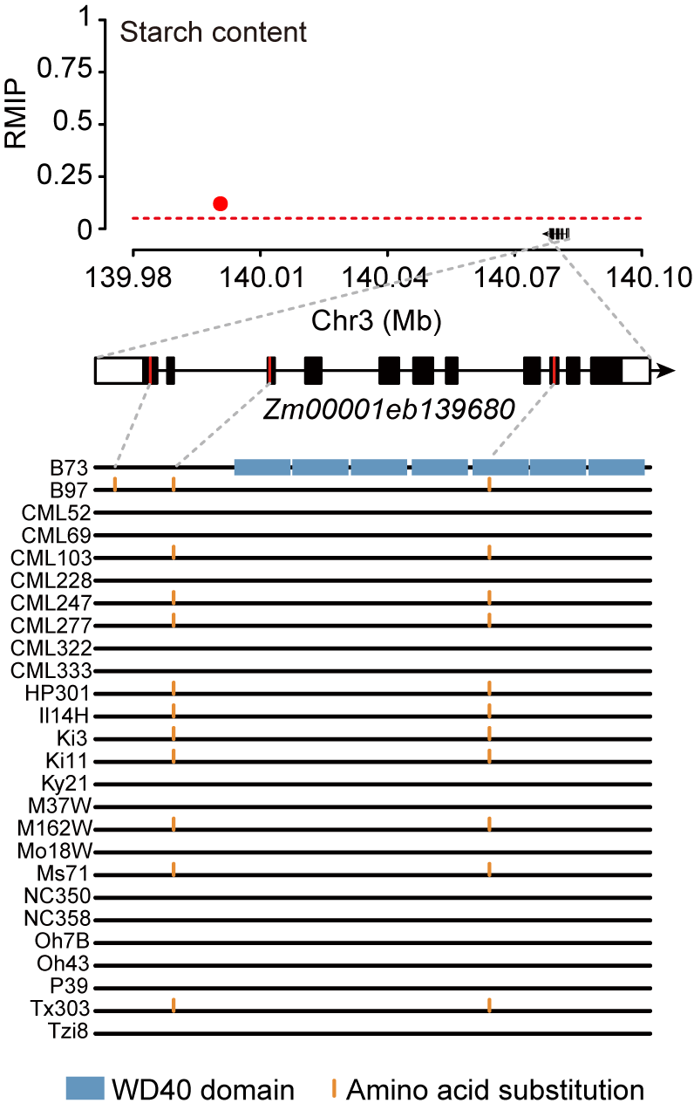
Fig. S11. Association of Zm00001eb139680 with starch content.
The top panel shows GWAS results from Cook et al. [56]. The red dashed line represents the GWAS threshold. The gene structure of Zm00001eb139680 is shown in the middle panel. Black boxes, exons; white boxes, UTRs. The red lines indicate the positions of polymorphic sites in coding regions of the 26 NAM founders. Detailed information on these polymorphic sites is shown in the panel below. The 26 black lines represent the protein sequences of the NAM founders. WD40 domains are represented with dark blue boxes in B73. Amino acid substitutions, identified by alignment to the B73 reference sequence, are indicated by orange vertical lines.

The script used for random selection of NAM founders in Saturation analysis
def rand_select(keys,n,i):
idx = 0
select_lst = []
while idx < i:
rand_select = random.sample(keys,n)
rand_select.sort()
idx = idx + 1
return select_lst
keys: a list of names of 26 NAM founders; n: the number of inbred lines sampled each time, with a value ranging from 2 to 24; i: 1000 random simulations

