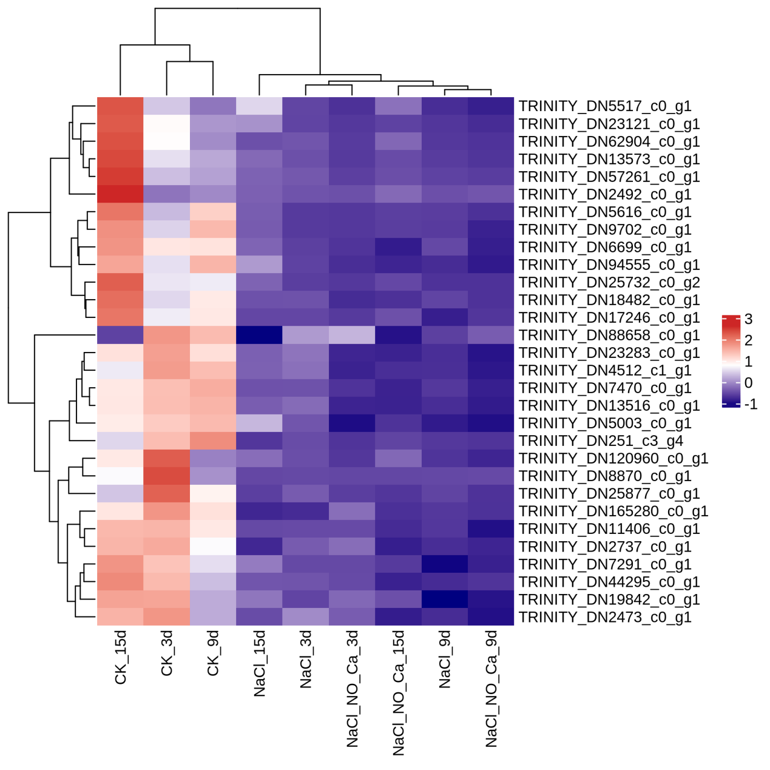
Figure S1 The heat map of upregulated and downregulated genes expression under different treatment.

