Supplemental Table1. The summary information on illumina transcriptome and assembly statistics for the Air and Sea group.
Parameters |  | Air group |  | Sea group
Total clean reads  Total clean nucleotides（bp）  Q30（%）  GC percentage（%） |  | 68,744,734  20,580,513,121  94.06  56.25 |  | 68,952,634  20,643,950,764  94.56  55.57
Assembly statistics
Total unigenes  Total length of unigenes（bp）  Mean length of unigenes（bp）  N50 length of unigenes（bp）  1000-2000 length of unigenes（%） |  | 99,970  98,770,360  988  1,687  20.12 |  | 93,683  89,279,899  953  1,588  20.30

Supplemental Table 2. The annotation statistics.
Databases | Number of unigenes | Percentage
Nr  GO  COG  Pfam  SwissPort  KOG  KEGG  All | 27,369  17,441  4,824  18,083  10,478  13,313  16,232  28,132 | 54.36%  34.64%  9.58%  35.91%  20.81%  26.44%  32.24%  55.88%

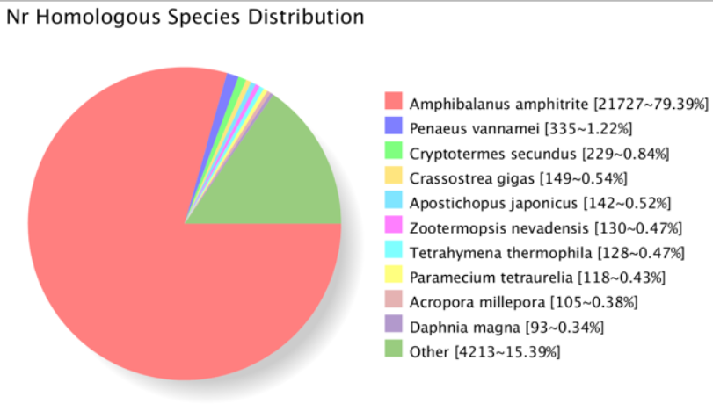
Supplemental Fig. 1 Distribution of the species similarity based on the NR database. The number indicated the percentages of genes were annotated by the species.

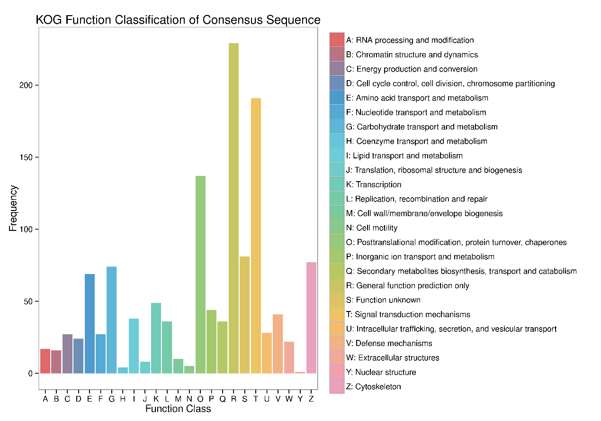
Supplemental Fig. 2. The functional classification of assembled unigenes based on the KOG database.

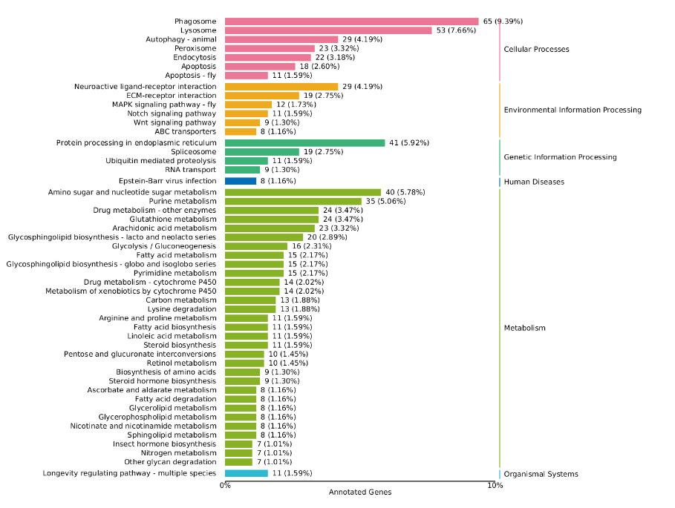
Supplemental Fig. 3. The KEGG annotation of assembled genes.

