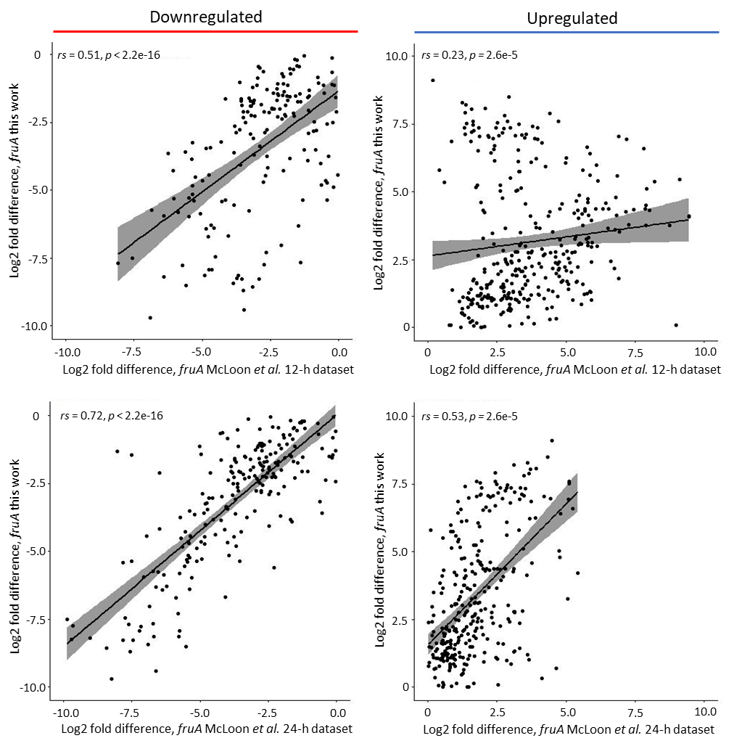

Additional file 12 Spearman correlation analysis for genes observed to be differentially downregulated (left) or upregulated (right) in the fruA mutants of the McLoon et al. (78) 12-h (top) and 24-h (bottom) datasets and this work. A linear, smoothed trendline is overlaid for illustrative purposes.

