Supplementary Figure 1. Sample clustering.
Sample clustering. Clustering was performed to eliminate outlier samples. There were no outliers in that clustering tree.

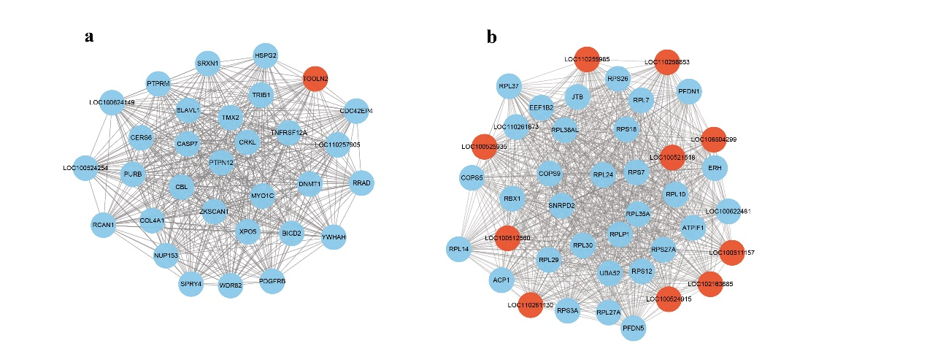
Supplementary Figure 2 Visualisation of the top 30 hub mRNAs and all hub lncRNAs in specific modules
The top hub mRNA was selected based on MM values. Red represents lncRNAs, and blue represents mRNAs. (a) magenta modulea, (b) turquoise module.

