Metabolomics and transcriptomics analyses reveal the complex molecular mechanisms by which the hypothalamus regulates sexual development in female goats
Qing Li; Tianle Chao; Yanyan Wang; Peipei He; Lu Zhang; Jianmin Wang

Supplementary figure

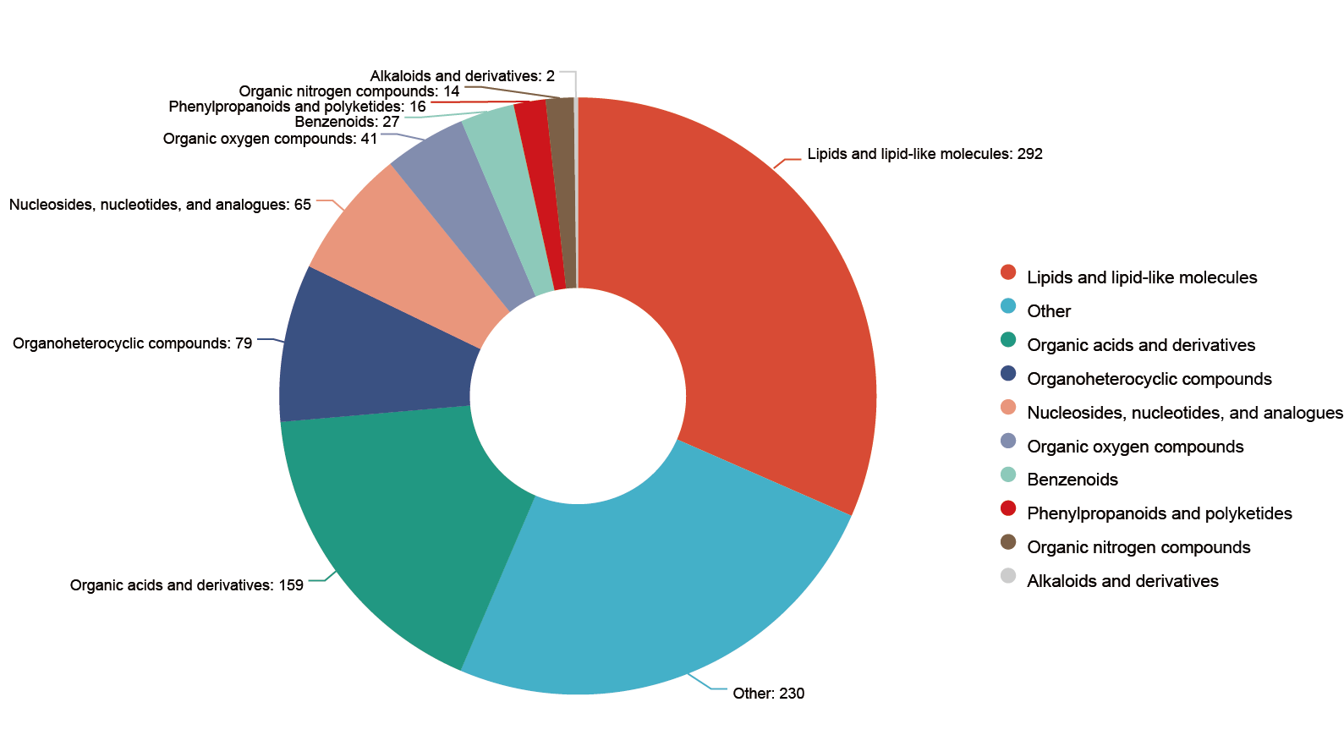
Figure S1. Pie chart shows the relative composition of hypothalamic metabolites in goats at different developmental stages.
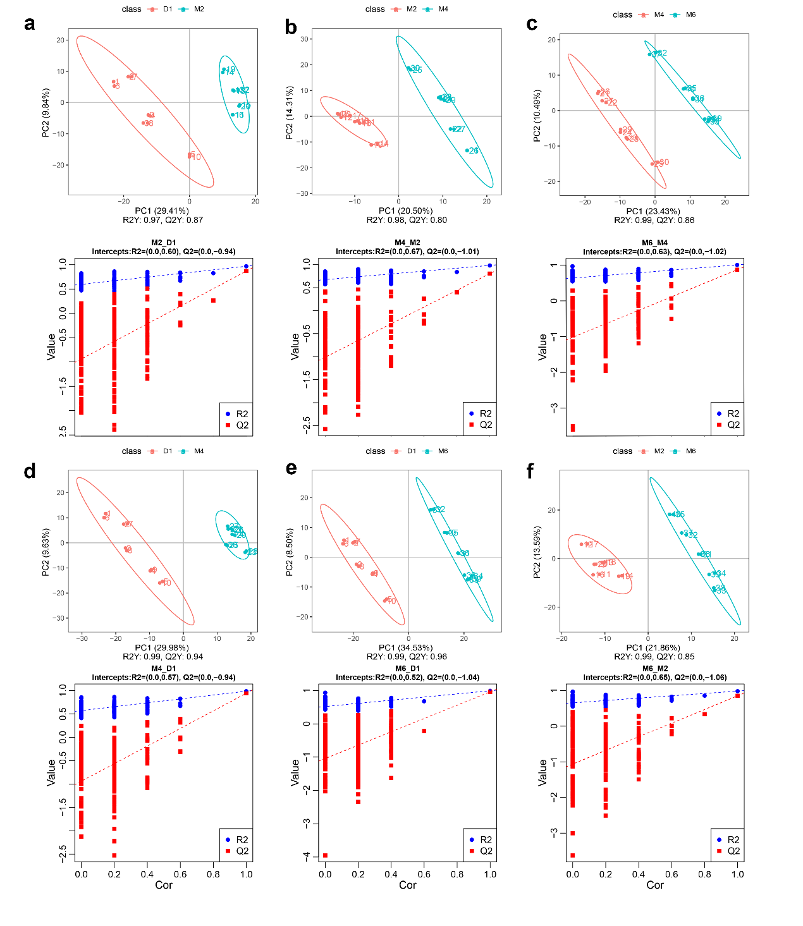
Figure S2. Multivariate statistical analysis of hypothalamic metabolomics data based on LS-MS/MS. (a)-(f): Principal component analysis (PCA) diagram and partial least squares discriminant analysis (PLS-DA) diagram of M2 vs. D1, M4 vs. M2, M6 vs. M4, M4 vs. D1, M6 vs. D1 and M6 vs. M2.
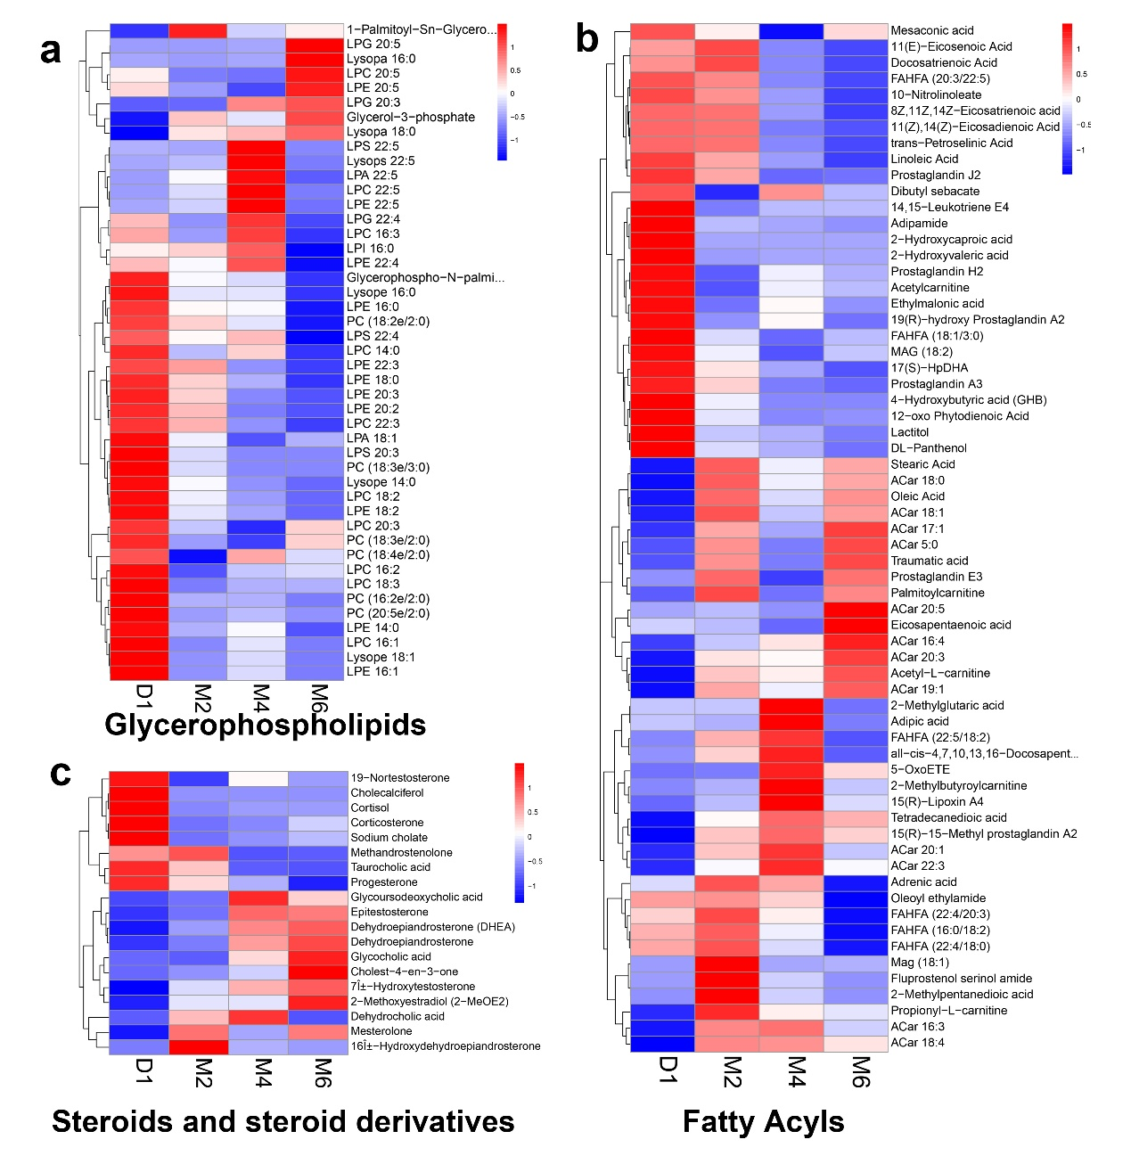
Figure S3. Calorimetric map of hypothalamic lipid metabolites expression during sexual maturation of Jining grey goats. (a) Glycerophospholipids. (b) Fatty acyls. (c) Steroids and steroid derivatives. Red represents high expression metabolites and blue represents low expression metabolites.
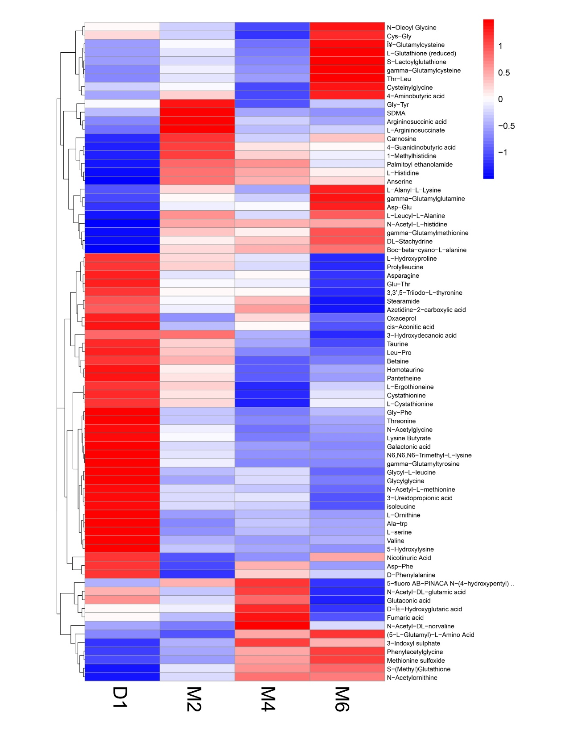
Figure S4. Calorimetric map of expression of organic acid metabolites in hypothalamus during sexual maturation of Jining grey goats. (a) Organic acids and derivatives. (b) Organoheterocyclic compounds (c) Nucleoside, nucleotides,and analogues. Red represents high expression metabolites and blue represents low expression metabolites.
Figure S5. Soft-thresholding power analysis was used to obtain the scale-free fit index of network topology. (a) The metabolome β values are confirmed. (b) The transcriptome β values are confirmed.
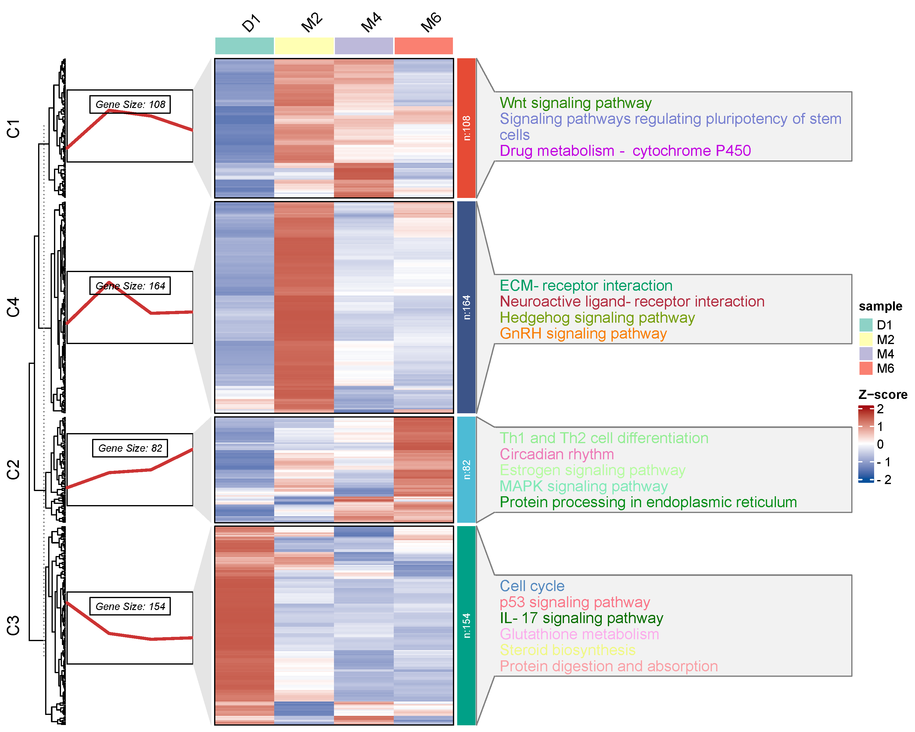
Figure S6. Heatmaps of DEGs and hierarchical clustering KEGG annotated maps of 4 stages of postnatal sexual development of Jining grey goats. The color represents the expression value of DEGs after normalization adjustment. Red and blue indicate up and down, respectively.
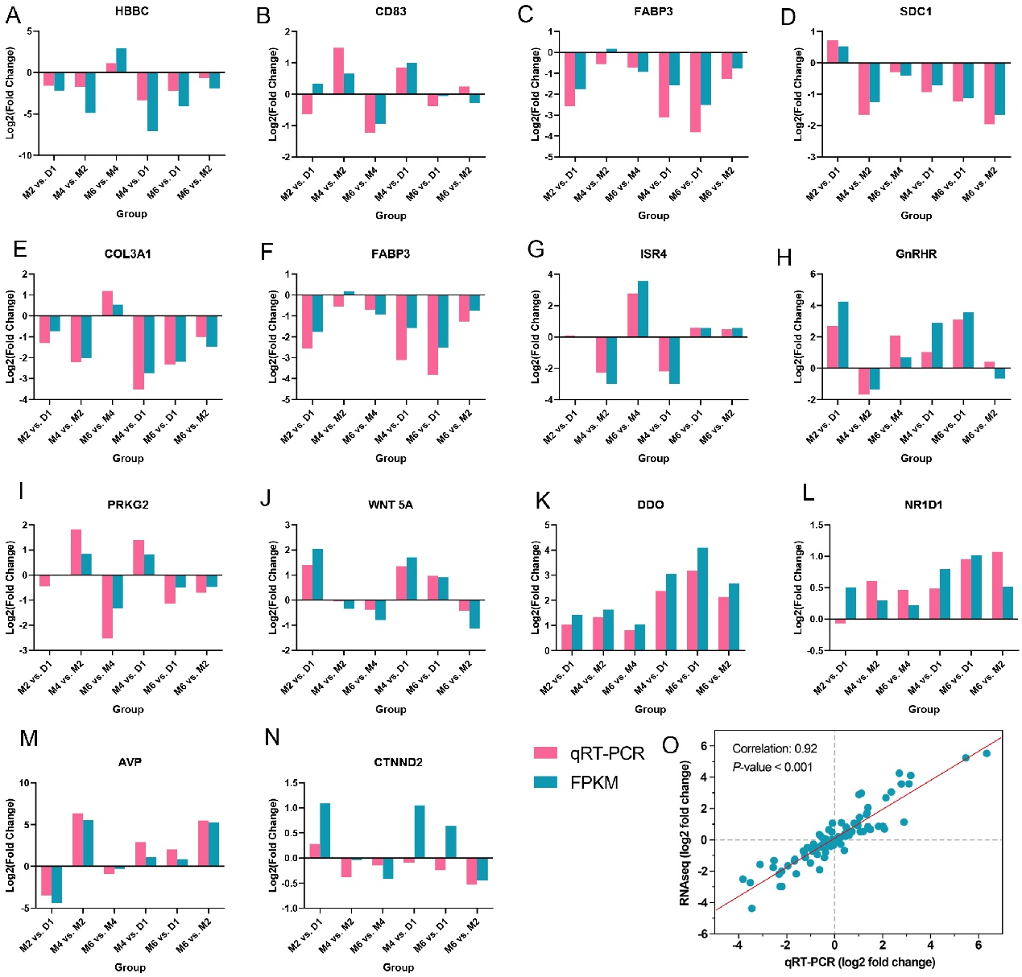
Figure S7. Quantitative validation of goat hypothalamus transcriptome data. (A–M): The X-axis represents different comparison groups, and the Y-axis represents log2(FoldChange) of qRT-PCR and RNA-seq. (N): The Correlation between qRT-PCR and RNA-seq (log2(FoldChange)).

