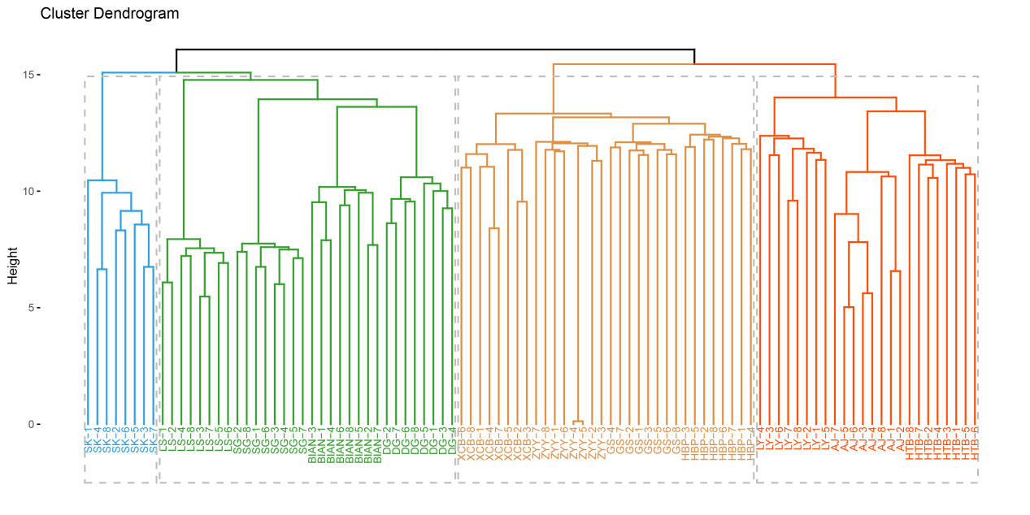
Figure S1. Hierarchical Clustering Results of IBS Tree for Genetic Donor Breeds of Beijing You Chicken.
To better understand the phylogenies, we first performed hierarchical clustering on the IBS tree of BY ’s genetic donor breeds, specifying 4 lineages. The blue lineage includes Silkies (SK). The green lineage includes Langshan chicken (LS), Shouguang chicken (SG), Bian chicken (BIAN), and Dagu chicken (DG). The orange lineage consists of Xichuan Black-bone chicken (XCB), Zhengyang Yellow chicken (ZYY), Gushi chicken (GS), and Huaibei Partridge chicken (HBP). The red lineage includes Liyang chicken (LY), Aijiao chicken (AJ), and Hetian Black chicken (HTB).

