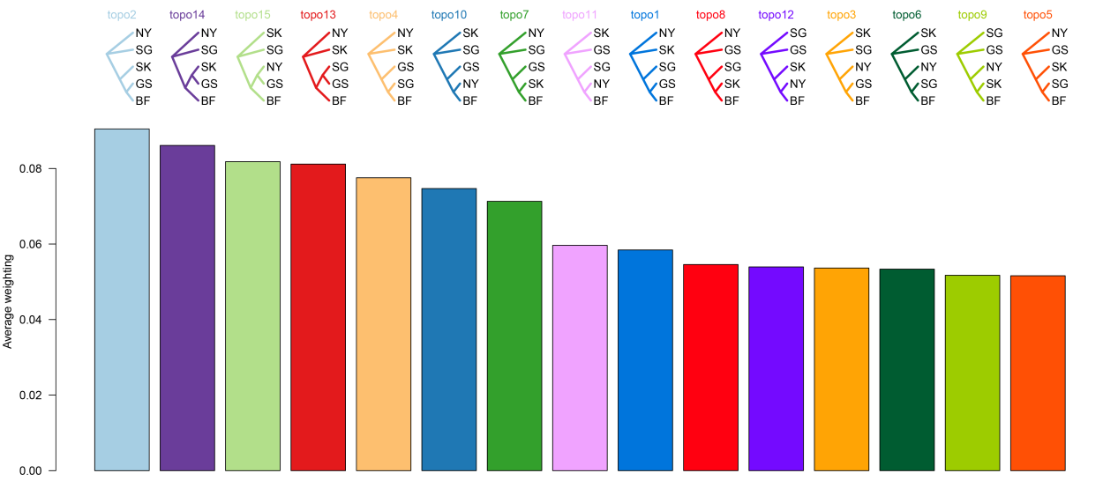
Figure S2. Results of the Genome-Wide Topologies and Their Weights from Twisst Analysis.
We selected one representative genetic donor population from each cluster based on the hierarchical clustering results of the IBS Tree for the Twisst analysis, namely Silkies (SK), Shouguang chicken (SG), Gushi chicken (GS), and Hetian Black chicken (HTB). The results indicated no dominant topology among the various topologies among the various topologies across the genomic blocks.

