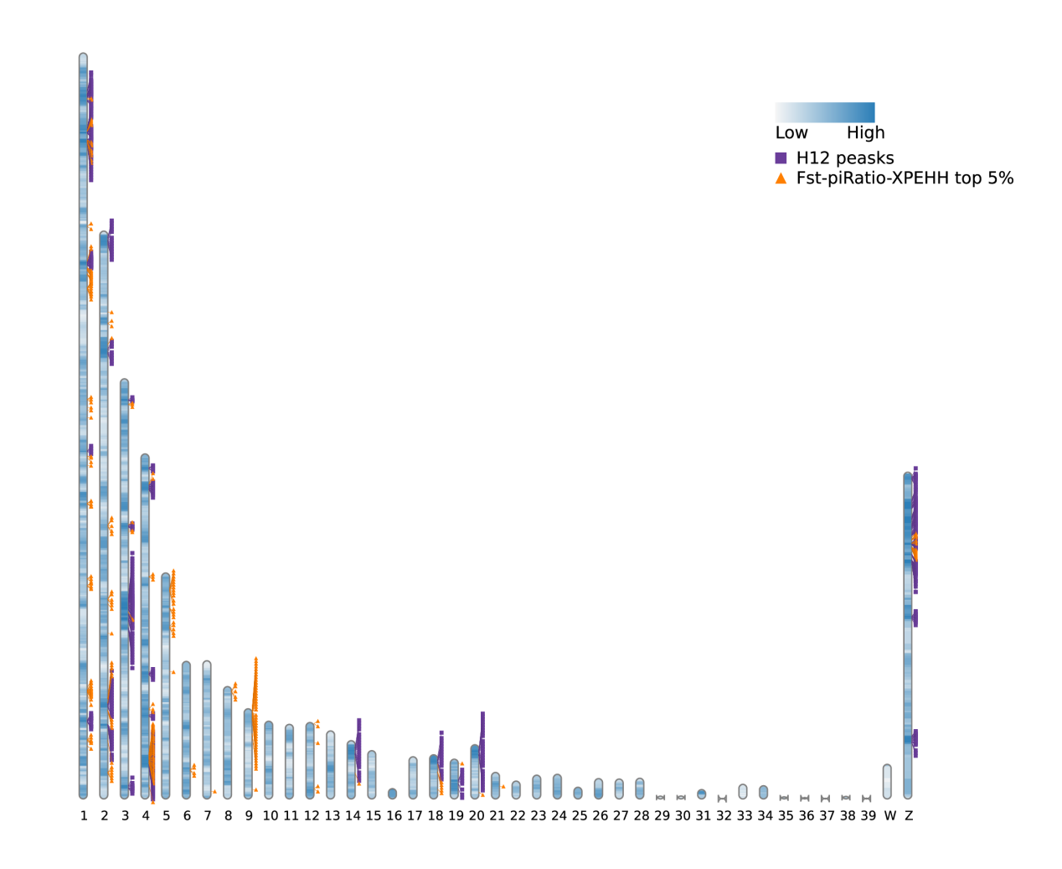
Figure S7. Distribution of selected regions by the three methods and the ancestry H12 peaks in BY_F.

