Allelic variation in a cluster of epsilon Glutathione S-transferase genes contributes to DDT and pyrethroid resistance in the major African malaria vector An. funestus

Supplementary materials
Supplementary Table 1: List of primers used in this study
Supplementary Table 2: Contemporary expression profile of the GSTe genes cluster in An. funestus populations across Africa.
Supplementary Figure 1: H1X signal of shared selective sweep at the GSTe locus in An. funestus across Africa
Supplementary Figure 2: Population studies of GSTe6 coding region across Africa
Supplementary Figure 3: Evaluation of the quality of GSTes structure model using Errat
Supplementary Table 3: GSTes proteins CNDB assay
Supplementary Figure 4: GSTes affinity with permethrin
Supplementary Figure 5: GSTes affinity with deltamethrin
Supplementary Figure 6: Alpha-cypermethrin bioassays result with transgenic flies
Supplementary Figure 7: Confirmation of GSTes expression in transgenic flies expressing GSTe3, GSTe4 and GSTe6 trough semi-quantitative PCR

Supplementary Table 1: List of primers used in this study.
Genes | Primer name | Sequences | Amplicon size (bp)
Polymorphism survey
GSTe3 | GSTe3 Forward | ATGGCACCGATCGTTTTGTA | 850
GSTe3 | GSTe3 Reverse | TTATACTTTGCCGAGCTTCT | 850
GSTe4 | GSTe4 Forward | ATGCCATCGACCATTAAGTT | 785
GSTe4 | GSTe4 Reverse | TCACTTAGATTTTGCACGAT | 785
GSTe6 | GSTe6 Forward | ATGTCTAAGAAGCAGGTTCT | 857
GSTe6 | GSTe6 Reverse | TTAATTCGCACTATTCTTTG | 857
Transgenic expression of GSTes in Drosophila melanogaster flies
GSTe3 | GSTe3-BglII F | AGATCTATGGCACCGATCGTTTTGTA | 850
GSTe3 | GSTe3- XbaI R | TCTAGATTATACTTTGCCGAGCTTCT | 850
GSTe4 | GSTe4-BglII F | AGATCTATGCCATCGACCATTAAGTT | 785
GSTe4 | GSTe4-XbaI R | TCTAGATCACTTAGATTTTGCACGAT | 785
GSTe6 | GSTe6-BglII F | AGATCTATGTCTAAGAAGCAGGTTCT | 857
GSTe6 | GSTe6- XbaI R | TCTAGATTAATTCGCACTATTCTTTG | 857
Semi-quantitative PCR
GSTe3 | qGSTe3 F | CCAACCGTTTTGGCATATCT | 197
GSTe3 | qGSTe3 R | TTTCTCACTGAGTACTTTGCCTTTT | 197
GSTe4 | qGSTe4 F | ATTGCGATTCTATGCGGAAC | 218
GSTe4 | qGSTe4 R | GCTTCGGATAGTTGGCTTCA | 218
GSTe6 | qGSTe6 F | GGAGGTGACTGTTCGTGGAT | 161
GSTe6 | qGSTe6 R | TCCGTCCTCGAAGGTAGGTA | 161
GSTes proteins expression
GSTe3 | GSTe3- NdeI F | GAATTCCATATGGCACCGATCGTTTTGTA | 850
GSTe3 | GSTe3- XhoI R | CCGCTCGAGTTATACTTTGCCGAGCTTCT | 850
GSTe4 | GSTe4- NdeI F | GAATTCCATATGCCATCGACCATTAAGTT | 785
GSTe4 | GSTe4- EcoRI R | CCGGAATTCACTTAGATTTTGCACGAT | 785
GSTe6 | GSTe6- NdeI F | GAATTC CATATGTCTAAGAAGCAGGTTCT | 857
GSTe6 | GSTe6- XhoI R | CCGCTCGAG TTAATTCGCACTATTCTTTG | 857

Supplementary Table 2: Contemporary expression profile of the GSTe genes cluster in An. funestus populations across Africa.
Gene ID | log2FC | FC | padj | Gene_Name | Treatment_comparison
AFUN015807 | 1.99 | 3.98 | 3.10E-06 | GSTE1 | C.Gha.Unx22_vs_S.Fang
AFUN015807 | 1.63 | 3.25 | 1.74E-04 | GSTE1 | R.Gha22_vs_S.Fang
AFUN015807 | 1.43 | 2.86 | 9.61E-04 | GSTE1 | R.Cam.Al22_vs_S.Fang
AFUN015807 | 1.40 | 2.81 | 1.08E-03 | GSTE1 | C.Uga.Unx22_vs_S.Fang
AFUN015807 | 1.22 | 2.44 | 6.99E-03 | GSTE1 | R.Uga_Al22_vs_S.Fang
AFUN015807 | 1.17 | 2.35 | 2.10E-03 | GSTE1 | R.Mal.Al22_vs_S.Fang
AFUN015807 | 1.09 | 2.18 | 2.20E-02 | GSTE1 | C.Mal_Unx22_vs_S.Fang
AFUN015807 | 1.04 | 2.08 | 8.46E-03 | GSTE1 | C.Mal_Unx22_vs_C.Mal_Unx15
AFUN015809 | 1.90 | 3.80 | 5.30E-05 | GSTE2 | C.Cam.Unx22_vs_S.Fang
AFUN015809 | 1.33 | 2.65 | 1.35E-02 | GSTE2 | C.Gha.Unx22_vs_C.Gha.Unx15
AFUN015809 | 3.24 | 6.48 | 2.57E-13 | GSTE2 | C.Gha.Unx22_vs_S.Fang
AFUN015809 | 1.55 | 3.10 | 8.53E-04 | GSTE2 | C.Uga.Unx22_vs_S.Fang
AFUN015809 | 2.58 | 5.15 | 1.20E-08 | GSTE2 | R.Cam.Al22_vs_S.Fang
AFUN015809 | 3.03 | 6.07 | 8.06E-12 | GSTE2 | R.Gha22_vs_S.Fang
AFUN015809 | 1.20 | 2.41 | 3.86E-03 | GSTE2 | R.Mal.Al22_vs_S.Fang
AFUN015809 | 1.51 | 3.03 | 4.82E-04 | GSTE2 | R.Uga_Al22_vs_R.Uga_Al15
AFUN015809 | 2.37 | 4.73 | 2.52E-07 | GSTE2 | R.Uga_Al22_vs_S.Fang
AFUN015808 | 1.60 | 3.20 | 3.09E-07 | GSTE3 | R.Gha22_vs_S.Fang
AFUN015808 | 1.60 | 3.19 | 4.24E-07 | GSTE3 | C.Gha.Unx22_vs_S.Fang
AFUN015808 | 1.20 | 2.39 | 2.39E-04 | GSTE3 | R.Uga_Al22_vs_S.Fang
AFUN015808 | 1.19 | 2.38 | 2.54E-04 | GSTE3 | C.Cam.Unx22_vs_S.Fang
AFUN015808 | 1.11 | 2.21 | 5.74E-04 | GSTE3 | R.Cam.Al22_vs_S.Fang
AFUN015810 | 1.03 | 2.06 | 2.44E-02 | GSTE4 | C.Gha.Unx22_vs_C.Gha.Unx15
AFUN015810 | 1.83 | 3.66 | 3.93E-06 | GSTE4 | C.Gha.Unx22_vs_S.Fang
AFUN015810 | 1.21 | 2.41 | 2.64E-03 | GSTE4 | R.Cam.Al22_vs_S.Fang
AFUN015810 | 1.81 | 3.62 | 3.45E-06 | GSTE4 | R.Gha22_vs_S.Fang
AFUN015810 | 1.02 | 2.04 | 1.59E-02 | GSTE4 | R.Uga_Al22_vs_S.Fang
AFUN015811 | 1.02 | 2.05 | 1.56E-04 | GSTE5 | C.Cam.Unx22_vs_S.Fang
AFUN015811 | 1.57 | 3.15 | 1.00E-09 | GSTE5 | C.Gha.Unx22_vs_S.Fang
AFUN015811 | 1.35 | 2.70 | 1.48E-07 | GSTE5 | C.Uga.Unx22_vs_S.Fang
AFUN015811 | 1.50 | 3.00 | 6.11E-09 | GSTE5 | R.Cam.Al22_vs_S.Fang
AFUN015811 | 1.17 | 2.34 | 1.13E-05 | GSTE5 | R.Gha22_vs_S.Fang
AFUN016008 | 1.20 | 2.41 | 6.38E-06 | GSTE6 | C.Cam.Unx22_vs_S.Fang
AFUN016008 | 1.54 | 3.08 | 2.64E-09 | GSTE6 | C.Gha.Unx22_vs_S.Fang
AFUN016008 | 1.07 | 2.15 | 1.04E-04 | GSTE6 | C.Mal_Unx22_vs_S.Fang
AFUN016008 | 1.60 | 3.21 | 2.09E-10 | GSTE6 | C.Uga.Unx22_vs_S.Fang
AFUN016008 | 1.59 | 3.18 | 6.77E-10 | GSTE6 | R.Cam.Al22_vs_S.Fang
AFUN016008 | 1.37 | 2.74 | 1.80E-07 | GSTE6 | R.Gha22_vs_S.Fang
AFUN016008 | 1.44 | 2.87 | 6.81E-10 | GSTE6 | R.Mal.Al22_vs_S.Fang
AFUN016008 | 1.29 | 2.59 | 1.02E-06 | GSTE6 | R.Uga_Al22_vs_S.Fang
AFUN001774 | 1.11 | 2.23 | 6.24E-03 | GSTE7 | C.Gha.Unx22_vs_C.Gha.Unx15
AFUN001774 | 1.21 | 2.41 | 1.26E-03 | GSTE7 | C.Gha.Unx22_vs_S.Fang
AFUN001774 | 1.52 | 3.03 | 3.81E-06 | GSTE7 | R.Gha_Al22vs_R.Gha15
The table presents the differential expression profile of GSTes (Glutathione S-Transferase Epsilon class) genes in An. funestus populations across Africa. Log₂FC (Log₂ Fold Change) measures the difference in gene expression between populations on a logarithmic scale (base 2), where a positive value indicates upregulation and a negative value indicates downregulation. FC (Fold Change) represents the ratio of gene expression levels between two conditions on a linear scale. padj (Adjusted p-value) indicates statistical significance, corrected for multiple testing using the False Discovery Rate (FDR), with values < 0.05 considered significant. The Treatment Comparison column shows the pairwise comparisons of mosquito populations: C = Control (Unexposed), R = Resistant, S = Susceptible, Cam = Cameroon, Gha = Ghana, Mal = Malawi, Uga = Uganda, and Fang = An. funestus fully susceptible reference strain from Angola.

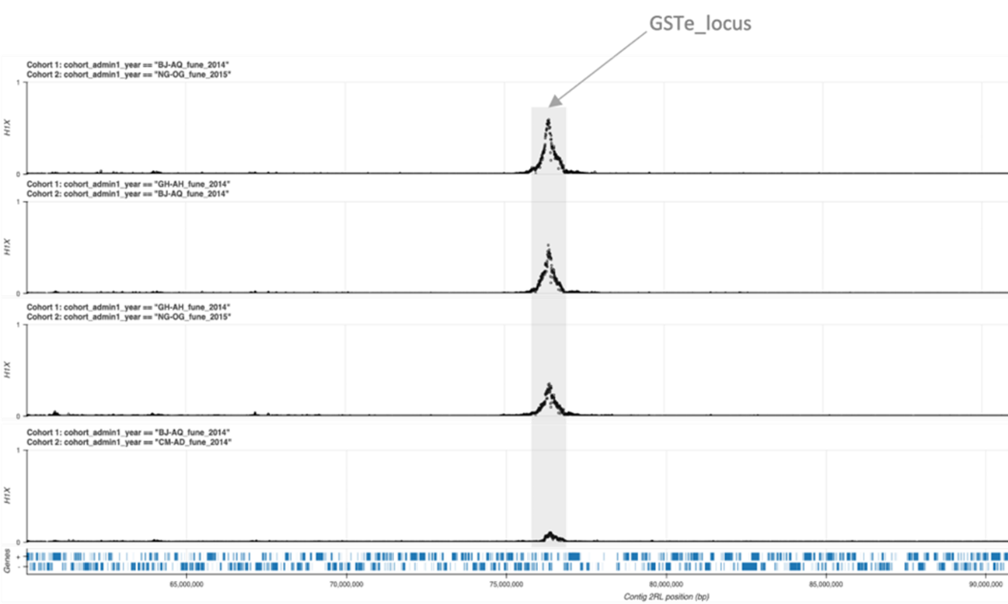Supplementary Figure 1: H_{1X} signal of shared selective sweep at the GSTe locus in An. funestus across Africa.

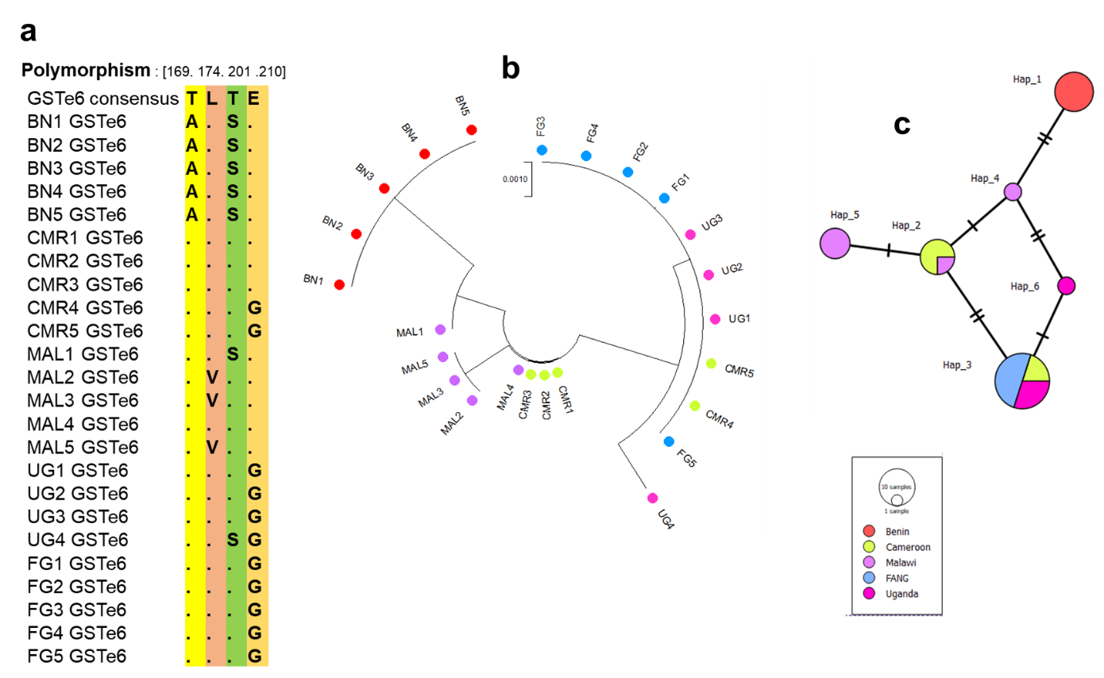
Supplementary Figure 2: Population studies of GSTe6 coding region across Africa. A) comparative GSTe6 amino acid change between An. funestus populations; b) GSTe6 phylogenetic tree; c) Haplotype diversity network: Benin sample are conserved and share one haplotype alone when the dominant haplotype 3 is being shared between susceptible lab strain FANG, Cameroun and Uganda. (BN: Benin; CMR: Cameroon; MAL: Malawi; UG: Uganda).

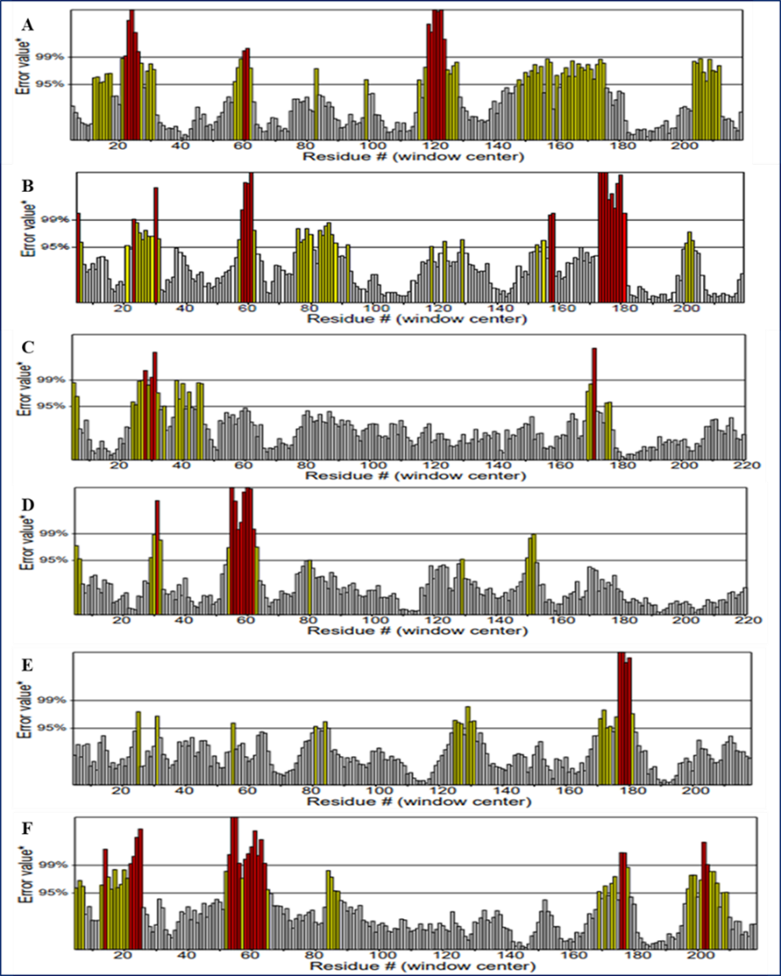
Supplementary Figure 3: Evaluation of the quality of GSTes structure model using Errat. a) BN-GSTe3; b) MAL-GSTe3; c) BN-GSTe4; d) MAL-GSTe4; e) BN-GSTe6 et f) MAL-GSTe6. All the structure has the quality factor > 50% chowing that all models are good quality.

Supplementary Table 3: GSTe proteins CNDB assay.
GSTe alleles | CNDB activity (µM/ml/min)
BN-GSTe3 | 23.357
MAL-GSTe3 | 21.352
BN-GSTe4 | 14.0141
MAL-GSTe4 | 18.571
BN-GSTe6 | 10.596
CMR-GSTe6 | 6.722

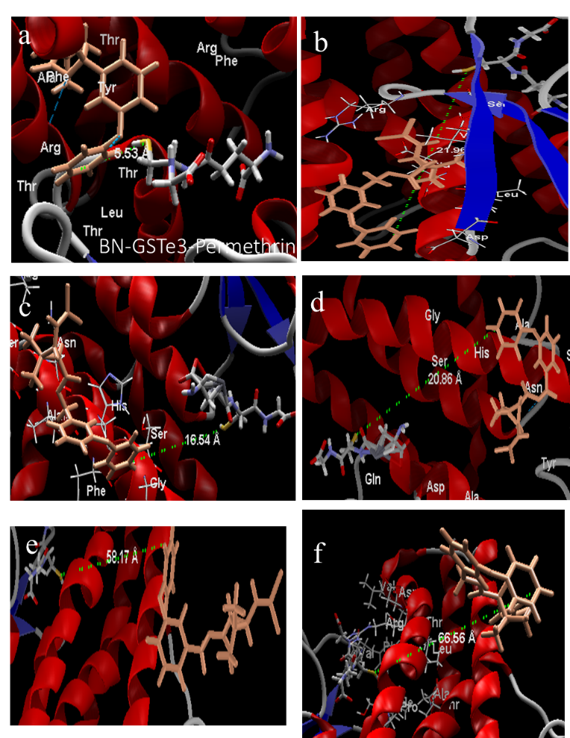
Supplementary Figure 4: Binding conformation of GSTe models toward permethrin. a) BN-GSTe3; b) MAL-GSTe3; c) BN-GSTe4; d) MAL-GSTe4; e) BN-GSTe6 and f) CMR-GSTe6.

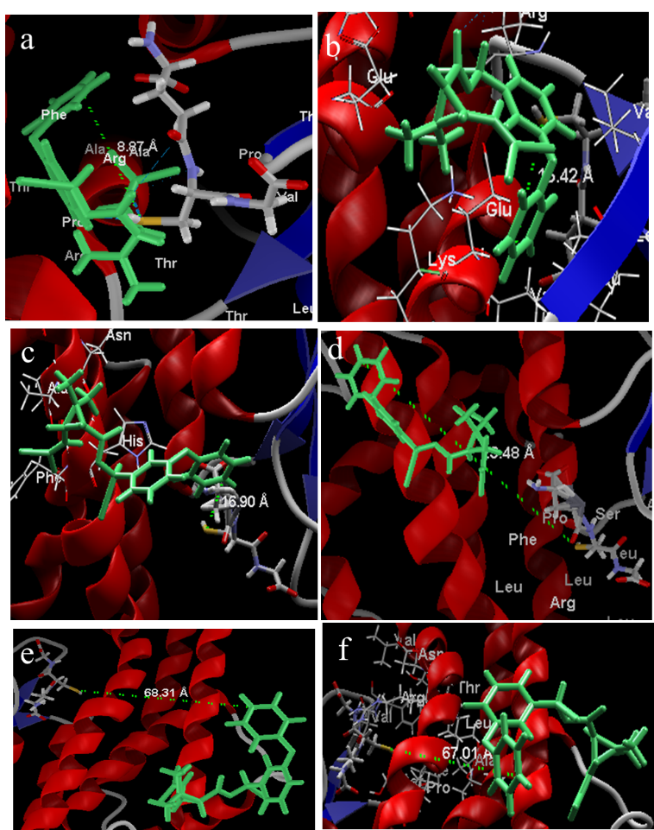
Supplementary Figure 5 Binding conformation of GSTe models toward deltamethrin. A) BN-GSTe3; B) MAL-GSTe3; C) BN-GSTe4; D) MAL-GSTe4; E) BN-GSTe6 and F) CMR-GSTe6.

Supplementary figure 6: Bioassays with alpha-cypermethrin using transgenic flies expressing recombinant GSTes. A) transgenic flies expressing recombinant GSTe3; B) transgenic flies expressing recombinant GSTe4; C) transgenic flies expressing recombinant GSTe6. (p-value: * p<0.05. and ** p<0.01).

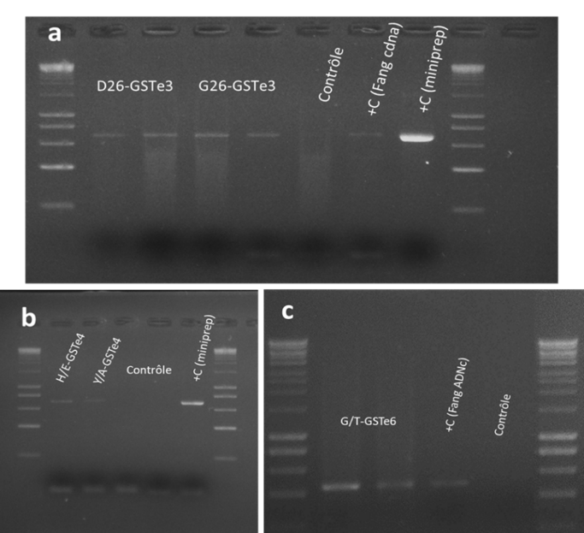
Supplementary figure 7: Confirmation of GSTes expression in transgenic flies expressing GSTe3, GSTe4 and GSTe6 trough semi-quantitative PCR. a) GSTe3; b) GSTe4; c) GSTe6. Bands of GSTes were observed in transgenic Drosophila and no bands were observed in control Drosophila, demonstrating the expression of GSTe3, GSTe4 and GSTe6 by GSTe3, GSTe4 and GSTe6 transgenic Drosophila respectively and the absence of An. funestus GSTes expression of in control Drosophila.

