S1 Table. All 402 nsSNPs of the AVPR1a gene including their ID, position, and amino acid change.
Serial No | SNP ID | variant | AA Substitution with Position
1 | rs113578517 | G>A,T | Phe308Leu
2 | rs1042615 | A>C,G,T | Phe136Leu
3 | rs2228154 | C>T | Gly6Ser
4 | rs2228155 | T>A,C | Gln161His
5 | rs61734518 | C>A | Gly399Val
6 | rs74745181 | C>A,T | Ala25Ser / Ala25Thr
7 | rs112945642 | C>T | Ala227Thr
8 | rs118093149 | C>A,T | Ala34Ser / Ala34Thr
9 | rs138652515 | T>A | Asp377Val
10 | rs141209147 | G>A,C | Phe270Leu
11 | rs142990953 | T>A | Ile55Phe
12 | rs143654785 | G>A,C | Thr398Met / Thr398Arg
13 | rs144329263 | G>C,T | Phe413Leu
14 | rs144823008 | C>A,G | Val57Leu
15 | rs146103040 | T>C,G | Tyr115Cys / Tyr115Ser
16 | rs146296879 | G>A,C | Leu160Val
17 | rs146970048 | G>A | Ala252Val
18 | rs147770997 | T>C | Asn47Asp
19 | rs151327743 | G>A,C | Asn327Lys
20 | rs180760072 | A>C,G | Phe133Cys / Phe133Ser
21 | rs183401493 | A>T | Phe373Ile
22 | rs190242785 | T>A | Gln209Leu
23 | rs199684240 | C>A,G,T | Glu193Ter / Glu193Gln / Glu193Lys
24 | rs200628977 | G>A,C | Phe62Leu
25 | rs201078943 | A>G | Ile282Thr
26 | rs201493231 | A>G,T | Cys359Arg / Cys359Ser
27 | rs201500135 | G>A | His77Tyr
28 | rs369310670 | C>A,T | Gly10Val / Gly10Glu
29 | rs369710823 | A>G | Met145Thr
30 | rs369914673 | C>T | Val302Ile
31 | rs372577812 | C>A,G,T | Arg81Leu / Arg81Pro / Arg81His
32 | rs375549087 | C>T | Val143Ile
33 | rs375748105 | C>G,T | Arg43Thr / Arg43Lys
34 | rs376412201 | T>A,C | Met349Leu / Met349Val
35 | rs376518166 | C>T | Gly212Ser
36 | rs377107751 | C>A,T | Val153Leu / Val153Met
37 | rs530784295 | C>A,T | Trp304Leu / Trp304Ter
38 | rs535731753 | T>C | Lys199Arg
39 | rs539390731 | G>A | Leu356Phe
40 | rs541619626 | C>A,T | Trp313Leu / Trp313Ter
41 | rs546723310 | C>T | Ala63Thr
42 | rs546786206 | C>A | Gly223Cys
43 | rs550956477 | C>A,T | Lys280Asn
44 | rs552601876 | T>C | Ile330Val
45 | rs560228990 | T>C | Thr61Ala
46 | rs563622430 | G>A,T | His129Gln
47 | rs564189895 | C>G,T | Gly68Arg / Gly68Ser
48 | rs569407663 | C>G,T | Arg30Pro / Arg30Gln
49 | rs576296040 | G>A,C | Arg81Cys / Arg81Gly
50 | rs745458336 | T>C,G | Tyr140Cys / Tyr140Ser
51 | rs745804366 | G>C | Phe363Leu
52 | rs746320911 | G>A,C | Ala273Val / Ala273Gly
53 | rs746853343 | T>C,G | Gln357His
54 | rs747069794 | C>G,T | Val66Leu / Val66Met
55 | rs747324909 | C>A | Gly269Val
56 | rs747558639 | C>G | Trp211Cys
57 | rs748117343 | T>C,G | Met135Val / Met135Leu
58 | rs748303041 | C>G,T | Gly40Arg / Gly40Ser
59 | rs748353963 | C>A,T | Val321Phe / Val321Ile
60 | rs748519112 | G>T | Arg168Ser
61 | rs748572296 | A>C | Phe207Val
62 | rs749186693 | C>G | Ala75Pro
63 | rs750330664 | G>A | Ser325Leu
64 | rs750340208 | G>C | Leu3Val
65 | rs750397223 | A>C,G,T | Trp18Gly / Trp18Arg
66 | rs750597661 | T>C | Ser341Gly
67 | rs750951531 | T>C | Asn391Ser
68 | rs751180151 | C>G | Asp112His
69 | rs751422743 | T>C | Asn14Ser
70 | rs751503737 | G>A | Ala285Val
71 | rs751899146 | C>T | Ala334Thr
72 | rs752200426 | G>A | Arg78Trp
73 | rs752306638 | T>C | Arg383Gly
74 | rs752367784 | G>A | Thr418Ile
75 | rs752737314 | G>A,T | Asn246Lys
76 | rs753214363 | G>A,C,T | Asp121Glu
77 | rs753356567 | T>C | Glu371Gly
78 | rs754016556 | C>A,G | Cys235Phe / Cys235Ser
79 | rs754356744 | G>A | Ser84Phe
80 | rs754449459 | T>A | Gln108His
81 | rs755583933 | G>A,T | Ala51Val / Ala51Asp
82 | rs756603967 | C>A | Arg166Leu
83 | rs756782362 | C>T | Met369Ile
84 | rs756854865 | C>G,T | Gly24Arg / Gly24Ser
85 | rs757258919 | A>C | Cys275Trp
86 | rs757489706 | A>C,G | Leu232Val
87 | rs758324485 | G>A,T | Asp44Glu
88 | rs758345632 | T>C | Thr183Ala
89 | rs758567125 | A>C,G | Trp219Gly / Trp219Arg
90 | rs759568983 | C>T | Arg284Gln
91 | rs759630291 | G>A | His129Tyr
92 | rs759692282 | A>G | Ile208Thr
93 | rs760265010 | C>T | Gly26Ser
94 | rs761146717 | A>G | Phe294Ser
95 | rs761842296 | G>A,C | Arg392Ter / Arg392Gly
96 | rs761941972 | A>C,G | Phe350Leu
97 | rs762174402 | G>A,T | Thr83Met / Thr83Lys
98 | rs762201579 | C>G | Glu48Gln
99 | rs762419353 | G>A | Ser404Leu
100 | rs762498670 | C>A | Arg288Leu
101 | rs762727489 | C>T | Ala259Thr
102 | rs763247211 | G>C | Ala34Gly
103 | rs763262198 | G>A | His155Tyr
104 | rs763402664 | C>A | Trp346Cys
105 | rs763541908 | C>G | Glu48Asp
106 | rs763745233 | G>C,T | Ile192Met
107 | rs763936762 | A>G | Leu177Pro
108 | rs764555580 | C>A,T | Arg116Leu / Arg116His
109 | rs764653385 | G>C | Leu88Val
110 | rs765994478 | T>C | Lys286Arg
111 | rs766681015 | C>A,T | Gly337Cys / Gly337Ser
112 | rs767540299 | G>A,T | Arg284Trp
113 | rs767709671 | G>C | Leu123Val
114 | rs769082006 | C>A,T | Gly263Val / Gly263Asp
115 | rs769533111 | C>A,G,T | Gly134Cys / Gly134Arg / Gly134Ser
116 | rs769689727 | A>G | Phe103Ser
117 | rs770644257 | C>A,T | Val100Leu / Val100Met
118 | rs770677863 | G>A | Thr206Ile
119 | rs770889859 | G>A | Ser408Phe
120 | rs771623728 | T>C | Asn196Asp
121 | rs771830223 | T>A,C,G | Ser362Cys / Ser362Gly / Ser362Arg
122 | rs772227542 | G>A | Leu93Phe
123 | rs773269527 | G>A,C,T | Pro156Leu / Pro156Arg / Pro156Gln
124 | rs773538485 | C>T | Ala59Thr
125 | rs773767307 | G>C | Leu35Val
126 | rs773976713 | C>T | Ala252Thr
127 | rs774213180 | G>A,T | Arg201Cys / Arg201Ser
128 | rs774566062 | G>A,T | Leu98Met
129 | rs774675978 | G>A | Pro7Leu
130 | rs775082681 | G>A | Arg30Trp
131 | rs776384659 | A>C | Met191Arg
132 | rs776399150 | C>A,G,T | Ala5Ser / Ala5Pro / Ala5Thr
133 | rs776488571 | A>C | Phe136Cys
134 | rs776555152 | G>A,T | Pro42Leu / Pro42Gln
135 | rs776846916 | T>A,C | Glu260Val / Glu260Gly
136 | rs777063012 | C>G | Gly353Ala
137 | rs777708544 | G>A | Ala75Val
138 | rs778097479 | C>A | Gln311His
139 | rs778188513 | C>A,T | Asp8Tyr / Asp8Asn
140 | rs778593759 | C>T | Ser70Asn
141 | rs778650138 | G>T | Arg166Ser
142 | rs778784149 | G>A,C | Pro405Leu / Pro405Arg
143 | rs778894727 | T>C | Met369Val
144 | rs778992096 | G>A | Pro274Ser
145 | rs779030335 | C>A,G,T | Val45Leu / Val45Met
146 | rs779608829 | C>G | Ala139Pro
147 | rs780020900 | G>T | Ser15Tyr
148 | rs780371622 | G>A,C | Arg214Cys / Arg214Gly
149 | rs780705756 | G>A,C,T | Pro107Leu / Pro107Arg / Pro107Gln
150 | rs780865060 | G>A | Pro80Leu
151 | rs781774666 | C>T | Arg168His
152 | rs865851696 | C>A | Gly399Cys
153 | rs866443755 | C>A,T | Ala273Ser / Ala273Thr
154 | rs866629670 | G>A | Ser253Leu
155 | rs866945190 | C>A,G | Gly36Val / Gly36Ala
156 | rs868390249 | G>A | Ala65Val
157 | rs868850167 | C>A,G | Ala99Ser / Ala99Pro
158 | rs896233011 | T>C | Lys280Arg
159 | rs899668332 | C>T | Ala164Thr
160 | rs903489126 | A>C,G | Val290Gly / Val290Ala
161 | rs914049115 | G>A | Arg165Cys
162 | rs920203508 | G>A | Ala200Val
163 | rs925524625 | T>A,C | Gln162Leu / Gln162Arg
164 | rs925546968 | A>C | Leu74Arg
165 | rs927452816 | T>C,G | Ile239Val / Ile239Leu
166 | rs943668675 | C>T | Arg91Gln
167 | rs951546942 | C>G | Trp18Cys
168 | rs956647874 | T>C | Gln267Arg
169 | rs959579694 | T>A | Ser71Cys
170 | rs962466503 | T>C | Thr333Ala
171 | rs976163430 | C>A,T | Cys110Phe / Cys110Tyr
172 | rs981495614 | T>A,G | Ile243Phe / Ile243Leu
173 | rs991062220 | C>G,T | Arg2Pro / Arg2His
174 | rs1007916577 | C>G,T | Val315Leu / Val315Ile
175 | rs1009494477 | G>C | Leu76Val
176 | rs1020309705 | T>C,G | Met141Val / Met141Leu
177 | rs1036804201 | A>T | Ile55Asn
178 | rs1037287168 | T>C | Tyr150Cys
179 | rs1037957085 | A>C | Phe387Cys
180 | rs1039342737 | G>A,T | His87Gln
181 | rs1044300040 | T>C | Asn374Ser
182 | rs1159983101 | G>A | Pro163Ser
183 | rs1167736794 | A>G | Trp316Arg
184 | rs1171242265 | A>G | Leu3Pro
185 | rs1172409368 | C>T | Gly233Asp
186 | rs1173894816 | A>T | Phe187Ile
187 | rs1177347254 | C>T | Val247Ile
188 | rs1183727665 | C>T | Val229Met
189 | rs1184435219 | C>T | Met86Ile
190 | rs1191166754 | G>A | Thr114Ile
191 | rs1192602911 | G>A | Pro274Leu
192  193 | rs1194171571  rs1195796654 | A>C | Leu21Arg
192  193 | rs1194171571  rs1195796654 | T>G | Asn391His
194 | rs1196990220 | C>T | Arg165His
195 | rs1197235496 | A>G | Val230Ala
196 | rs1204714362 | C>T | Cys154Tyr
197 | rs1210867120 | C>T | Gly68Asp
198 | rs1215991365 | T>A,G | Lys372Asn
199 | rs1217655720 | G>T | Pro7Thr
200 | rs1219177658 | T>G | Ile151Leu
201 | rs1220645264 | A>G,T | Met319Thr / Met319Lys
202 | rs1221383319 | G>A | Ala174Val
203 | rs1221639437 | G>A,C | Ala56Val / Ala56Gly
204 | rs1224803936 | A>G | Met381Thr
205 | rs1239455732 | A>T | Met349Lys
206 | rs1240430577 | A>T | Val217Glu
207 | rs1251003918 | C>T | Gly40Asp
208 | rs1259240369 | G>A,T | Ala32Val / Ala32Asp
209 | rs1260022270 | C>T | Arg85His
210 | rs1265388342 | T>C | Met400Val
211 | rs1267958616 | C>T | Asp202Asn
212 | rs1272264396 | C>T | Met135Ile
213 | rs1272926314 | G>A | Ala9Val
214 | rs1273708494 | T>C | Thr293Ala
215 | rs1286855193 | C>T | Ala101Thr
216 | rs1288401863 | G>C | Ala172Gly
217 | rs1295525942 | A>G | Phe266Ser
218 | rs1297272177 | T>C | Asn27Asp
219 | rs1297557645 | C>T | Glu37Lys
220 | rs1298420729 | A>T | Val321Asp
221 | rs1299646826 | C>T | Val180Met
222 | rs1300642152 | C>G,T | Arg384Thr / Arg384Lys
223 | rs1301868002 | T>C | Thr159Ala
224 | rs1303300427 | C>T | Arg78Gln
225 | rs1303306844 | T>C | Asn390Asp
226 | rs1308466899 | C>T | Gly237Asp
227 | rs1309352758 | T>A | Glu37Val
228 | rs1312014872 | C>G | Ser352Thr
229 | rs1312488536 | C>A,T | Ala96Ser / Ala96Thr
230 | rs1312839078 | G>T | Asp8Glu
231 | rs1315504088 | A>C | Phe102Cys
232 | rs1316046268 | G>A,C | Pro415Ser / Pro415Ala
233 | rs1319185886 | G>C | Asn69Lys
234 | rs1320798936 | A>G | Cys235Arg
235 | rs1321821927 | G>A | Arg254Cys
236 | rs1321994497 | T>C | Glu54Gly
237 | rs1322532385 | G>A | Leu355Phe
238 | rs1324347370 | C>A,G | Val144Phe / Val144Leu
239 | rs1325662981 | T>G | His92Pro
240 | rs1330870131 | T>A,G | His354Leu / His354Pro
241 | rs1332110246 | T>A,C | Thr418Ser / Thr418Ala
242 | rs1337643184 | C>A | Asp148Tyr
243 | rs1338176647 | A>C | Cys203Gly
244 | rs1341420758 | C>G | Ser94Thr
245 | rs1341599085 | C>T | Ser29Asn
246 | rs1342372730 | C>A,T | Gly119Cys / Gly119Ser
247 | rs1345261430 | C>A | Trp18Leu
248 | rs1347240517 | G>A | Ala173Val
249 | rs1348420810 | C>A | Trp244Cys
250 | rs1351872607 | C>G | Val279Leu
251 | rs1358616164 | T>C | Ile347Val
252 | rs1359215976 | T>G | Lys52Thr
253 | rs1360382211 | A>C | Phe350Cys
254 | rs1361288220 | T>C | Lys82Arg
255 | rs1364742294 | A>G | Cys275Arg
256 | rs1365149530 | A>C | Val264Gly
257 | rs1369668995 | C>T | Val297Met
258 | rs1377891669 | T>A | Asp148Val
259 | rs1378131285 | C>T | Arg214His
260 | rs1385058509 | A>G | Ile296Thr
261 | rs1385940976 | T>C | Lys286Glu
262 | rs1387200841 | G>A | Thr79Met
263 | rs1389297909 | C>A,G,T | Glu324Ter / Glu324Gln / Glu324Lys
264 | rs1390868557 | T>A | Asp121Val
265 | rs1392510893 | T>C | Thr146Ala
266 | rs1393840323 | G>A | Thr159Ile
267 | rs1394474229 | G>C | Ala164Gly
268 | rs1398515623 | T>C | Ser178Gly
269 | rs1401929138 | G>T | Thr289Lys
270 | rs1402235947 | A>C | Cys240Gly
271 | rs1402421702 | G>A,T | Thr28Ile / Thr28Lys
272 | rs1402438914 | T>C | Asn39Asp
273 | rs1405525372 | G>A | Arg118Cys
274 | rs1411666875 | A>T | Trp313Arg
275 | rs1416060967 | A>T | Ser190Thr
276 | rs1417441306 | C>T | Ser182Asn
277 | rs1417520524 | C>A,T | Val126Leu / Val126Met
278 | rs1418496427 | C>G | Cys359Ser
279 | rs1421432118 | G>A | Pro20Ser
280 | rs1422210760 | C>G | Glu49Asp
281 | rs1424280726 | T>A | Gln108Leu
282 | rs1424319046 | C>T | Arg392Gln
283 | rs1424485681 | T>A | Asn246Ile
284 | rs1424573727 | C>A | Asp44Tyr
285 | rs1426249628 | G>A,C | Leu50Val
286 | rs1426294003 | T>G | Lys409Gln
287 | rs1428303593 | G>A | Arg85Cys
288 | rs1430326572 | T>C | Ser397Gly
289 | rs1430751035 | G>A | Pro415Leu
290 | rs1433016690 | G>T | Ala96Asp
291 | rs1436117307 | T>C | Ser16Gly
292 | rs1438183474 | A>T | Leu339Met
293 | rs1439359247 | C>A | Gly38Val
294 | rs1439791699 | C>T | Gly249Glu
295 | rs1440280008 | G>A | Arg149Cys
296 | rs1442129687 | C>T | Arg248His
297 | rs1442370799 | T>C | Asp403Gly
298 | rs1449556252 | C>A,T | Gly212Val / Gly212Asp
299 | rs1457203008 | A>G,T | Ile243Thr / Ile243Asn
300 | rs1459387277 | T>A | Ile231Phe
301 | rs1463874984 | C>T | Gly222Ser
302 | rs1464952193 | C>T | Val295Met
303 | rs1467427445 | C>T | Ala51Thr
304 | rs1470419966 | T>G | Gln367Pro
305 | rs1471556584 | T>C | Thr329Ala
306 | rs1475024151 | G>A,T | Ala227Val / Ala227Glu
307 | rs1476711355 | C>T | Met191Ile
308 | rs1477109101 | T>G | Lys406Thr
309 | rs1478849841 | G>A,T | Asn396Lys
310 | rs1478894251 | G>C,T | Ser167Trp / Ser167Ter
311 | rs1481652349 | C>A,T | Arg46Leu / Arg46His
312 | rs1483615468 | A>G | Val229Ala
313 | rs1484581250 | C>A | Gln209His
314 | rs1487454105 | G>A,C | Ile171Met
315 | rs1489089472 | G>A | His87Tyr
316 | rs1489739352 | T>C,G | Gln261Arg / Gln261Pro
317 | rs1565878804 | G>A | Ala305Val
318 | rs1565878843 | C>T | Cys275Tyr
319 | rs1565878870 | C>G | Ser256Thr
320 | rs1565878986 | G>A | Ser190Phe
321 | rs1565879282 | C>T | Gly10Arg
322 | rs1592333206 | A>C | Ser253Ala
323 | rs1592333222 | A>C,G | Cys245Gly / Cys245Arg
324 | rs1592333258 | T>G | Thr234Pro
325 | rs1592333404 | A>C | Val153Gly
326 | rs1592333445 | A>C | Val143Gly
327 | rs1592333489 | A>C | Val132Gly
328 | rs1592333505 | A>C | Val127Gly
329 | rs1592333513 | A>C | Cys124Gly
330 | rs1592333536 | T>G | Thr114Pro
331 | rs1592333545 | A>G | Ile113Thr
332 | rs1592333613 | A>C | Ser84Ala
333 | rs1592333681 | A>C | Val60Gly
334 | rs1592333743 | G>A,T | Pro41Ser / Pro41Thr
335 | rs1592333755 | C>T | Gly38Ser
336 | rs1592333864 | A>G | Ser4Pro
337 | rs1733961467 | G>A,T | Ala262Val / Ala262Glu
338 | rs1766468187 | G>T | Ala265Asp
339 | rs1868373277 | T>C,G | Lys412Arg / Lys412Thr
340 | rs1868373543 | A>G | Ser407Pro
341 | rs1868373852 | T>C | Lys402Arg
342 | rs1868374358 | G>C | Thr395Arg
343 | rs1868374395 | T>C | Thr395Ala
344 | rs1868374432 | G>A | Pro394Leu
345 | rs1868375356 | G>A | Thr386Ile
346 | rs1868375666 | G>A | Thr378Ile
347 | rs1868376261 | T>C,G | Lys370Arg / Lys370Thr
348 | rs1868376416 | A>G | Met369Thr
349 | rs1868376512 | T>C | Asn368Ser
350 | rs1868376753 | C>T | Ser362Asn
351 | rs1868376980 | G>T | Asp358Glu
352 | rs1868377067 | T>C | Gln357Arg
353 | rs1868377390 | A>T | Phe350Leu
354 | rs1868378135 | A>G,T | Ile332Thr / Ile332Asn
355 | rs1868378386 | G>T | Pro328Thr
356 | rs1868378508 | T>C | Asn327Asp
357 | rs1868429941 | A>G,T | Asp317Glu
358 | rs1868430216 | A>C | Val315Gly
359 | rs1868430556 | T>A | Met312Leu
360 | rs1868431655 | T>A,G | Ile301Phe / Ile301Leu
361 | rs1868432757 | G>A | Arg288Cys
362 | rs1868433490 | G>A | Ser281Phe
363 | rs1868433490 | C>G | Gln255His
364 | rs1868435957 | C>A | Arg254Leu
365 | rs1868437644 | T>C | Asn242Ser
366 | rs1868440193 | G>A | Ala215Val
367 | rs1868440745 | G>A | Pro210Leu
368 | rs1868441783 | C>T | Ala200Thr
369 | rs1868442688 | T>C | Thr198Ala
370 | rs1868442947 | C>G | Val194Leu
371 | rs1868444455 | A>G | Val180Ala
372 | rs1868444700 | C>A | Ser178Ile
373 | rs1868445613 | T>C | Met170Val
374 | rs1868446698 | G>A | Pro163Leu
375 | rs1868447269 | A>G | Leu160Pro
376 | rs1868448038 | G>T | His155Gln
377 | rs1868448092 | T>C | His155Arg
378 | rs1868448979 | C>A | Arg149Leu
379 | rs1868449322 | G>C | Ala147Gly
380 | rs1868450260 | A>G | Tyr140His
381 | rs1868451168 | C>A | Gly134Val
382 | rs1868451963 | C>T | Val127Met
383 | rs1868452328 | C>T | Arg125His
384 | rs1868452889 | C>A | Gly119Val
385 | rs1868453206 | A>T | Phe117Tyr
386 | rs1868453863 | T>C | Ile113Val
387 | rs1868454566 | C>T | Val105Met
388 | rs1868458620 | C>A,T | Val72Leu / Val72Ile
389 | rs1868458717 | C>T | Ser71Asn
390 | rs1868459457 | A>G | Val66Ala
391 | rs1868460264 | A>G | Phe62Ser
392 | rs1868460264 | G>A | Ala59Val
393 | rs1868461208 | C>G | Ala56Pro
394 | rs1868464718 | C>T | Ala32Thr
395 | rs1868465300 | C>G | Gly26Ala
396 | rs1868468793 | T>C,G | Met1Val / Met1Leu
397 | rs2120759000 | C>A | Ala299Ser
398 | rs2120760012 | G>C | Thr234Ser
399 | rs2120761761 | G>T | Arg125Ser
400 | rs2120762320 | G>T | Ser94Arg
401 | rs2120763708 | G>A | Ala22Val
402 | rs3182072 | A>C,G,T | Phe136Leu

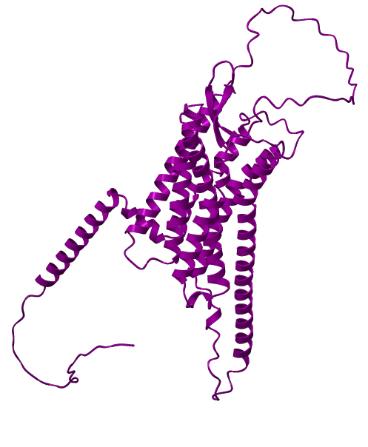

Figure S1: Three-dimensional structure of AVPR1a protein.

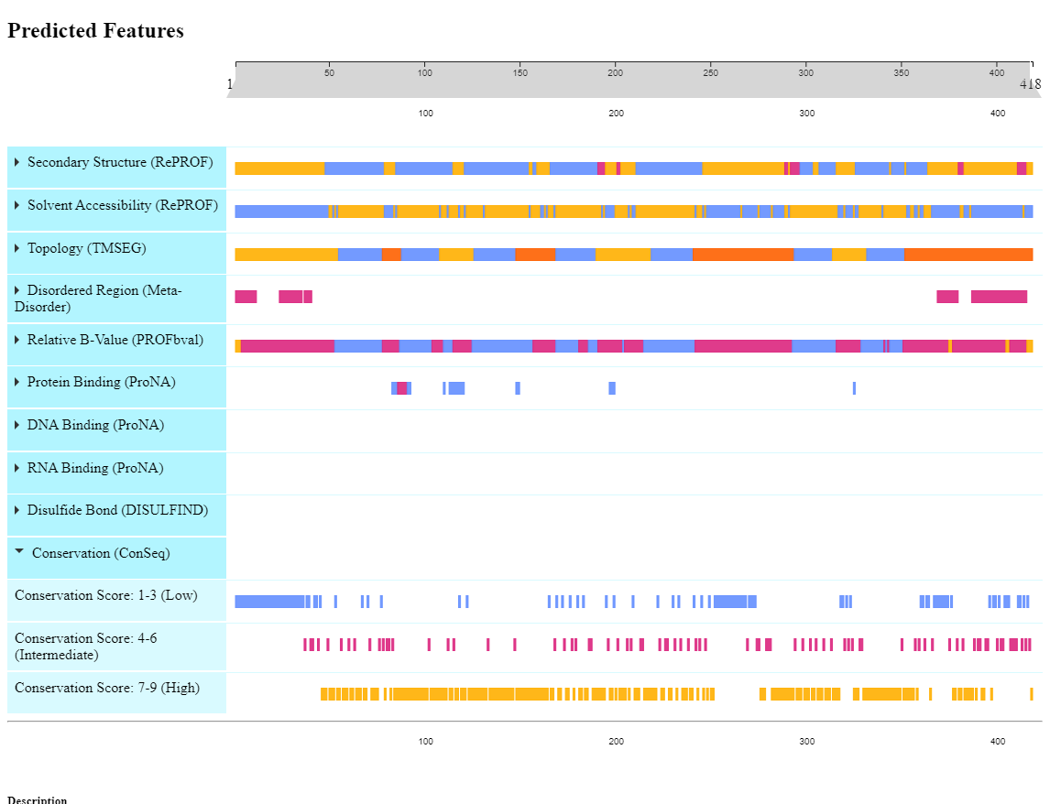

Figure S2: Graphical representation of conservation analysis of AVPR1a protein by Predict Protein server. Score 7-9 denotes highly conserved amino acid positions.

S2 Table: Post-translational modifications (PTM). It includes the results of phosphorylation sites of the AVPR1a protein.

Phosphorylation sites
Tool: NetPhos 3.1

Sequence Position | Score | Types of Phosphorylation | Prediction
S4 | 0.699 | PKA | YES
S4 | 0.501 | PKG | YES
S16 | 0.771 | unsp | YES
S16 | 0.691 | cdk5 | YES
S16 | 0.503 | GSK3 | YES
T23 | 0.677 | PKC | YES
T28 | 0.992 | unsp | YES
T28 | 0.548 | PKC | YES
T28 | 0.532 | CKII | YES
S29 | 0.951 | unsp | YES
S29 | 0.572 | CKII | YES
T61 | 0.537 | PKC | YES
S70 | 0.501 | PKA | YES
T79 | 0.967 | unsp | YES
T79 | 0.510 | cdk5 | YES
T79 | 0.510 | GSK3 | YES
T83 | 0.965 | unsp | YES
T83 | 0.724 | PKC | YES
S84 | 0.987 | unsp | YES
S84 | 0.830 | PKA | YES
S84 | 0.634 | PKG | YES
S84 | 0.571 | RSK | YES
S94 | 0.970 | unsp | YES
S94 | 0.852 | PKA | YES
S94 | 0.596 | RSK | YES
T114 | 0.816 | PKC | YES
S138 | 0.560 | PKA | YES
Y150 | 0.864 | unsp | YES
Y150 | 0.548 | INSR | YES
S167 | 0.723 | PKA | YES
S167 | 0.594 | PKG | YES
S167 | 0.518 | cdc2 | YES
S182* | 0.571 | PKC | YES
T183 | 0.559 | cdk5 | YES
T183 | 0.503 | p38MAPK | YES
Y186 | 0.545 | unsp | YES
S190 | 0.535 | CKII | YES
S190 | 0.527 | PKG | YES
S190 | 0.511 | cdc2 | YES
T206 | 0.735 | PKC | YES
S213 | 0.536 | DNAPK | YES
S213 | 0.504 | PKA | YES
T234 | 0.563 | PKC | YES
S253 | 0.779 | PKC | YES
S256 | 0.991 | unsp | YES
S256 | 0.675 | PKC | YES
S256 | 0.589 | PKA | YES
S278 | 0.896 | PKC | YES
S278 | 0.794 | unsp | YES
S281 | 0.986 | unsp | YES
S281 | 0.622 | PKC | YES
S283 | 0.752 | unsp | YES
T289 | 0.788 | PKC | YES
 | 0.677 | unsp | YES
T323 | 0.594 | CKII | YES
S338 | 0.560 | PKA | YES
S341 | 0.512 | CKI | YES
S380 | 0.908 | unsp | YES
S382 | 0.994 | unsp | YES
S382 | 0.597 | PKC | YES
T386 | 0.976 | unsp | YES
T386 | 0.831 | PKC | YES
T386 | 0.527 | RSK | YES
T386 | 0.522 | PKA | YES
Y388 | 0.776 | unsp | YES
S389 | 0.573 | PKC | YES
S393 | 0.962 | unsp | YES
S393 | 0.591 | cdk5 | YES
S393 | 0.584 | p38MAPK | YES
S393 | 0.524 | GSK3 | YES
S397 | 0.889 | unsp | YES
S404 | 0.996 | unsp | YES
S404 | 0.526 | p38MAPK | YES
S404 | 0.501 | GSK3 | YES
S407 | 0.997 | unsp | YES
S407 | 0.869 | PKC | YES
S408 | 0.633 | unsp | YES
S408 | 0.519 | PKC | YES
S410 | 0.995 | unsp | YES
S417 | 0.693 | PKC | YES
S417 | 0.505 | PKA | YES

Threshold Score: ≥ 0.50

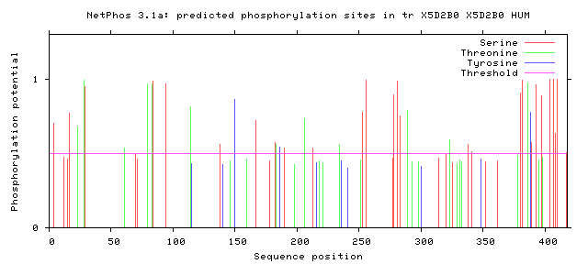

Figure S3: Graphical representation of phosphorylation sites in the AVPR1a protein.

S3 Table: Post-translational modifications (PTM). It includes the results of MHC binding sites of the AVPR1a protein.

MHC binding sites:
Tool: GPS-MBA 1.0

Position | Peptide | Score | Cutoff | Type
25-33 | AGNTSREAE | 1.352 | 1.193 | CLASS II I-Ag7
26-34 | GNTSREAEA | 1.289 | 1.193 | CLASS II I-Ag7
29-37 | SREAEALGE | 2.578 | 1.193 | CLASS II I-Ag7
96 -104 | ADLAVAFFQ | 1.262 | 1.193 | CLASS II I-Ag7
100-108 | VAFFQVLPQ | 1.458 | 1.193 | CLASS II I-Ag7
154-162 | CEPLKTLQQ | 1.369 | 1.193 | CLASS II I-Ag7
253-261 | SRQSKGAEQ | 1.286 | 1.193 | CLASS II I-Ag7
260 - 268 | EQAGVAFQK | 1.605 | 1.193 | CLASS II I-Ag7
273-281 | APCVSSVKS | 1.326 | 1.193 | CLASS II I-Ag7

S4 Table: List of 93 compounds considered for protein-ligand molecular docking analysis.
Serial No | PubChem CID | Compound Name
1 | 753 | Glycerin
2 | 892 | Inositol
3 | 896 | Melatonin
4 | 1054 | Pyridoxine
5 | 2160 | Amitriptyline
6 | 2284 | Baclofen
7 | 2366 | Betahistine
8 | 2391 | Bisacodyl
9 | 2471 | Bumetanide
10 | 2477 | Buspirone
11 | 2764 | Ciprofloxacin
12 | 2771 | Citalopram
13 | 2789 | Clobazam
14 | 2803 | Clonidine
15 | 3007 | Amphetamine
16 | 3100 | Diphenhydramine
17 | 3152 | Donepezil
18 | 3365 | Fluconazole
19 | 3386 | Fluoxetine
20 | 3446 | Gabapentin
21 | 3519 | Guanfacine
22 | 3559 | Haloperidol
23 | 3676 | Lidocaine
24 | 3821 | Ketamine
25 | 3869 | Labetalol
26 | 4032 | Mecamylamine
27 | 4054 | Memantine
28 | 4091 | Metformin
29 | 4158 | Methylphenidate
30 | 4192 | Midazolam
31 | 4205 | Mirtazapine
32 | 4485 | Nifedipine
33 | 4594 | Omeprazole
34 | 4737 | Pentobarbital
35 | 4829 | Pioglitazone
36 | 4943 | Propofol
37 | 4946 | Propranolol
38 | 5070 | Riluzole
39 | 5073 | Risperidone
40 | 5350 | Sulforaphane
41 | 5563 | Triclofos
42 | 5732 | Zolpidem
43 | 6234 | D-cycloserine
44 | 8955 | Pregnenolone
45 | 9651 | Galantamine
46 | 10917 | L-carnitine
47 | 12035 | N-Acetylcysteine
48 | 23897 | Molindone
49 | 24261 | Silicon Dioxide
50 | 34312 | Oxcarbazepine
51 | 41693 | Sufentanil
52 | 43672 | Piperacillin
53 | 44602 | Arbaclofen
54 | 51263 | Alfentanil
55 | 53232 | Lovastatin
56 | 60795 | Aripiprazole
57 | 60854 | Ziprasidone
59 | 65833 | Milnacipran
60 | 68617 | Sertraline
61 | 68870 | Tianeptine
62 | 71158 | Acamprosate
63 | 104865 | Bosentan
64 | 115237 | Paliperidone
65 | 123630 | Tazobactam
66 | 124886 | Glutathione
67 | 213046 | Lurasidone
68 | 216326 | Lenalidomide
69 | 441074 | Quinidine
70 | 441290 | Rocuronium
71 | 644019 | Cannabidiol
72 | 2724354 | Succimer
73 | 5280795 | Cholecalciferol
74 | 5284603 | Oxycodone
75 | 5311068 | Dexmedetomidine
76 | 5360515 | Naltrexone
77 | 5479537 | Cefepime
78 | 9548634 | Glucoraphanin
79 | 9568614 | Esomeprazole
80 | 9948102 | Pitolisant
81 | 10071196 | Pimavanserin
82 | 10220503 | Tasimelteon
83 | 11313622 | Tideglusib
84 | 11601669 | Cannabidivarin
85 | 11978813 | Brexpiprazole
86 | 24965990 | Suvorexant
87 | 46184405 | Vatiquinone
88 | 46200932 | Balovaptan
89 | 54675783 | Minocycline
90 | 135398654 | Sapropterin
91 | 135398737 | Clozapine
92 | 135398745 | Olanzapine
93 | 135403648 | Leucovorin

