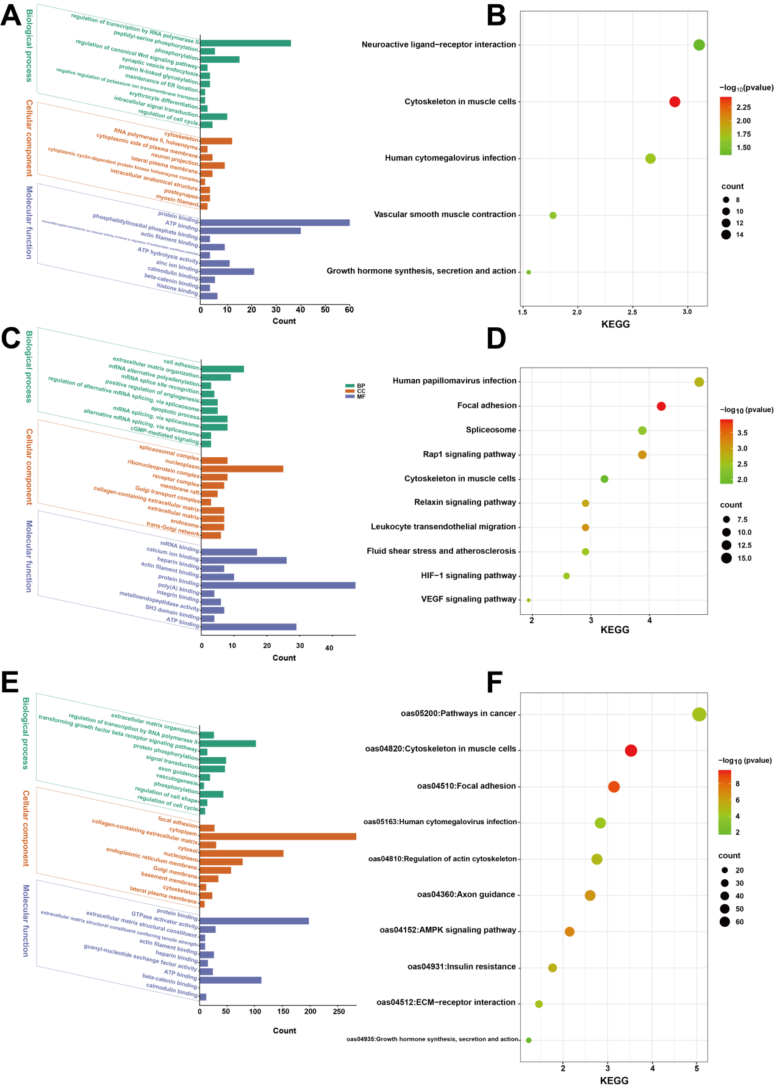
Fig. S1 Functional enrichment of genes regulating tail lipid deposition in multiple omics. (A-B) Functional enrichment analysis of genes obtained from genome-wide selection signal analysis. (C-D) Functional enrichment of differentially expressed genes at the transcriptome level. (E-F) Functional enrichment of differentially expressed genes in adipocytes at the single-cell level.
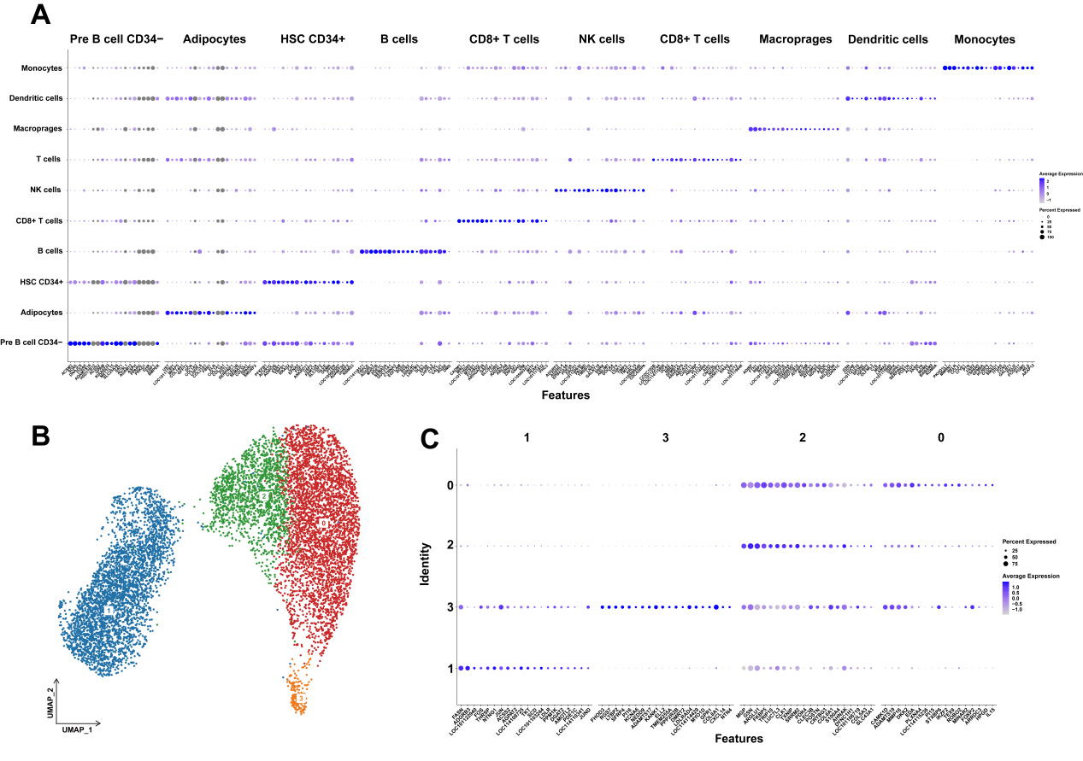
Fig. S2 Marker genes for each cell type. (A) Bubble plots of marker genes for each cell type. (B) UMAP plot of adipocyte clustering, and 4 clusters were marked with different colors.. (C) Bubble plot of marker genes for adipocyte subtypes.
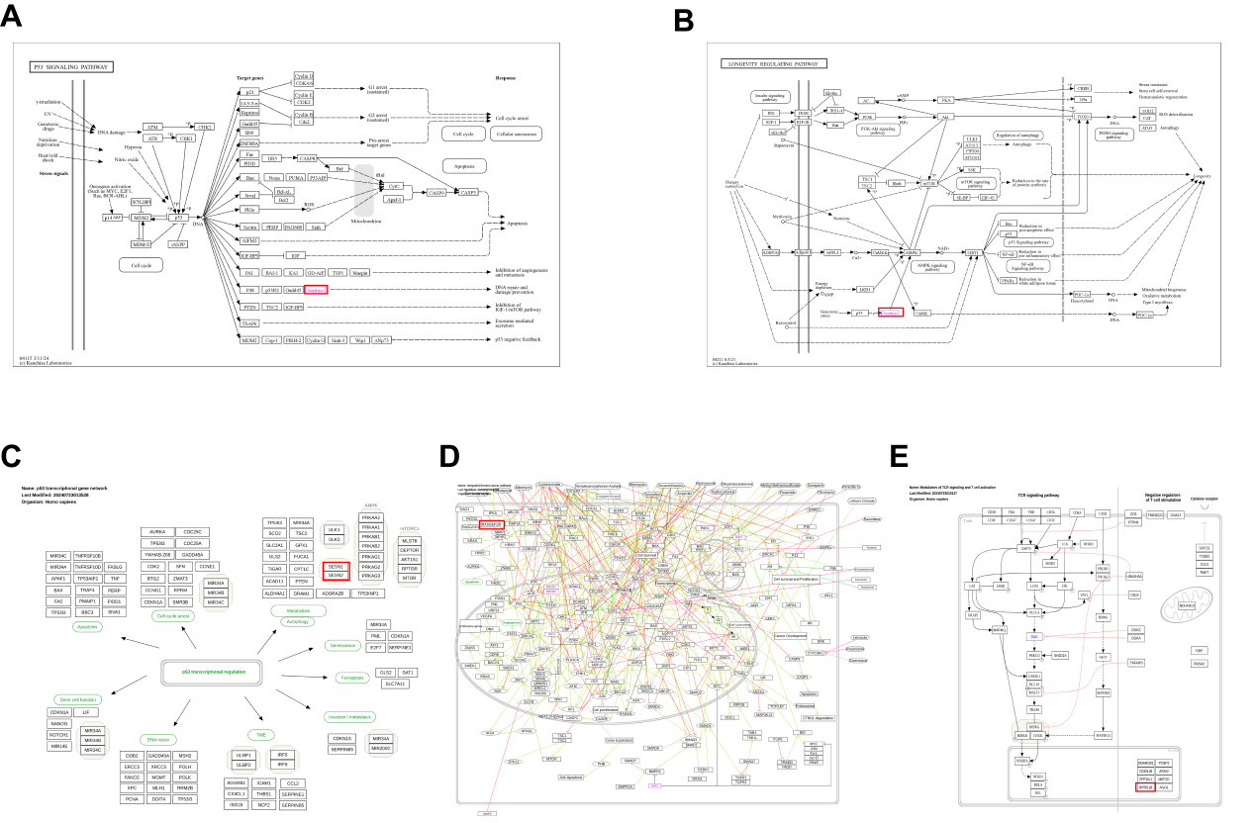
Fig. S3 Pathway diagram of hub genes. (A) P53 signaling pathway involved in SESN1. (B) Longevity regulation pathway involved in SESN1. (C) P53 transcription gene network involved in SESN1 in humans. (D) Breast cancer network involved in RASGEF1A in humans. (E) TCR signaling and T cell activation involved in RPRD1B in humans.
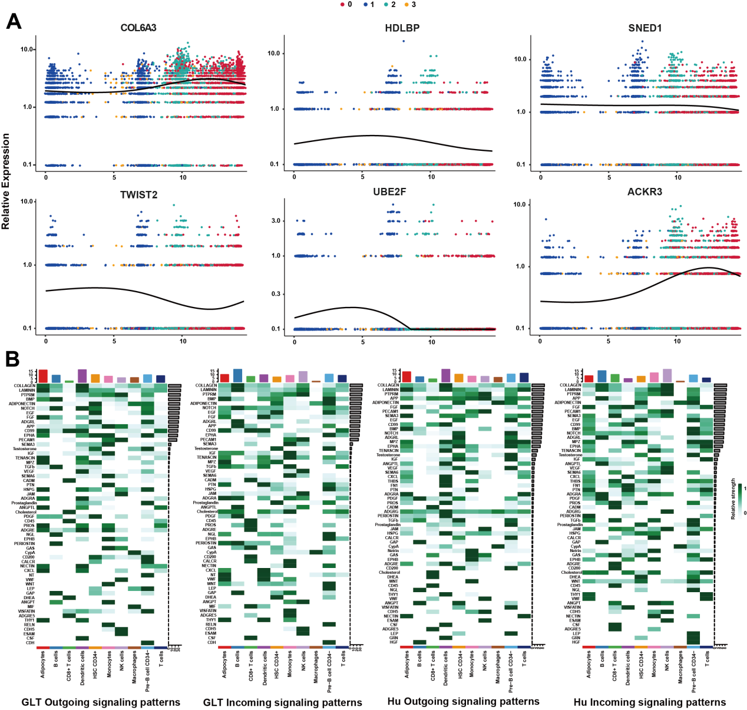
Fig. S4 Gene expression in pseudo-time trajectories and expression strength of pathways in cell communication. (A) Expression of genes regulating tail fat deposition in sheep in pseudo-time trajectory. (B) Strength of pathways detected in GLT and Hu cell communication in various cell types.
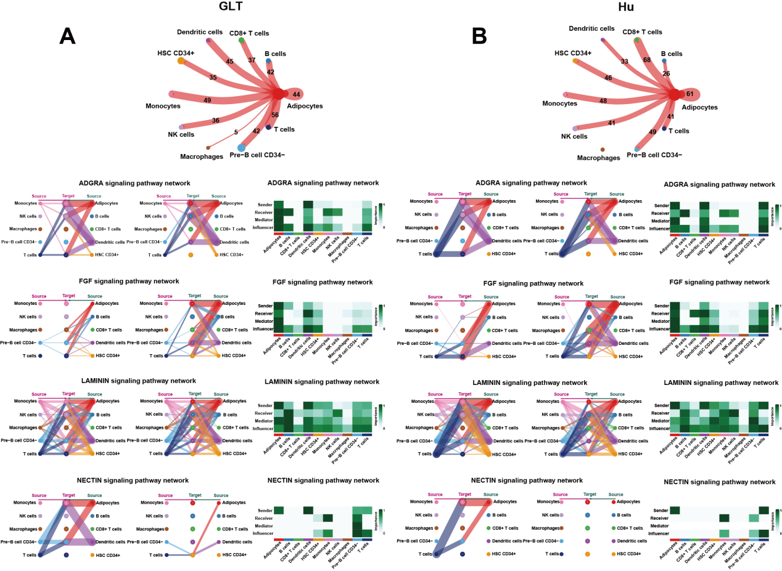
Fig. S5 GLT and Hu adipocyte-related signaling pathways. (A) GLT adipocyte-related signaling pathways. (B) Hu adipocyte-related signaling pathways.
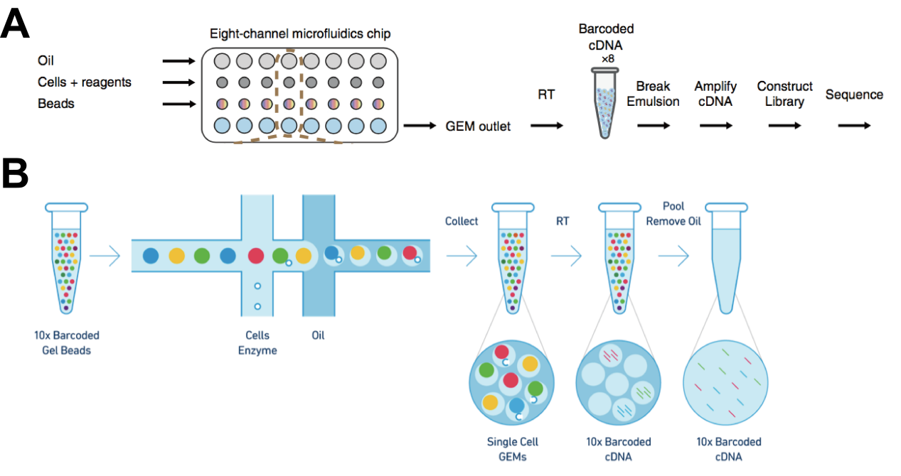
Fig. S6 The single-cell sequencing pipeline used in this study. (A) Gemcode platform single cell RNA-Seq. (B) 10× library construction process.

