A
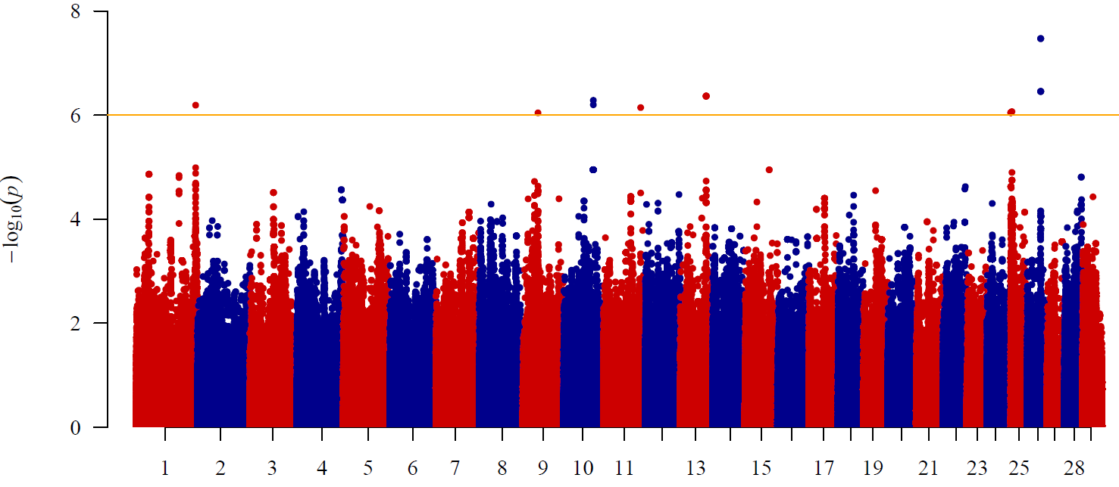
B
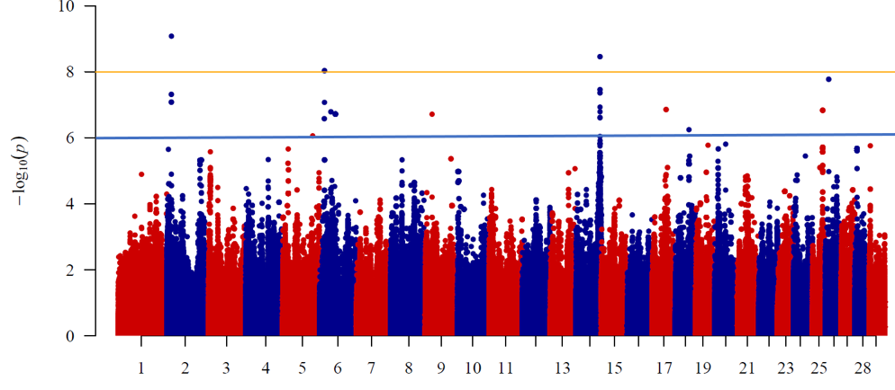
C
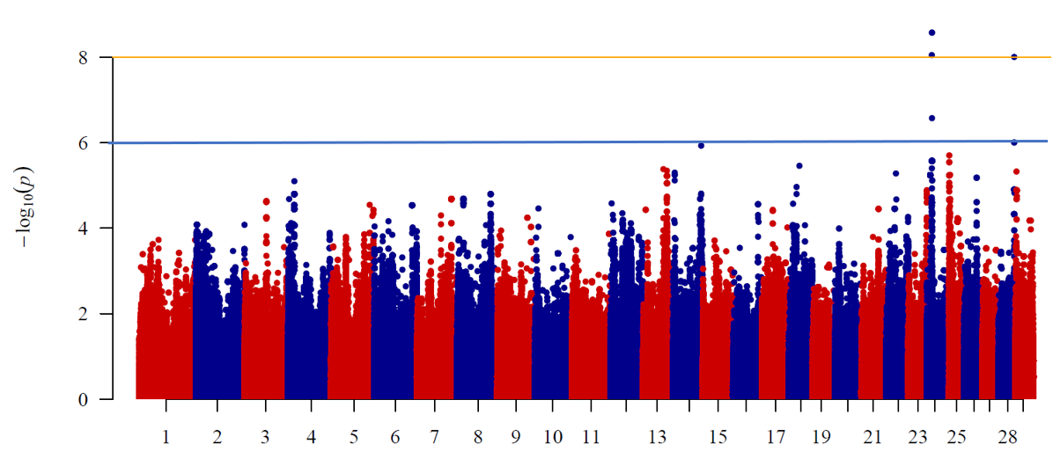
Fig. 1 Manhattan plot of the genome-wide p values of association for reproductive traits in cow: A days from calving to first service; B days open; C number of services per conception. The solid line represents the p < 10⁻⁶ and p < 10⁻⁸ significance threshold.
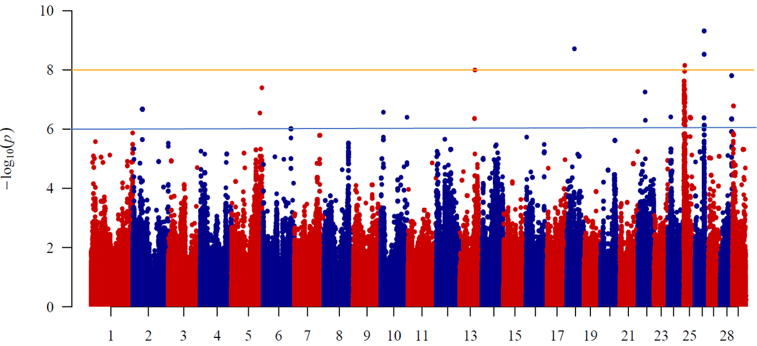
Fig. 2 Manhattan plot of the genome-wide p values of association for age at first calving trait in cow. The solid line represents the p < 10⁻⁶ and p < 10⁻⁸ significance threshold.

