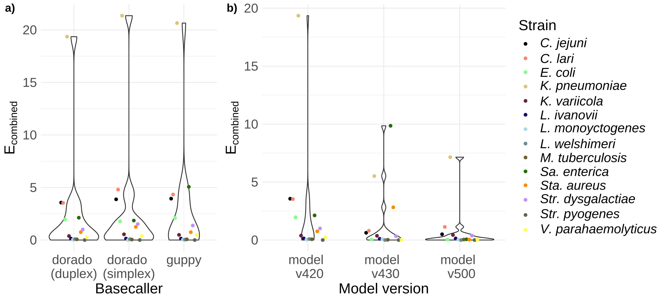
Figure S1: Evaluation of the basecaller and models influencing the accuracy the final assembly (comparison group). a) Violin plot of $E_{combinedError}$ of final assemblies for dorado duplex, dorado simplex, and guppy with model v420. b) Violin plot of $E_{combinedError}$ of final assemblies for dorado duplex using models v420, v430, and v500.

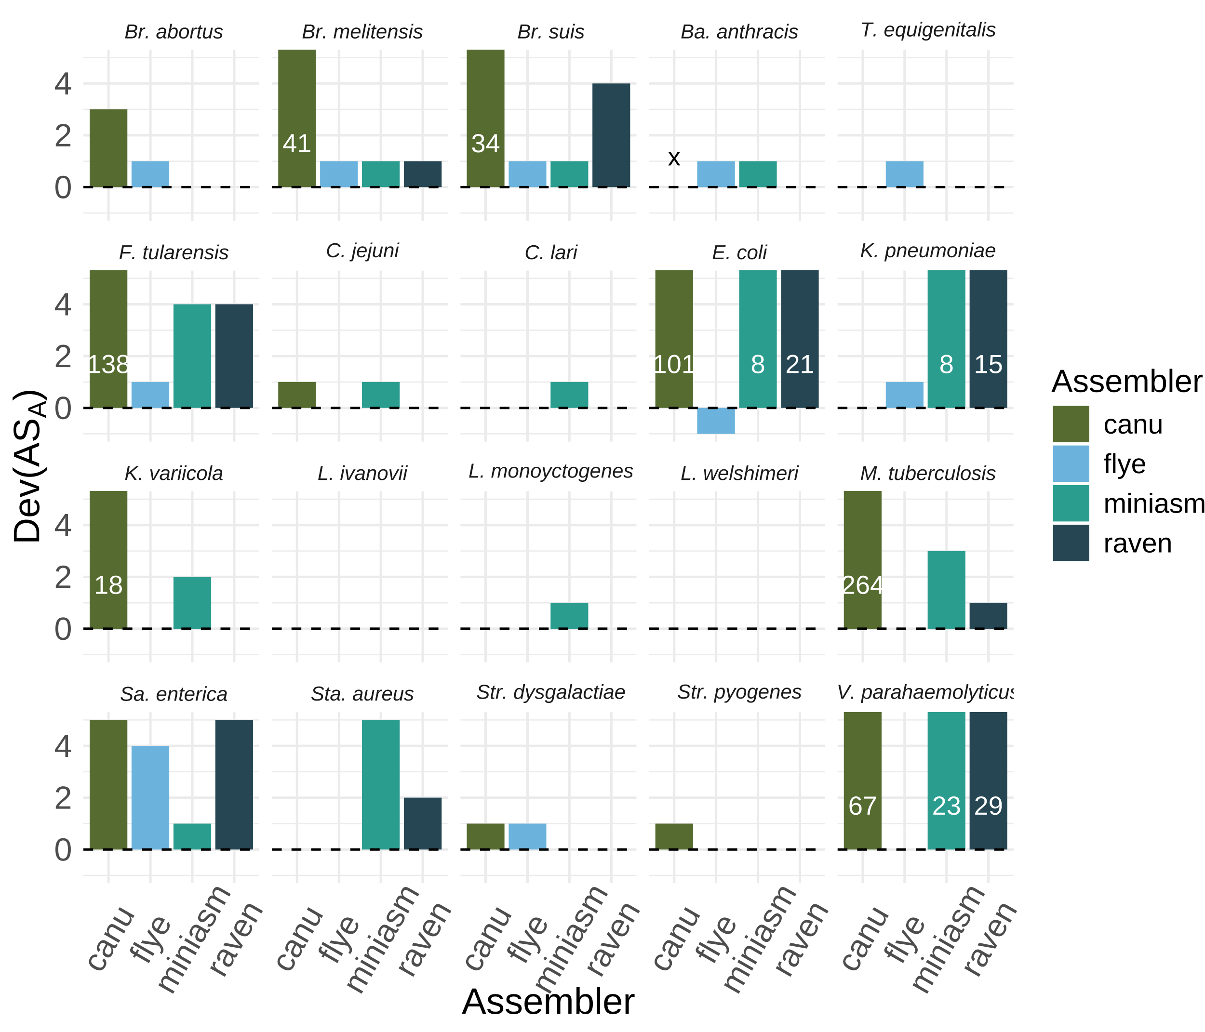
Figure S2: Continuity of final assemblies for each assembler (all strains). The deviation $Dev\left(AS_{A}\right)$ (y-axis) for each strain and assembler. The white numbers indicate $Dev\left(AS_{A}\right)$, when $Dev\left(AS_{A}\right)>5$. An “X” indicates that the assembly process failed. The colors indicate the different assemblers (on the x-axis).

