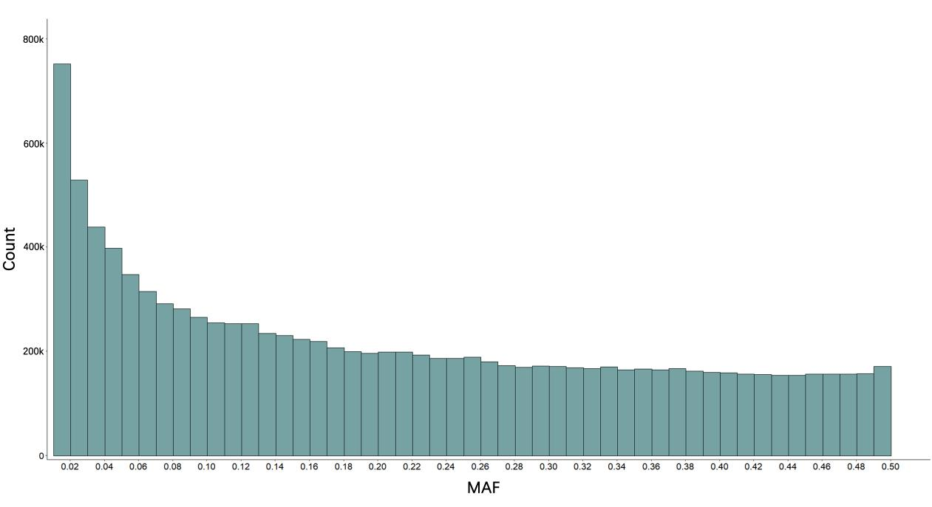
Figure S1. Histogram of Minor Allele Frequencies for SNPs.

Figure S2. The principal component analysis by 316,290 SNPs for 504 Lion-head geese.

(A)
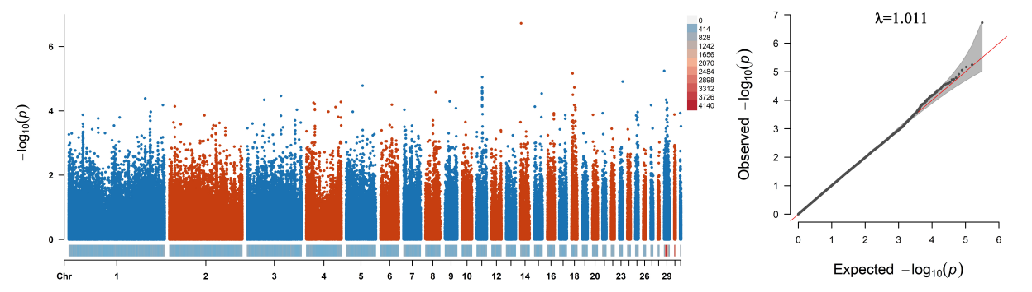

(B)
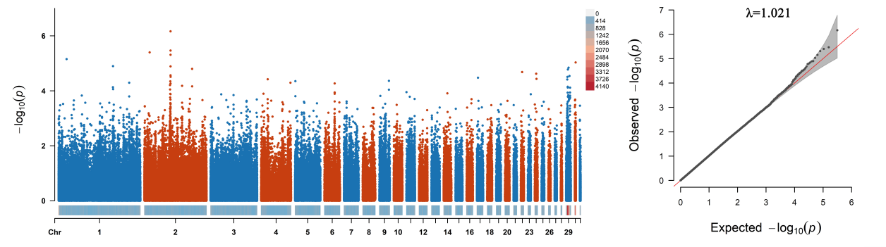

(C)
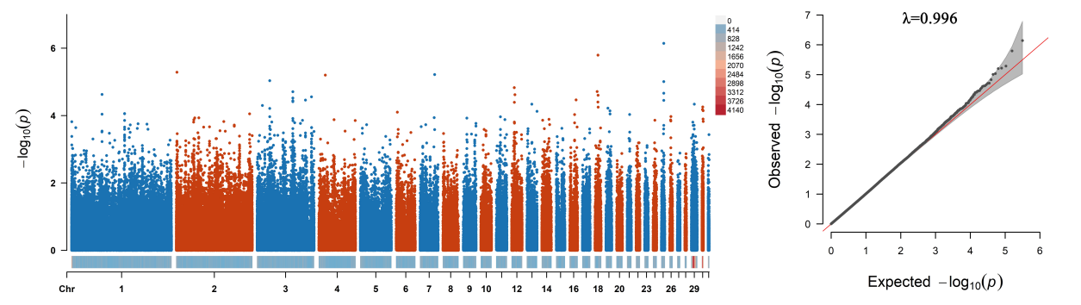

(D)
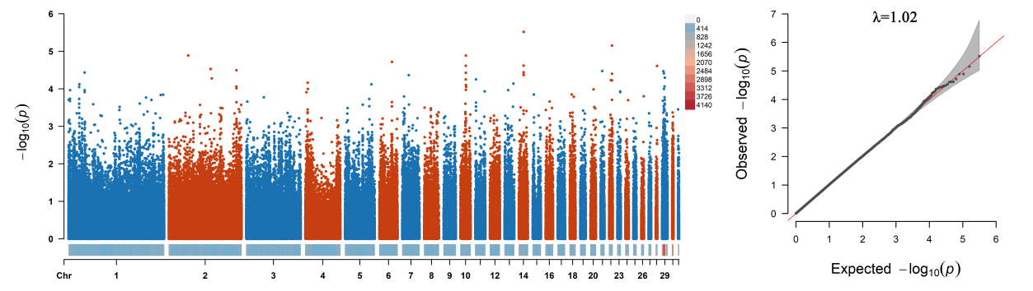

(E)
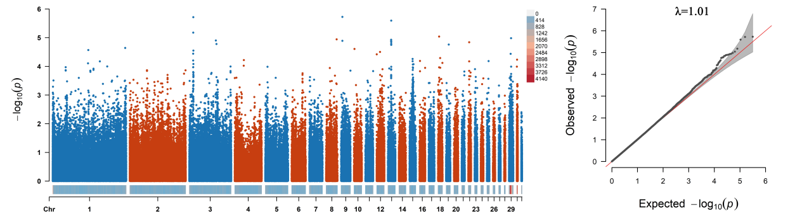

(F)
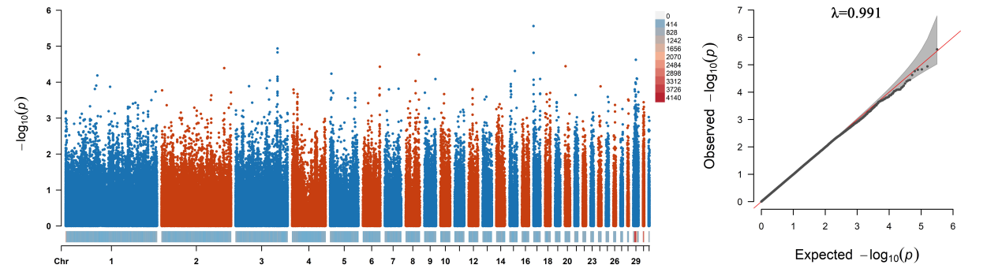

(G)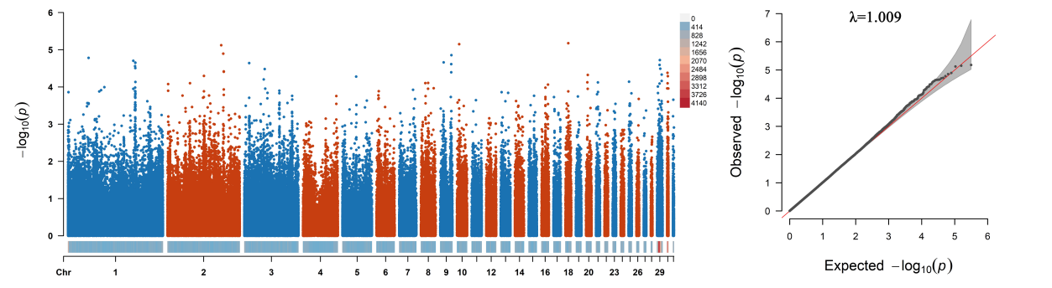
Figure S3. The manhattan (left) and Q–Q (right) plots for single-trait genome-wide association study for (A) chest width, (B) chest angle, (C) neck length, (D) neck circumference, (E) shank circumference, (F) shank length and (G) body oblique length

