Supplementary Materials

Integrative Analysis of Hub1 Overexpression: Driving Transcriptional Reprogramming and Alternative Splicing in Saccharomyces cerevisiae

Supplementary Figures

Supplementary Figure S1. Principal Component Analysis of Hub1 overexpression samples
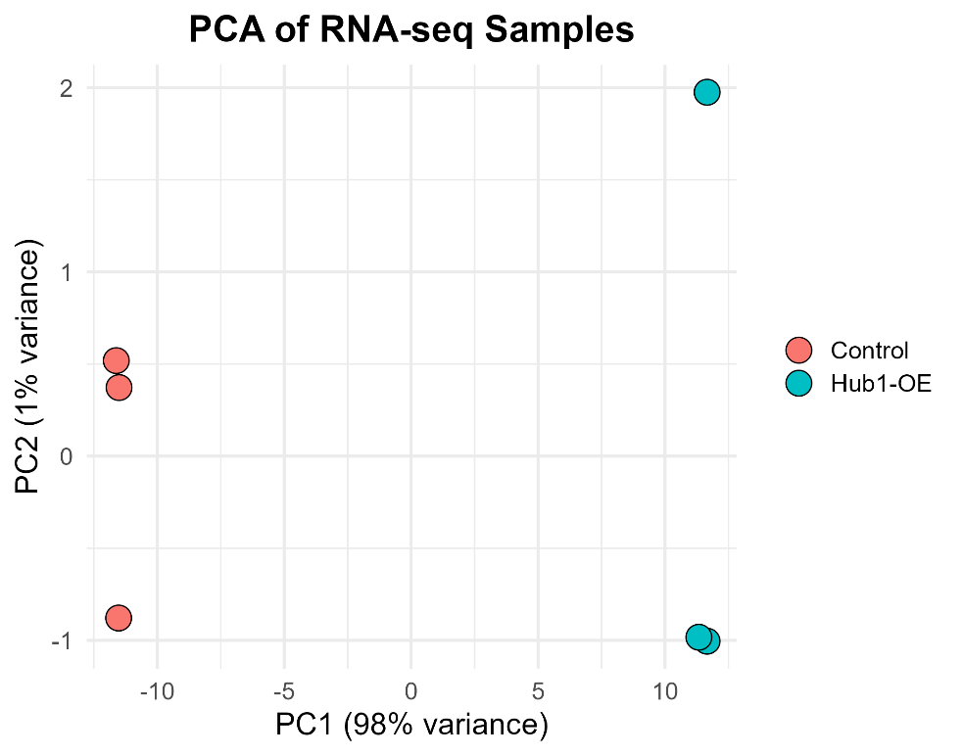

Supplementary Fig. S1. PCA plot of control vs. Hub1-OE RNA-seq samples. Principal component analysis was performed on variance-stabilized transformed (VST) gene expression data. The first principal component (PC1) explains 98% of the total variance and clearly separates Hub1-overexpressing samples from controls, while PC2 accounts for 1% of the variance. Biological replicates within each group cluster tightly, demonstrating high experimental reproducibility and minimal technical variability.

Supplementary Figure S2. Differential Exon Usage Analysis
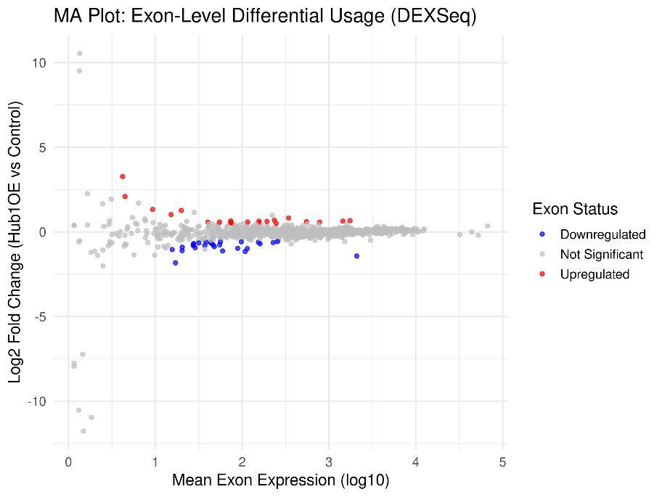
A

B

Supplementary Fig. S2. Differential Exon Usage Analysis in Hub1-OE vs. Control Yeast Cells (A) MA plot of differential exon usage generated using DEXSeq. Each dot represents an exon, plotted by log2 fold change (Hub1-OE vs. Control) on the y-axis and base mean expression on the x-axis (log10 scale). Red: significantly upregulated (padj < 0.05); blue: downregulated; gray: non-significant. A total of 27 exons were significantly downregulated and 21 exons upregulated. (B) Heatmap of top differentially used exons (padj < 0.05). Rows represent individual exons and columns represent biological replicates. Values are log2-transformed normalized exon counts, scaled per row. Color indicates relative expression (red = high; blue = low). Dendrogram shows clustering by condition.

Supplementary Tables

Supplementary Table S1. Splice Site Motif Scores for Hub1-Regulated Exons
Exon ID | Splice Site | Sequence | MaxEnt Score
DYN2_exon | 5′ donor | GGTGTAAGT | −18.32
DYN2_exon | 3′ acceptor | TTGTGTGTAAGTCACCAATTTTC | −5.52
YDL246C_E1 | 5′ donor | TGAATGAAA | −17.90
YDL243C_E1 | 5′ donor | CGATTAATC | −10.06
YDR387C_E1 | 5′ donor | CCATTGATG | −14.73
YDL094C_E1 | 5′ donor | TTTTTAATT | −10.80
YDR438W_E1 | 5′ donor | GAATGAATC | −15.91
YDL246C_E1 | 3′ acceptor | AATATGTCTCAAAATAGTAACCC | −9.07
YDL243C_E1 | 3′ acceptor | TTTATGGGCTCTATGAATAAGGA | −3.17
YDR387C_E1 | 3′ acceptor | GGTATGTCTACAGATGAAAGTGA | −12.01
YDL094C_E1 | 3′ acceptor | ACGATGGCAGTAAATATCAGCAA | −6.42
YDR438W_E1 | 3′ acceptor | GACCTATCTTGGATGCCTAACGT | −6.73
Supplementary Table S1. Splice site motif sequences and MaxEntScan scores for Hub1-regulated exons. Splice site sequences (9 bp for 5′ donor, 23 bp for 3′ acceptor) were extracted from the Saccharomyces cerevisiae genome and evaluated using MaxEntScan scoring models. Lower scores indicate weaker splice sites. The DYN2 exon shows significantly weak 5′ donor site (score = −18.32, p = 0.03 compared to canonical sites) and moderately weak 3′ acceptor site (score = −5.52), consistent with Hub1's role in facilitating recognition of non-consensus splice sites.

