Table S1 List of qRT-PCR primers used to validate transcriptome data
Gene_ID | Gene name | Primers | Primer sequence (5´-3´) | Primer length | Primer tm value | PCR product length
TRINITY_DN26995_c0_g1 | PYL2 | PYL2-F | CCTGCAAATTTCGTCTGGCC | 20 | 60.11 | 100
TRINITY_DN26995_c0_g1 | PYL2 | PYL2-R | CACTCCCATCACCGGAAGTT | 20 | 59.68 | 100
TRINITY_DN37540_c0_g | GAI | GAI-F | GAGTTGAGCGACACGAGACA | 20 | 60.04 | 126
TRINITY_DN37540_c0_g | GAI | GAI-R | CACCAGCAAACAGAGCCAAC | 20 | 59.97 | 126
TRINITY_DN16300_c0_g1 | ARF11 | ARF11-F | ATGAGGTGTACGCGCAGATT | 20 | 59.82 | 137
TRINITY_DN16300_c0_g1 | ARF11 | ARF11-R | GCTTGTGTCTGAGGCTGTCA | 20 | 60.25 | 137
TRINITY_DN7116_c0_g1 | SPS2 | SPS2-F | AGTAGTGGAGGCGAGGTGTA | 20 | 59.67 | 100
TRINITY_DN7116_c0_g1 | SPS2 | SPS2-R | CCCAGCGGTAGTCAATGTGT | 20 | 60.04 | 100
TRINITY_DN23315_c0_g2 | AGPS1 | AGPS1-F | AATGGATGAGAAGCGTGCCA | 20 | 60.04 | 146
TRINITY_DN23315_c0_g2 | AGPS1 | AGPS1-R | CTCTCACATCATCGAGGCCC | 20 | 59.97 | 146
TRINITY_DN16651_c0_g1 | PER42 | PER42-F | TGACACCCCTGGACTTGTTG | 20 | 59.82 | 150
TRINITY_DN16651_c0_g1 | PER42 | PER42-R | ATCTGGTCTGGGCACTTGTG | 20 | 59.96 | 150
TRINITY_DN3649_c0_g2 | CYP73A10 | CYP73A10-F | GCGGATCATGACTGTCCCTT | 20 | 59.82 | 70
TRINITY_DN3649_c0_g2 | CYP73A10 | CYP73A10-R | CTCATCCTCCCACCCAAACC | 20 | 60.03 | 70
TRINITY_DN842_c2_g1 | CCR1 | CCR1-F | CTGAGAAAGCTGCCTGGGAA | 20 | 59.96 | 86
TRINITY_DN842_c2_g1 | CCR1 | CCR1-R | GAGAATGGGGCCTATCACGG | 20 | 59.96 | 86
TRINITY_DN5008_c0_g3 | ACT11 | ACT11-F | GGATTTGCTGGTGACGATGC | 20 | 64.43 | 87
TRINITY_DN5008_c0_g3 | ACT11 | ACT11-R | GCCCATTCCAACCATCACAC | 20 | 64.9 | 87

Table S2 Unigene annotation statistics
Database | GO | KEGG | Pfam | Swiss-Prot | eggNOG | NR
Count | 115216 | 46564 | 108074 | 92904 | 130914 | 111845
Ratio(%) | 55.06 | 22.25 | 51.65 | 44.40 | 62.56 | 53.45

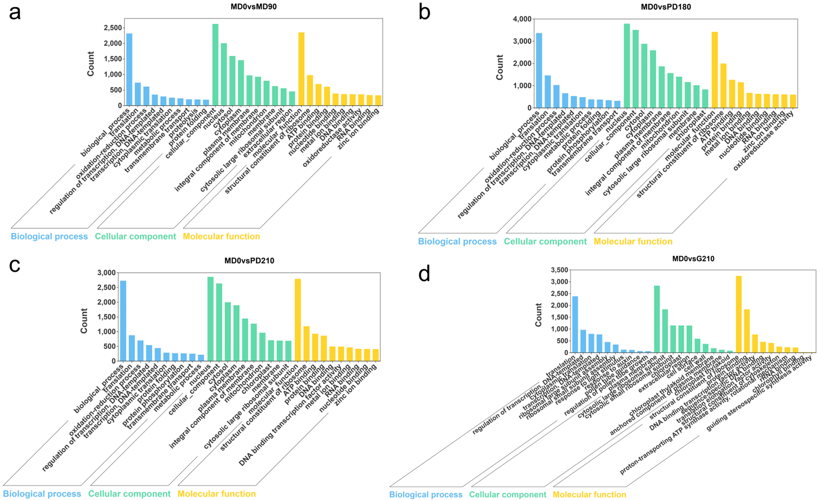
Figure S1 GO annotation distribution histogram. (a–d) Classification plots with GO annotations show the DEGs in the MD0vsMD90, MD0vsPD180, MD0vsPD210, and MD0vsG210 groups.

