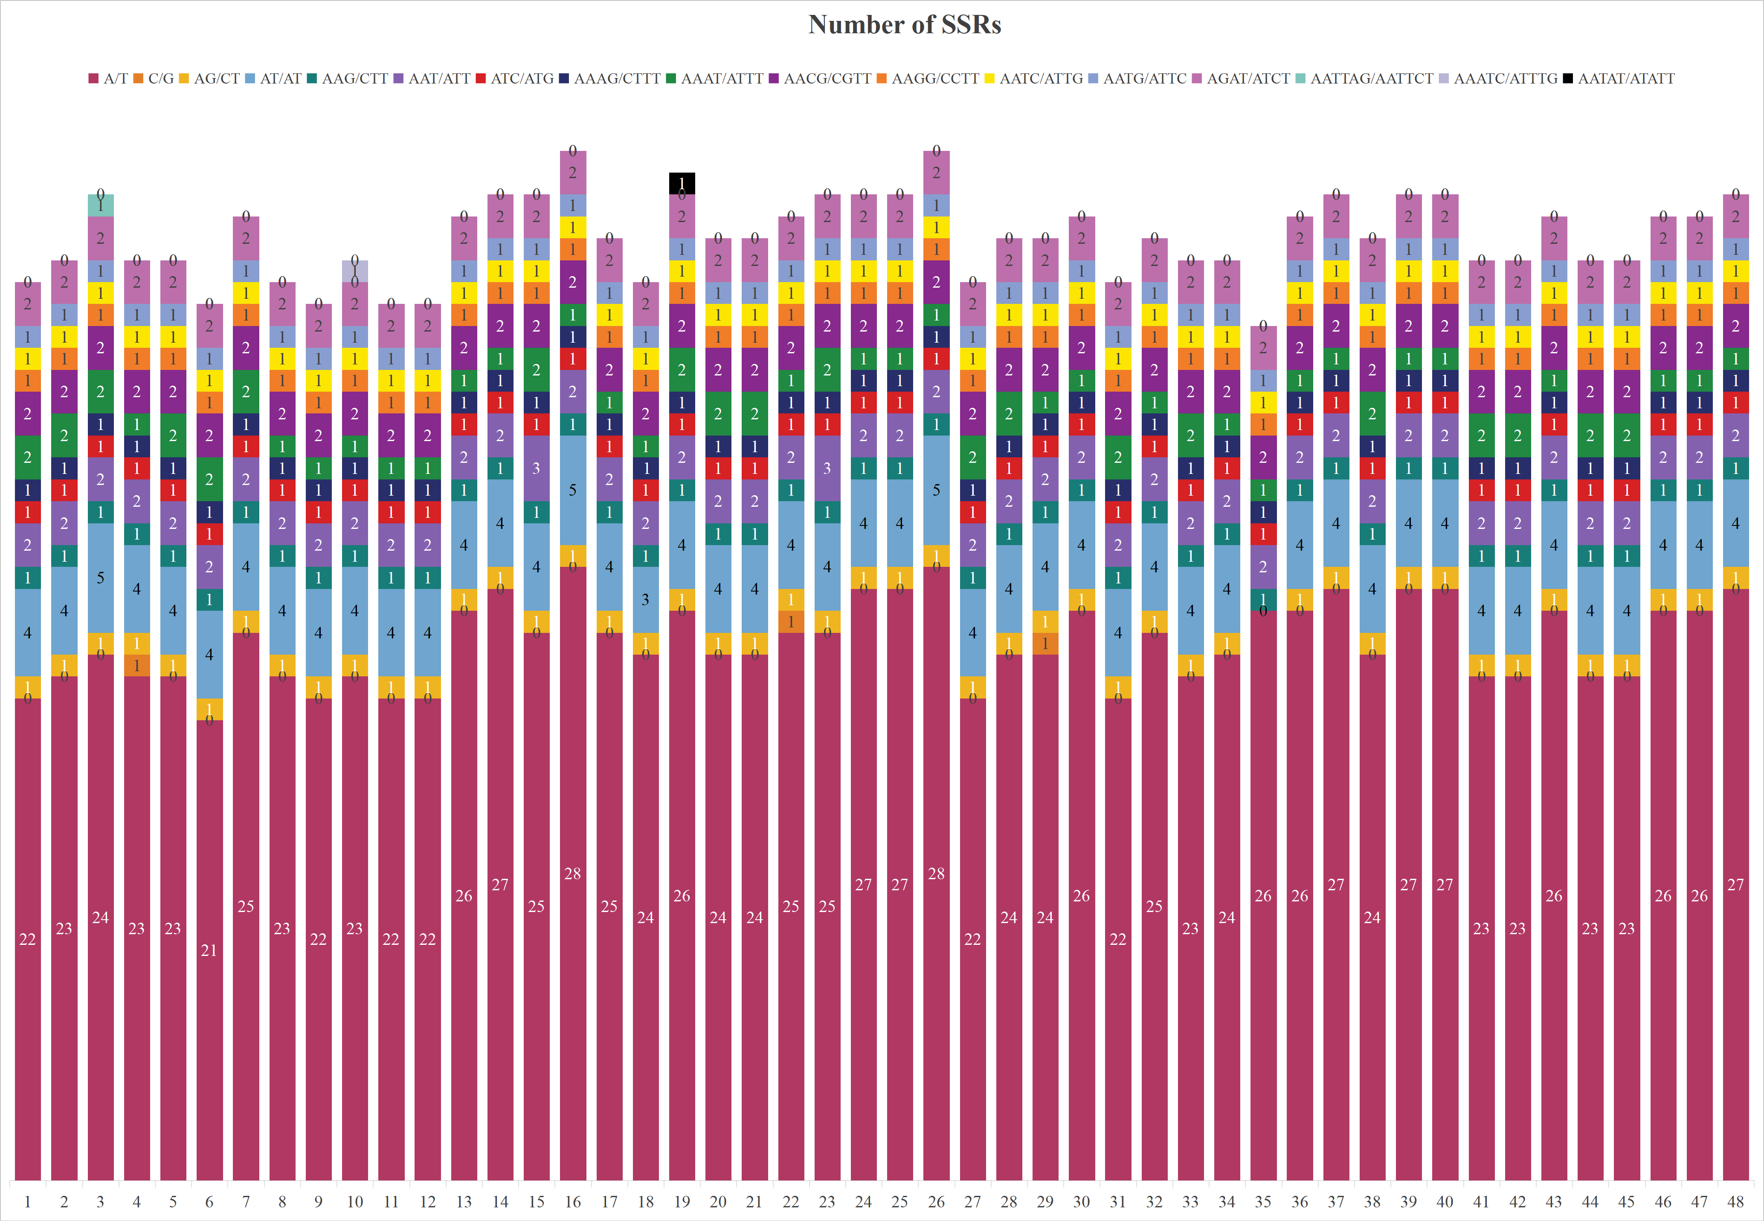
Fig. S1 Number of different SSR types in 48 Agropyron accessions. The abscissas (1–48) correspond to 48 accessions of Agropyron species and varieties, with the last four digits of sample IDs following the Latin names:1–9: A. cristatum 0642, 1134, 1538, 1734, 1910, 1955, 2041, 2065, 2169;10–12: A. cristatum var. pectinatum 1502, 2039, 2040;13–25: A. desertorum 0202, 0206, 0209, 0517, 1058, 1318, 1916, 1956, 2020, 2038, 2060, 2062, 7275;26–33: A. desertorum var. pilosiusculum 0507, 0959, 1229, 1312, 1324, 1337, 1812, 2011;34–35: A. michnoi 0712, 1010; 36–46: A. mongolicum 0203, 0205, 0506, 0937, 0945, 1557, 2010, 2018, 2019, 2024, 2906; 47–48: A. sibiricum 1150, 1152. The x-axis shows sample numbers and corresponding species/varieties (grouped by taxon), while the y-axis represents the quantity of SSR type.
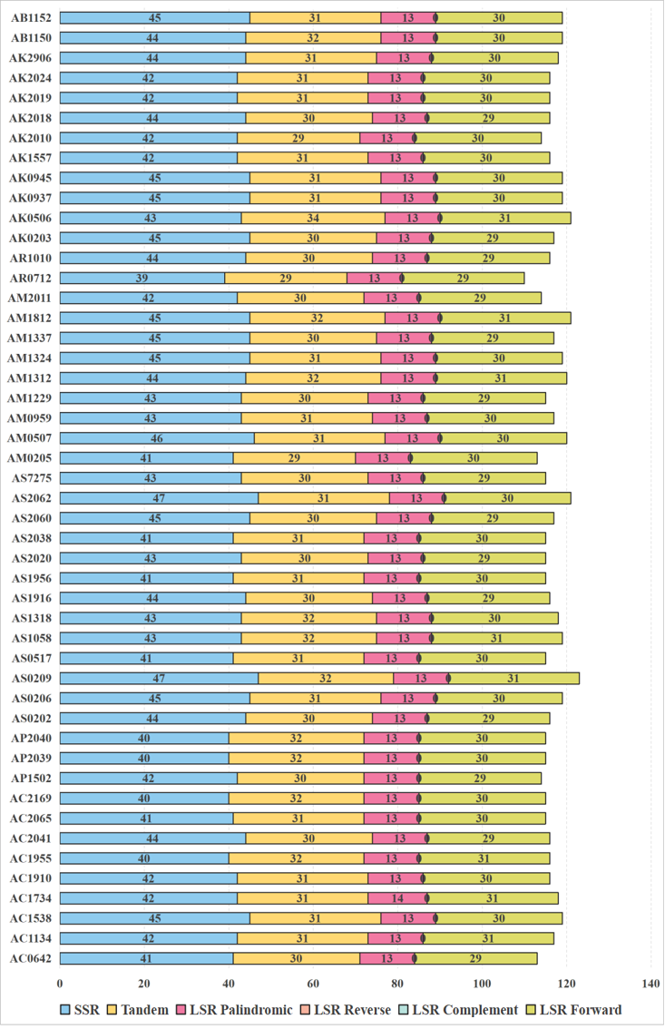
Fig. S2 Number and type of repeats. AC, AP, AS, AM, AR, AK, AB denote A. cristatum, A. cristatum var. pectinatum, A. desertorum, A. desertorum var. pilosiusculum, A. michnoi, A. mongolicum, A. sibiricum respectively.
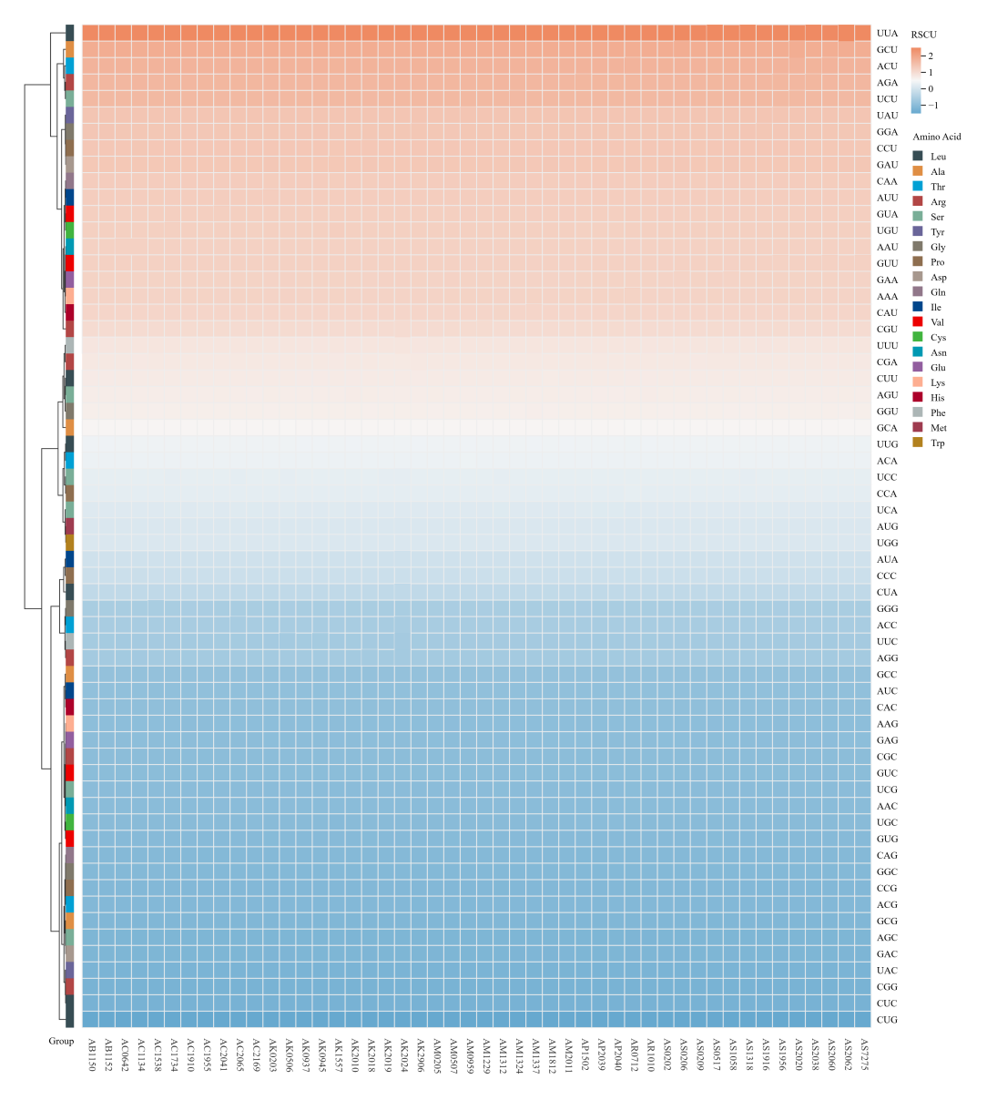
Fig. S3 The heat map of RSCU values for 48 Agropyron samples. AC, AP, AS, AM, AR, AK, AB denote A. cristatum, A. cristatum var. pectinatum, A. desertorum, A. desertorum var. pilosiusculum, A. michnoi, A. mongolicum, A. sibiricum respectively.
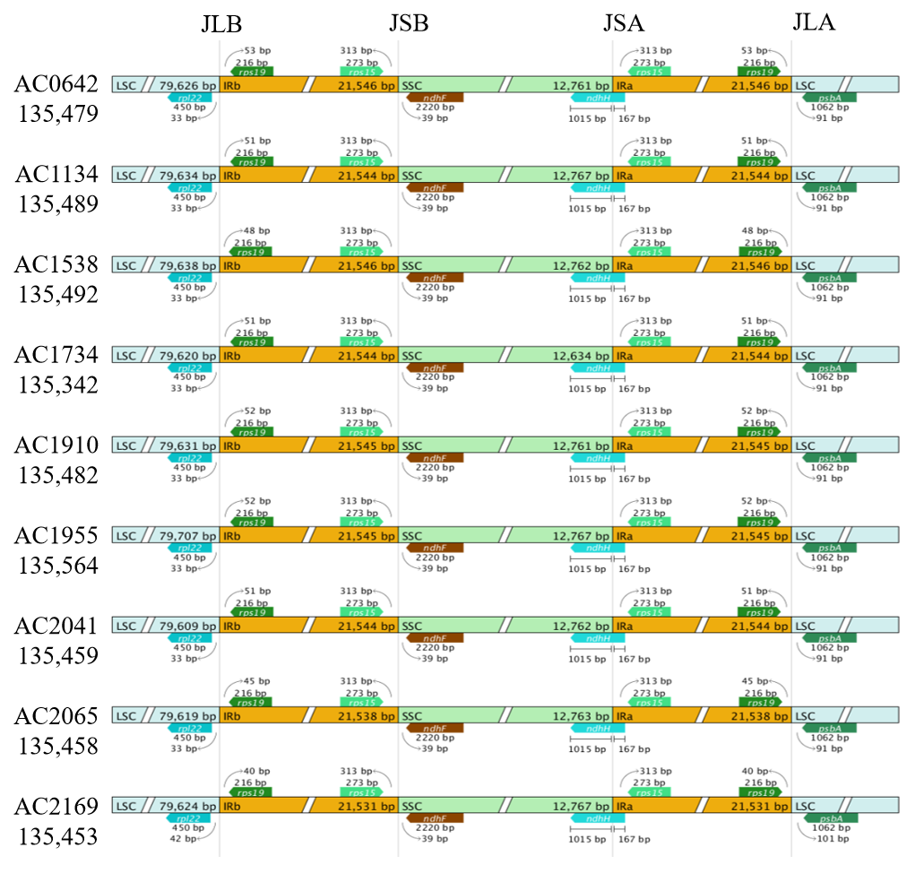
Fig. S4 Chloroplast genomes comparison of IR, LSC, and SSC regions in nine A. cristatum samples. Within the corresponding region, the gene length is displayed above the box of the gene name. Arrows indicate the distance of the gene from a specific region. JLB (LSC/IRb), JSB (IRb/SSC), JSA (SSC/IRa), and JLA (IRa/LSC) represent the junction points between each two corresponding regions on the chloroplast genome. Arrows indicate the distance of the gene from a specific region. AC denote A. cristatum.
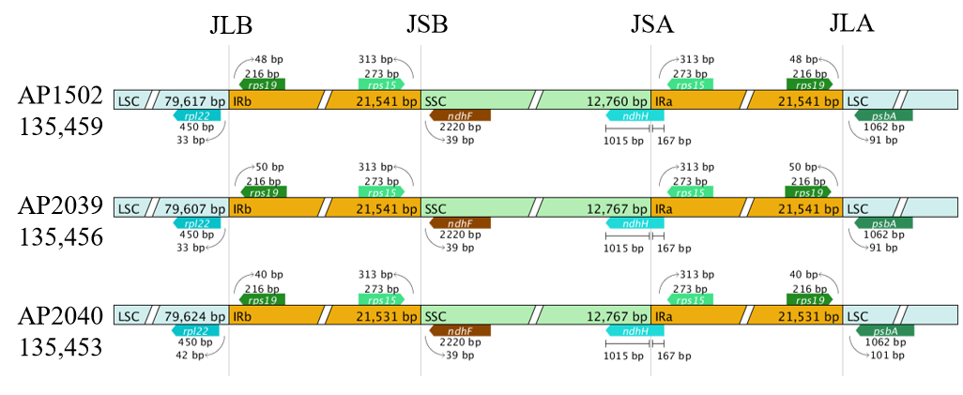
Fig. S5 Comparison of IR, LSC, and SSC regions in three A. cristatum var. pectinatum chloroplast genomes. Within the corresponding region, the gene length is displayed above the box of the gene name. Arrows indicate the distance of the gene from a specific region. JLB (LSC/IRb), JSB (IRb/SSC), JSA (SSC/IRa), and JLA (IRa/LSC) represent the junction points between each two corresponding regions on the chloroplast genome. Arrows indicate the distance of the gene from a specific region. AP denote A. cristatum var. pectinatum.
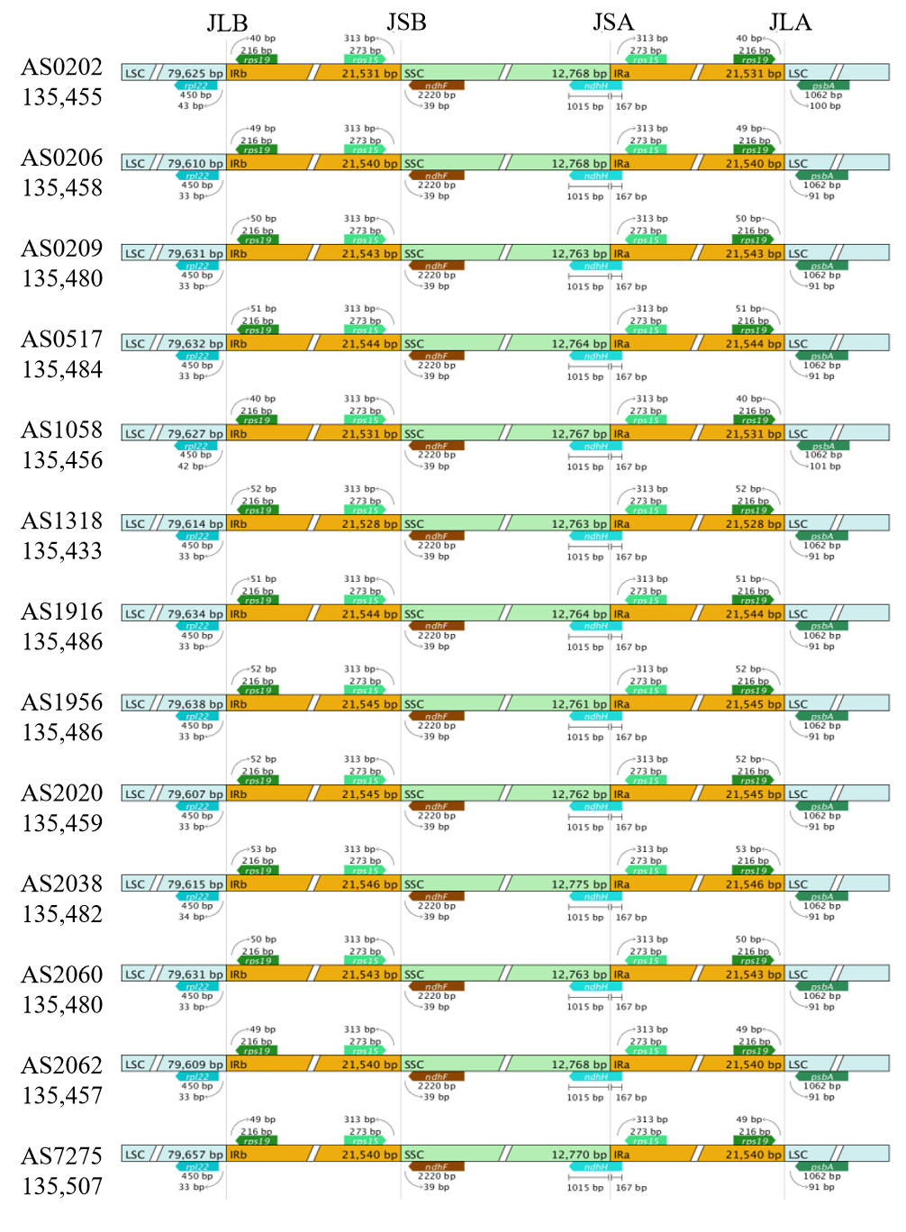
Fig. S6 Chloroplast genomes comparison of IR, LSC, and SSC regions in thirteen A. desertorum samples. Within the corresponding region, the gene length is displayed above the box of the gene name. Arrows indicate the distance of the gene from a specific region. JLB (LSC/IRb), JSB (IRb/SSC), JSA (SSC/IRa), and JLA (IRa/LSC) represent the junction points between each two corresponding regions on the chloroplast genome. Arrows indicate the distance of the gene from a specific region. AS denote A. desertorum.
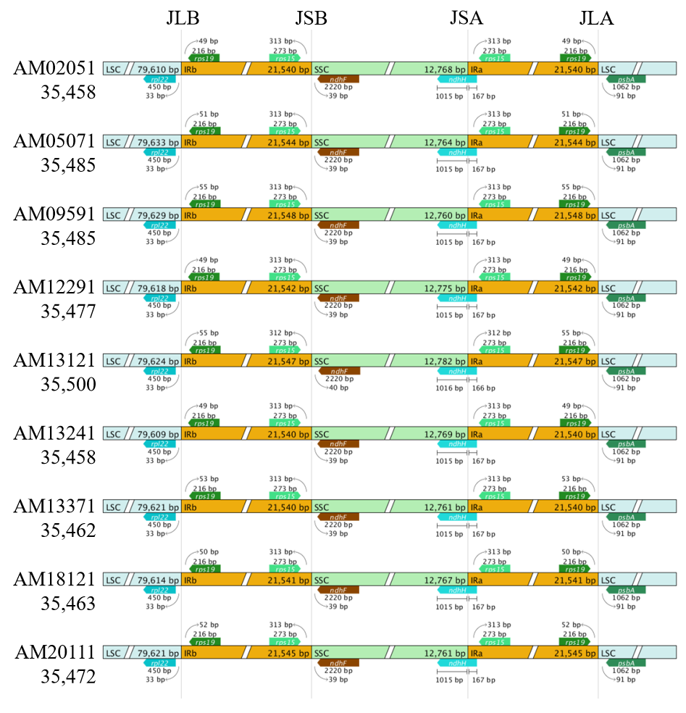
Fig. S7 Chloroplast genome comparison of IR, LSC, and SSC regions in nine A. desertorum var. pilosiusculum samples.Within the corresponding region, the gene length is displayed above the box of the gene name. Arrows indicate the distance of the gene from a specific region. JLB (LSC/IRb), JSB (IRb/SSC), JSA (SSC/IRa), and JLA (IRa/LSC) represent the junction points between each two corresponding regions on the chloroplast genome. Arrows indicate the distance of the gene from a specific region. AM denote A. desertorum var. pilosiusculum.
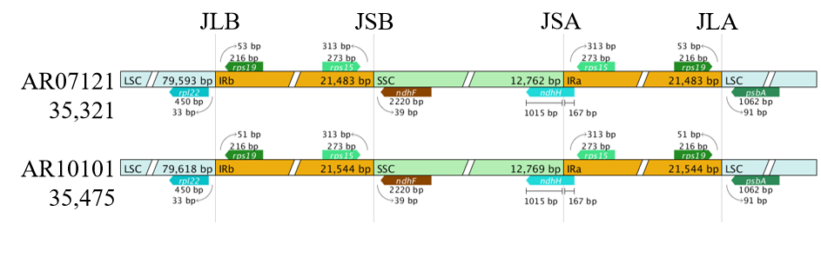
Fig. S8 Chloroplast genomes comparison of IR, LSC, and SSC regions in two A. michnoi samples.Within the corresponding region, the gene length is displayed above the box of the gene name. Arrows indicate the distance of the gene from a specific region. JLB (LSC/IRb), JSB (IRb/SSC), JSA (SSC/IRa), and JLA (IRa/LSC) represent the junction points between each two corresponding regions on the chloroplast genome. Arrows indicate the distance of the gene from a specific region. AR denote A. michnoi.
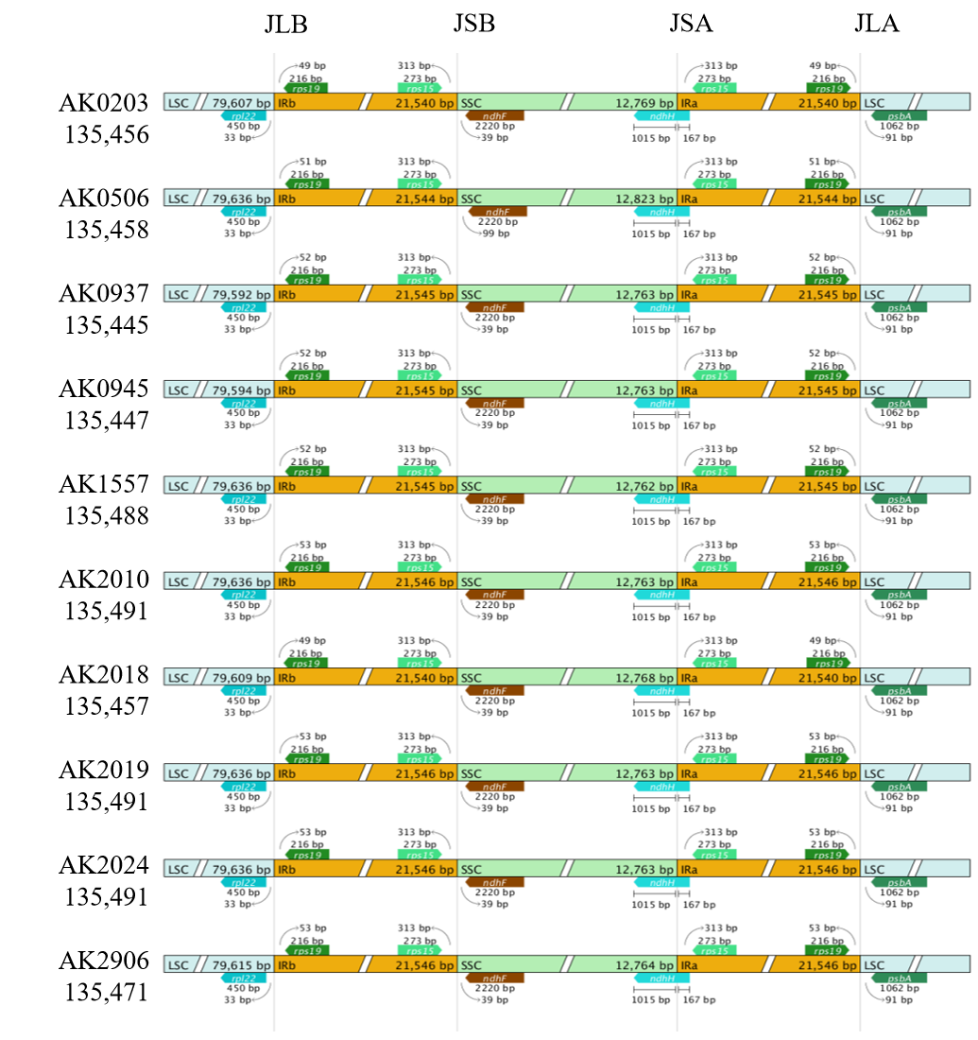
Fig. S9 Chloroplast genome comparison of IR, LSC, and SSC regions in ten A. mongolicum samples. Within the corresponding region, the gene length is displayed above the box of the gene name. Arrows indicate the distance of the gene from a specific region. JLB (LSC/IRb), JSB (IRb/SSC), JSA (SSC/IRa), and JLA (IRa/LSC) represent the junction points between each two corresponding regions on the chloroplast genome. Arrows indicate the distance of the gene from a specific region. AK denote A. mongolicum.
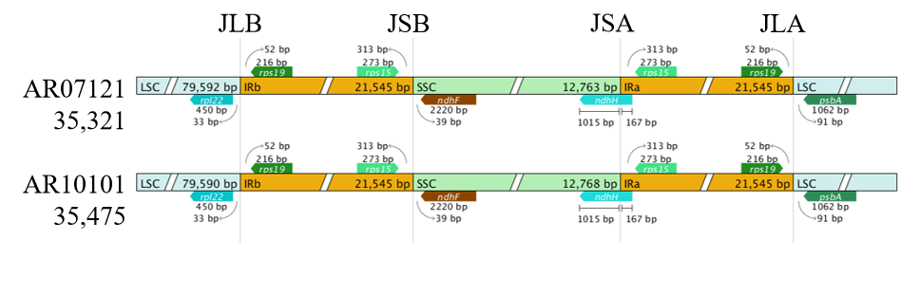
Fig. S10 Chloroplast genome comparison of IR, LSC, and SSC regions in two A. sibiricum samples. Within the corresponding region, the gene length is displayed above the box of the gene name. Arrows indicate the distance of the gene from a specific region. JLB (LSC/IRb), JSB (IRb/SSC), JSA (SSC/IRa), and JLA (IRa/LSC) represent the junction points between each two corresponding regions on the chloroplast genome. Arrows indicate the distance of the gene from a specific region. AB denote A. sibiricum.

