Supplementary information
Table S1: Variables used in the differential analysis with Methylkit. Group 0 represents control cows, while Group 1 represents diseased cows. The age of each cow is expressed in days, and Lambda refers to an internal control added prior to the conversion step. Unmethylated lambda was utilized to verify accurate DNA conversion for each sample.

Table S2: Comparison of sequencing parameters between the control and diseased groups. An unpaired Student's t-test was conducted for reads mapped and coverage, while an unpaired Wilcoxon Mann-Whitney test was used for sequencing depth and lambda. No significant differences were observed, with all p-values exceeding 0.05, except for coverage.

A 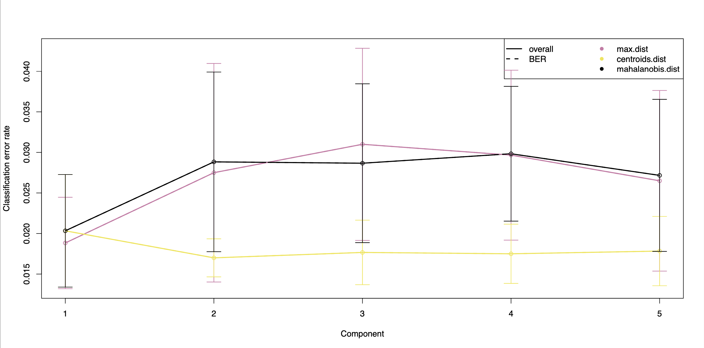B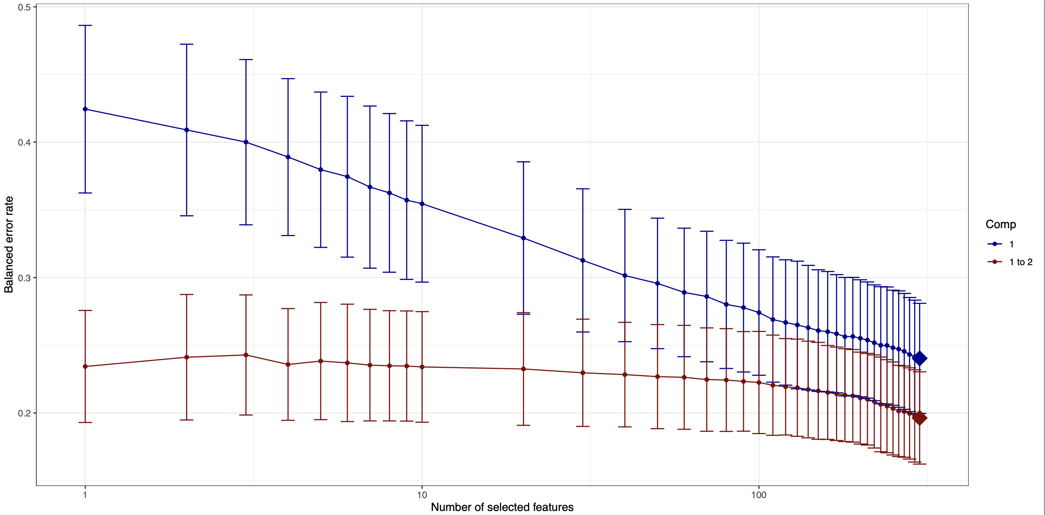
C 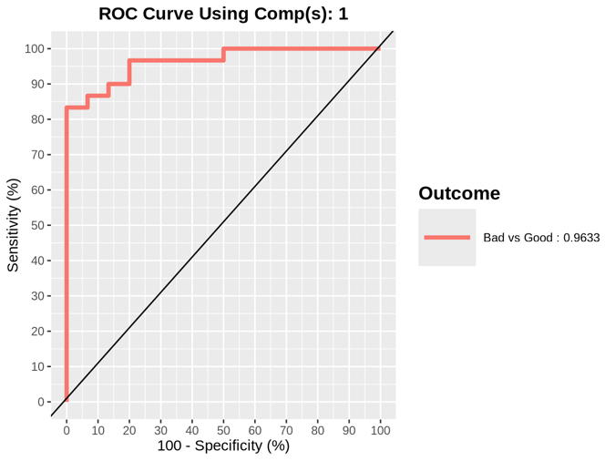 D 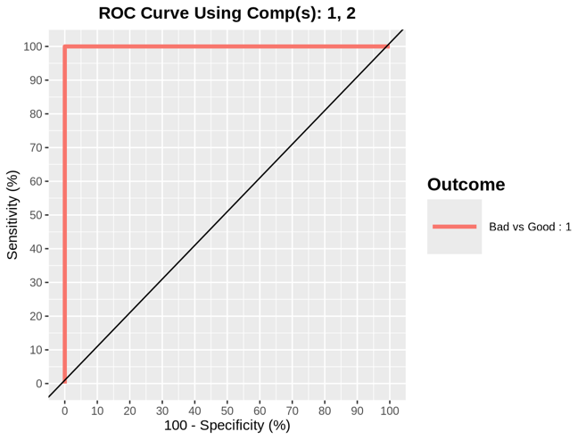
E 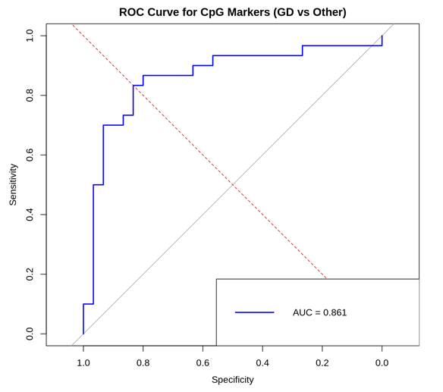
Figure S1: A. Tuning the number of components in PLS-DA: Repeated cross-validation (100 × 5-fold CV) is performed for each component to evaluate the classification performance of PLS-DA. The performance metrics include overall error rate (OER) and balanced error rate (BER) for different prediction distances: max.dist, centroids.dist, and mahalanobis.dist. In this study, we used centroids.dist. B. Tuning keepX for sPLS-DA: Each colored line represents the BER (y-axis) per component across the tested keepX values (x-axis). The SD is calculated from the repeated cross-validation folds. C. Receiver operating characteristic (ROC) curve for Component 1: The area under the curve (AUC) is 0.9633, with a p-value of 7.043e-10 for the comparison between the control and diseased groups. D. ROC curve using Components 1 and 2: The AUC is 1, with a p-value of 2.872e-11 for the comparison between the control and diseased groups. E. ROC curve using methylation percentage values of the selected markers: The AUC is 0.861.
Age-Related Methylation

In this study, we observed a significant negative correlation between age and methylation levels. Detailed results, including regression coefficients and model performance metrics for both CMCs and VMCs, are provided in the Supplementary Data.

Correlations
The Pearson and Spearman correlations were calculated to assess the relationship between age and methylation levels for two datasets, CMCs and VMCs:
- CMCs:
  - Pearson Correlation: -0.5317
- VMCs:
  - Pearson Correlation: -0.5478

Linear Regression Summary
The relationship between age (in days) and mean methylation levels was modeled using linear regression for CMCs and VMCs:
CMCs:
- Model Formula: colMeansCMCs ~ Age
- Coefficients:
  - Intercept: 79.150 ± 0.248 (p < 2e-16)
  - Age: -0.00054 ± 0.00011 (p = 1.23e-05)
- Residual Standard Error: 0.6257
- R-squared: 0.2827
- Adjusted R-squared: 0.2703
- F-statistic: 22.86 (p = 1.233e-05)
VMCs:
- Model Formula: colMeansVMC ~ Age
- Coefficients:
  - Intercept: 57.160 ± 0.173 (p < 2e-16)
  - Age: -0.00039 ± 0.00008 (p = 5.91e-06)
- Residual Standard Error: 0.4353
- R-squared: 0.3000
- Adjusted R-squared: 0.2880
- F-statistic: 24.86 (p = 5.909e-06)

Predicted Methylation Reduction Over 10 Years
To estimate the impact of aging on methylation levels over 10 years (≈3,652.5 days), the following calculations were performed using the regression coefficients:
- CMCs Reduction:
  - Predicted reduction = −0.0005375×3652.5=−1.963%
- VMCs Reduction:
  - Predicted reduction = −0.0003900×3652.5=−1.424%

Notes
The predicted percentage reductions assume an initial methylation level of 100%.
These reductions indicate that both conserved and variable methylation levels decline with age, with a slightly faster decline in conserved methylated cytosines (CMCs).

