Supporting Information

Article title: Analyses of contiguous reference genomes of Amaranthus tuberculatus highlights the landscape of sex-determining region, PEBP gene family diversity, and organelle-derived nuclear insertions
Authors: Damilola A. Raiyemo¹, Luan Cutti², Eric Patterson², Victor Llaca³, Kevin Fengler³, Jacob S. Montgomery⁴, Sarah Morran⁴, Todd A. Gaines⁴ and Patrick J. Tranel^{1,*}
*Correspondence: tranel@illinois.edu

The following Supporting Information is available for this article:

Fig. S1 Heatmaps of tandem repeat structures for each of the 16 chromosome of haplome 1 assembly. Higher-order repeats represented by brightly-colored region indicates the centromere.
Fig. S2 Heatmaps of tandem repeat structures for each of the 16 chromosome of haplome 2 assembly. Higher-order repeats represented by brightly-colored region indicates the centromere.
Fig. S3 Search of the 572 bp male-specific marker to a database of transposable element encoded proteins. The marker matched to two hits with about 79.54% or 94.23% of the sequences masked. Softmasked sequences are represented with lowercase.
Fig. S4 Genomic features of the two haplotype assemblies of A. tuberculatus. (a) Dotplot of base alignment between the two haplomes. (b) synteny pattern between both haplomes indicating a 1:1 relationship in gene content.
Fig. S5 Gene structure of FT and its homologs in Hap1 of the A. tuberculatus genome assembly showing exon-intron organization.
Fig. S6 Schematic representation of trees displaying branches used as foreground (red color) in CODEML analysis. (a) Haplotype 1 was used as the foreground branch while others were background branches. (b) Haplotype 2 was used as the foreground branch while others were the background branches. (c) Both haplotypes were used as the foreground branches (d) Both haplotypes including the branch leading to their common ancestor were used as foreground branches.

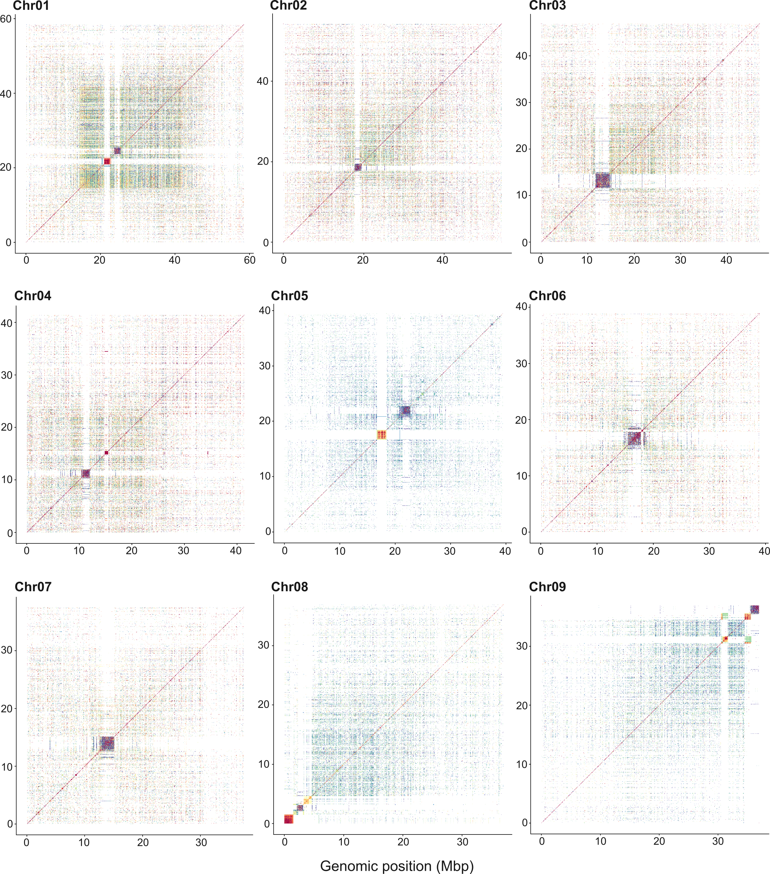

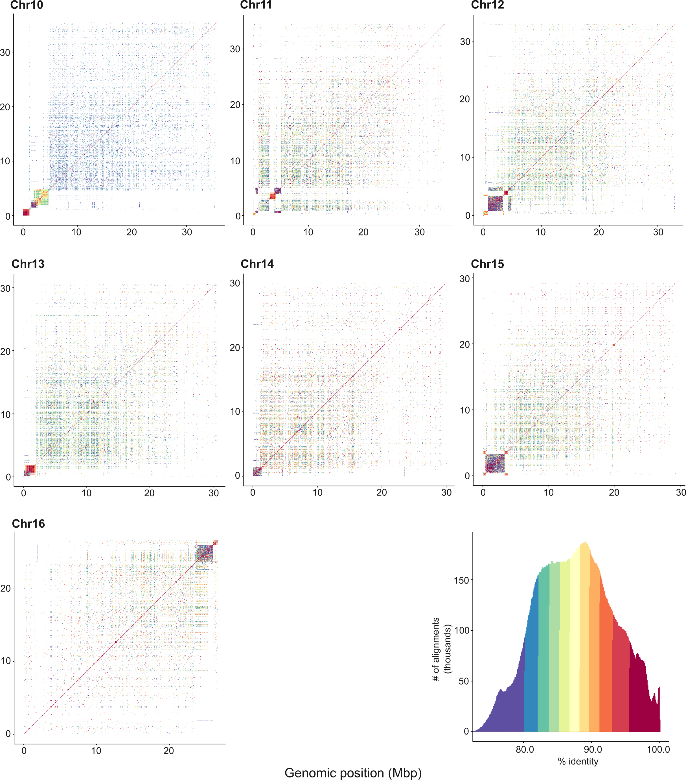
Fig. S1 Heatmaps of tandem repeat structures for each of the 16 chromosome of haplome 1 assembly. Higher-order repeats represented by brightly-colored region indicates the centromere.

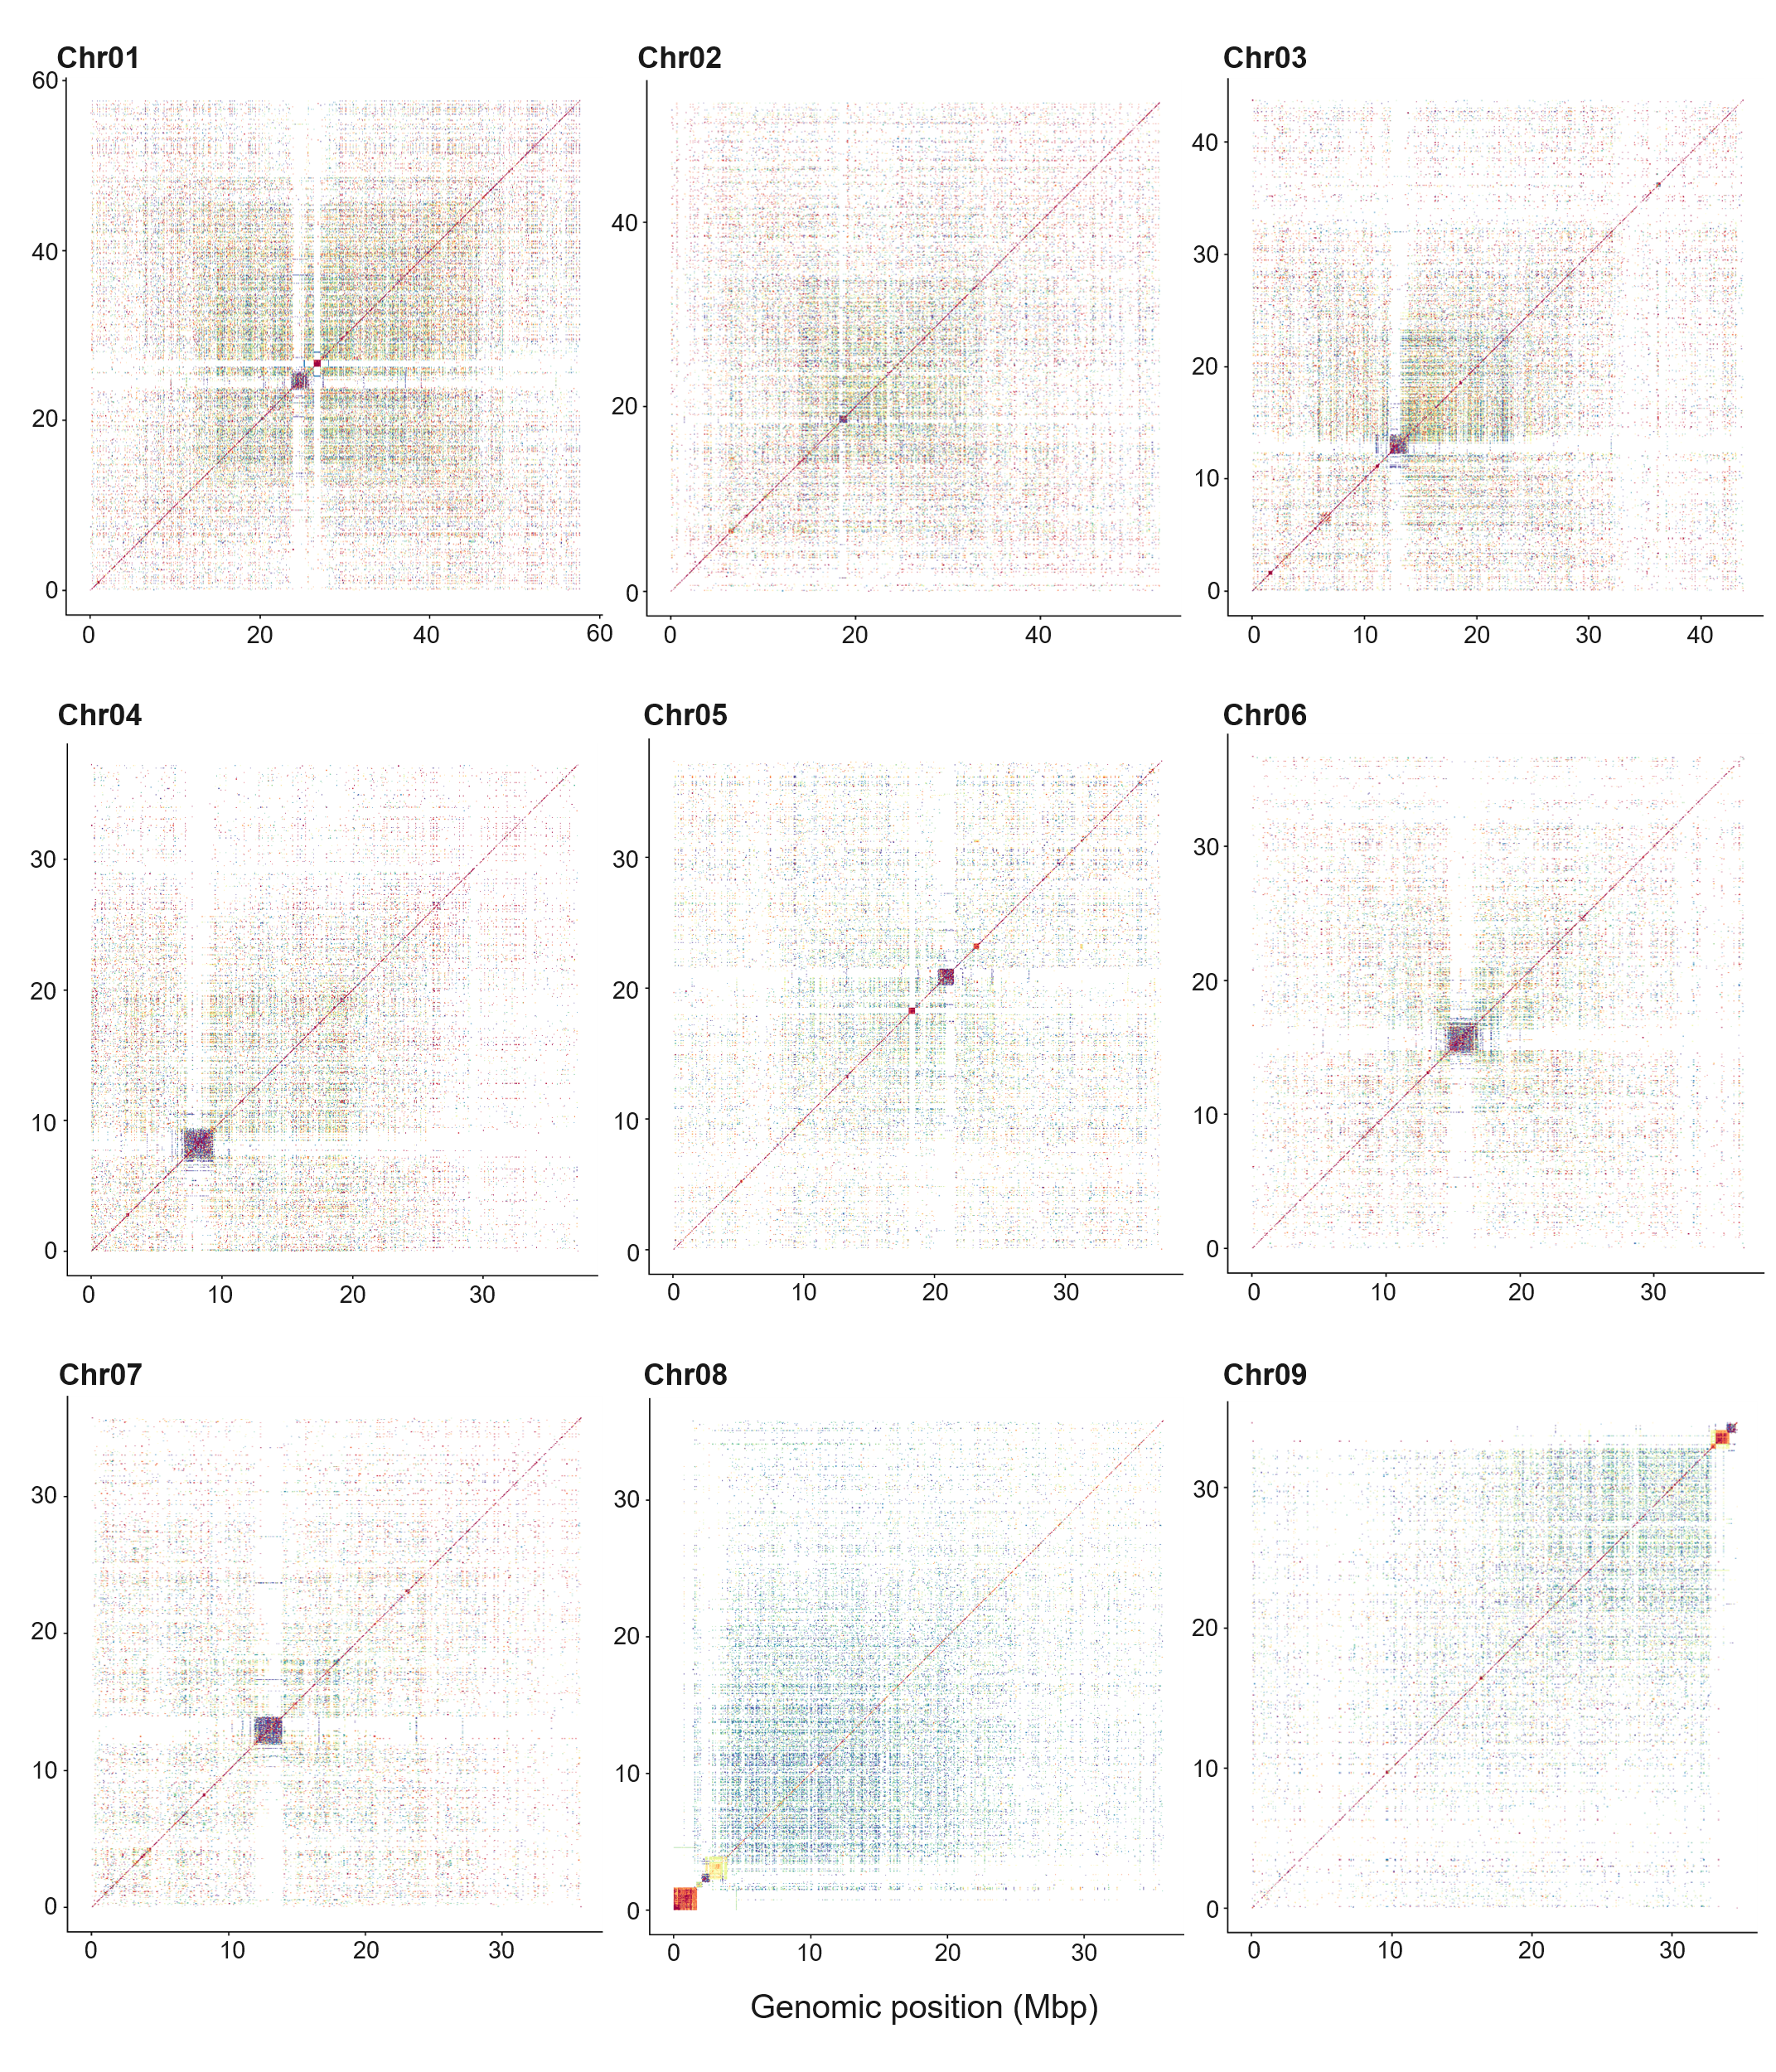

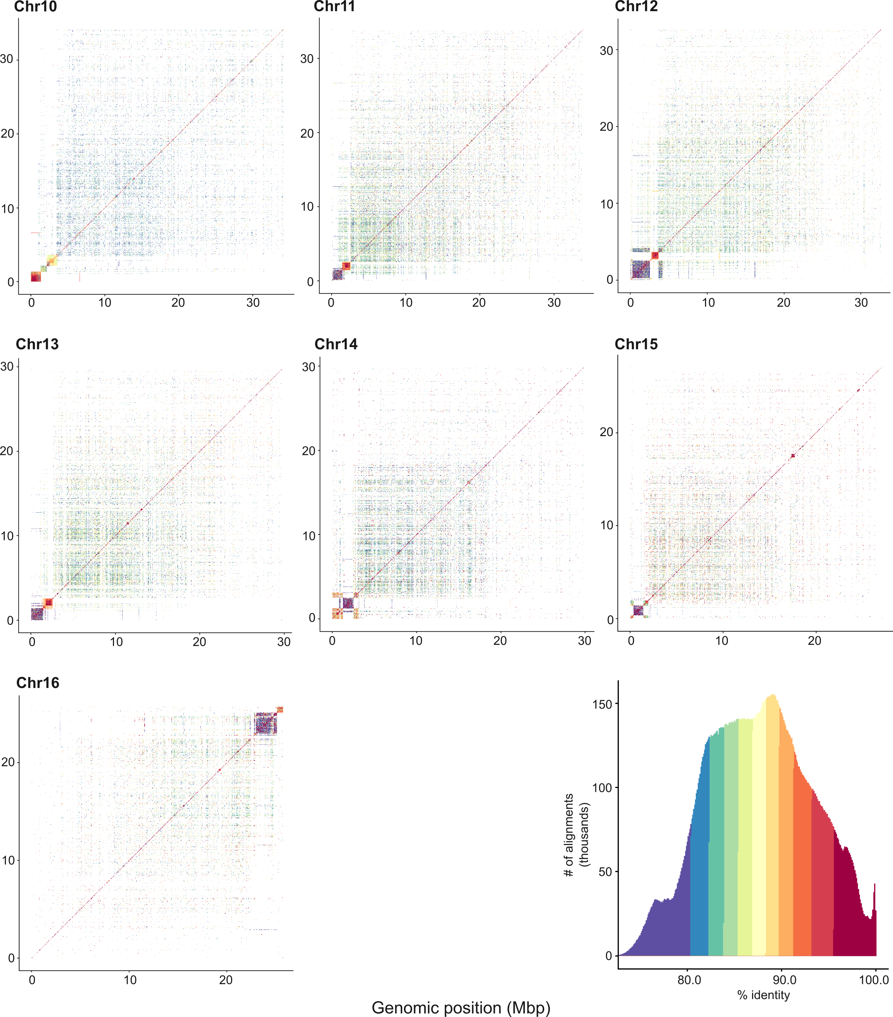
Fig. S2 Heatmaps of tandem repeat structures for each of the 16 chromosome of haplome 2 assembly. Higher-order repeats represented by brightly-colored region indicates the centromere.

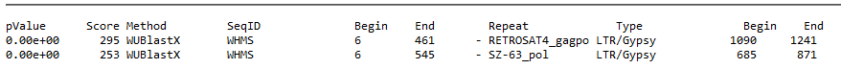
>WHMS_572bp_marker
atgacatcattccctcactgagtcctaagtagtcaaaccacaaaatccatagagatcgaa
tcccacttccaatcagggacaagcaagggttgaagcagtcctgaactctttttccttttg
aattttacctgctgacataataaacacttagacacaaactctgatacatcttttcttagc
cctttccaccagattagctctctaatttcttcaatcattttatcacgaccaggatgtaaa
tgaaacaagctttgagtacctactttcaaaatgtcattcttcaactcgagttgatttgga
acgcacAACCTACCATTCATCCTTAGCTCCCCTCTCTCCCCCAACTCAAAAGCATTAATc
ttattagcttcatctctatgtatcaattccacaacctctagatcctcaagttgtgcctca
atgatatgatcaaacaaggacagttgcacagtcattgctcccaaggagtgaccaacctct
ggccgtgtaaaatctctaacccaaagttctgcacctcacgatacaactccCATGGTACAG
TCATCAAAGCATTTAGACTcactcttggtctcc
Fig. S3 Search of the 572 bp male-specific marker to a database of transposable element encoded proteins. The marker matched to two hits with about 79.54% or 94.23% of the sequences masked. Softmasked sequences are represented with lowercase.

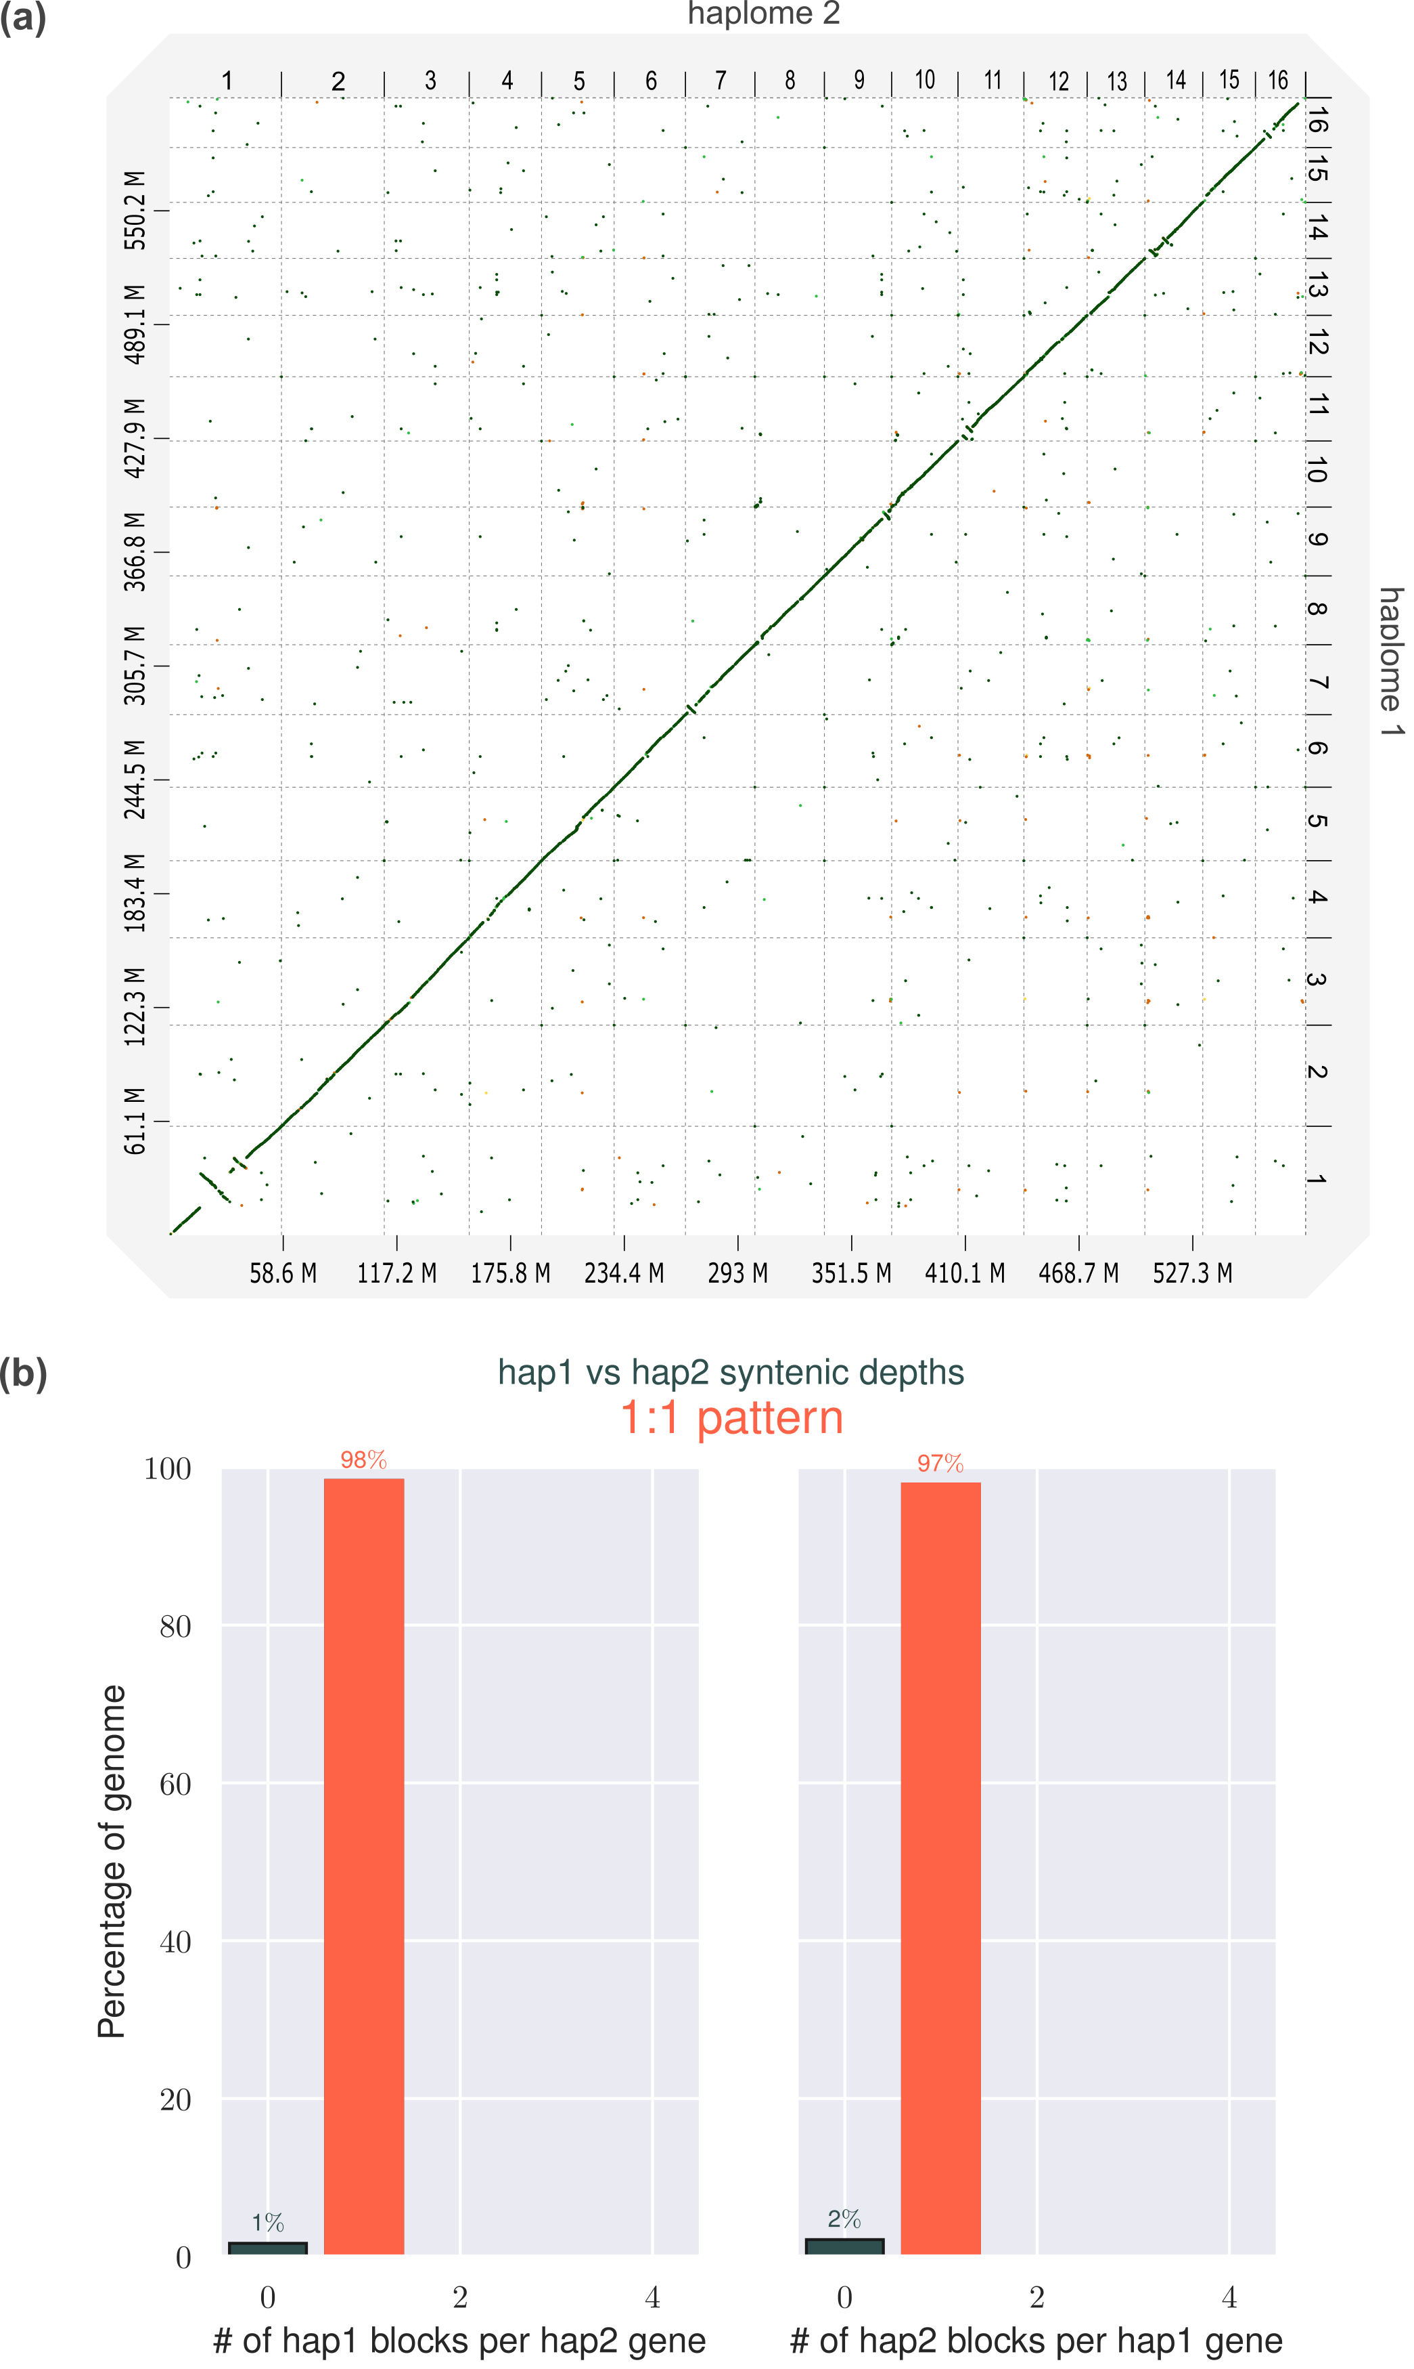
Fig. S4 Genomic features of the two haplotype assemblies of A. tuberculatus. (a) Dotplot of base alignment between the two haplomes. (b) synteny pattern between both haplomes indicating a 1:1 relationship in gene content.
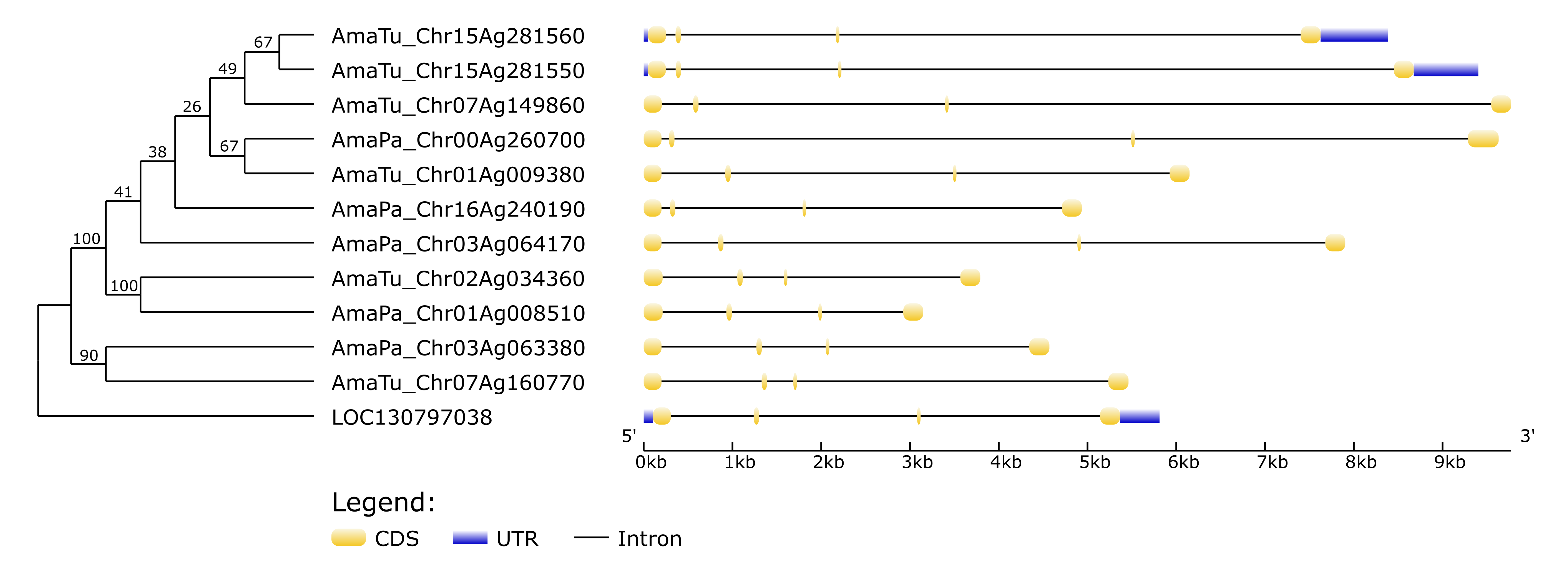
Fig. S5 Phylogenetic tree of FT protein sequences and gene structures in Hap1 of A. tuberculatus and A. palmeri genome assembly showing exon-intron organization. The tree was rooted with an FT homolog from A. tricolor. Values on the tree represent RAxML bootstarp support (BS) values.

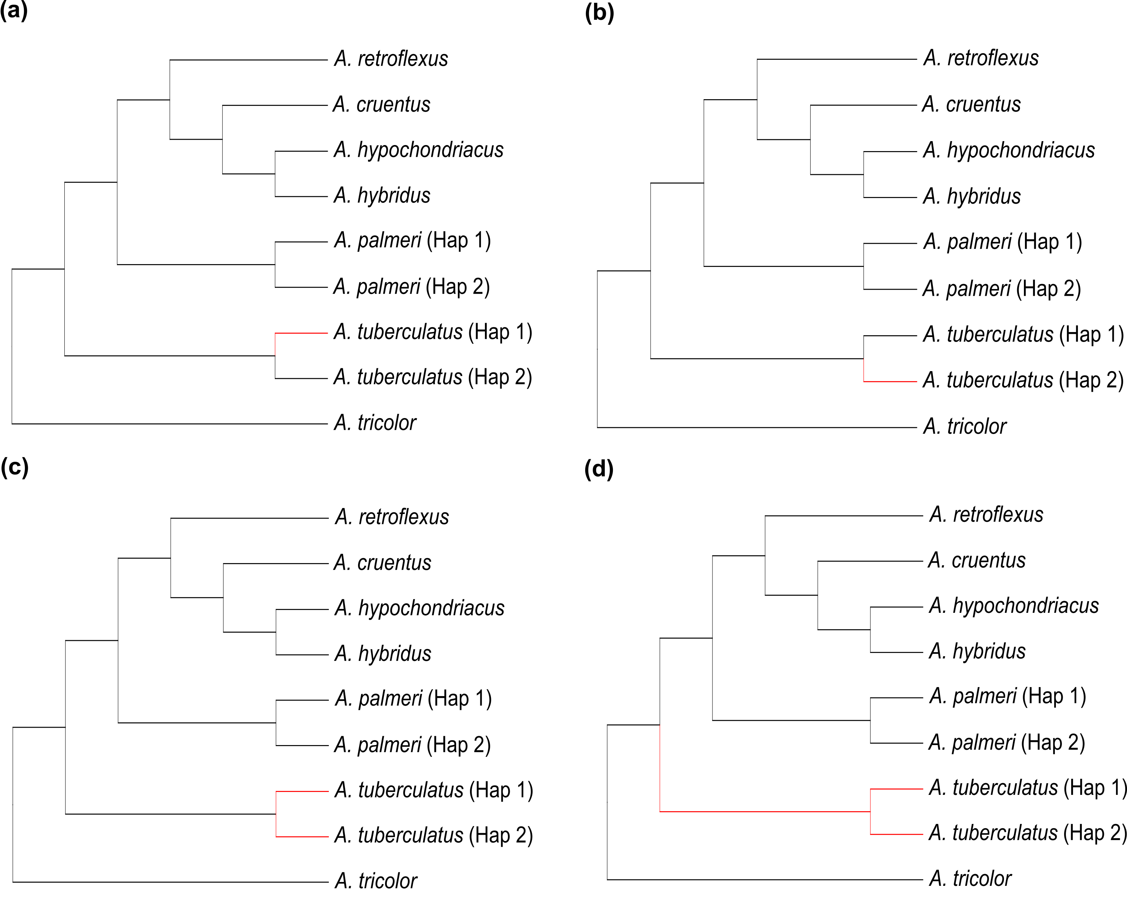
Fig. S6 Schematic representation of trees displaying branches used as foreground (red color) in CODEML analysis. (a) Haplotype 1 was used as the foreground branch while others were background branches. (b) Haplotype 2 was used as the foreground branch while others were the background branches. (c) Both haplotypes were used as the foreground branches (d) Both haplotypes including the branch leading to their common ancestor were used as foreground branches.

