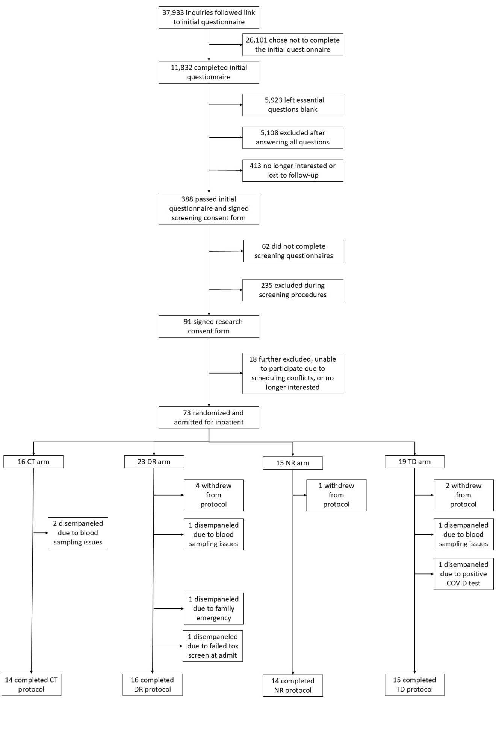
Figure S1. CONSORT diagram of participant recruitment, ending with the number of participants that completed each of the four study condition groups: control (CT), daytime sleep restriction (DR), nighttime sleep restriction (NR), and total sleep deprivation (TD). Initially potential participants were directed to an online questionnaire, followed by participant online and in-person based screening procedures. Participants who passed screening criteria were admitted to the inpatient study.

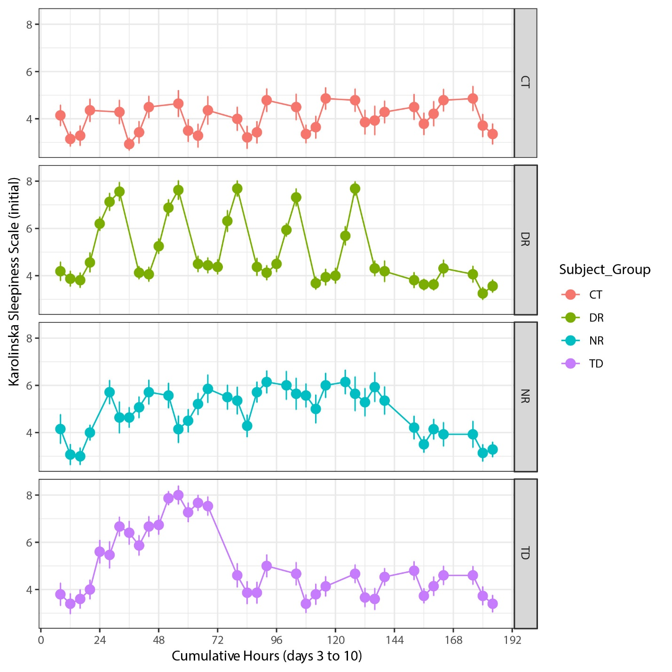
Figure S2. Mean (+/- 1 standard error) of Karolinska Sleepiness Scale scores from midnight at the outset of baseline study day 3 through the end of the 10-day inpatient study, reflecting the initial Karolinska Sleepiness Scale towards the beginning of each ~45-minute neurobehavioral test battery. All times are Relative Clock Hour (RCH).

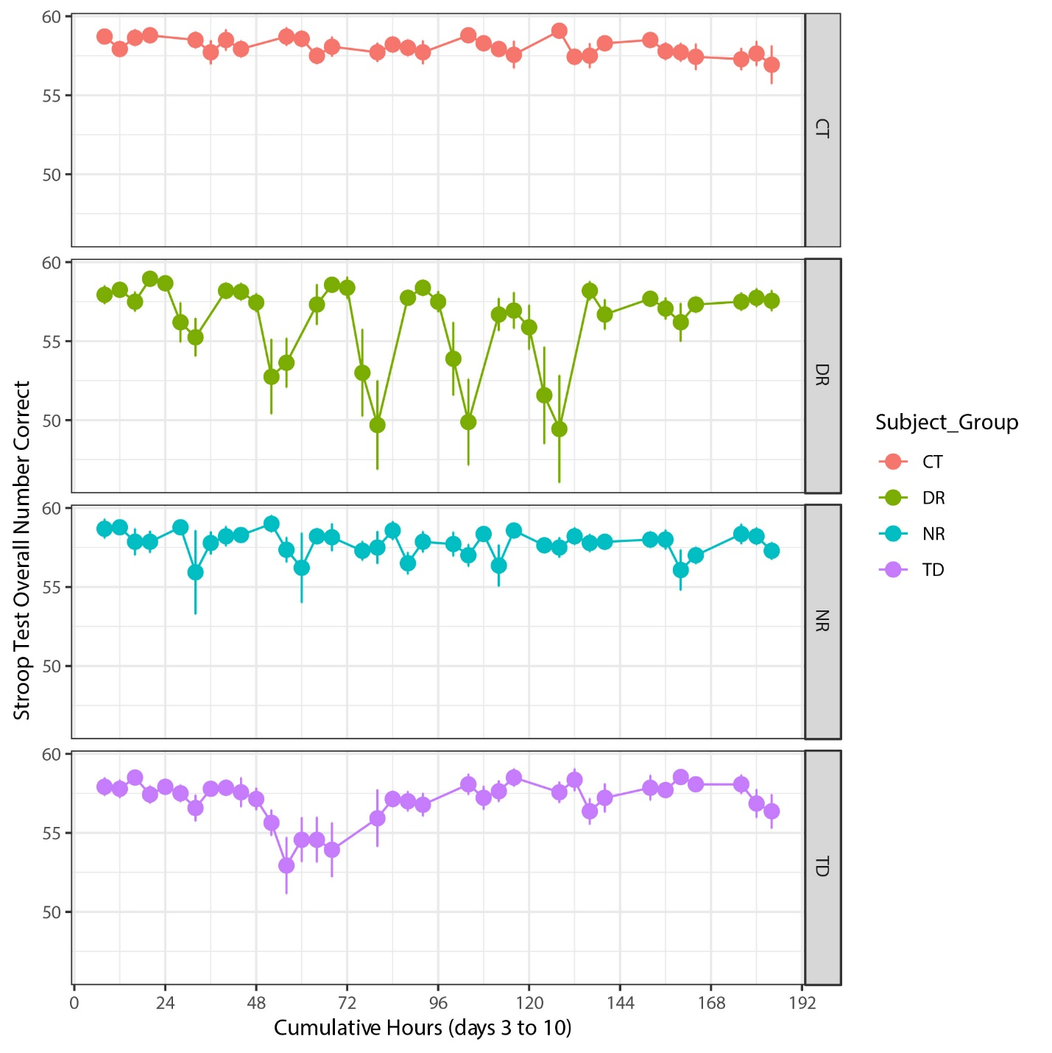
Figure S3. Mean (+/- 1 standard error) of the number of correct responses on blue-yellow tests only for the STROOP results. Scores are shown from midnight at the outset of baseline study day 3 through the end of the 10-day inpatient study. All times are Relative Clock Hour (RCH).

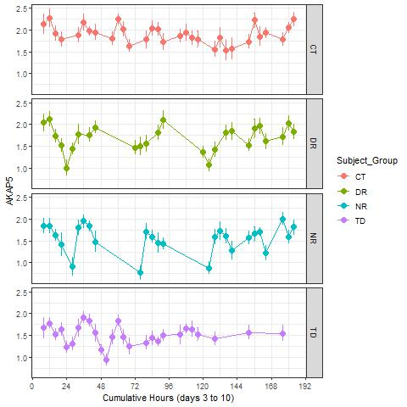
Figure S4. Mean (+/- 1 standard error) log2 counts per million gene expression, based on normalized libraries, for the gene AKAP5. All times are Relative Clock Hour (RCH), showing study day 3 through the end of the 10-day inpatient study.

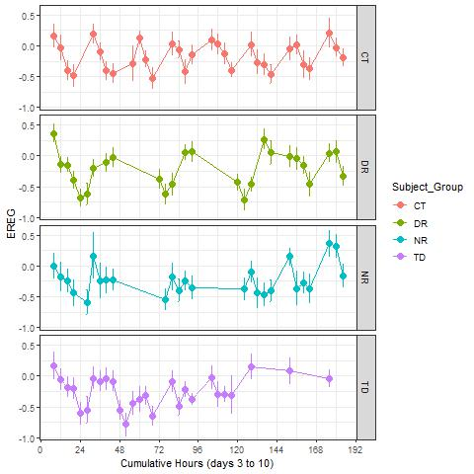
Figure S5. Mean (+/- 1 standard error) log2 counts per million gene expression, based on normalized libraries, for the gene EREG. All times are Relative Clock Hour (RCH), showing study day 3 through the end of the 10-day inpatient study.

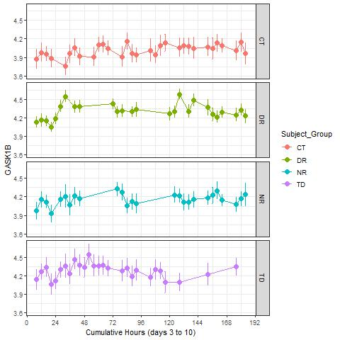
Figure S6. Mean (+/- 1 standard error) log2 counts per million gene expression, based on normalized libraries, for the gene GASK1B. All times are Relative Clock Hour (RCH), showing study day 3 through the end of the 10-day inpatient study.

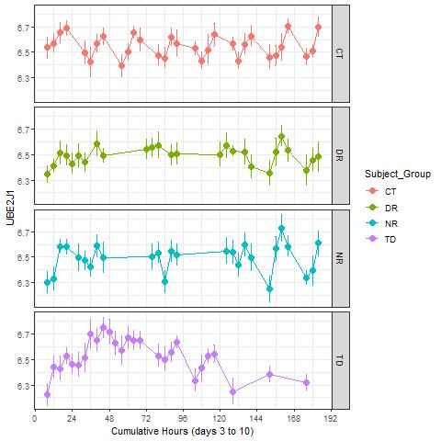
Figure S7. Mean (+/- 1 standard error) log2 counts per million gene expression, based on normalized libraries, for the gene UBE2J1. All times are Relative Clock Hour (RCH), showing study day 3 through the end of the 10-day inpatient study.
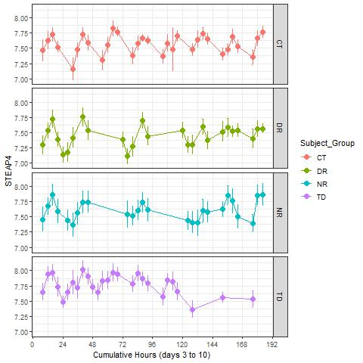
Figure S8. Mean (+/- 1 standard error) log2 counts per million gene expression, based on normalized libraries, for the gene STEAP4. All times are Relative Clock Hour (RCH), showing study day 3 through the end of the 10-day inpatient study.

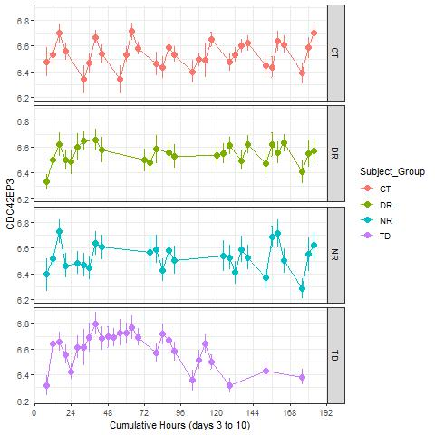
Figure S9. Mean (+/- 1 standard error) log2 counts per million gene expression, based on normalized libraries, for the gene CDC42EP3. All times are Relative Clock Hour (RCH), showing study day 3 through the end of the 10-day inpatient study.

