Functional Analysis of the FGF2 Gene in Horn Development in Sheep and Identification of Key Regulatory Variants
Fei Liu ^{1,2,3}, Hao Li ^{2,3}, Zhu Meng ^{2,3}, Shiwen Zhang ^{2,3}, Huaiqiang Yang ^{2,3}, Yangshuo Hu ^{2,3}, Renzeng Ciwang ⁴, Jianning He ^{1,*}, Zhangyuan Pan ^{1,2,3,*}
¹ College of Animal Science and Technology, Qingdao Agricultural University, Qingdao 266109, China
² State Key Laboratory of Animal Biotech Breeding, Institute of Animal Science, Chinese Academy of Agricultural Sciences, Beijing 100193, China
³ National Nanfan Research Institute (Sanya), Chinese Academy of Agricultural Sciences, Sanya 572024, China
⁴ Institute of Animal Science, Tibet Academy of Agricultural and Animal Husbandry Sciences, Lhasa 850009, China
Corresponding authors: Jianning He; Zhangyuan Pan.
E-mail address: hexingxing104@163.com (J.H.); zhypan01@163.com (Z.P.)

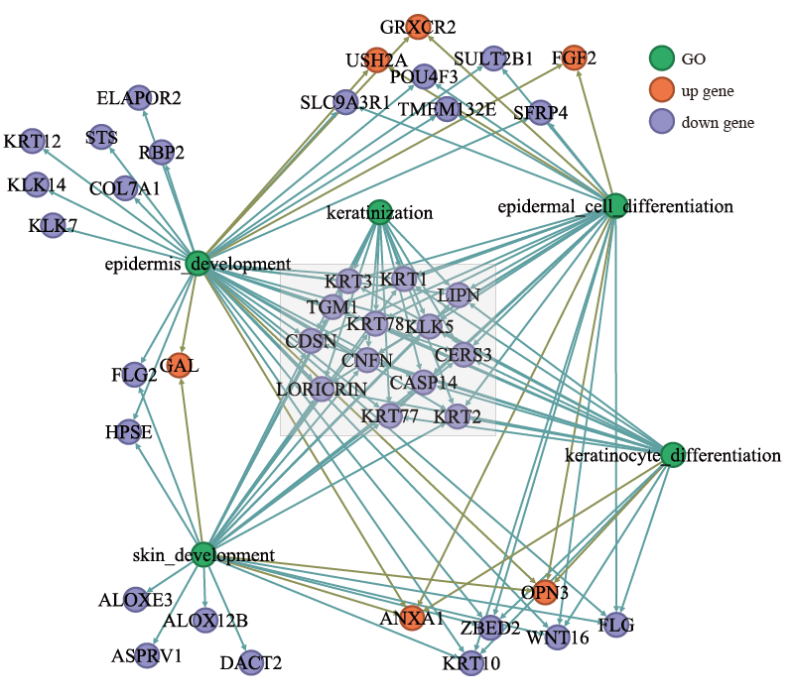
Supplementary Figure 1. GO enrichment network of genes related to FGF2 function in sheep. The gene ontology (GO) enrichment analysis revealed that FGF2 (highlighted with a red border) is associated with epidermis development and epidermal cell differentiation. Nodes in green represent GO terms, orange nodes indicate upregulated genes, and purple nodes indicate downregulated genes. Edges represent functional associations between genes and GO terms.
Supplementary Figure 2. Correlation analysis of FGF2 expression with NUDT6 across different sheep tissues. (A–N) Scatter plots show the correlation between FGF2 and NUDT6 expression levels (log2-transformed) across 14 sheep tissues, including blood, CNS, heart, horn, intestine, kidney, liver, muscle, ovary, periosteum, skin, spleen, stomach, and testes. Pearson correlation coefficients (R) and p-values are shown in each panel.

