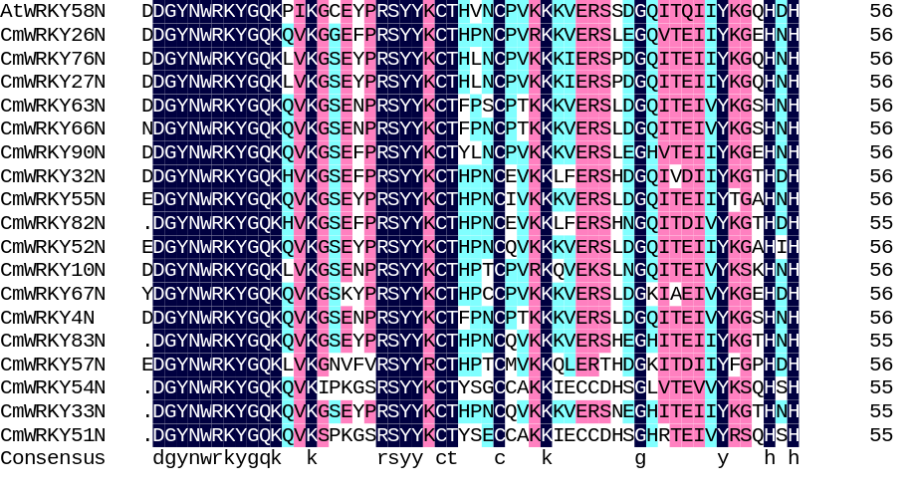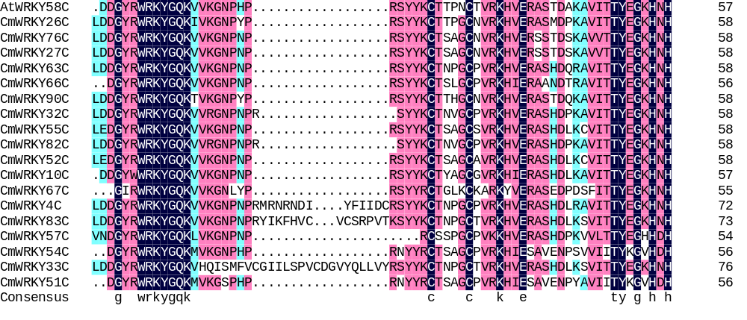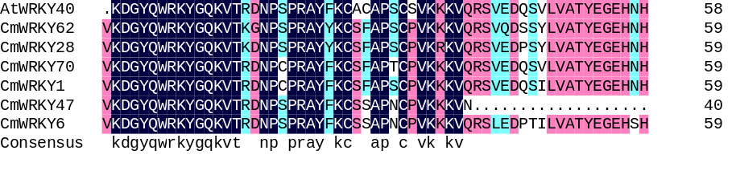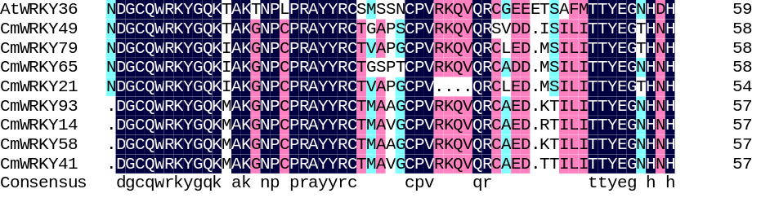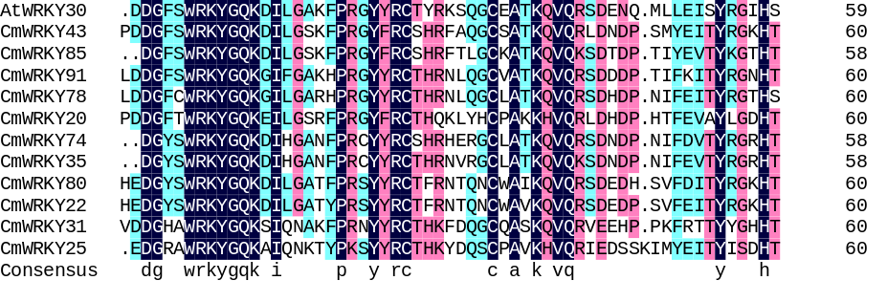
Group IN
Group IC
Group IIa
Group IIb
Group III
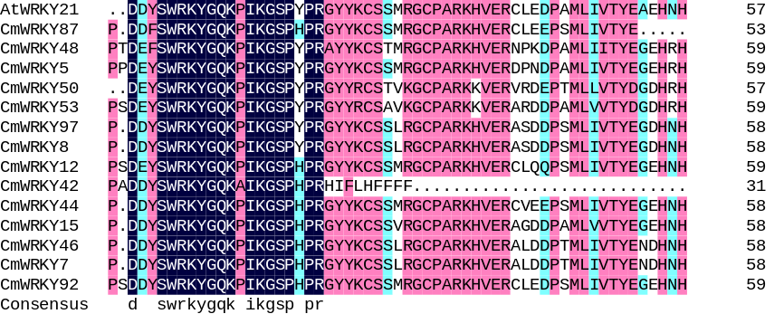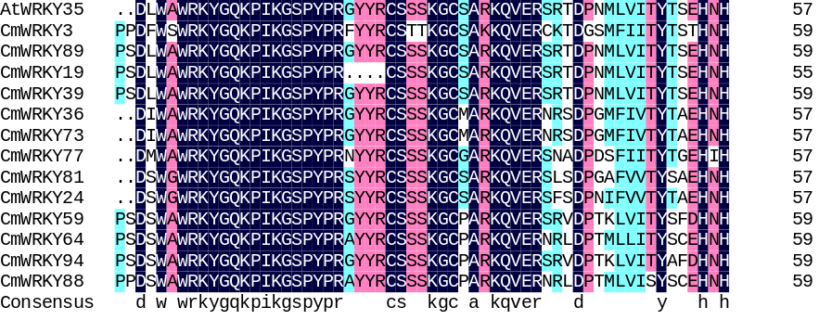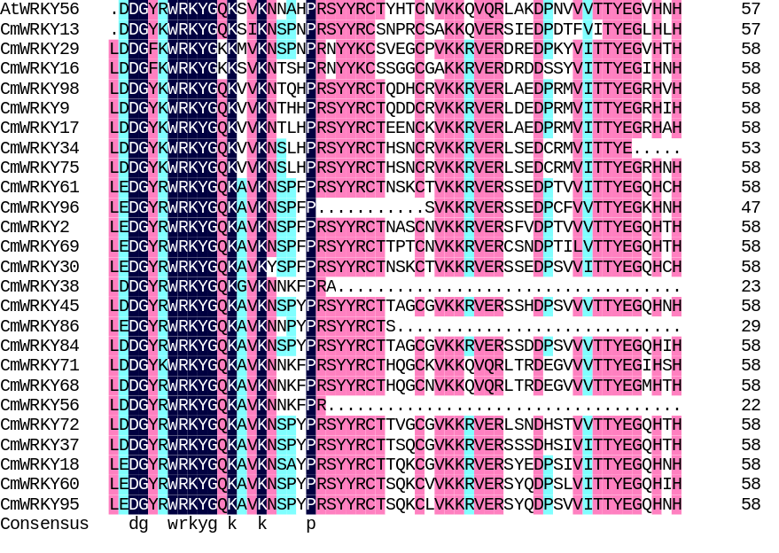
Group IIc
Group IId
Group IIe
Fig. S1 Multiple sequence alignment of the WRKY domains in pumpkin and Arabidopsis. Alignment was performed using Clustal W. The suffix ‘N’ or ‘C’ indicates the N-terminal WRKY domain or the C-terminal WRKY domain, respectively. The highly conserved WRKYGQK and zinc finger motif sequences are highlighted in different colors, and gaps are marked with dots.

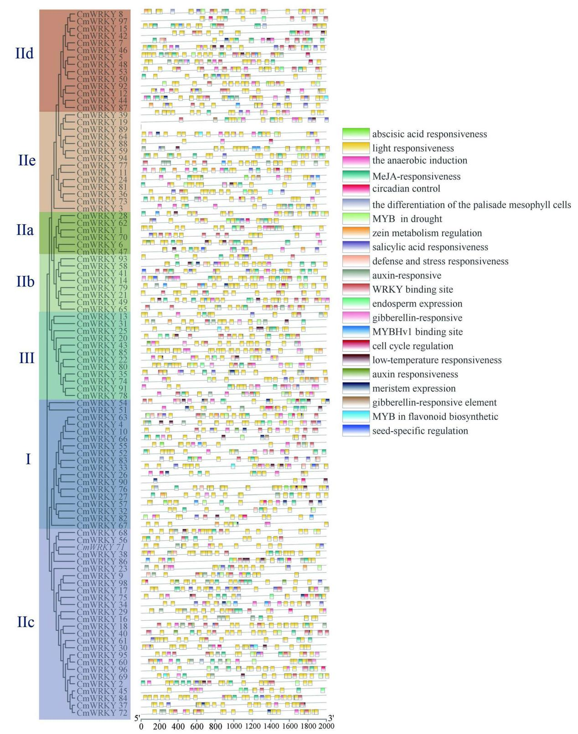
Fig. S2 Cis-acting elements prediction of CmWRKY genes along with phylogenetic tree. The length of promoters can be estimated using the scale at the bottom. The cis-acting elements are indicated by different color boxes. Details of cis-acting element are shown in Table S5.

