Supplemental Information
Global characterization of Dictyostelium discoideum gene and protein expression changes under hypoxic conditions
Julie Hesnard¹, Elisabet Gas-Pascual², Hanke van der Wel², Olivier Cochet-Escartin¹, Stephane Joly¹, Jean-Paul Rieu¹, Christopher M. West² and Christophe Anjard¹

Table S1: Transcriptomic data across the time course. AX3 cells were placed in shaking flasks that were continuously and serially purged with a humidified atmosphere of 1% O₂ in N₂ for 24 h and then reoxygenated with 20% O₂ for 5 h. A flask was removed to collect cells at 1 h, 5 h, and 24 h under hypoxia, and at 1 h and 5 h during reoxygenation. The standard t0 was collected from the culture tube. At each time point, transcripts were extracted and sequenced using MACE-seq (GenXpro)
A: Total transcripts per million (TPM). The TPM values were provided by the sequencing company GenXpro. For each detected transcript, TPM values related to each replicate are indicated (n=3), such as the mean of the triplicate for each time point. These TPM values were used to calculate the turnover rate (Fig. 1C).
B: Coding RNA transcriptomic data. For each transcript, the expression level compared to the standard condition (t0, 21% O₂) is expressed in log2FC, with a corresponding FDR (provided by GenXpro). Only coding RNA are represented, since tRNA and transposable elements were manually removed. Those data were used to determine correlation between transcripts at each time point of the time course (Fig. 1E), and to compare with protein abundance (Fig. 2D and E)
C: Actin-related transcripts. Differentially regulated transcripts (log2≥1 or log2FC≤-1; FDR<0.05) related to actin polymerisation were summarized.
D: Calcium-associated transcripts. Differentially regulated transcripts (log2≥1 or log2FC≤-1; FDR<0.05) encoding calcium-binding or calcium-dependant proteins were summarized.
E: cAMP pathway-associated transcripts. Differentially regulated transcripts (log2≥1 or log2FC≤-1; FDR<0.05) associated with cAMP production, reception and degradation were summarized. Those data support Fig.7A-E.
F: Cell adhesion-associated transcripts. Differentially regulated transcripts (log2≥1 or log2FC≤-1; FDR<0.05) were summarized.

Table S2: Differentially expressed proteins at 5 h of low O₂.
Proteins were identified with an FDR ≤ 0.05, from ≥2 peptides each identified with an FDR < 0.01, and quantified based on spectral counting of the peptides. Data from 6 independent 5 h 1D trials from Series 1 and Series 2, each with 3 technical replicates (18 total analyses), were analyzed together using Proteome Discoverer 2.5. Single samples from each series were analyzed using the 2D method, each with 3 technical replicates, and analyzed separately. Protein abundances from samples maintained at 1% O₂ were ratioed to abundances from samples maintained at 21% for 5 h. These data derive from Table S4 and support Fig. 4. Proteins that were significantly up-regulated according to criteria described in Methods are reported. Proteins were classified into functional categories based on annotations at dictyBase.org and sequence similarities based on pBLAST searches.
A: Up-regulated proteins at 5h at 1% O₂.
B: Down-regulated proteins at 5h at 1% O₂.

Table S3. Differentially expressed proteins at 24 h of low O₂.
Proteins were identified with an FDR≤0.05 from ≥2 peptides identified with an FDR<0.01, and quantified based on spectral counting. Data from 3 independent 1D trials from Series 2, each with 3 technical replicates (9 total analyses), were analyzed together using Proteome Discoverer 2.5. Protein abundances from samples maintained at 1% O₂ for 24 h were ratioed to abundances at 0 h (21%). These data support Figs. 5D and E, Fig. 6C, Fig. S4. NA indicates data not assigned.
A: Proteins whose ratios were statistically different from 1 (p<0.05) at 24 h are considered DEPs, and are sorted according to FC from high to low. Adjacent columns show p-values and FDR-adjusted p-values. For each protein, relative abundances and corresponding statistical significance from the 5 h (1% O₂), and 1 h and 5 h reoxygenation (21% O₂) trials from Series 2 are also included for comparison and highlighted in dark green. In addition, the Sequest score and protein false discovery rate (FDR) data (high, FDR<0.01; medium, FDR<0.05) that formed the basis for protein identification, and the number of unique peptides that formed the basis for quantifying abundance are shown. The data derive from Table S4. Finally, corresponding RNAseq data, also ratioed to abundance at 0 h, are also shown. In individual tabs, proteins are grouped according to inferred roles, and sub-grouped according to up- or down-regulation.
B: The subset of entries in A that were associated with the redox proteins.
C: The subset of entries in A that were associated with Central carbon metabolism.
D: The subset of entries in A that were associated with macromolecular synthesis (RNA, protein). Lipidation proteins and discoidins are also included.
E: The subset of entries in A that were associated with ubiquitin, proteasomes, and autophagy.
F: The subset of entries in A that were associated with the protein transport via vesicles.
G: The subset of entries in A that were associated with organelles (mitochondria, lysosomes, peroxisomes).
H: The subset of entries in A that were associated with the histones.
I: The subset of entries in A that were associated with tRNA synthetases.
J: The subset of entries in A that were associated with the cytoskeleton.
K: The subset of entries in A that were associated with signalling, including G-proteins, calcium, cell cycle, and adhesion.

Table S4: Merged total transcriptomic and proteomic data across the time course. In this inclusive list, all proteins detected in at least one trial with ≥2 peptides and a protein FDR of ≤0.05 are shown, together with the number of peptides, the FDR for protein identification, and p-values and FDR-corrected p-values for significance of being up- or down-regulated. Series 1 (4 biological replicates) consisting of 1D experiments at 1 and 5 h of low oxygen are reported as 1% 5h/21% 0h. Series 2 (3 biological replicates) consisting of 1D experiments at 5, 24, 25 (1 h reoxygenation) and 29 (5 h reoxgenation) h of low oxygen are reported as 1% 5h/21% 0h). The two 5-h 2D analyses (reported as 1% 5h/21% 5h) are also included, as well as the reprocessed analyses from all six 5-h 1D analyses, separating results reported as 1% 5h/21% 5h or 1% 5h/21% 0h. All corresponding detected coding RNAs are aligned with their corresponding detected proteins. Transcriptomic data are expressed in log2 fold change (log2FC) along with their associated false discovery rate (FDR). Proteomic data are shown with both fold change (FC) and log2 fold change (log2FC), along with their respective p-values and FDR-corrected p-values. NA indicates data not assigned. These data support Tables S2 and S3.
Table S5: Gene Ontology annotation for transcripts regulated across the time course.
Transcripts that were differentially regulated (log2≥1 or log2FC≤-1; FDR<0.05) at 1 h, 1 h and 5 h, 24 h, and 24 h reoxygenation were analyzed with DAVID, using dictyBase_IDs. The direct GO terms associated with the biological functions are listed in this table. For each function, the number of genes in the provided list (count), as well as the relative percentage (%) compared to the total number of transcripts in the list (list total), are annotated. The IDs of the associated transcripts (gene) are also provided. Additionally, the fold enrichment was calculated using the 7519 genes annotated with dictyBase_IDs. Three statistical tests are provided (Benjamini, Bonferroni, and FDR) to determine if the fold enrichment is statistically different from what is expected under controlled conditions. In this study, only fold enrichments with FDR<0.05 were analyzed. These data support Figs. 3B, Fig. 5B and C, Fig. 6B.
A: Biological functions associated with transcripts regulated after 1 h in hypoxia.
B: Biological function associated with transcripts regulated at 1h and 5 h hypoxia.
C: Biological functions associated with transcripts regulated during chronic hypoxia (24 h) and reoxygenation.
D: Biological functions associated with transcripts regulated at 24 h.

Percentage of induction | srsA | fhbB | rabR | cxgS
DMOG | 0,3 ± 0,3 | 2 ± 0,4 | 0,10 ± 0,04 | 1 ± 0,5
CoCl₂ | 0,03 ± 0,02 | 2 ± 0,4 | 0,1 ± 0,04 | 1 ± 0,2
Deferoxamine | 0,04 ± 0,04 | 2 ± 0,1 | 0,10 ± 0,04 | 0,80 ± 0,1

Table S6: Effects of drugs that mimic hypoxia in mammals on Dictyostelium gene expression 21 % O₂ (n=3). Cells were incubated with the different chemicals for 1 hour at either 1% or 21% O₂. For each gene, relative expression was determined using the 2^{-ΔΔCt} method, using rnlA as a housekeeping gene. For cells placed at 21% O₂, the relative expression was calculated using the condition without chemical treatment as the standard. Finally, the percentage of induction at 21% O₂ was calculated using the hypoxic expression level without the drug as the 100% expression (% of induction 21% = 100 * (relative expression at 21% O₂ with drug normalized to the 21% condition without drug)/ (relative expression at 1% O₂ no drug normalized to the conditions at 21% without drug)). Mean values are indicated with their associated standard deviations.

Percentage of induction | srsA | fhbB | rabR | cxgS
DMOG | 36 ± 20 | 104 ± 30 | 134 ± 22 | 34 ± 18
CoCl₂ | 214 ± 79 | 94 ± 25 | 224 ± 99 | 141 ± 182
Deferoxamine | 172 ± 133 | 84 ± 6 | 119 ± 54 | 107 ± 131

Table S7: Effects of drugs that mimic hypoxia in mammals on Dictyostelium gene expression at 1% O₂ (n=3). Cells were inoculated with the different chemicals for 1 hour at either 1% or 21% O₂. For each gene, relative expression was determined using the 2^{-ΔΔCt} method, using rnlA as a housekeeping gene. For cells placed at 1% O₂, the relative expression was determined using the same chemical condition at 21% O₂ as the standard. Finally, the percentage of induction at 1% O₂ was calculated using the hypoxic expression level without the drug as the 100% expression (% of induction 1% = 100 * (relative expression at 1% O₂ with drug)/ (relative expression at 1% O₂ no drug)). Mean values are indicated with their associated standard deviations.
Table S8: PRIDE submission files

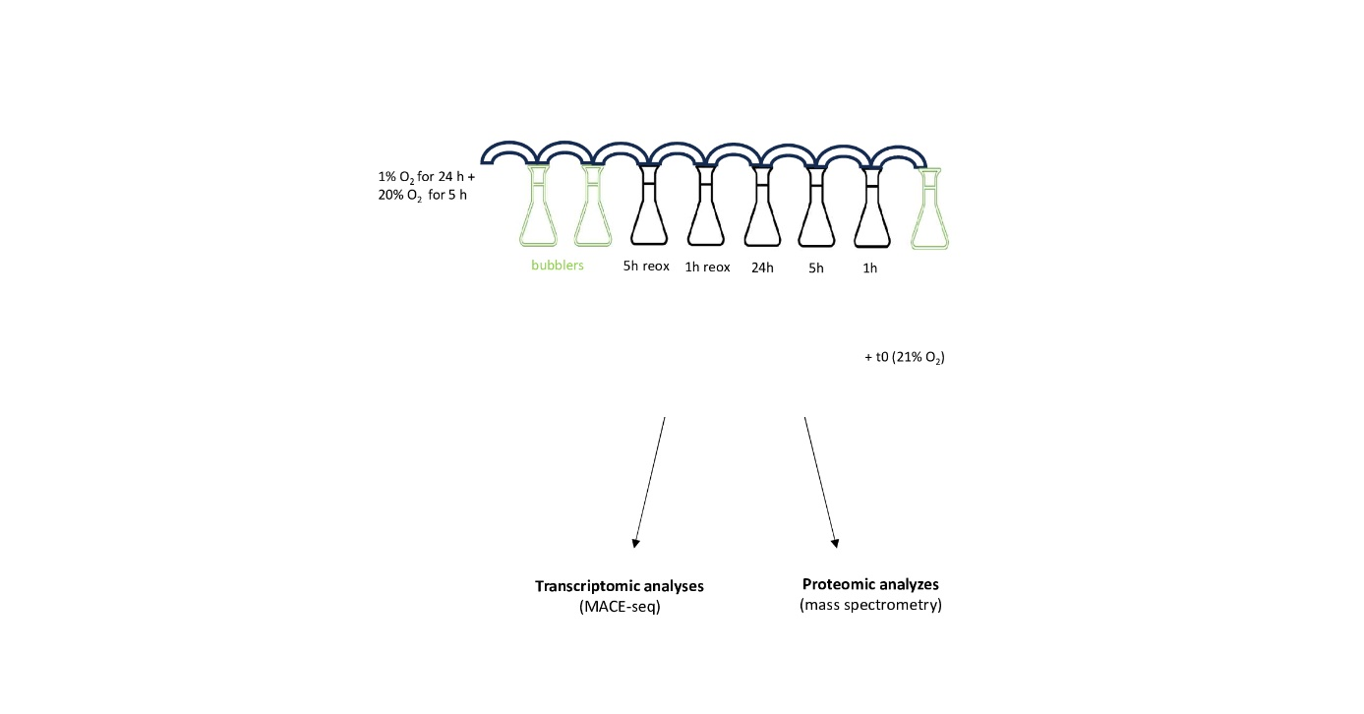
Figure S1: Experimental setup used for the transcriptomic and proteomic time course. AX3 cells were placed in standard 500-ml or 125-ml rimless Erlenmeyer flasks containing 150 ml (proteomic) or 30 ml (transcriptomic) degassed HL5 medium, respectively. Shaking flasks (150 rpm) were continuously and serially purged with a humidified atmosphere of 1% O₂ in N₂ for 24 h and then reoxygenated with 20% O₂ for 5 h. A flask was removed to collect cells at 1 h, 5 h, and 24 h under hypoxia, and at 1 h and 5 h during reoxygenation. The standard t0 was collected from the culture tube. For proteomics analyses, a parallel set of samples maintained at 21% O₂ was collected. At each time point, total RNA and protein was extracted. Transcripts were sequenced using MACE-seq, and proteomic analyses were performed using peptide mass spectrometry.

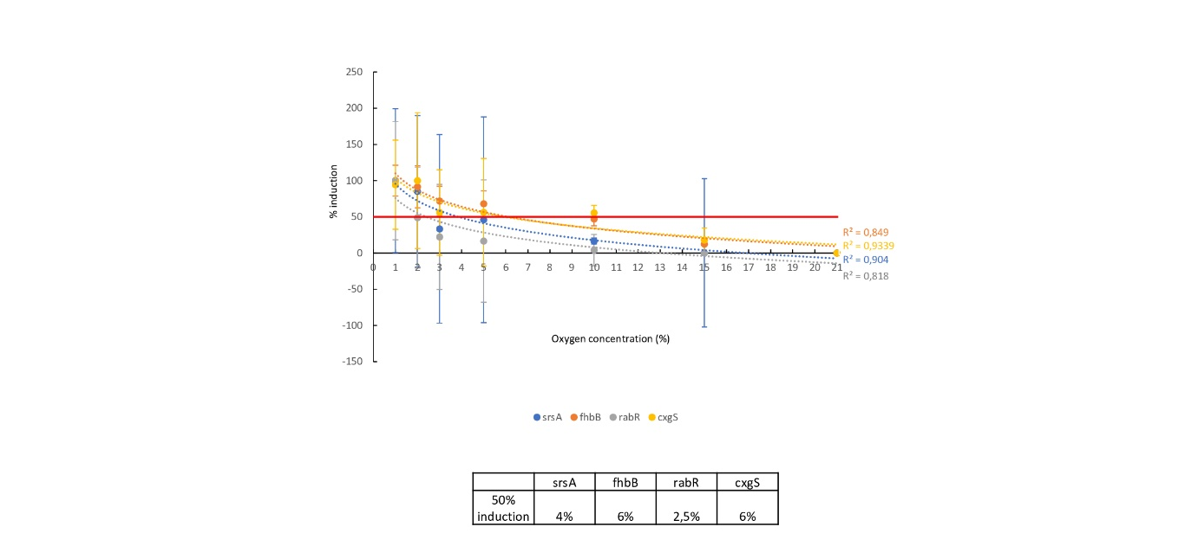
Figure S2: Percentage of induction depending on the oxygen concentration. For each marker gene, the maximum induction (at 1% O₂ for srsA, rabR and fhbB or 2% O₂ for cxgS) was normalized to 100%. This value was used to calculate the induction levels at other concentrations. Only the mean values and their associated standard deviations are shown. The corresponding curves were fitted using logarithmic functions, and the half-induction values (50% induction) were manually determined from these curves. Those data support Fig. 9C-E

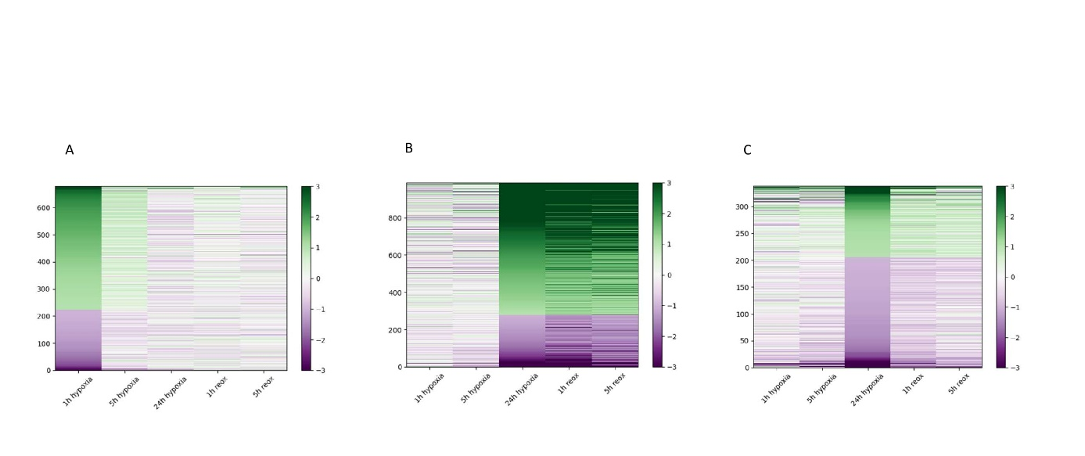
Figure S3: Heat maps of transcript regulation over the time course. For each heat maps, only differentially regulated transcripts (log2≥1 or log2FC≤-1; FDR<0.05 from Table S1) are represented. The up-regulated transcripts are represented in green, while the down-regulated are shown in purple.
A: Heat map of genes regulated after 1 hour of hypoxia.
B: Heat map of genes regulated at 24 hours and during reoxygenation.
C: Heat map of transcripts regulated exclusively after 24 hours of hypoxia.

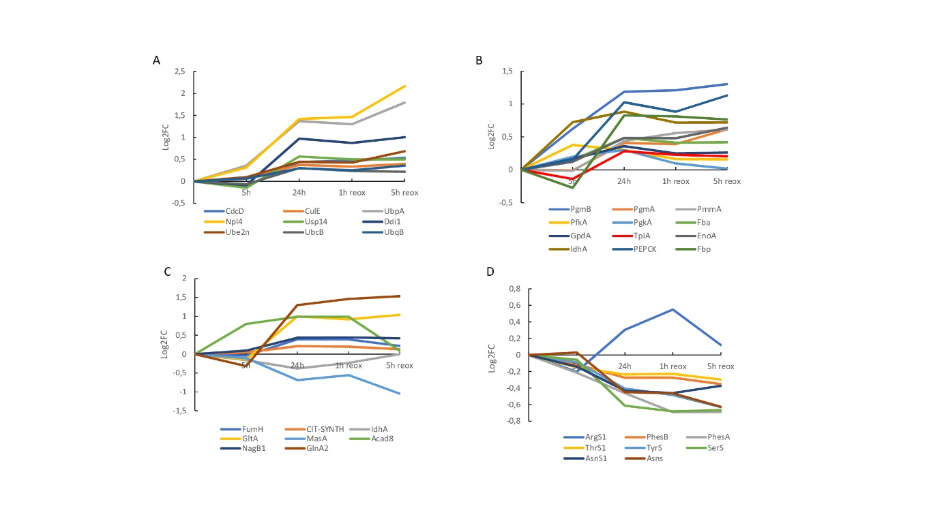Figure S4: Expression profile of proteins regulated during chronic hypoxia. All profiles were built using Series 2 (late response) and Table S3C,E,I.
A: Proteasome-associated and ubiquitin-associated proteins across the late time course.
B: Expression profile of glycolysis and gluconeogenesis-associated proteins.
C: Regulation of TCA- and glyoxylate cycle related proteins.
D: tRNA synthetase profile.

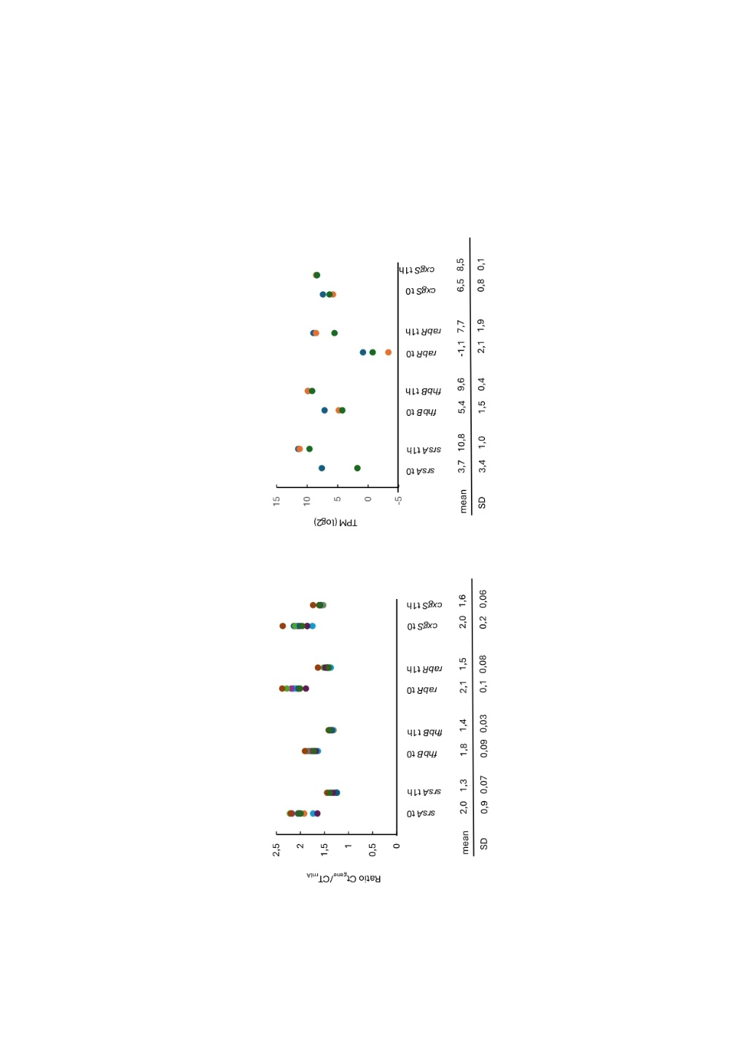
Figure S5: Variability among RT-qPCR replicates at t0 and 1 h hypoxia time point.
A: Ratio Ct_{gene}/CT_{rnlA} at t0 and 1 h for the presented RT-qPCR experiments (n=10). For each marker gene, the Ct value was divided by the Ct value of the housekeeping gene (rnlA) from the same condition (t0 or 1 hour after hypoxia). Data from RT-qPCR in the short time course (n=4), O₂ concentration (n=3), the experiment with chemical (n=3) were used. Each dot represents a replicate. For each gene, the mean values and standard deviations were annotated at the bottom of the graph
B: TPM from the RNA-seq at t0 and 1 h after hypoxia (n=3). For each marker gene, all three TPM values associated with each replicate are presented for both t0 and 1 h of hypoxia. The TPM values were extracted from Table S1A. For data visualization, the TPM values were converted to log2. Each dot represents a replicate. For each gene, the mean values and standard deviations were annotated at the bottom of the graph

Figure S6: Comparison of the transcriptomic response of Dictyostelium to hypoxia and exposure to various bacteria (adapted from Lamrabet et al. studies). For each graph, Only differentially expressed transcripts (log2FC≥1 or log2FC≤-1; FDR<0.05) compared to normoxia, or differentially expressed transcript (log2FC≥1 or log2FC≤-1; p-value adj<0.05) compared to cells curltured without bacteria (Klebsiella pneumoniae (KpGe), the pathogenic LM21 strain of K. pneumoniae (Kp21), the nonsporulating Bacillus subtilis 36.1 (Bs), or Micrococcus luteus (Ml)., were analysed). Lamrabet et al. data are available on Frontiers website (https://www.frontiersin.org/journals/microbiology/articles/10.3389/fmicb.2020.00410/full).
A: Expression profiles of transcripts encoding glutamate receptor-like proteins regulated in the presence of bacteria. In their study, Lamrabet et al. showed that Grls were highly regulated in cells exposed to bacteria or folate.
B: Expression profiles of hypoxia marker genes across both studies.

