Supplementary file 1. Supplementary figures for “Protein-coding genes in humans and model mammals (mouse, rat and pig): gene identifiers and disambiguation of gene nomenclature retrieved from the Ensembl genome browser”.

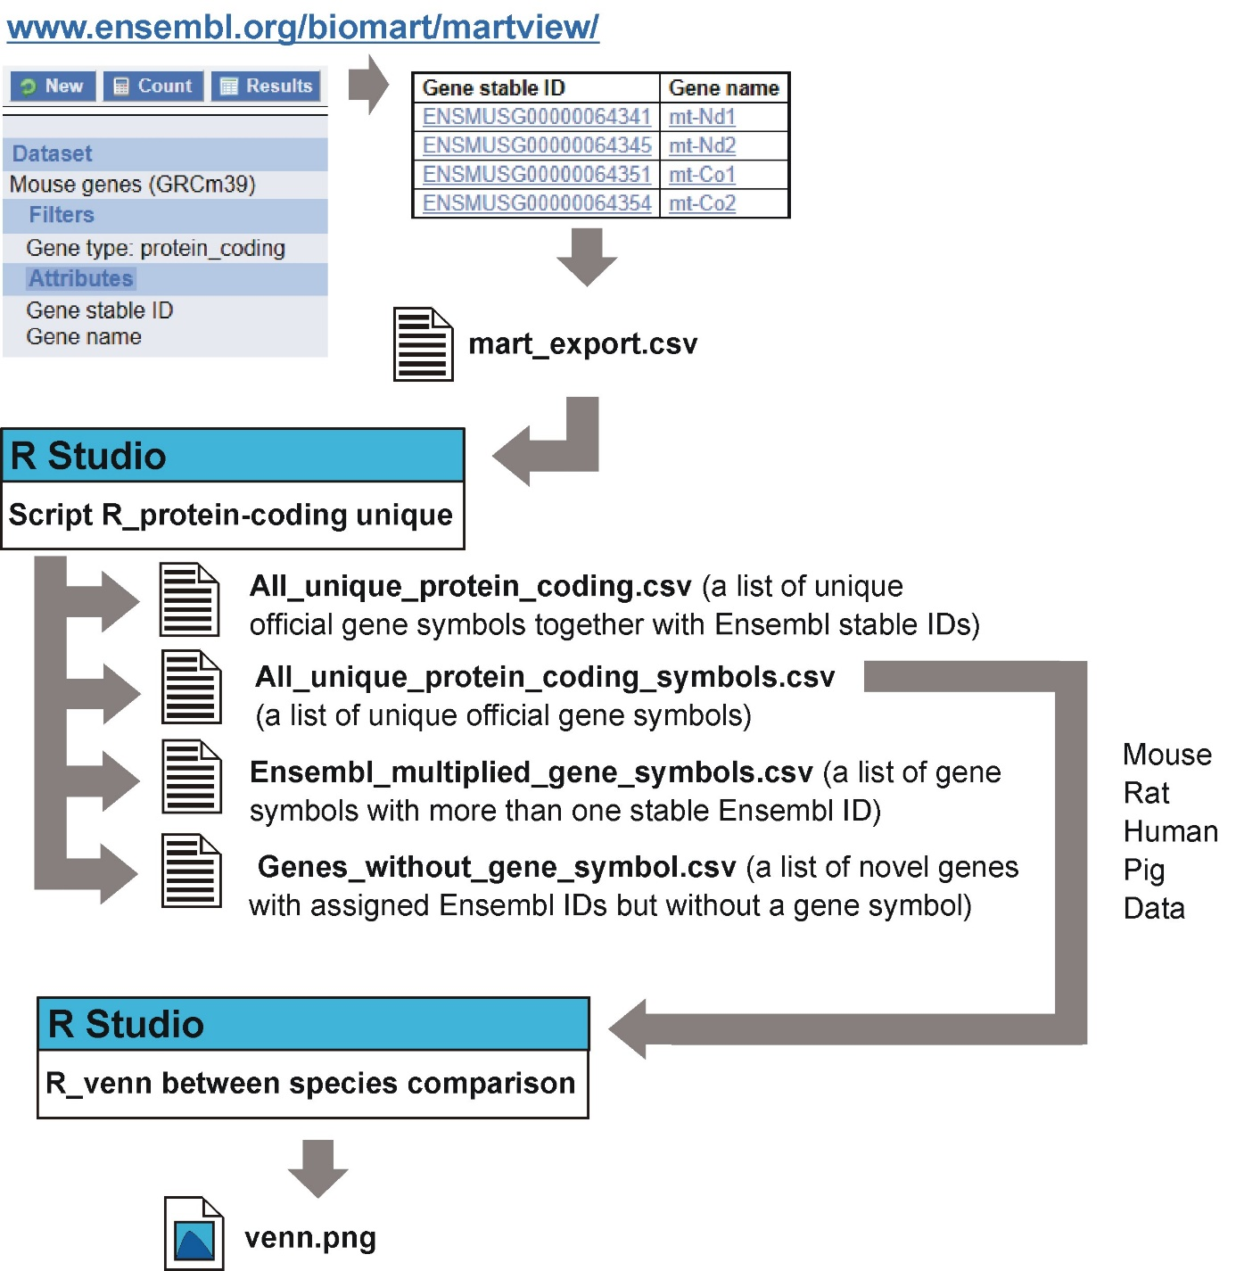

Supplementary Figure 1. Summary of protein-coding genomes.

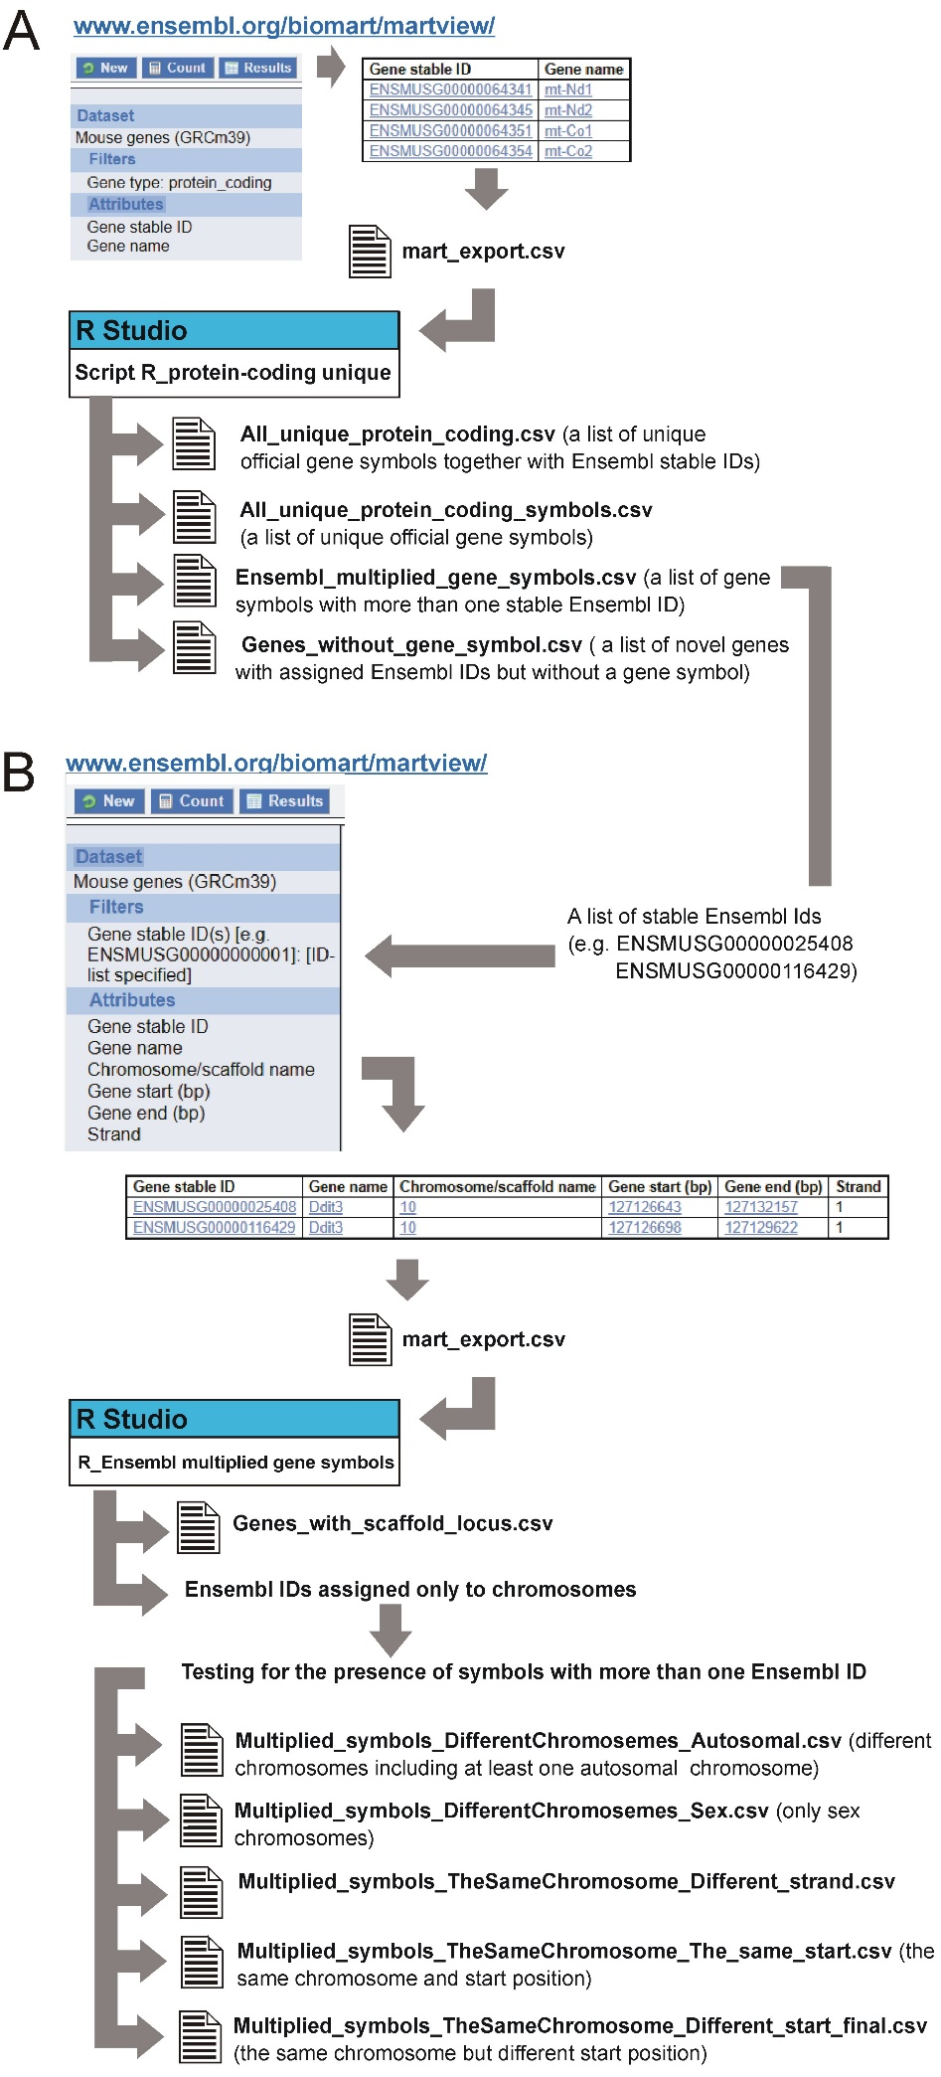
Supplementary Figure 2. Genomic localization of genes with multiple Ensembl IDs.
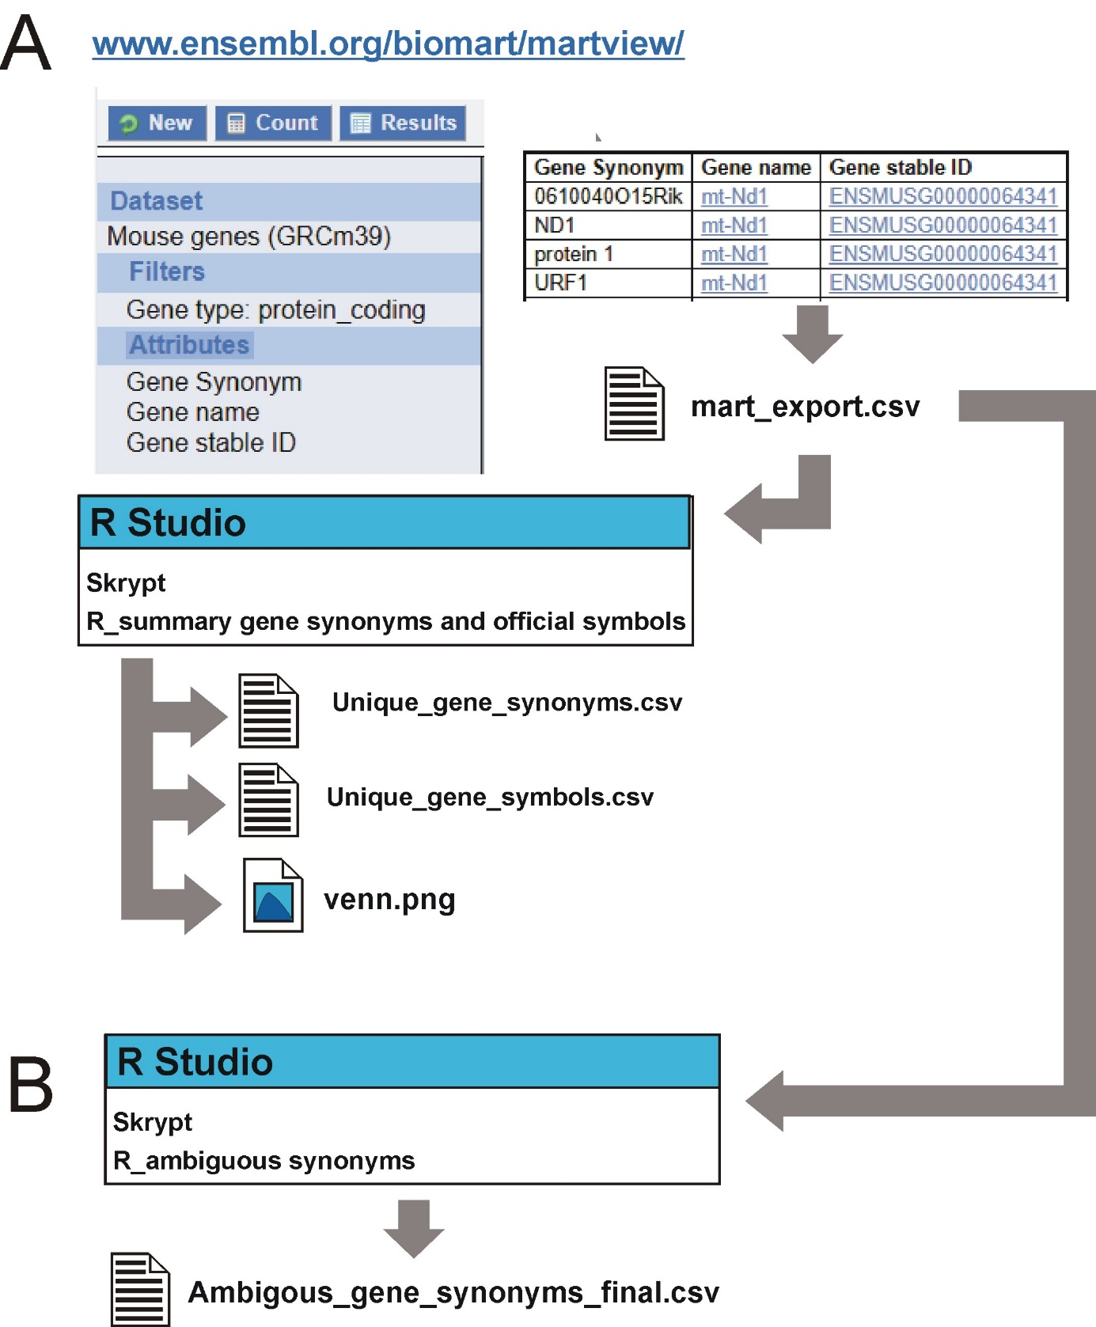

Supplementary Figure 3. Summary of gene synonyms and official symbols.

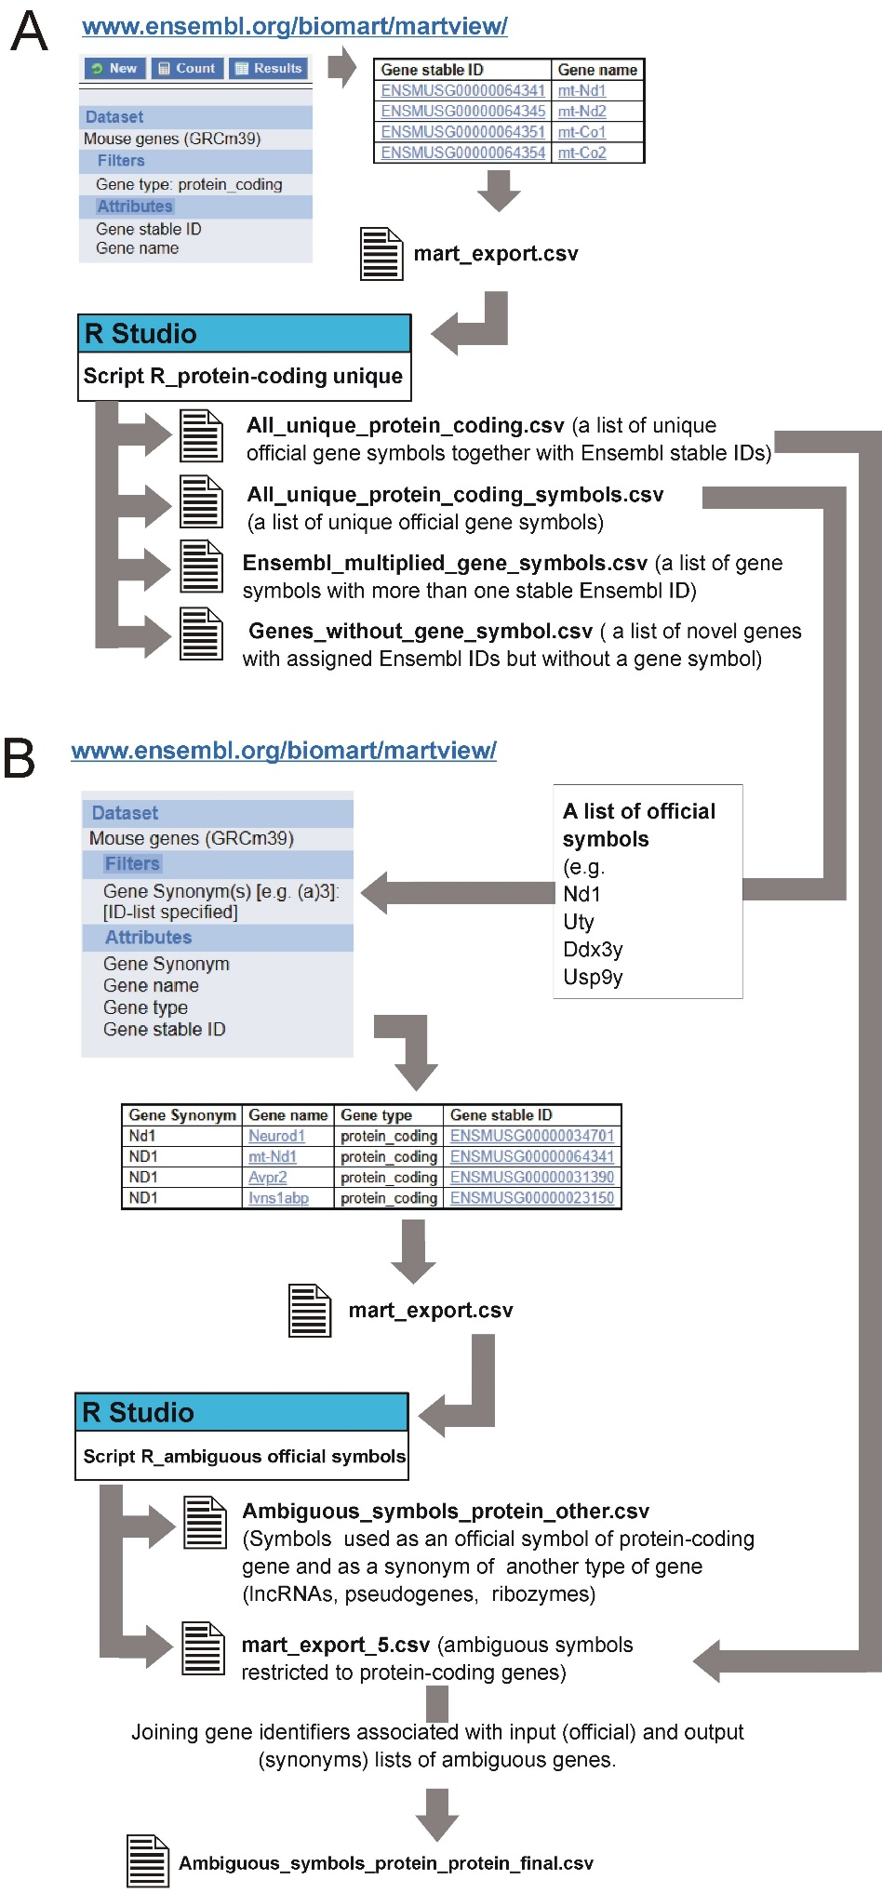

Supplementary Figure 4. Ambiguous official symbols.
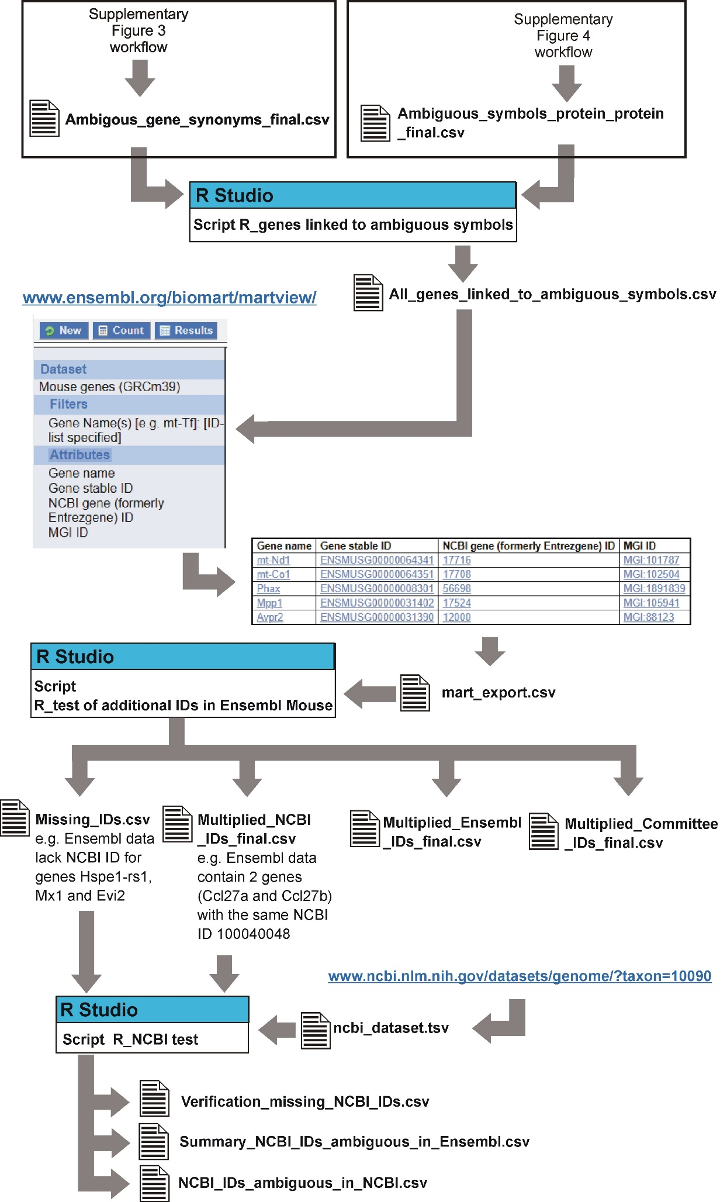
Supplementary Figure 5. Verification of additional gene IDs.

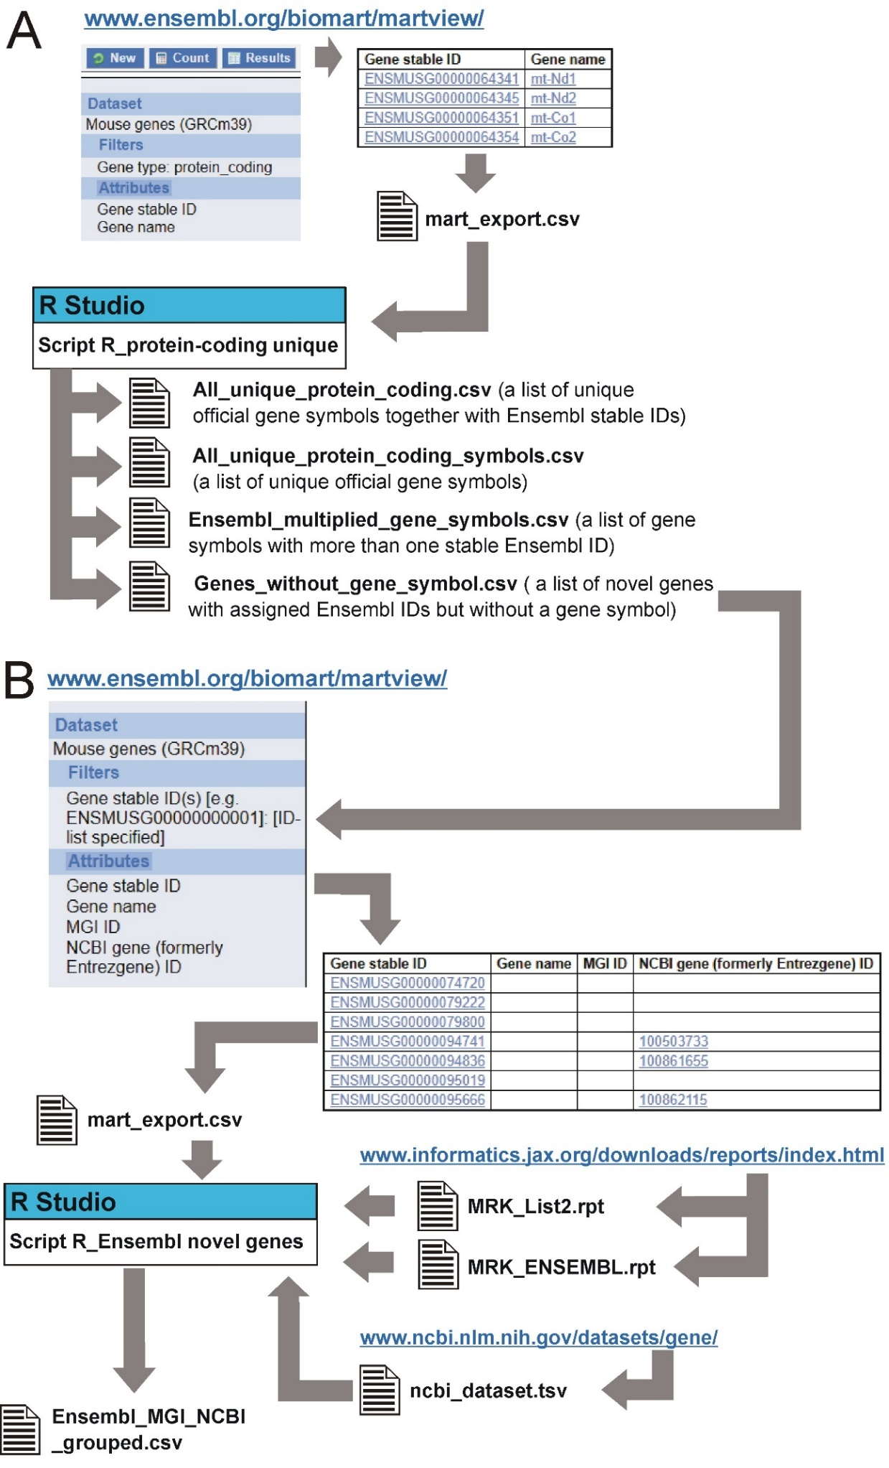
Supplementary Figure 6. Ensembl genes without a symbol.

