Supplementary Material

ASAPv2: An improved platform for exploring gene function in Angelica sinensis

Wei Zhu^{1#}, Silan Wu^{1#}, Xingxing Zhao¹, Jiaotong Yang^{1*}, Qiaoqiao Xiao^{1*}
¹ Guizhou University of Traditional Chinese Medicine, Guizhou 550025, China

#These authors are equal to this work.

*Correspondence:
Jiaotong Yang (y_jiaotong@163.com)
Qiaoqiao Xiao (xqqiao2021@163.com)

- Determine the cut-off of co-expression network
- Supplementary Figure

- Methods to determine the cut-off of co-expression network
Since co-expressed gene pairs often exhibit correlated expression patterns, they may have certain functional relevance. The biological relevance of a co-expression network is closely tied to the functional consistency among its constituent gene pairs, as reflected by the similarity of their GO annotations. To ensure the reliability of co-expression network, our analysis was restricted to GO terms associated with 4–20 genes, which constituted the prior knowledge set for subsequent evaluations. For gene pairs derived from the predicted co-expression network were assessed according to their shared GO annotations. If genes in a gene pair share at least one common GO term, the gene pair is assigned a classification label of 1; if genes in a gene pair have no shared GO term, the label is 0. The PCC or MR value is then used as a threshold, and together with the classification labels, it serves as input to calculate the true positive rate (TPR), false positive rate (FPR) and the area under the curve (AUC) value. ROC curves were generated under different PCC thresholds (>0.6, >0.7, >0.8) and the area under the curve (AUC) values were compared. For the 2022 version, the AUC reached maximum when PCC > 0.8, whereas for the 2023 version, the AUC peaked when PCC > 0.7. To maximize gene coverage, we uniformly set PCC > 0.7 as the selection threshold (Supplementary Figure 1A and 1C). Based on this threshold, we further evaluated AUC values for different mutual ranking (MR) cutoffs (MR<20, 30, 40, 50) and determined MR < 40 as the optimal threshold in both genome (Supplementary Figure 1B and 1D). Using these parameters, we identified 431,657 and 623,916 pairs of positively co-expressed genes, respectively.

- Supplementary Figure
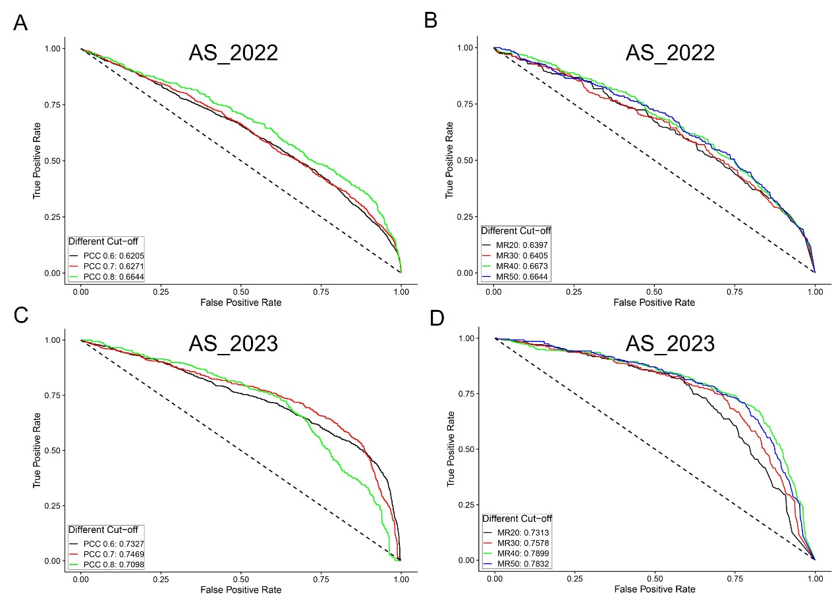
Supplementary Figure 1 Evaluation of the reliability of co-expression networks under different PCC and MR thresholds based on GO similarity. (A) The ROC curve of PCC network analysis of the 2022 version. (B) The ROC curve of MR network analysis of the 2022 version. (C) The ROC curve of PCC network analysis of the 2023 version. (D) The ROC curve of MR network analysis of the 2023 version.

