Supplementary Table 1. Drug resistance associated with conferring mutations
Drug | Gene | Locus tag | Genome position | Mutations | variant type | Frequency
Rifampicin | rpoB | Rv0667 | 761155 | Ser450Leu | Missense | 8
 |  | Rv0667 | 761139 | His445Tyr | Missense | 1
 |  | Rv0667 | 761101, 761127, 761131, 761133, 761196 | Gln432Pro:25.23 + Gly442Glu:71.13 | Missense | 1
Isoniazid | katG | Rv1908c | 2155168 | Ser315Thr | Missense | 10
Pyrazinamide | pncA | Rv2043c | 2289073 | His57Asp | Missense | 2
 |  | Rv2043c | 2289119 | Tyr41* | Stop gained | 1
 |  | Rv2043c | 2288869 | Val125Phe | Missense | 1
 |  | Rv2043c | 2289016 | Thr76Pro | Missense | 1
 |  | Rv2043c | 2289252 | c.-11A>G | upstream_gene_variant | 1
 |  | Rv2043c | 2289096 | Asp49Ala | Missense | 1
 |  | Rv2043c | 2289049 | c.192_193insA | frameshift | 1
Ethambutol | embB | Rv3795 | 4247429 | Met306Val | Missense | 1
 |  | Rv3795 | 4247431, 4247553 | Met306Ile, Ser347Thr | Missense | 1
 |  | Rv3795 | 4247431 | Met306Ile | Missense | 1
 |  | Rv3795 | 4247730 | Gly406Ala |  | 1
 | embB and embA | Rv3794, Rv3795 | 4243221, 4247431 | embA c.-12C>T, embB p.Met306Ile | Upstream and Missense | 1
 |  | Rv3795 |  | Gly406Asp, Met306Ile | Missense | 1
Streptomycin | rpsL | Rv0682 | 781822 | Lys88Arg | Missense | 3
 |  | Rv0682 | 781687 | Lys43Arg | Missense | 2
 | gid,rpsL | Rv3919c, Rv0682 | 4407997, 781822 | gid p.Gly69Asp, rpsL p.Lys88Thr | Missense | 1
 | gid, | Rv3919c | 4408100 | c.102delG | Frame shift | 1
 |  | Rv3919c | 4407997 | Gly69Asp | Missense | 2
 | rrs, gid | Rv3919c, EBG00000313325 | 4407816, 1472359 | gid c.386delG, rrs n.514A>C | frameshift,non_coding_transcript_exon | 1
Capromicin | tlyA | Rv1694 | 1918647 | Asn236Lys | Missense | 2
 | rrs | EBG00000313325 | 1473247, 1473329 | rrs n.1402C>A, rrs n.1484G>T | non_coding_transcript_exon | 1
Amikacin/Kanamicin | rrs | EBG00000313325 | 1473247, 1473329 | rrs n.1402C>A, rrs n.1484G>T | non_coding_transcript_exon | 1
Ethionamide | ethA | Rv3854c | 4327472 | Met1? | start_lost | 3
 |  | Rv3854c | 4326461 | Ile338Ser | Missense | 1
 |  | Rv3854c | 4327480 | c.-7T>C | upstream_gene | 1

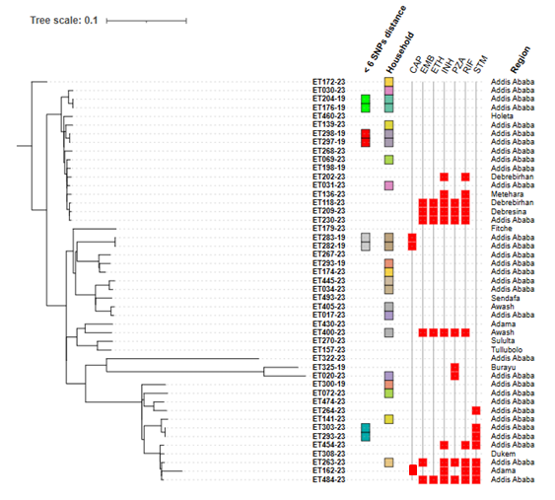
Supplementary figure 1. Pairwise SNP distance comparisons between isolates, stratified by household membership, phylogenetic lineage, geographic location and drug resistance profiles.
SNP-based approximately-maximum-likelihood phylogenetic tree of 47 Mycobacterium tuberculosis isolates inferred by FastTree 2.1.10 and visualized through iTOL v6. Clustered strains (< 6 SNPs distance cut-off) and household information are reported in different colours. Presence of DR to anti-TB drugs is shown as red squares (indicating presence of resistance markers as interpreted by the WHO 2023 Catalogue; CAP: capreomycin, EMB: ethambutol, ETH: ethionamide, INH: isoniazid, PZA: pyrazinamide, RIF: rifampicin, STM: streptomycin). City/town of isolation information is also reported for each strain.

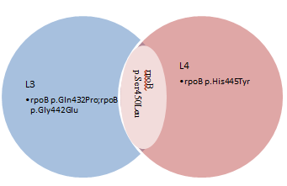
Supplementary figure 2. A venn diagram presentation showing drug resistance conferring variant by lineage type on Rifampicin drug from isolates collected from central Ethiopia,2023

902 HHCs of 303 index cases were screened
13 HHC-index pair cases were identified
30.0%(3/10) pairs have exact genotype match
76.92%(10/13) HHC-index pair cases included in WGS analysis
70.0 %(7/10) have non exact genotype match

Supplementary Figure 3. Genotype concordance in pulmonary tuberculosis index case-household contact pair identified in central Ethiopia,2023.

