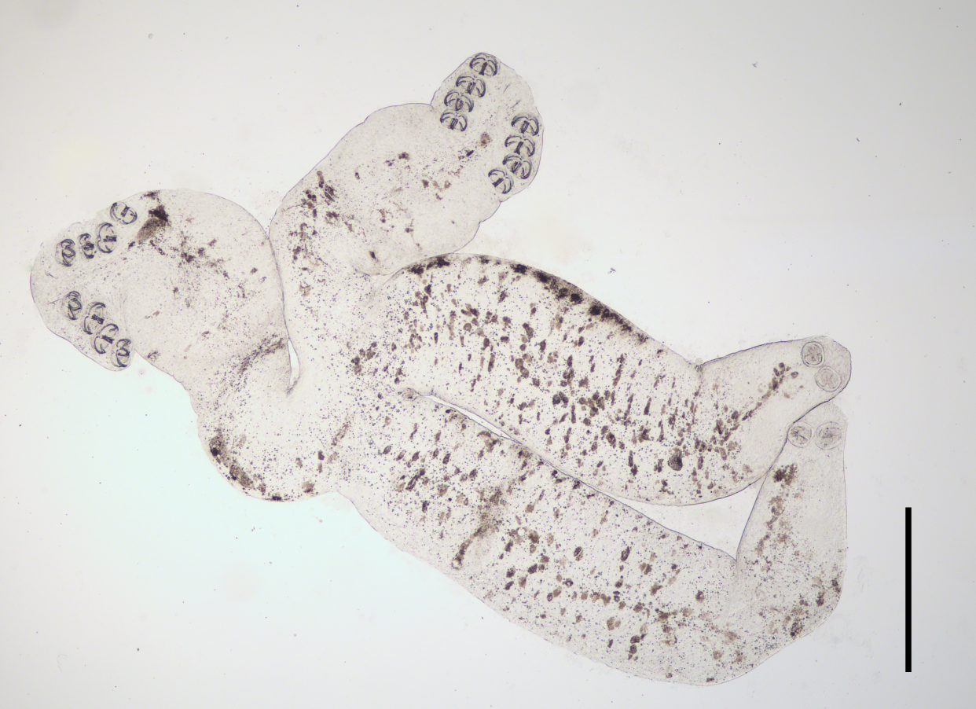
Figure S3. The whole body of S. coreius. (scale bar: 500 μm)

