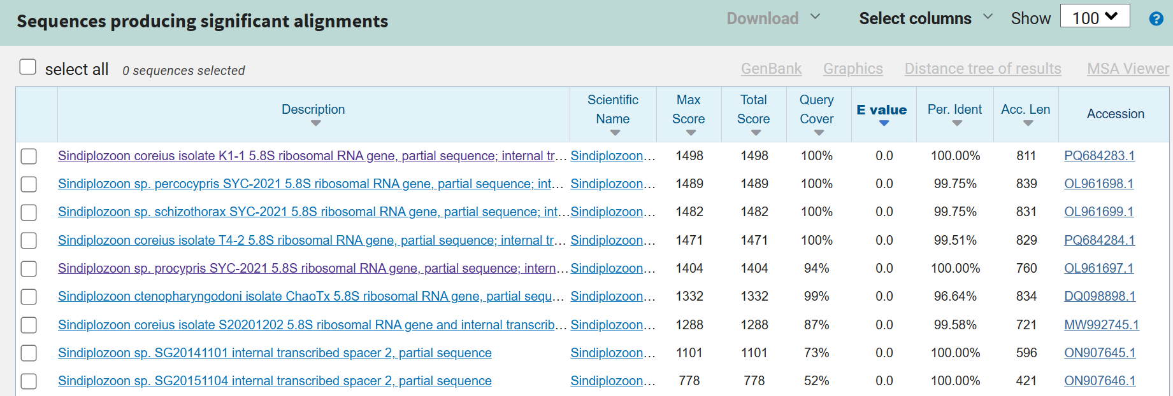
Figure S6. BLAST results for the ITS-2 of S. coreius.

