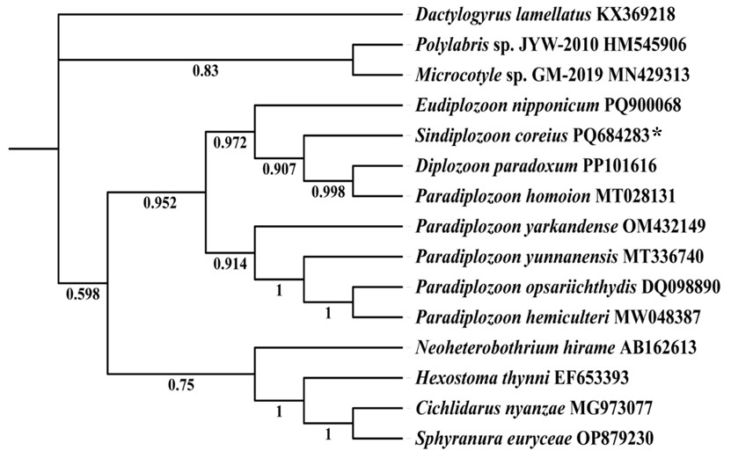
Figure S7. Phylogenetic Bayesian tree constructed based on ITS2 Sequences. The monogenean Dactylogyrus lamellatus was used as outgroup. The Sindiplozoon coreius in the present study is marked with *.

