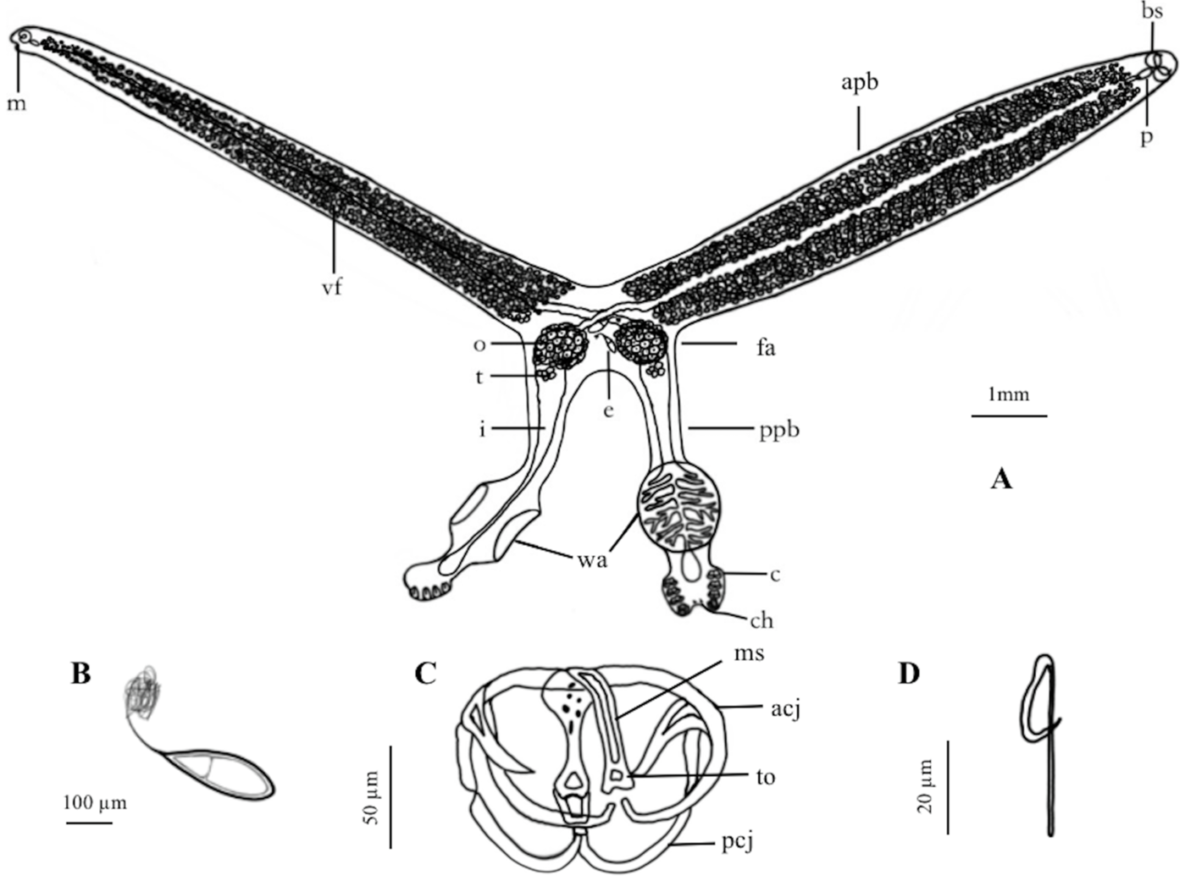
Figure S1. A drawing of a S. coreius specimen. (A) adult pair, the left half is a lateral view, and the right half is a ventral view. Apb: anterior part of body; bs: buccal suckers; c: clamps; ch: central hooks; e: eggs; fa: fusion area; i: intestine; m: mouth; o: ovary; p: pharynx; ppb: posterior part of body; t: testis; vf: vitelline follicles; wa: widened
area. (B) egg, with long, curly filament. (C) clamp. Acj: anterior clamp jaw; ms: median sclerite; pcj: posterior clamp jaw; to: trapezoid outgrowth. (D) central hooks. [2].

References
- Bh W, Long S, Wang W: Fauna Sinica, Platyhelminthes: Monogenea. Science Press, Beijing; 2000.
- Cao S, Fu P, Zou H, Li M, Wu S, Wang G, et al. Sindiplozoon coreius n. sp. (Monogenea: Diplozoidae) from the gills of Coreius guichenoti (Cyprinidae) in China. 2022;87:102494.

