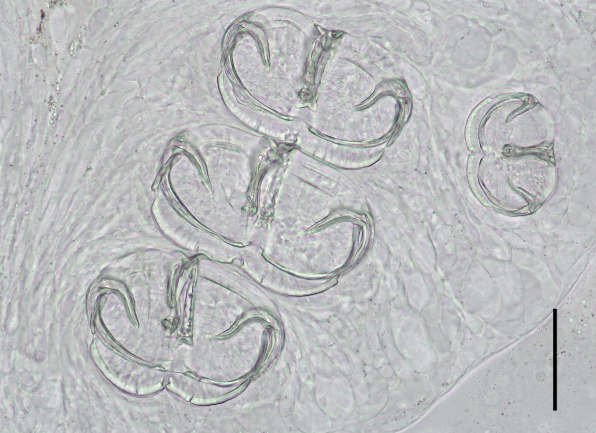
Figure S4. The clamps of S. coreius. (scale bar: 50 μm)

