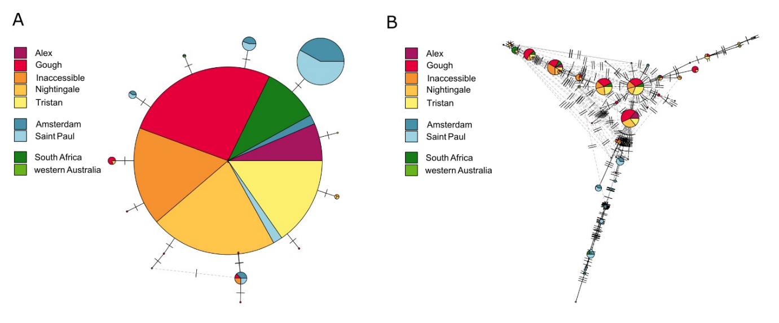Supplementary Figure 1. Parsimony haplotype networks based on fragments of the A) NADH dehydrogenase 2 (ND2) gene and B) the control region (CR). Each of the haplotypes are represented by a circle, which are scaled by frequency of occurrence, where strikes on branches indicate the number of mutational changes between haplotypes. Haplotypes are coloured by location with Atlantic Ocean populations represented in warm colours, Indian Ocean populations represented in blues, and vagrant individuals represented in greens.
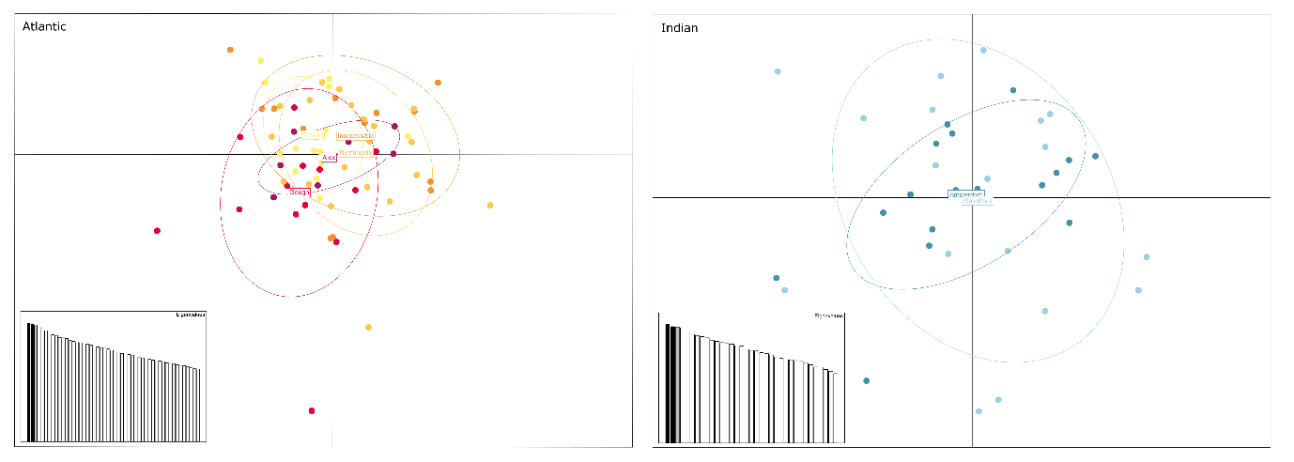
Supplementary Figure 2. Principal components analysis of Northern rockhopper penguin populations from five islands in the Atlantic Ocean and two islands in the Indian Ocean. Individuals are coloured by location with Atlantic Ocean populations represented in warm colours and Indian Ocean populations represented in blues.
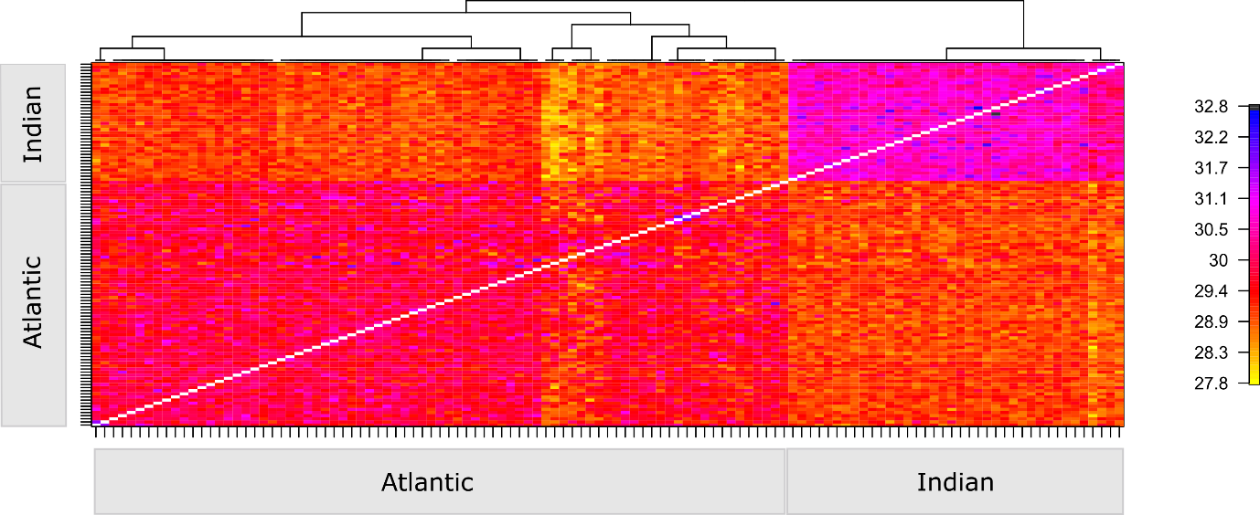
Supplementary Figure 3. Clustered fineRADstructure matrix of co-ancestry coefficients. Each square represents the co-ancestry coefficient generated between two individuals which is scaled from less to more shared co-ancestry.

Supplementary Table 1. Sample information for Northern rockhopper individuals used in this study with the number of samples successfully sequenced at two mitochondrial loci, the number of samples sequenced using ddRAD, and the number of ddRAD samples that passed QC and were used for downstream analysis.
 | Population | mtDNA | ddRAD sequenced | ddRAD passed QC
Atlantic Ocean | Alex | 8 | 7 | 7
Atlantic Ocean | Gough | 43 | 20 | 16
Atlantic Ocean | Inaccessible | 24 | 20 | 14
Atlantic Ocean | Nightingale | 30 | 23 | 21
Atlantic Ocean | Tristan da Cunha | 20 | 15 | 15
Indian Ocean | Amsterdam | 26 | 18 | 18
Indian Ocean | Saint Paul | 30 | 18 | 18
Vagrants | western Australia | 1 | 1 | 1
Vagrants | South Africa | 12 | 12 | 7

Supplementary Table 2. Haplotype data for all sequenced individuals including individual ID and location data.
 |  | NADH dehydrogenase 2 (ND2) |  | Control region (CR)
Population | Individual ID | Haplotype | NCBI Ref | Haplotype | NCBI Ref
Alex | PEN403 | A | PX216465 | BL | PX216543
Alex | PEN404 | A | PX216465 | BV | PX216553
Alex | PEN405 | A | PX216465 | BW | PX216554
Alex | PEN406 | A | PX216465 | B | PX216481
Alex | PEN407 | A | PX216465 | AM | PX216518
Alex | PEN408 | A | PX216465 | BX | PX216555
Alex | PEN409 | A | PX216465 | B | PX216481
Alex | PEN410 | A | PX216465 | A | PX216480
Gough | PEN036 | A | PX216465 | E | PX216484
Gough | PEN037 | A | PX216465 | E | PX216484
Gough | PEN038 | A | PX216465 | C | PX216482
Gough | PEN039 | J | PX216474 | H | PX216487
Gough | PEN040 | A | PX216465 | N | PX216493
Gough | PEN041 | A | PX216465 | E | PX216484
Gough | PEN042 | L | PX216476 | O | PX216494
Gough | PEN043 | A | PX216465 | AL | PX216517
Gough | PEN044 | E | PX216469 | AX | PX216529
Gough | PEN045 | O | PX216479 | B | PX216481
Gough | PEN046 | A | PX216465 | BP | PX216547
Gough | PEN047 | M | PX216477 | BD | PX216535
Gough | PEN048 | A | PX216465 | N | PX216493
Gough | PEN049 | A | PX216465 | BK | PX216542
Gough | PEN050 | A | PX216465 | B | PX216481
Gough | PEN051 | A | PX216465 | V | PX216501
Gough | PEN052 | A | PX216465 | C | PX216482
Gough | PEN053 | A | PX216465 | G | PX216486
Gough | PEN054 | A | PX216465 | Z | PX216505
Gough | PEN055 | J | PX216474 | H | PX216487
Gough | PEN056 | A | PX216465 | D | PX216483
Gough | PEN057 | A | PX216465 | C | PX216482
Gough | PEN058 | K | PX216475 | O | PX216494
Gough | PEN059 | J | PX216474 | H | PX216487
Gough | PEN060 | A | PX216465 | D | PX216483
Gough | PEN061 | A | PX216465 | P | PX216495
Gough | PEN062 | A | PX216465 | P | PX216495
Gough | PEN063 | A | PX216465 | A | PX216480
Gough | PEN064 | A | PX216465 | BQ | PX216548
Gough | PEN065 | D | PX216468 | B | PX216481
Gough | PEN066 | A | PX216465 | E | PX216484
Gough | PEN067 | A | PX216465 | AB | PX216507
Gough | PEN068 | J | PX216474 | H | PX216487
Gough | PEN069 | A | PX216465 | C | PX216482
Gough | PEN070 | A | PX216465 | A | PX216480
Gough | PEN071 | A | PX216465 | D | PX216483
Gough | PEN072 | A | PX216465 | D | PX216483
Gough | PEN073 | A | PX216465 | E | PX216484
Gough | PEN074 | A | PX216465 | A | PX216480
Gough | PEN075 | A | PX216465 | B | PX216481
Gough | PEN076 | A | PX216465 | B | PX216481
Gough | PEN077 | A | PX216465 | B | PX216481
Gough | PEN078 | A | PX216465 | AI | PX216514
Inaccessible | PEN107 | A | PX216465 | E | PX216484
Inaccessible | PEN108 | A | PX216465 | G | PX216486
Inaccessible | PEN109 | A | PX216465 | C | PX216482
Inaccessible | PEN110 | A | PX216465 | A | PX216480
Inaccessible | PEN111 | C | PX216467 | AB | PX216507
Inaccessible | PEN112 | A | PX216465 | G | PX216486
Inaccessible | PEN113 | A | PX216465 | A | PX216480
Inaccessible | PEN114 | A | PX216465 | M | PX216492
Inaccessible | PEN115 | A | PX216465 | BH | PX216539
Inaccessible | PEN116 | A | PX216465 | BL | PX216543
Inaccessible | PEN117 | A | PX216465 | AM | PX216518
Inaccessible | PEN118 | A | PX216465 | A | PX216480
Inaccessible | PEN119 | A | PX216465 | BM | PX216544
Inaccessible | PEN120 | A | PX216465 | C | PX216482
Inaccessible | PEN121 | K | PX216475 | Y | PX216504
Inaccessible | PEN122 | A | PX216465 | Z | PX216505
Inaccessible | PEN123 | A | PX216465 | BJ | PX216541
Inaccessible | PEN124 | A | PX216465 | AG | PX216512
Inaccessible | PEN125 | A | PX216465 | AF | PX216511
Inaccessible | PEN126 | K | PX216475 | Y | PX216504
Inaccessible | PEN127 | A | PX216465 | D | PX216483
Inaccessible | PEN128 | A | PX216465 | G | PX216486
Inaccessible | PEN129 | A | PX216465 | D | PX216483
Inaccessible | PEN132 | A | PX216465 | A | PX216480
Nightingale | PEN079 | A | PX216465 | M | PX216492
Nightingale | PEN080 | A | PX216465 | A | PX216480
Nightingale | PEN081 | B | PX216466 | A | PX216480
Nightingale | PEN082 | A | PX216465 | B | PX216481
Nightingale | PEN083 | A | PX216465 | AE | PX216510
Nightingale | PEN084 | A | PX216465 | BR | PX216549
Nightingale | PEN085 | A | PX216465 | BC | PX216534
Nightingale | PEN086 | A | PX216465 | BI | PX216540
Nightingale | PEN087 | A | PX216465 | AI | PX216514
Nightingale | PEN088 | A | PX216465 | X | PX216503
Nightingale | PEN089 | C | PX216467 | AD | PX216509
Nightingale | PEN090 | A | PX216465 | B | PX216481
Nightingale | PEN091 | A | PX216465 | AJ | PX216515
Nightingale | PEN092 | A | PX216465 | BG | PX216538
Nightingale | PEN093 | A | PX216465 | X | PX216503
Nightingale | PEN094 | A | PX216465 | D | PX216483
Nightingale | PEN095 | A | PX216465 | D | PX216483
Nightingale | PEN096 | A | PX216465 | M | PX216492
Nightingale | PEN097 | A | PX216465 | G | PX216486
Nightingale | PEN098 | A | PX216465 | C | PX216482
Nightingale | PEN099 | A | PX216465 | C | PX216482
Nightingale | PEN100 | A | PX216465 | AH | PX216513
Nightingale | PEN101 | A | PX216465 | BS | PX216550
Nightingale | PEN102 | J | PX216474 | H | PX216487
Nightingale | PEN103 | A | PX216465 | B | PX216481
Nightingale | PEN104 | A | PX216465 | T | PX216499
Nightingale | PEN105 | A | PX216465 | C | PX216482
Nightingale | PEN106 | A | PX216465 | BT | PX216551
Nightingale | PEN130 | A | PX216465 | B | PX216481
Nightingale | PEN131 | A | PX216465 | Z | PX216505
Tristan | PEN383 | A | PX216465 | B | PX216481
Tristan | PEN384 | A | PX216465 | C | PX216482
Tristan | PEN385 | A | PX216465 | BU | PX216552
Tristan | PEN386 | A | PX216465 | D | PX216483
Tristan | PEN387 | A | PX216465 | E | PX216484
Tristan | PEN388 | A | PX216465 | AB | PX216507
Tristan | PEN389 | A | PX216465 | D | PX216483
Tristan | PEN390 | A | PX216465 | B | PX216481
Tristan | PEN391 | A | PX216465 | AF | PX216511
Tristan | PEN392 | A | PX216465 | A | PX216480
Tristan | PEN393 | A | PX216465 | D | PX216483
Tristan | PEN394 | A | PX216465 | E | PX216484
Tristan | PEN395 | A | PX216465 | BL | PX216543
Tristan | PEN396 | A | PX216465 | C | PX216482
Tristan | PEN397 | A | PX216465 | AI | PX216514
Tristan | PEN398 | A | PX216465 | D | PX216483
Tristan | PEN399 | A | PX216465 | AE | PX216510
Tristan | PEN400 | A | PX216465 | AG | PX216512
Tristan | PEN401 | A | PX216465 | C | PX216482
Tristan | PEN402 | C | PX216467 | AB | PX216507
Amsterdam | PEN140 | H | PX216472 | AO | PX216520
Amsterdam | PEN141 | H | PX216472 | AZ | PX216531
Amsterdam | PEN142 | F | PX216470 | AS | PX216524
Amsterdam | PEN143 | H | PX216472 | BA | PX216532
Amsterdam | PEN144 | H | PX216472 | AA | PX216506
Amsterdam | PEN145 | H | PX216472 | AW | PX216528
Amsterdam | PEN146 | K | PX216475 | I | PX216488
Amsterdam | PEN147 | H | PX216472 | AN | PX216519
Amsterdam | PEN148 | A | PX216465 | U | PX216500
Amsterdam | PEN149 | K | PX216475 | Q | PX216496
Amsterdam | PEN150 | F | PX216470 | F | PX216485
Amsterdam | PEN151 | G | PX216471 | BE | PX216536
Amsterdam | PEN152 | H | PX216472 | AA | PX216506
Amsterdam | PEN154 | H | PX216472 | J | PX216489
Amsterdam | PEN155 | H | PX216472 | S | PX216498
Amsterdam | PEN156 | H | PX216472 | S | PX216498
Amsterdam | PEN159 | N | PX216478 | Q | PX216496
Amsterdam | PEN160 | F | PX216470 | BB | PX216533
Amsterdam | PEN161 | F | PX216470 | F | PX216485
Amsterdam | PEN162 | A | PX216465 | T | PX216499
Amsterdam | PEN164 | I | PX216473 | L | PX216491
Amsterdam | PEN165 | H | PX216472 | AU | PX216526
Amsterdam | PEN166 | H | PX216472 | J | PX216489
Amsterdam | PEN167 | H | PX216472 | W | PX216502
Amsterdam | PEN168 | K | PX216475 | I | PX216488
Amsterdam | PEN199 | I | PX216473 | L | PX216491
Saint Paul | PEN169 | F | PX216470 | F | PX216485
Saint Paul | PEN170 | F | PX216470 | BB | PX216533
Saint Paul | PEN171 | H | PX216472 | J | PX216489
Saint Paul | PEN172 | H | PX216472 | R | PX216497
Saint Paul | PEN173 | K | PX216475 | I | PX216488
Saint Paul | PEN174 | F | PX216470 | F | PX216485
Saint Paul | PEN175 | H | PX216472 | AT | PX216525
Saint Paul | PEN176 | I | PX216473 | L | PX216491
Saint Paul | PEN177 | A | PX216465 | U | PX216500
Saint Paul | PEN178 | H | PX216472 | R | PX216497
Saint Paul | PEN179 | H | PX216472 | AP | PX216521
Saint Paul | PEN180 | H | PX216472 | AW | PX216528
Saint Paul | PEN181 | H | PX216472 | K | PX216490
Saint Paul | PEN182 | I | PX216473 | AC | PX216508
Saint Paul | PEN183 | H | PX216472 | J | PX216489
Saint Paul | PEN184 | H | PX216472 | K | PX216490
Saint Paul | PEN185 | F | PX216470 | F | PX216485
Saint Paul | PEN186 | H | PX216472 | K | PX216490
Saint Paul | PEN187 | H | PX216472 | AY | PX216530
Saint Paul | PEN188 | H | PX216472 | AR | PX216523
Saint Paul | PEN189 | H | PX216472 | R | PX216497
Saint Paul | PEN190 | I | PX216473 | L | PX216491
Saint Paul | PEN191 | A | PX216465 | AK | PX216516
Saint Paul | PEN192 | K | PX216475 | I | PX216488
Saint Paul | PEN193 | H | PX216472 | BF | PX216537
Saint Paul | PEN194 | F | PX216470 | AQ | PX216522
Saint Paul | PEN195 | H | PX216472 | W | PX216502
Saint Paul | PEN196 | H | PX216472 | AP | PX216521
Saint Paul | PEN197 | H | PX216472 | J | PX216489
Saint Paul | PEN198 | H | PX216472 | AV | PX216527
western Australia | PEN340 | G | PX216471 | AZ | PX216531
South Africa | PEN341 | A | PX216465 | C | PX216482
South Africa | PEN342 | A | PX216465 | E | PX216484
South Africa | PEN343 | A | PX216465 | BN | PX216545
South Africa | PEN344 | A | PX216465 | BG | PX216538
South Africa | PEN345 | A | PX216465 | BG | PX216538
South Africa | PEN346 | A | PX216465 | F | PX216485
South Africa | PEN347 | A | PX216465 | BL | PX216543
South Africa | PEN348 | A | PX216465 | BG | PX216538
South Africa | PEN349 | A | PX216465 | A | PX216480
South Africa | PEN350 | A | PX216465 | BO | PX216546
South Africa | PEN351 | A | PX216465 | D | PX216483
South Africa | PEN352 | A | PX216465 | BG | PX216538

Supplementary Table 3. Migration estimates performed within BayesAss v3.0.5 with 95% confidence intervals determined as the mean ± 1.96 x SD. Results are calculated between the two identified genetic clusters (K=2), and between all island populations in each ocean.
 |  |  | Migrants FROM
 |  |  | Atlantic Ocean |  |  |  |  | Indian Ocean |  | K=2
 |  |  | Alex | Gough | Inaccessible | Nightingale | Tristan | Amsterdam | Saint Paul | Atlantic | Indian
Migrants TO | Atlantic Ocean | Alex | 0.6905(0.0222) | 0.0239(0.0222) | 0.0239(0.0223) | 0.0238(0.0220) | 0.1905(0.0425)
Migrants TO | Atlantic Ocean | Gough | 0.0145(0.0140) | 0.7689(0.0316) | 0.0143(0.0138) | 0.0144(0.0139) | 0.1588(0.0342)
Migrants TO | Atlantic Ocean | Inaccessible | 0.0161(0.0154) | 0.0160(0.0153) | 0.7612(0.0503) | 0.0192(0.0176) | 0.1559(0.0566)
Migrants TO | Atlantic Ocean | Nightingale | 0.0119(0.0114) | 0.0118(0.0114) | 0.0119(0.0115) | 0.7178(0.0284) | 0.2228(0.0338)
Migrants TO | Atlantic Ocean | Tristan | 0.0151(0.0145) | 0.0152(0.0146) | 0.0151(0.0144) | 0.0152(0.0144) | 0.9092(0.0308)
Migrants TO | Indian Ocean | Amsterdam |  |  |  |  |  | 0.6804(0.0132) | 0.2539(0.0279)
Migrants TO | Indian Ocean | Saint Paul |  |  |  |  |  | 0.0132(0.0127) | 0.9201(0.0279)
Migrants TO | K=2 | Atlantic |  |  |  |  |  |  |  | 0.9955(0.0044) | 0.0045(0.0044)
Migrants TO | K=2 | Indian |  |  |  |  |  |  |  | 0.0178(0.0121) | 0.9822(0.0121)

