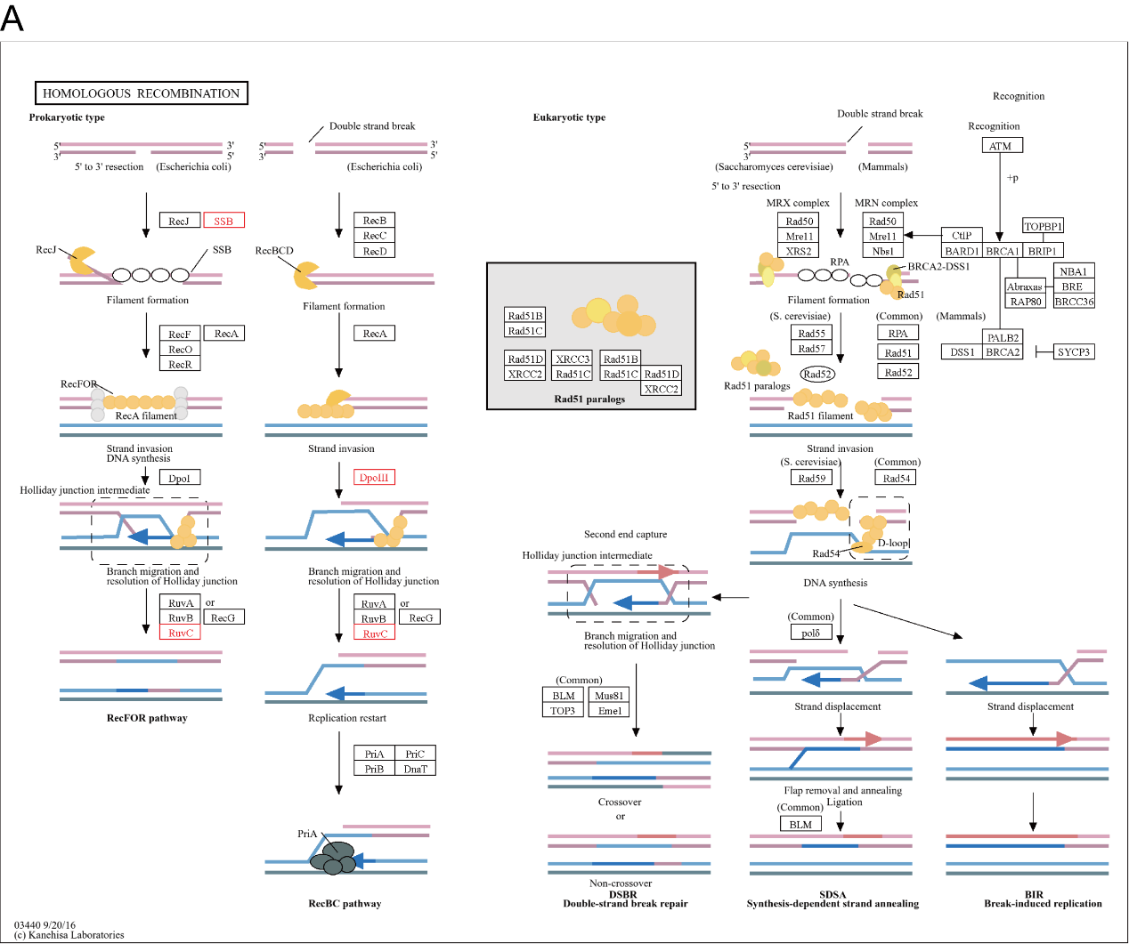
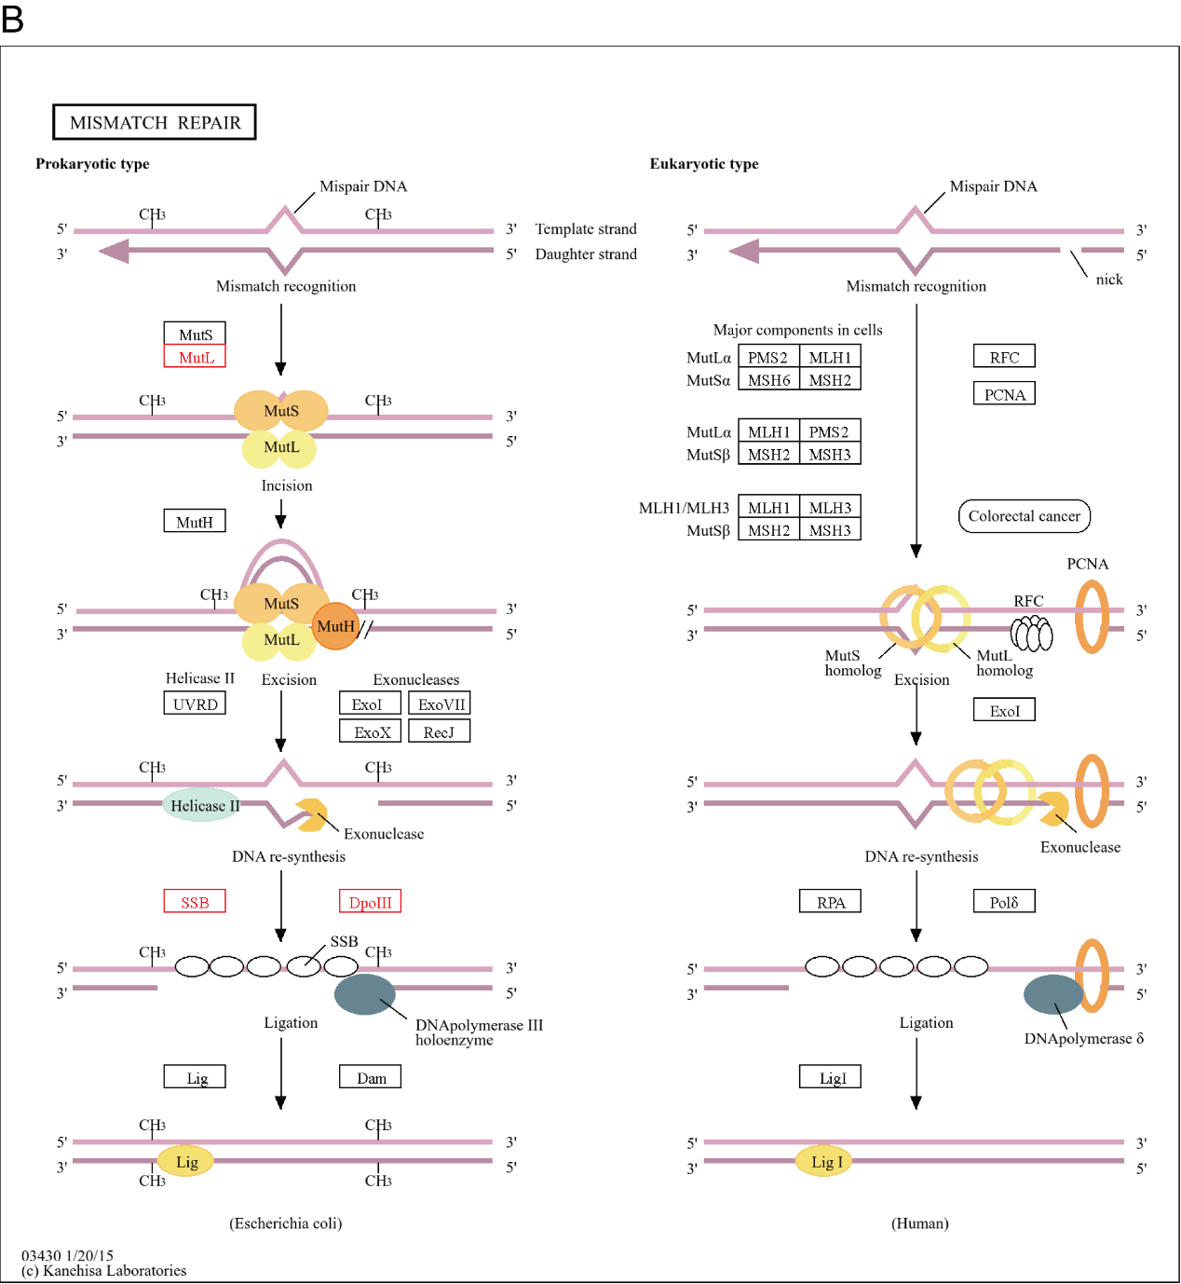
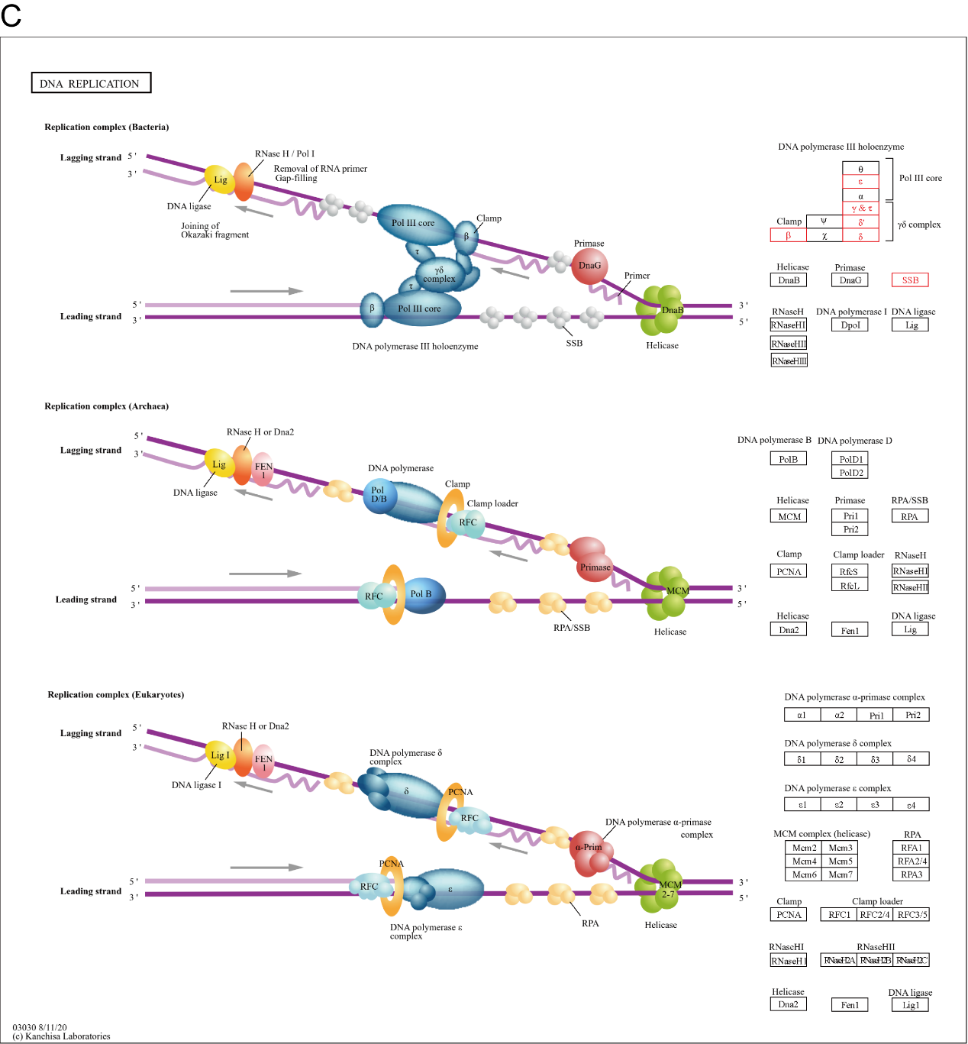
Fig. S5. KEGG maps related to genes absent from Portiera of Bemisia. A Homologous recombination. B Mismatch repair. C DNA replication

