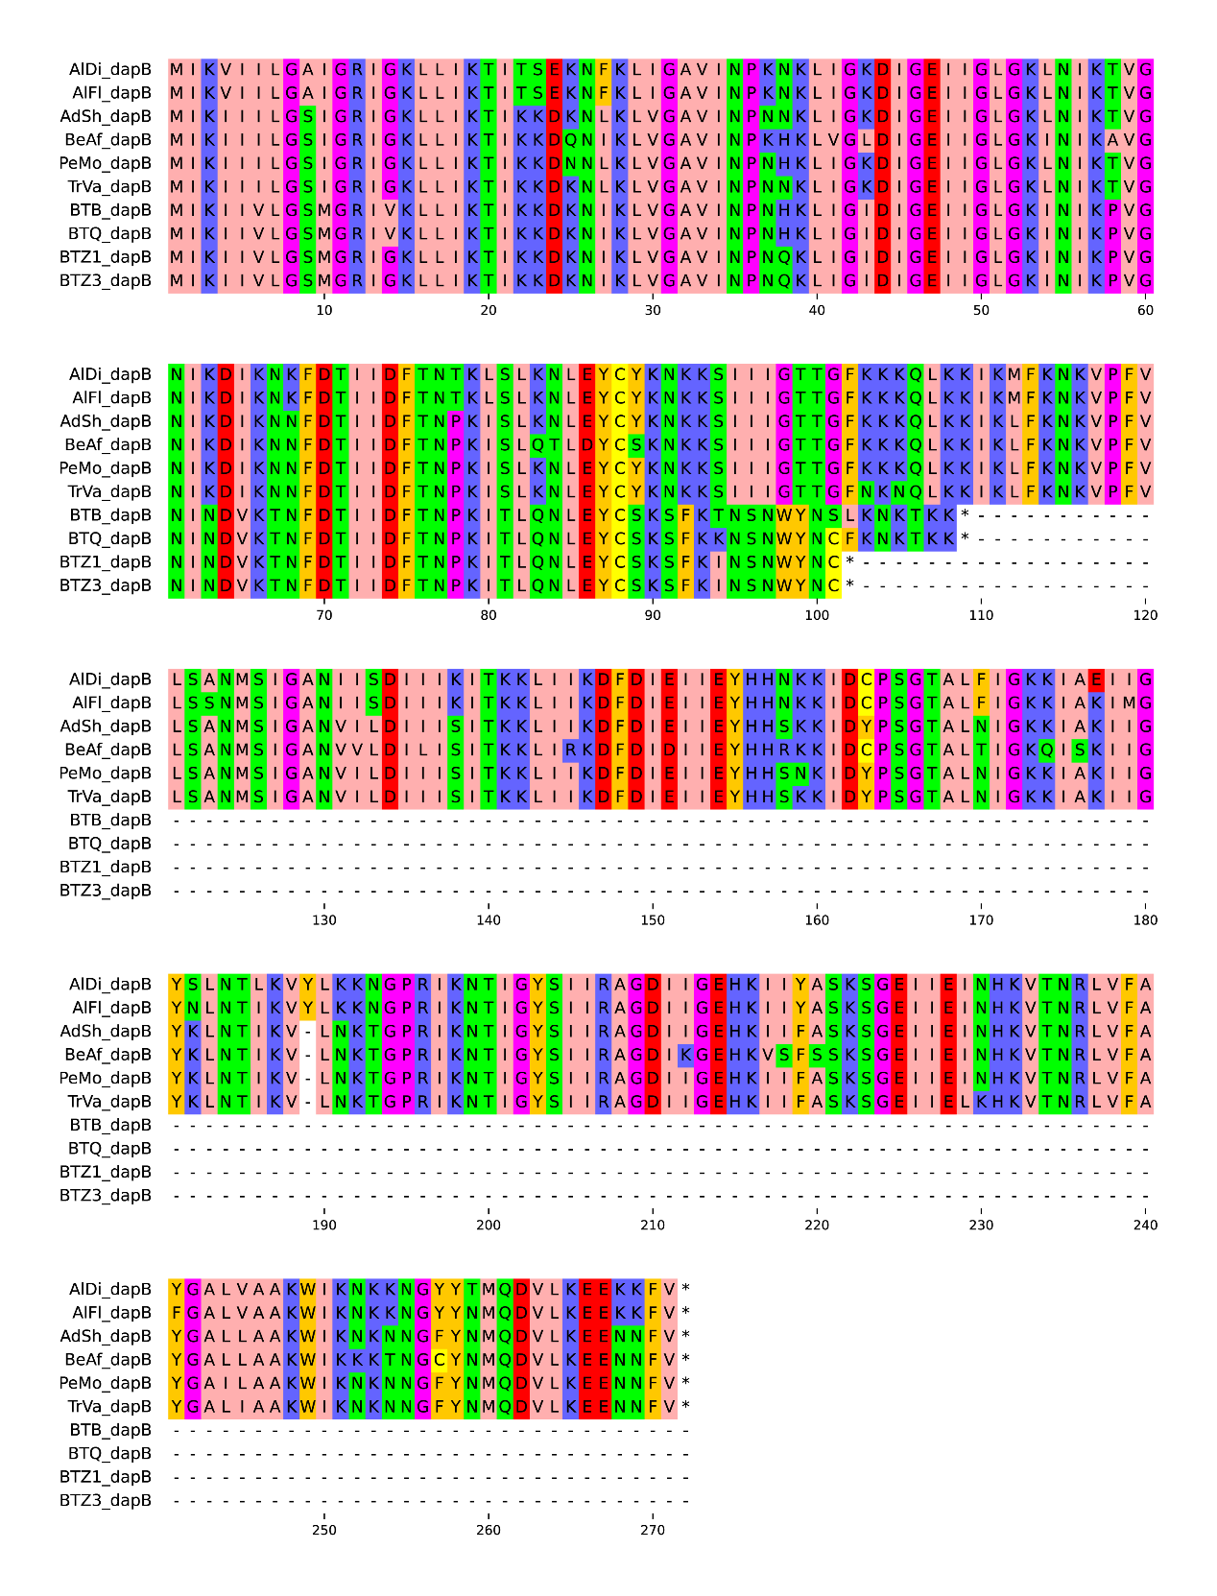
Fig. S6. Protein sequence alignment of dapB genes from Portiera lineages

