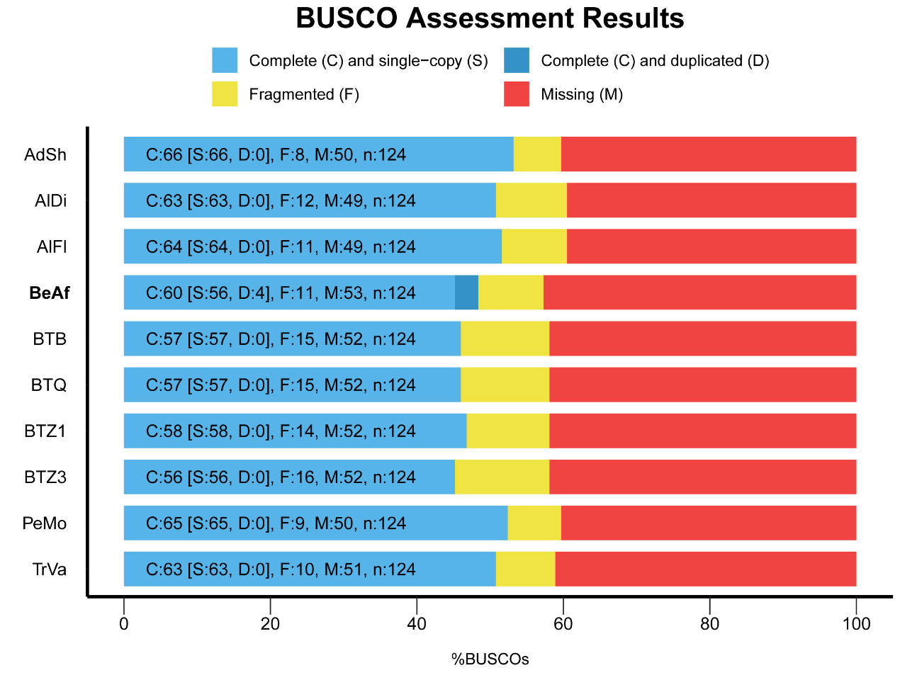
Fig. S1. BUSCO assessment results of Portiera lineages

